Project 2: QC Project evaluation of a novel sequencing platform

Your research institute has just acquired a new Illumina sequencing machine and they have recently performed their first sequencing run. As you are the only person in your institute that has attended an NGS course and have the skills to analyse NGS data, the head of your department has volunteered you to analyse the data and present your findings to the head of the institute. The sequencing data consists of 2 lanes of Illumina data for two Salmonella Paratyphi B isolates and your task is to download the sequencing data for the run, QC and analyse it. Prepare a short presentation for the head of the institute describing the results of your analyses.

Data download
Download the sequencing data
- Open the Firefox browser in the VM
- Navigate to https://tinyurl.com/WCS-GSA-QC1
- Press “Download all”.
- Wait for the file to be zipped and downloaded (< 5 minutes)
- Process this file further in the command line

# Create project directory and change to it
mkdir $HOME/Project2 && cd "$_"

# Extract downloaded zip file and cleanup
unzip -j $HOME/Downloads/QC_Project*.zip -d Data
rm $HOME/Downloads/QC_Project*.zip

Download the FASTA file. Note: The Salmonella enterica subsp. enterica serovar Paratyphi B strain SPB7 reference genome is from NCBI

# Download the FASTA
wget -O CP000886.fasta \ "https://eutils.ncbi.nlm.nih.gov/entrez/eutils/efetch.fcgi?db=nuccore&id=CP000886&rettype=fasta&retmode=text"

Tools to be used
- Bwa mem
- Samtools stats
- Bcftools

Tasks
Use your knowledge from the QC, alignment and variant calling modules.

Task 1: Align the reads to the reference genome with bwa mem for each group.
# Group 2
bwa mem -M -t 4 CP000886.fasta Data/Group2_S2_L001_R1_001.fastq.gz Data/Group2_S2_L001_R2_001.fastq.gz | samtools sort -@ 4 -O bam -o Group2.sorted.bam

samtools index Group2.sorted.bam

picard MarkDuplicates -I Group2.sorted.bam -O Group2.markdup.bam -M Group2.picard_metrics.txt

samtools index Group2.markdup.bam
# Group 4
bwa mem -M -t 4 CP000886.fasta Data/Group4_S4_L001_R1_001.fastq.gz Data/Group4_S4_L001_R2_001.fastq.gz | samtools sort -@ 4 -O bam -o Group4.sorted.bam

samtools index Group4.sorted.bam

picard MarkDuplicates -I Group4.sorted.bam -O Group4.markdup.bam -M Group4.picard_metrics.txt

samtools index Group4.markdup.bam

Task 2: Collect the statistics about the alignments (‘samtools stats’ command) and produce QC plots? Can you spot any problems in the QC plots?

samtools stats Group2.markdup.bam | plot-bamstats -p Group2_plot/alignment/ -
samtools stats Group4.markdup.bam | plot-bamstats -p Group4_plot/alignment/ -

Explanation: Students can navigate to Group*_plot/alignment/index.html and open it in firefox. They should spot most of the following issues.

Metrics summary
Group 2 has lower mapping rate (at read and base level) and higher base error rate.
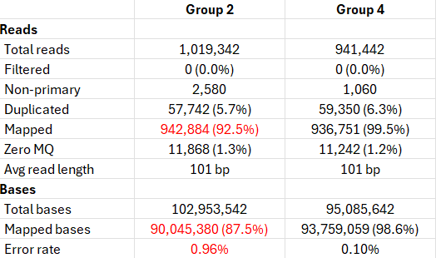

Mismatches per cycle
Group 2 is abnormal. High quality mismatches (Q>30, red line) are elevated and flat across all cycles suggesting true sequence differs greatly from the reference. Possibility of different strain.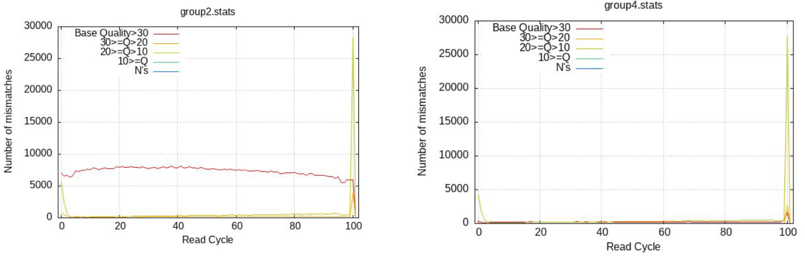Insert size
Group 2 is abnormal. Large plateau of outward-facing pairs (aqua) in first 100 bases with an abrupt hard cutoff. Suggests mate-pair contamination or adapter issues.
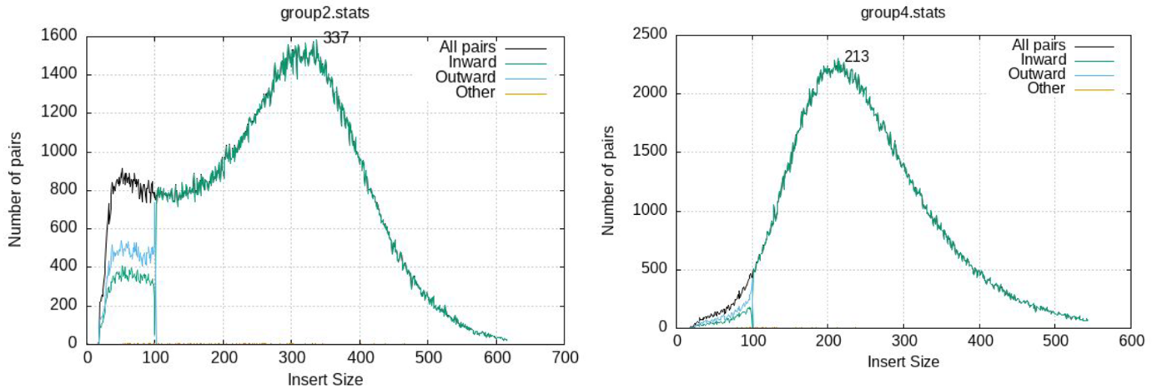

GC content
Group 2 is abnormal. Small but visible bump around at ~65% GC in first fragment (purple) suggesting minor contamination with organism with higher GC content.
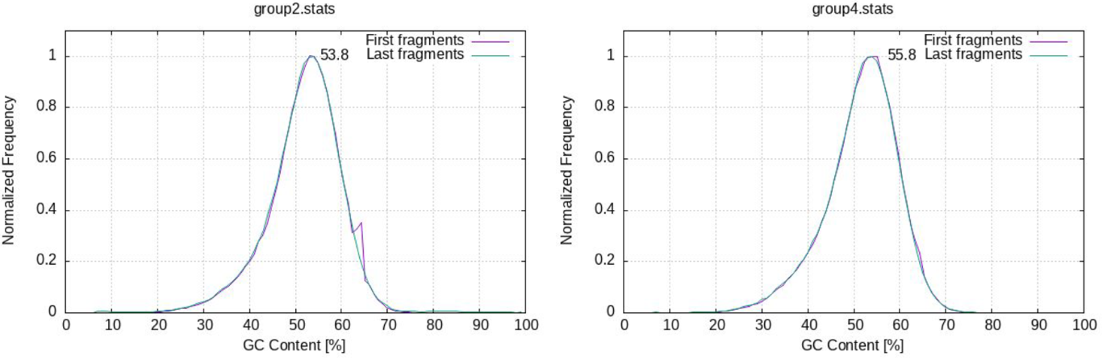

Task 3: Call variants with bcftools to produce a VCF file (~5 min per group)
- Filter variants that pass QUAL>=30 and DP>=20.

bcftools mpileup -a AD -f CP000886.fasta Group2.markdup.bam -Ou | bcftools call -mv -o Group2.vcf

bcftools filter -s LowQual -i'QUAL>=30 && DP>=20' Group2.vcf -o Group2.filtered.vcf
bcftools mpileup -a AD -f CP000886.fasta Group4.markdup.bam -Ou | bcftools call -mv -o Group4.vcf

bcftools filter -s LowQual -i'QUAL>=30 && DP>=20' Group4.vcf -o Group4.filtered.vcf

Explanation:
- bcftools mpileup computes per-base alignment statistics. The -a AD flag adds the allele depth info and -Ou outputs uncompressed file
- bcftools call performs the actual variant filtering. The -mv means call multiallelic variants and output only the variant sites
- bcftools filter with -s LowQual flag soft-filters variants. i.e. instead of hard filtering (removing low quality variants from the file), it tags them with “LowQual” in the FILTER column of the VCF (PASS otherwise). Retaining all variants is preferable as allows you to revisit the filtered variants later.

- What is the number of SNPs, indels and TS/TV before and after filtering in Group2 and Group4 samples?

bcftools stats Group2.vcf | grep -E "^SN|^TSTV"
bcftools stats -i'QUAL>=30 && DP>=20' Group2.vcf | grep -E "^SN|^TSTV"
bcftools stats Group4.vcf | grep -E "^SN|^TSTV"
bcftools stats -i'QUAL>=30 && DP>=20' Group4.vcf | grep -E "^SN|^TSTV"

 | Before filtering | After filtering
Group2 | No. of SNPs: 38,993  No. of indels: 356  TS/TV: 3.38 | No. of SNPs: 14,030  No. of indels: 95  TS/TV: 3.83
Group4 | No. of SNPs: 40  No. of indels: 16  TS/TV: 0.90 | No. of SNPs: 7  No. of indels: 4  TS/TV: 1.33

- Can you draw any conclusions about the first sequencing run. Was it a success? Should the institute keep the sequencing instrument? What are your recommendations moving forward.

Explanation: QC or contamination issues with Group2 samples leading to high false positive variant calls. Suggest review training in sample preparation steps and repeating the run again, perhaps with a few more samples.

