Project 3: Identifying host genetic factors for resistance to SARS-CoV
In this project, you'll hunt for genetic mutations that make mice more or less susceptible to COVID-like infection. By the end, you'll understand how to:
- Extract variants from genomic databases
- Interpret what variants do to proteins
- Link genetic changes to disease risk
Background: Why this matters?
Humans get COVID at different severity levels. Some people barely get sick; others get severe disease. Part of this comes from host genetics—variations in our DNA that affect how our immune system fights the virus.
To study this safely, researchers use mice. Different mouse strains (like different ethnic backgrounds in humans, but more extreme) respond very differently to SARS-CoV:
- NOD/ShiLtJ: Resistant, barely gets sick
- A/J, C57BL/6J: Moderate disease, recovers fine
- CAST/EiJ, PWK/PhJ, WSB/EiJ: Severe disease, lose weight, sometimes die
Researchers found four major genomic regions (called QTLs) linked to disease severity. In this project, you will focus specifically on the HrS1 locus and characterize genetic variants within Trim55 across 52 inbred mouse strains to identify candidate mutations which could be driving susceptibility or resistance SARS-CoV infection.

References
Genome Wide Identification of SARS-CoV Susceptibility Loci Using the Collaborative Cross
https://journals.plos.org/plosgenetics/article?id=10.1371/journal.pgen.1005504

Data download
- Open the Firefox browser in the VM
- Download VCF with SNPs and indels of the 52 mouse strains. (Note: The full VCF is available from the European Variation Archive under PRJEB43298. However, the VCF file for the whole genome is very large. In this project, we will only focus on chromosome 3, which can be downloaded https://drive.google.com/file/d/1dNfcO49nov0MzA2UIuOStJIlc1y_oZ3w/view?usp=sharing

Explanation: You can download the files manually through the Firefox browser in the VM and move it to project folder. Alternatively, you can download using wget like this:

# Create project directory
mkdir $HOME/Project3 && cd "$_"

# Download the VCF directly from Google Drive
wget -O "mgp_REL2005_snps_indels.3.18000000-22000000.vcf.gz" "https://drive.google.com/uc?export=download&id=1dNfcO49nov0MzA2UIuOStJIlc1y_oZ3w"

Tasks

Task 1: Confirm that you have 52 samples (i.e. strains) in this VCF. Extract the SNP and indel variants in the Trim55 gene into another VCF file (there should be 2,711 variants).

Explanation: Let’s assign the long filename to a shell variable VCF for convenience. Also, it’s a good habit to explore the VCF file,

# Create shell variables to hold the long filenames
VCF=mgp_REL2005_snps_indels.3.18000000-22000000.vcf.gz

# Explore the VCF
bcftools view -h $VCF
bcftools query -l $VCF | wc -l

-h for view only the header lines of the VCF
-l for listing the sample names

First we need to identify coordinates for Trim55 gene. One option is to download and check the corresponding GTF but you need to ensure to use the same genome build used for the VCF file generation. Alternatively, we can check within the VCF file using the CSQ field.

"The CSQ field contains predictions about how each variant affects genes — whether it's harmless (silent), changes a protein (missense), or breaks something critical. This was added by a tool called Ensembl VEP.

# Step 1: Extract the coordinates for Trim55
bcftools query -f '%CHROM\t%POS\t%CSQ\n' $VCF | grep -i trim55 | sort -k2 > Trim55_coords.txt

head -1 Trim55_coords.txt # Start position of the Trim55 variants
tail -1 Trim55_coords.txt # End position of the Trim55 variants
# This will be 3:19639519-19697415

The next step is to extract the variants using the identified coordinates:

# Step 2: Extract variants in the Trim55 gene region
bcftools index $VCF

bcftools view -r 3:19639519-19697415 $VCF -o Trim55_variants.vcf.gz -O z

bcftools index Trim55_variants.vcf.gz

# Step 3: Verify the number of variants
bcftools view -H Trim55_variants.vcf.gz | wc -l

Task 2 Identify variants that are most likely to affect the function of the gene.
Hint:
- Print the CSQ at position 3:19671000 to understand more about the variant.
- Repeat again for position 3:19694085. Can you explain this?
- Hint: comma in the CSQ field?

# Check if there's a CSQ field in your VCF header
bcftools view -h Trim55_variants.vcf.gz | grep CSQ

# Visualize two variants
bcftools query -r 3:19671000 -f '%POS %CSQ\n' Trim55_variants.vcf.gz
bcftools query -r 3:19694085 -f '%POS %CSQ\n' Trim55_variants.vcf.gz

Output should like this:
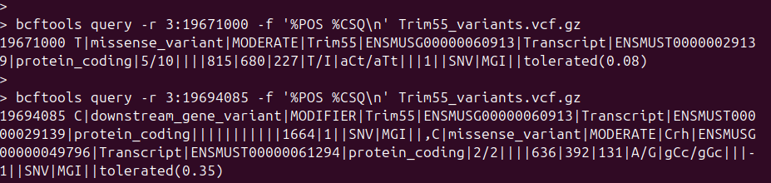

- The first variant (3:19671000) is a missense variant within the Trim55 gene itself.

- The second variant (3:19694085) has two annotations (separated by commas). The variant lies downstream of Trim55, but within the coding region of the Crh gene, where it causes a missense change.

- Genes can overlap or be very close together. A single DNA change might fall in both genes (or in ambiguous regions), so VEP reports all possible consequences. Thus one variant can potential affect multiple genes. The comma separates multiple annotations for the same variant.

Task 3 (optional): Tabulate the different CSQ predictions (Consequence|Impact|Symbol) and their counts. There should be a total of 4659 CSQ predictions.
Hint:
- you can use sed ‘s/,/\n/g’ to replace comma (,) in the CSQ field with a new line character (\n) (i.e. start a new line whenever there is comma in the CSQ field)
- then capture the column that you are interested in using cut command, then explore the CSQ type of interest
- Here is a guide which describes the CSQ annotations of the variants: https://m.ensembl.org/info/genome/variation/prediction/predicted_data.html

Explanation: The first part is to print the CSQ field. The next parts are more Linux manipulation commands. Changing comma to newline puts each record onto its own line. Using the pipe (|) as delimiter, we can select the (Consequence|Impact|Symbol) combination for tabulation. This shows that there are missense variants in Trim55 and Crh genes.

bcftools query -f '%CSQ\n' Trim55_variants.vcf.gz | sed 's/,/\n/g' | cut -d"|" -f2-4 | sort > predictions.txt

uniq -c predictions.txt | sort -rn
# 2416 intron_variant|MODIFIER|Trim55
# 488 upstream_gene_variant|MODIFIER|Trim55
# 476 downstream_gene_variant|MODIFIER|Trim55
# 300 upstream_gene_variant|MODIFIER|BC002189
# 267 downstream_gene_variant|MODIFIER|Crh
# 256 downstream_gene_variant|MODIFIER|BC002189
# 217 intron_variant&non_coding_transcript_variant|MODIFIER|Trim55
# 61 upstream_gene_variant|MODIFIER|Crh
# 49 non_coding_transcript_exon_variant|MODIFIER|BC002189
# 43 3_prime_UTR_variant|MODIFIER|Trim55
# 18 synonymous_variant|LOW|Trim55
# 12 non_coding_transcript_exon_variant|MODIFIER|Trim55
# 12 missense_variant|MODERATE|Trim55
# 12 intron_variant|MODIFIER|Crh
# 9 3_prime_UTR_variant|MODIFIER|Crh
# 6 splice_region_variant&intron_variant|LOW|Trim55
# 6 5_prime_UTR_variant|MODIFIER|Trim55
# 4 synonymous_variant|LOW|Crh
# 4 missense_variant|MODERATE|Crh
# 2 5_prime_UTR_variant|MODIFIER|Crh
# 1 splice_region_variant&intron_variant&non_coding_transcript_variant|LOW|Trim55

uniq -c predictions.txt | grep missense
# 4 missense_variant|MODERATE|Crh
# 12 missense_variant|MODERATE|Trim55

- Most variants are intronic (in the junk regions between exons) - probably harmless
- Only 12 missense variants in Trim55 - these change the protein and might matter
- Only 4 missense variants in the neighboring Crh gene which is not of interest here

Task 4: Most variants are harmless (intronic, downstream). We want to focus on the ones that change proteins (missense). Find only the missense variants present in Trim55 and save into a text file. There should be 11 such variants.

Explanation:
- [%SAMPLE:%GT] prints out the genotype for each sample (i.e. strain). This will be useful for the next question which filters out strains that do not vary from the reference genome.
- The key point here is to grep for the specific (Consequence|Impact|Symbol) combo

bcftools query -f '%POS %REF>%ALT %CSQ [%SAMPLE:%GT ]\n' Trim55_variants.vcf.gz | grep 'missense_variant|MODERATE|Trim55' > Trim55_missense_variant.txt

wc -l Trim55_missense_variant.txt

Task 5: Find the strains that have missense mutations in the Trim55 gene. This gives you a clue to find potential mutations in Trim55 that may mediate response to SARS-CoV pathogenesis in mice.

Explanation: The file from Task 4 stores [%SMPLE:%GT] in a wide format. For example:

19670978 G>A missense_variant|MODERATE|Trim55|... CAST_EiJ:1/1 QSi5:1/1 NOD_ShiLtJ:0/0 A_J:0/0 ...
Translation:
- Variant at position 19670978: G changed to A
- CAST_EiJ has 1/1 (two copies of the variant = affected)
- QSi5 has 1/1 (also affected)
- NOD_ShiLtJ has 0/0 (doesn't carry the variant)
- A_J has 0/0 (doesn't carry the variant)

We convert into long format. Then we have to remove the non-varying genotypes (0/0).

sed 's/ /\n/g' Trim55_missense_variant.txt | grep -v '0/0' > Trim55_missense_variant_strains.txt

The file Trim55_missense_variant_strains.txt shows which strains have SNVs in the Trim55 gene at various locations.
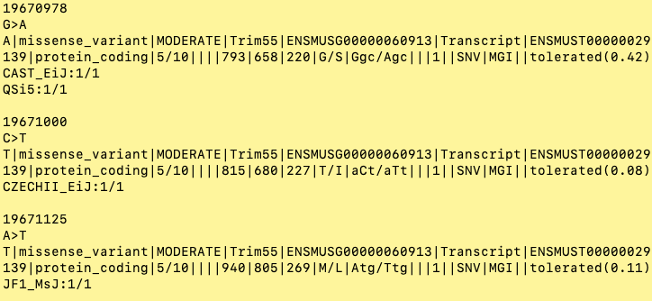

We can tidy up this file into a table format.

genomic_position | mutation | exon | protein_position | amino_acid_change | sift_score | sift_confidence | strain_count | strains
19670978 | G>A | 5 | 220 | G220S | 0.42 | Normal | 2 | CAST_EiJ(1/1); QSi5(1/1)
19671000 | C>T | 5 | 227 | T227I | 0.08 | Normal | 1 | CZECHII_EiJ(1/1)
19671125 | A>T | 5 | 269 | M269L | 0.11 | Normal | 1 | JF1_MsJ(1/1)
19671534 | G>A | 7 | 289 | V289M | 0.13 | Normal | 1 | SPRET_EiJ(1/1)
19672780 | G>A | 8 | 337 | G337E | 1 | Normal | 1 | ZALENDE_EiJ(1/1)
19672798 | G>T | 8 | 343 | G343V | 0.16 | Normal | 3 | CAST_EiJ(1/1); MOLF_EiJ(1/1); QSi5(1/1)
19672808 | G>T | 8 | 346 | E346D | 0.33 | Normal | 4 | CAST_EiJ(1/1); MOLF_EiJ(1/1); QSi5(1/1); SPRET_EiJ(1/1)
19672830 | G>A | 8 | 354 | A354T | 0.65 | Normal | 4 | CAST_EiJ(1/1); MOLF_EiJ(1/1); QSi5(1/1); SPRET_EiJ(1/1)
19672870 | G>C,T | 8 | 367 | S367T | 0.47 | Low | 4 | CAST_EiJ(1/1); MOLF_EiJ(2/2); QSi5(1/1); SPRET_EiJ(1/1)
19672920 | G>A | 8 | 384 | A384T | 0.36 | Normal | 3 | CAST_EiJ(1/1); MOLF_EiJ(1/1); QSi5(1/1)
19672933 | T>C | 8 | 388 | L388P | 0.08 | Normal | 1 | SM_J(1/1)

From this point, it is rather free-style. Participants can use this information to explore each position and interpret the consequences of the variants on the Trim55 function. For example, you can get the full sequence of the gene on Uniprot and check protein domain via nice interaction using InterProScan and see if the missense variants occur on any particular regions. Note that previous work has identified CAST_EiJ as highly susceptible to SARS-CoV infection.
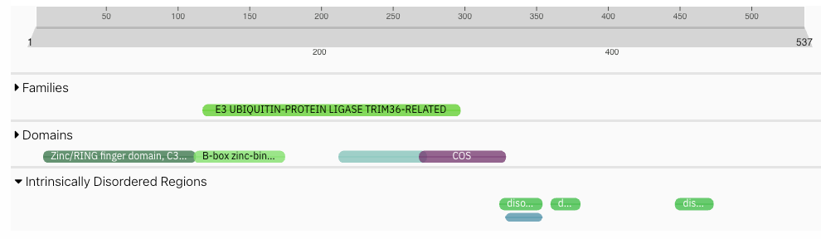

There is no right or wrong way to discuss at this point. But to point out some potentially interesting finding:
- Most variants (7/11) cluster in exon 8, which appears to encode unstructured/disordered protein regions that may be functionally important for substrate recognition
- CAST_EiJ shares multiple variants with QSi5, MOLF_EiJ, and SPRET_EiJ - though we may not have SARS-CoV susceptibility data for all these strains to compare with CAST_EiJ's known high susceptibility
- Several variants show borderline SIFT scores (T227I and L388P at 0.08, M269L at 0.11) or low confidence predictions, which might warrant closer functional examination
- Some variants fall in uncharacterized E3 ubiquitin ligase domains, so their functional significance during infection contexts remains unclear
- While individual SIFT scores suggest tolerance, the clustering of multiple missense mutations within a ~50 amino acid region could have cumulative effects on protein function that single-variant predictions would miss(?)

Recommended tools
- bcftools view
- bcftools query
- Interproscan, or any other tools that let you explore structures and function of proteins (optional)

