To create sequential and parallel job in Jenkins..

1.Sequential job

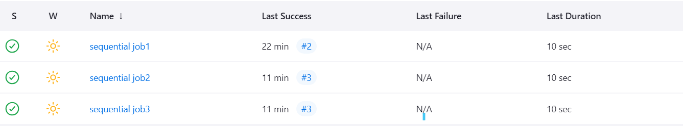

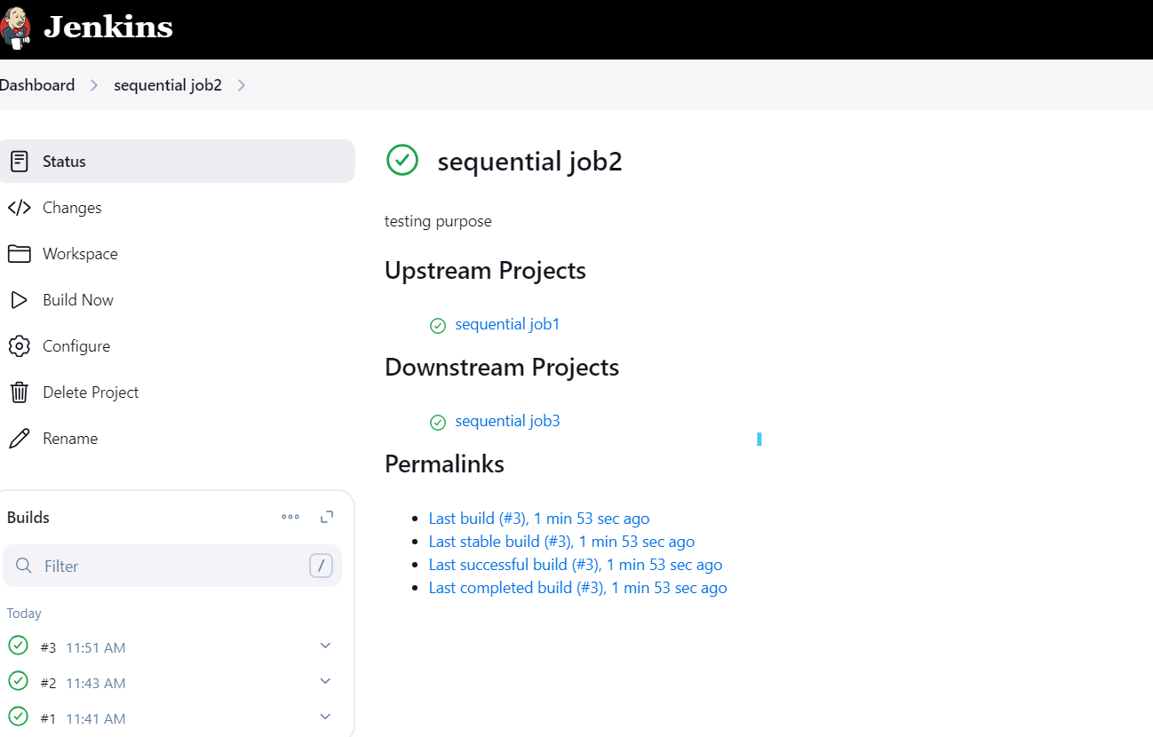

2.Parallel job :

