**Question 1**-Create job and execute shell for install httpd service with Jenkins.

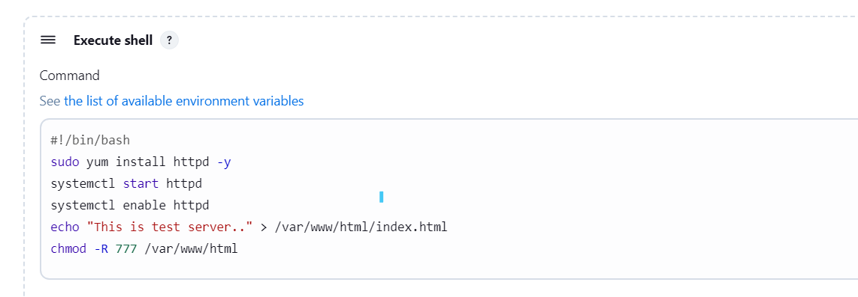

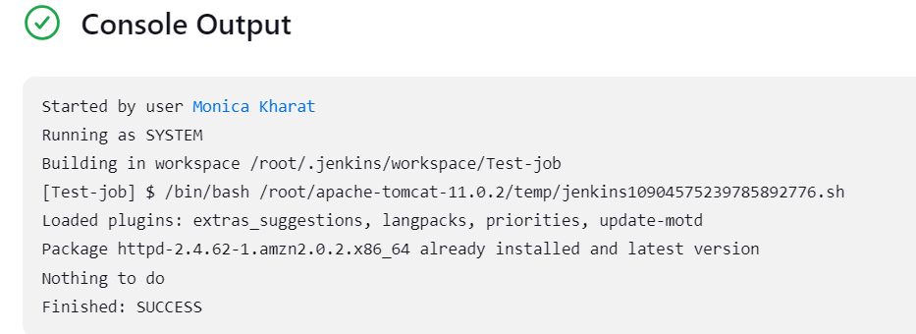

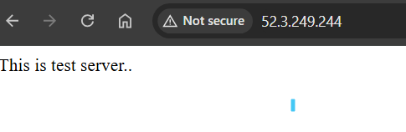

**Question 2**- Create job and execute shell for create 3 users and check user created on system or not.

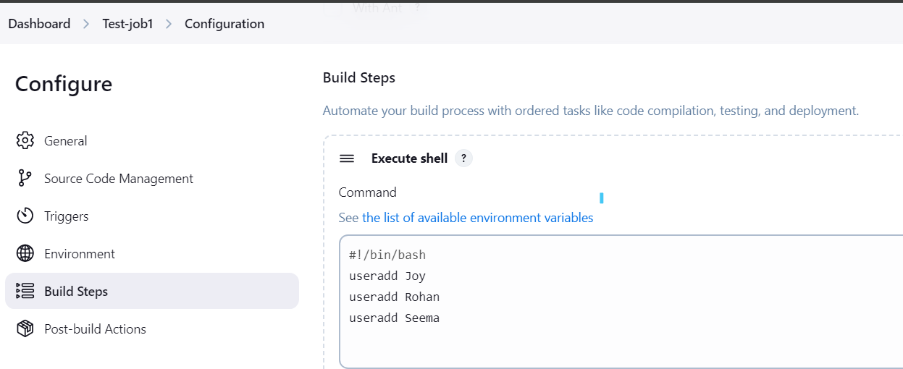

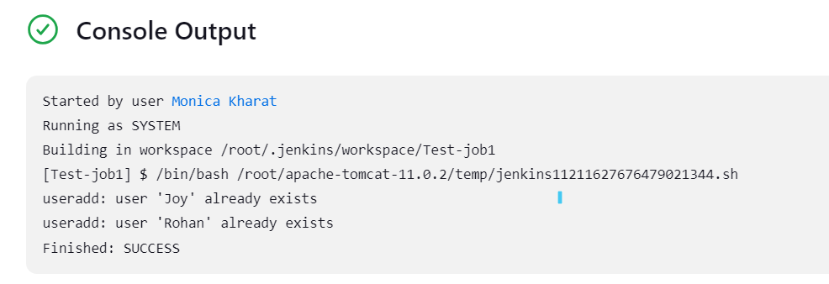

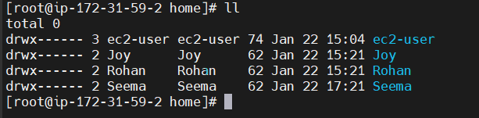

**Question 3**- Create job and execute shell for delete 3 users and check user deleted from system or not.

