**Assignment-** **1**

Quetion- write a script to clone the web page ..

Script :

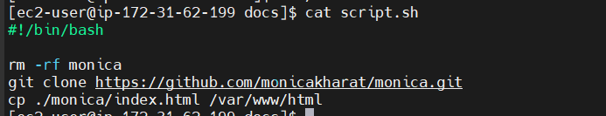

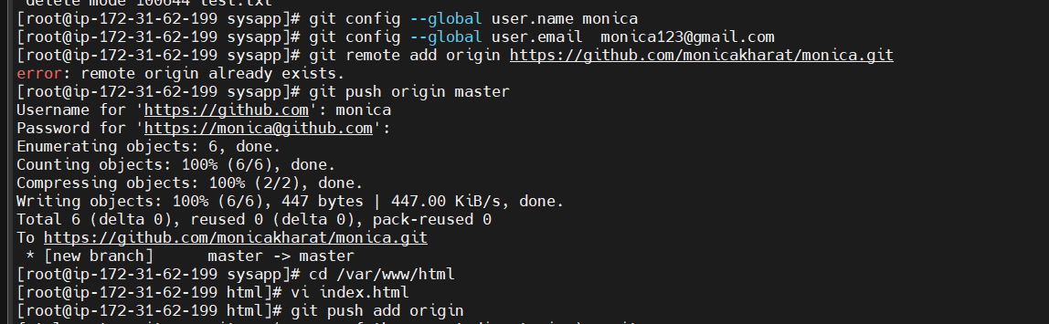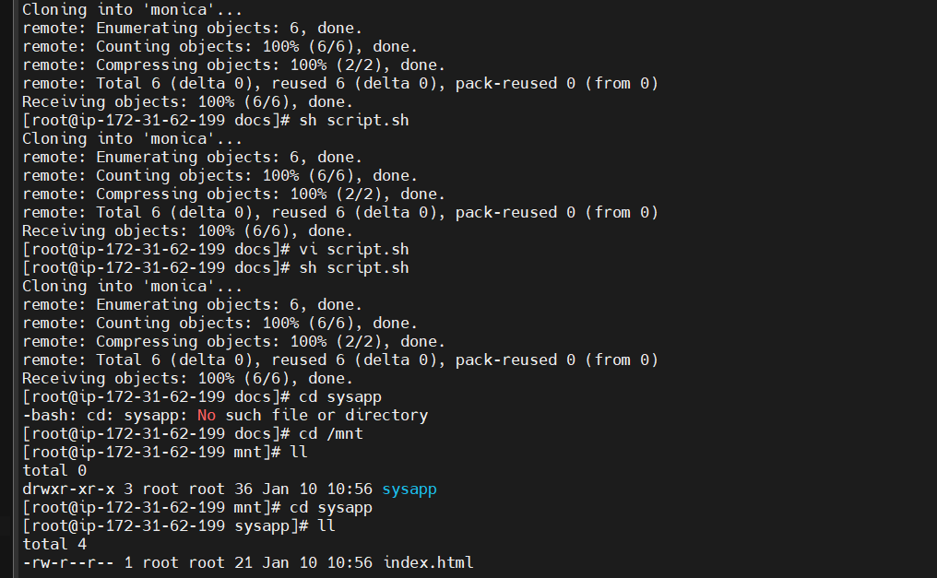

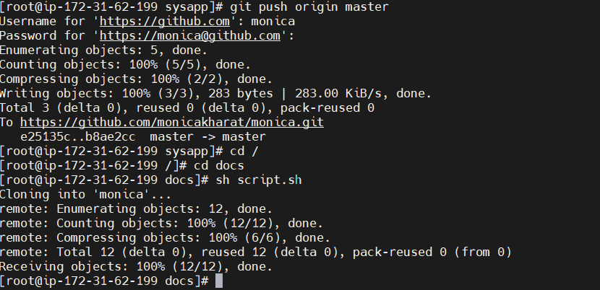

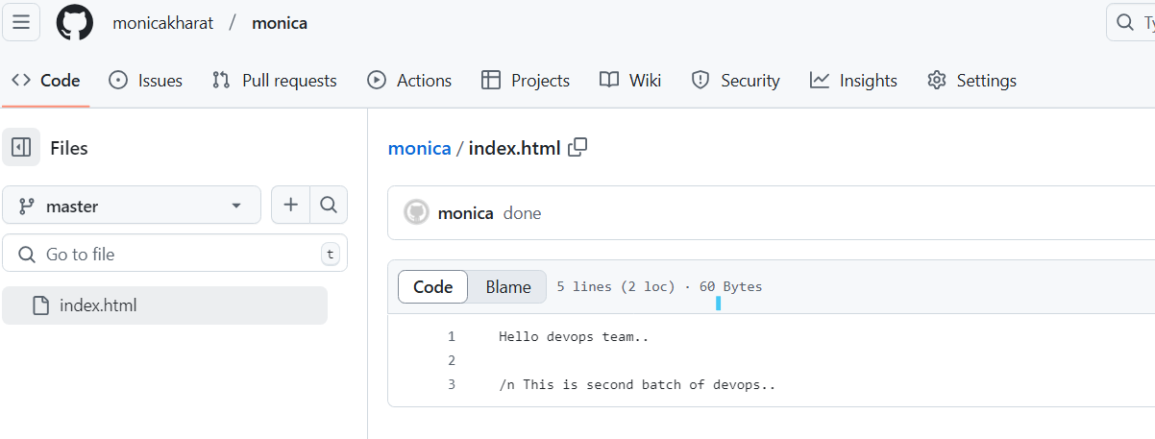

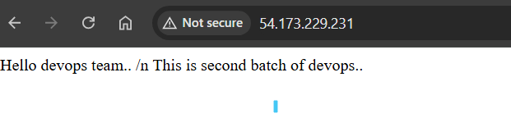

**Assignment -2**

Question-Install maven and check build success or not,

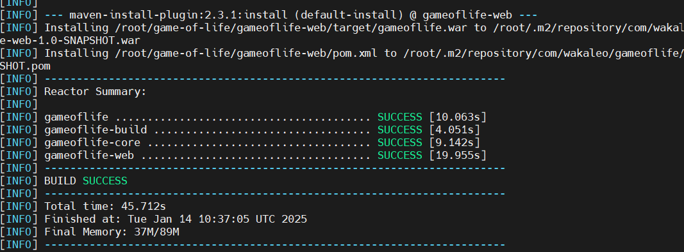

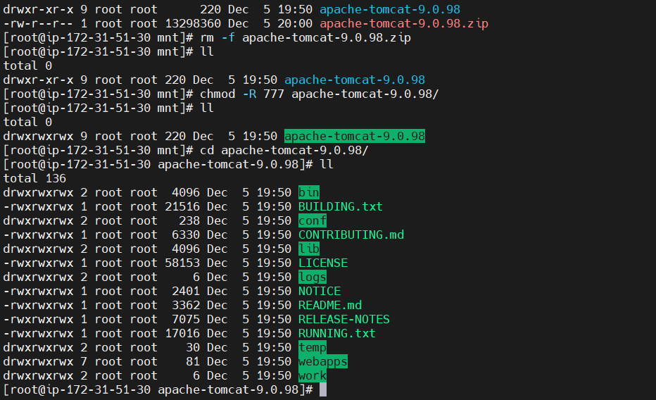

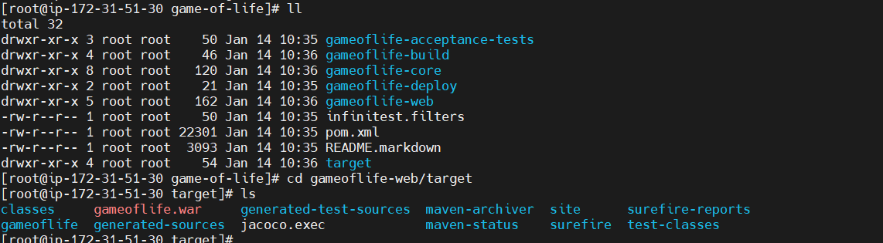

**Assignment -3**

Question - Install maven and Apache tomcat check for .war file generated..







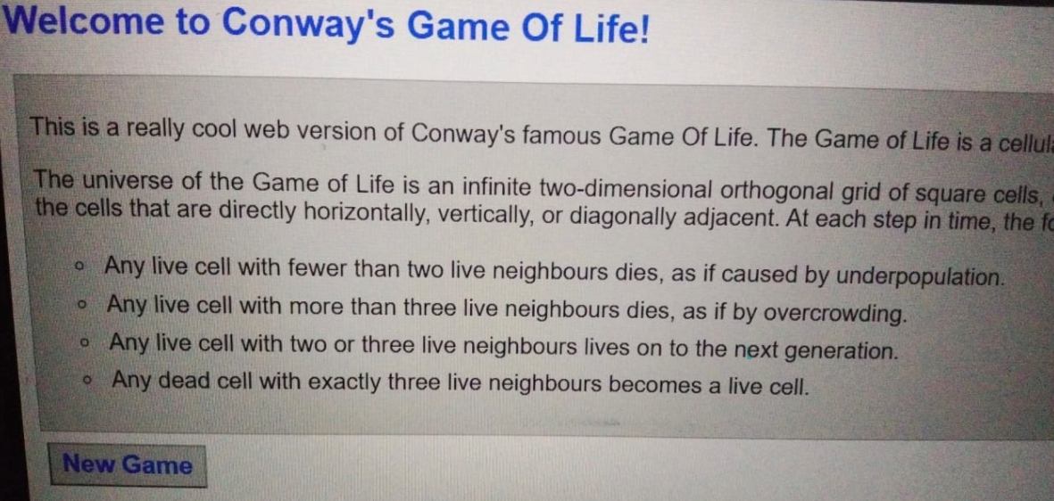

**Assignment -4**

Question -Change configuration of connector port 8080 to 8081.

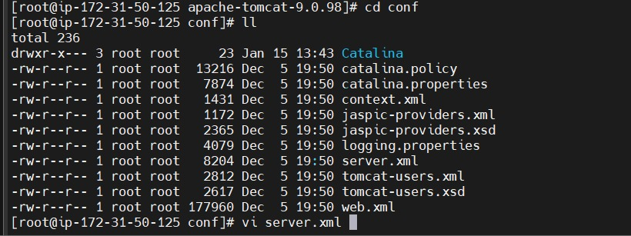

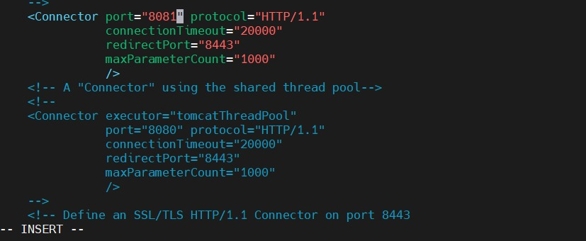

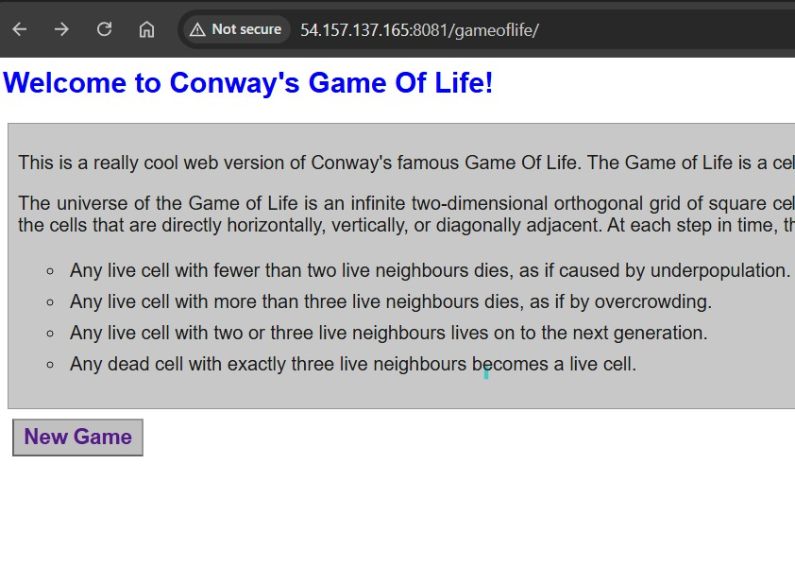

**Assignment -5**

Question -write a script to clone repo where project is install and install mvn also deploy war in webapps.

Will update this shortly..

**Assignment -6**

Question -Install Jenkins with first method “Jenkins as service installation”

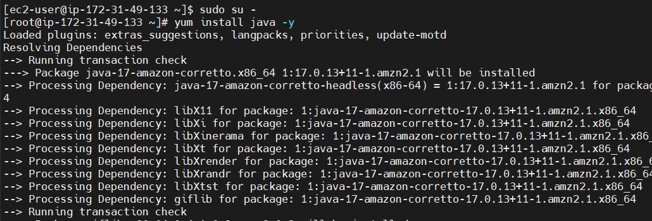

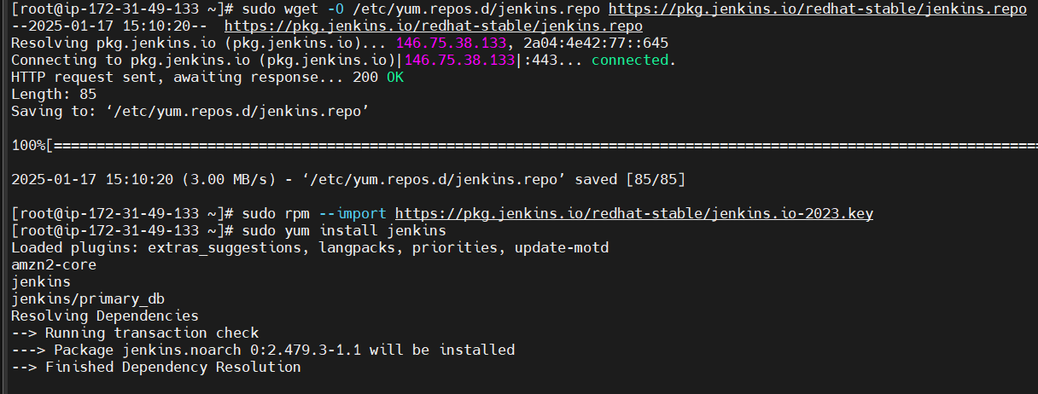

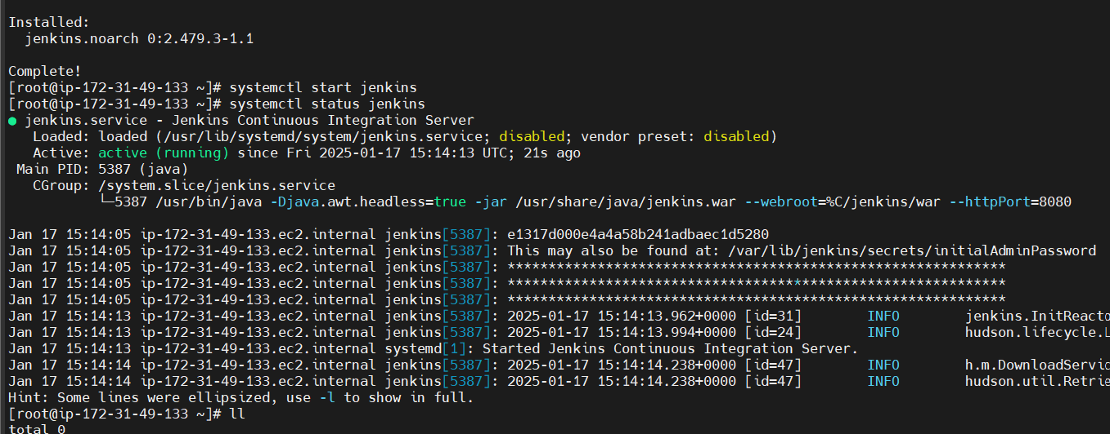

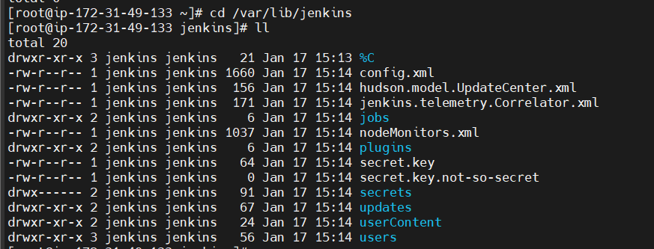

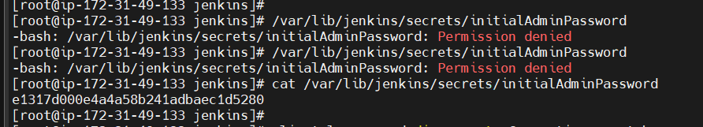

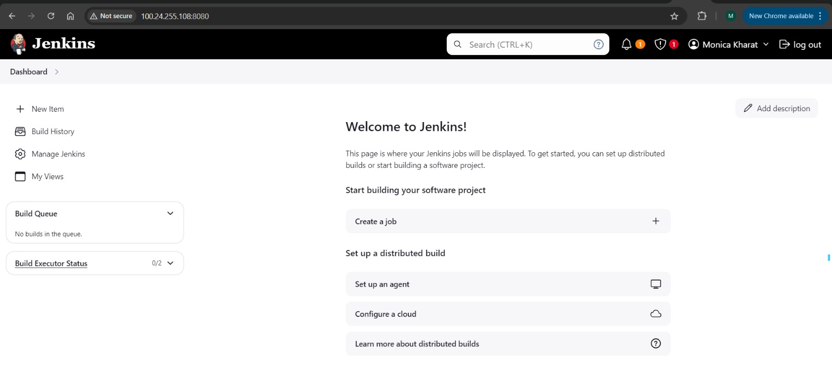

**Assignment -7**

Question -Install Jenkins with second method “Jenkins as tomcat application”

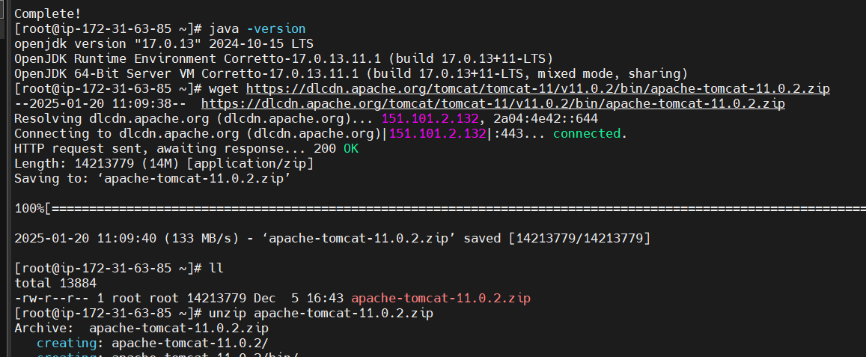

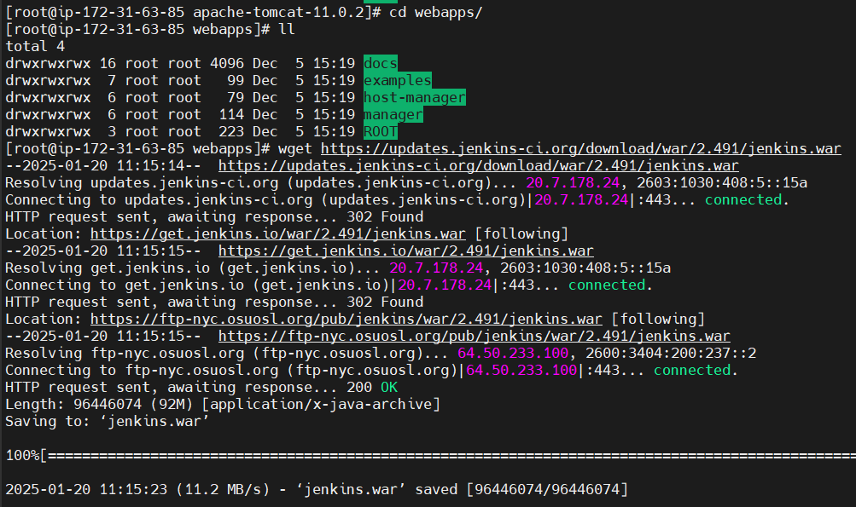

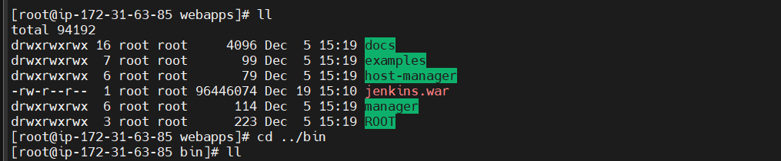

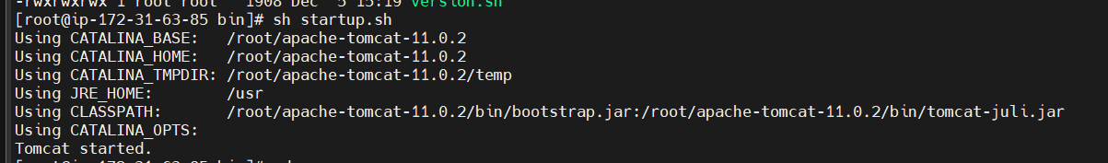

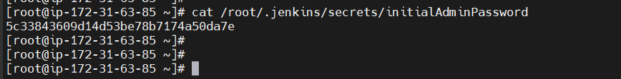

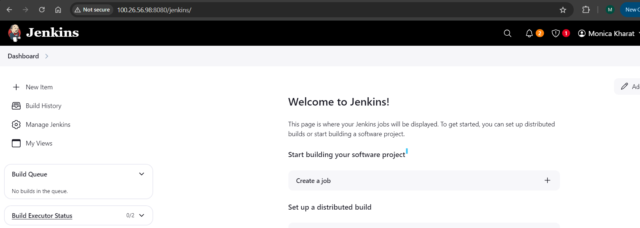

**Assignment -8**

Question- Create a job with the help of Jenkins and write a script to check file is present or not, if file is not present then create a file.

