**Creating Tables & Their Relationships**

In total, there are four tables; FallsRiskData_Sessions, Triax_Data, Practitioner and Subject. FallsRiskData_Sessions has a primary key Session_ID, where each number is mapped to a session of a trial where the TrueFallsRisk data is obtained. Similarly, Triax_Data’s primary key is also Session_ID, mapped to the three Triax data and ‘Markers’. Practitioner and Subjects both have primary keys Practitioner_ID and Subject_ID respectively. These correspond to an individual practitioner or subject.

To achieve normalisation, the three normal forms were maintained.

* + 1st normal form. Each column contains only one value. Each column has a unique name.
  + 2nd normal form. There are no composite primary keys so no partial dependency.
  + 3rd normal form. No dependencies on non-key fields i.e. all depend on primary key.

Relationships between the four tables can be observed in Figure 1. Each table is seen to have one primary key. FallsRiskData_Sessions has two foreign keys; Practitioner_ID and Subject_ID. Triax_Data has only one foreign key, Subject_ID. It is through these foreign keys that the relationship is built.

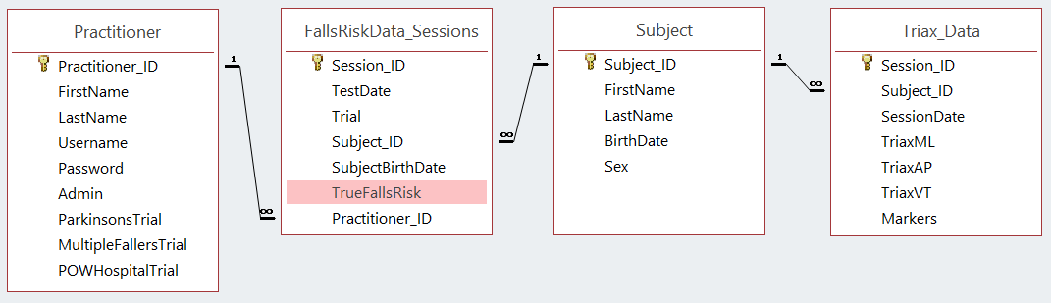Figure 1. Relationship between the four tables.

**Fields**

All fields are ‘Required’ except for

* Practitioner_ID in FallsRiskData_Sessions and Triax_ Data as practitioners are assigned to subjects by admins, and a trial can be recorded with no practitioner (as per the original database).
* TriaxML, TriaxAP, TriaxVT and Markers in Triax_Data as some data in these fields are missing from the original database.

None of the fields can have zero length. They are either ‘Required’ and must have a non-zero value or are not required and hence must be null.

In each table, both the primary and foreign keys are indexed. The most useful indexes will be Practitioner_ID and Subject_ID, as these are used to edit/insert/view subject data and edit or add practitioner data.

* Shorten first/last names to field size 35 characters. Change sex to field size 1.