ActiveMQ install on Windows:

<https://activemq.apache.org/activemq-51512-release>

1. Download the latest stable release of ActiveMQ.
2. Extract the zip file to a desired location.
3. CD to the bin directory and start the MQ broker by entering the command: activemq start
4. Open the console at <http://127.0.0.1:8161/admin/>
5. Click on the Queue link and create a Queues with name ‘restdemo_queue’
6. Click on the Topic link and create a Topics with name ‘restdemo_topic’
7. Queues and Topics are administered objects
8. Now you are ready to subscribe to a topic or queue and consume messages being posted to them.
9. **To test sending/receiving messages to/from restdemo_queue and/or restdemo_topic** follow these steps:

**Test activeMQ installation:**

Assumption: you have python installed and can access ‘python manage.py shell’ within a virtual environment where stomp.py is installed. If stomp.py is not installed in the virtual environment you are using, install stomp.py with ‘pip install stomp.py’.

Further assumptions: ActiveMQ is installed on the same machine where the python shell is running. Also, it assumes we are using the default ‘admin’, ‘admin’ for the ActiveMQ admin console. Also the port that ActiveMQ is listening on is 61613, which is the default port that is configured in the ActiveMQ config file, located in the config directory of the ActiveMQ installation directory, for example, C:\applications\ActiveMQ\apache-activemq-5.15.12\conf.

**Configure the STOMP connector:**

The config file is an XML file and is named: activemq.xml. The important line to look for is inside the transportConnectors block. Make sure it includes the STOMP connector: **<transportConnector name="stomp" uri="stomp://localhost:61613"/>**

<transportConnectors>

<!-- DOS protection, limit concurrent connections to 1000 and frame size to 100MB -->

<transportConnector name="openwire" uri="tcp://0.0.0.0:61616?maximumConnections=1000&amp;wireFormat.maxFrameSize=104857600"/>

<transportConnector name="amqp" uri="amqp://0.0.0.0:5672?maximumConnections=1000&amp;wireFormat.maxFrameSize=104857600"/>

**<transportConnector name="stomp" uri="stomp://localhost:61613"/>**

<transportConnector name="mqtt" uri="mqtt://0.0.0.0:1883?maximumConnections=1000&amp;wireFormat.maxFrameSize=104857600"/>

<transportConnector name="ws" uri="ws://0.0.0.0:61614?maximumConnections=1000&amp;wireFormat.maxFrameSize=104857600"/>

</transportConnectors>

**Test the ActiveMQ broker using the python shell:**

Open the python shell and enter the following commands:

1. (restdemo) C:\data\pythonworkspace2\RestDemo2\RestDemo>**python manage.py shell**
2. Python 3.6.3 (v3.6.3:2c5fed8, Oct 3 2017, 18:11:49) [MSC v.1900 64 bit (AMD64)] on win32
3. Type "help", "copyright", "credits" or "license" for more information.
4. (InteractiveConsole)
5. >>> **from stomp import \***
6. >>> **c = stomp.Connection([('127.0.0.1', 61613)])**
7. **>>> c.connect('admin', 'admin', wait=True)**
8. >>> **c.subscribe('restdemo_queue', 123)**
9. >>> **c.set_listener('', PrintingListener())**
10. **>>> c.send('restdemo_queue', 'a test message')**
11. on_send SEND {'destination': 'restdemo_queue', 'content-length': 14} a test message
12. >>> on_before_message {'content-length': '14', 'expires': '0', 'destination': '/queue/restdemo_queue', 'subscription': '123', 'priority': '4', 'message-id': 'ID:DESKTOP-0MV2FVN-60947-1585609213799-3:124:-1:1:1', 'timestamp': '1585750749980'} a test message
13. **on_message** {'content-length': '14', 'expires': '0', 'destination': '/queue/restdemo_queue', 'subscription': '123', 'priority': '4', 'message-id': 'ID:DESKTOP-0MV2FVN-60947-1585609213799-3:124:-1:1:1', 'timestamp': '1585750749980'} **a test message**
14. c1 = stomp.Connection([('127.0.0.1', 61613)])
15. >>> c1.connect('admin', 'admin', wait=True)
16. >>> **c1.subscribe('restdemo_topic', 123)**
17. >>> **c1.set_listener('', PrintingListener())**
18. >>> **c1.send('restdemo_topic', 'a test message to the topic restdemo_topic')**
19. on_send SEND {'destination': 'restdemo_topic', 'content-length': 42} a test message to the topic restdemo_topic
20. >>> on_before_message {'content-length': '42', 'expires': '0', 'destination': '/queue/restdemo_topic', 'subscription': '123', 'priority': '4', 'message-id': 'ID:DESKTOP-0MV2FVN-60947-1585609213799-3:125:-1:1:1', 'timestamp': '1585750926550'} a test message to the topic restdemo_topic
21. **on_message** {'content-length': '42', 'expires': '0', 'destination': '/queue/restdemo_topic', 'subscription': '123', 'priority': '4', 'message-id': 'ID:DESKTOP-0MV2FVN-60947-1585609213799-3:125:-1:1:1', 'timestamp': '1585750926550'} **a test message to the topic restdemo_topic**
22. >>>

**Access the ActiveMQ console:**

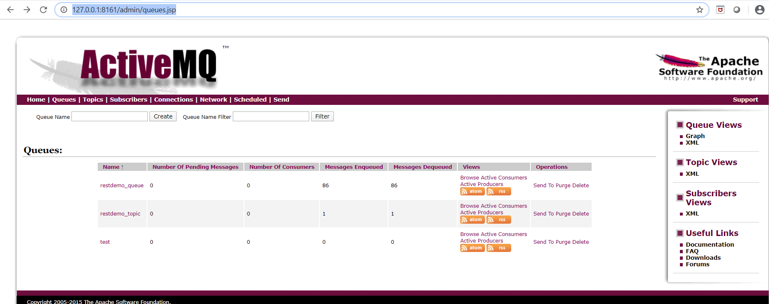

MQ console output when starting the MQ broker:

C:\applications\ActiveMQ\apache-activemq-5.15.12\bin>activemq start

Warning: JAVA_HOME environment variable is not set.

Java Runtime: Oracle Corporation 1.8.0_101 C:\ODBootCampWorkshops\tools\jdk1.8.0_101\jre

Heap sizes: current=1005056k free=989327k max=1005056k

JVM args: -Dcom.sun.management.jmxremote -Xms1G -Xmx1G -Djava.util.logging.config.file=logging.properties -Djava.security.auth.login.config=C:\applications\ActiveMQ\apache-activemq-5.15.12\bin\..\conf\login.config -Dactivemq.classpath=C:\applications\ActiveMQ\apache-activemq-5.15.12\bin\..\conf;C:\applications\ActiveMQ\apache-activemq-5.15.12\bin\../conf;C:\applications\ActiveMQ\apache-activemq-5.15.12\bin\../conf; -Dactivemq.home=C:\applications\ActiveMQ\apache-activemq-5.15.12\bin\.. -Dactivemq.base=C:\applications\ActiveMQ\apache-activemq-5.15.12\bin\.. -Dactivemq.conf=C:\applications\ActiveMQ\apache-activemq-5.15.12\bin\..\conf -Dactivemq.data=C:\applications\ActiveMQ\apache-activemq-5.15.12\bin\..\data -Djava.io.tmpdir=C:\applications\ActiveMQ\apache-activemq-5.15.12\bin\..\data\tmp

Extensions classpath:

[C:\applications\ActiveMQ\apache-activemq-5.15.12\bin\..\lib,C:\applications\ActiveMQ\apache-activemq-5.15.12\bin\..\lib\camel,C:\applications\ActiveMQ\apache-activemq-5.15.12\bin\..\lib\optional,C:\applications\ActiveMQ\apache-activemq-5.15.12\bin\..\lib\web,C:\applications\ActiveMQ\apache-activemq-5.15.12\bin\..\lib\extra]

ACTIVEMQ_HOME: C:\applications\ActiveMQ\apache-activemq-5.15.12\bin\..

ACTIVEMQ_BASE: C:\applications\ActiveMQ\apache-activemq-5.15.12\bin\..

ACTIVEMQ_CONF: C:\applications\ActiveMQ\apache-activemq-5.15.12\bin\..\conf

ACTIVEMQ_DATA: C:\applications\ActiveMQ\apache-activemq-5.15.12\bin\..\data

Loading message broker from: xbean:activemq.xml

INFO | Refreshing org.apache.activemq.xbean.XBeanBrokerFactory$1@239963d8: startup date [Mon Mar 30 17:00:13 MDT 2020]; root of context hierarchy

INFO | Using Persistence Adapter: KahaDBPersistenceAdapter[C:\applications\ActiveMQ\apache-activemq-5.15.12\bin\..\data\kahadb]

INFO | KahaDB is version 6

INFO | PListStore:[C:\applications\ActiveMQ\apache-activemq-5.15.12\bin\..\data\localhost\tmp_storage] started

INFO | Apache ActiveMQ 5.15.12 (localhost, ID:DESKTOP-0MV2FVN-60947-1585609213799-0:1) is starting

INFO | Listening for connections at: tcp://DESKTOP-0MV2FVN:61616?maximumConnections=1000&wireFormat.maxFrameSize=104857600

INFO | Connector openwire started

INFO | Listening for connections at: amqp://DESKTOP-0MV2FVN:5672?maximumConnections=1000&wireFormat.maxFrameSize=104857600

INFO | Connector amqp started

INFO | Listening for connections at: stomp://127.0.0.1:61613

INFO | Connector stomp started

INFO | Listening for connections at: mqtt://DESKTOP-0MV2FVN:1883?maximumConnections=1000&wireFormat.maxFrameSize=104857600

INFO | Connector mqtt started

INFO | Starting Jetty server

INFO | Creating Jetty connector

WARN | ServletContext@o.e.j.s.ServletContextHandler@7203c7ff{/,null,STARTING} has uncovered http methods for path: /

INFO | Listening for connections at ws://DESKTOP-0MV2FVN:61614?maximumConnections=1000&wireFormat.maxFrameSize=104857600

INFO | Connector ws started

INFO | Apache ActiveMQ 5.15.12 (localhost, ID:DESKTOP-0MV2FVN-60947-1585609213799-0:1) started

INFO | For help or more information please see: http://activemq.apache.org

INFO | ActiveMQ WebConsole available at http://0.0.0.0:8161/

INFO | ActiveMQ Jolokia REST API available at http://0.0.0.0:8161/api/jolokia/

INFO | Connector vm://localhost started

**Run the mq unit tests:**

(restdemo) C:\data\pythonworkspace2\RestDemo2\RestDemo>python manage.py test --settings=RestDemo.settings --keepdb

Using existing test database for alias 'default'...

System check identified no issues (0 silenced).

test_subscribe_send_Queue()

received a message on queue"This is a message sent to restdemo_queue in test case"

0

1

.disconnected

disconnected

test_subscribe_send_Topic()

received a message on topic "This is a message sent to restdemo_topic from test case"

received a message on topic "This is a message sent to restdemo_topic from test case"

0

0

1

1

.disconnected

disconnected

test_create_Snippet

.test_delete_Snippet, self.id = 1019

.test_get_Snippet, self.id = 1021

.test_update_patch_Snippet, self.id = 1023

test_update_patch_Snippet url = /snippets/1023/

.test_update_put_Snippet, self.id = 1025

test_update_put_Snippet url = /snippets/1025/

.test_list_Snippet

.test_list_Snippet with force_authenticate

.

----------------------------------------------------------------------

Ran 9 tests in 8.680s

OK

Preserving test database for alias 'default'...