ActiveMQ install on Windows:

<https://activemq.apache.org/activemq-51512-release>

1. Download the latest stable release of ActiveMQ.
2. Extract the zip file to a desired location.
3. CD to the bin directory and start the MQ broker by entering the command: activemq start
4. Open the console at <http://127.0.0.1:8161/admin/>
5. Click on the Queue link and create a Queues with name ‘restdemo_queue’
6. Click on the Topic link and create a Topics with name ‘restdemo_topic’
7. Queues and Topics are administered objects
8. Now you are ready to subscribe to a topic or queue and consume messages being posted to them.

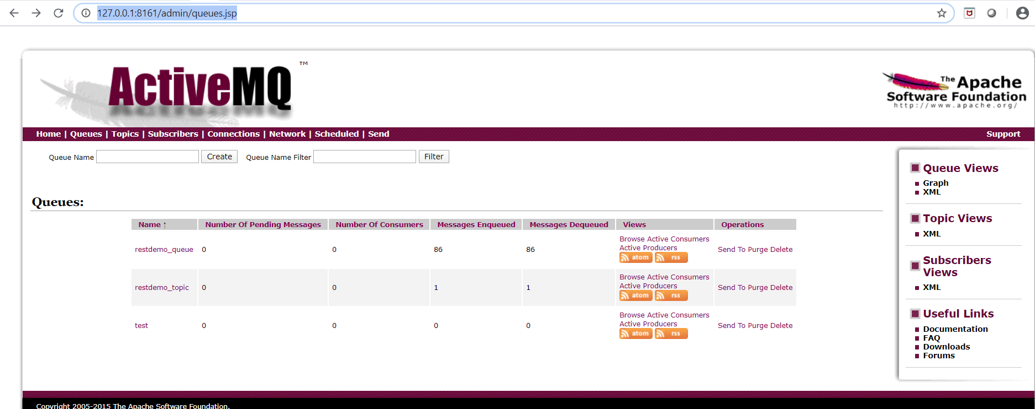

MQ console output when starting the MQ broker:

C:\applications\ActiveMQ\apache-activemq-5.15.12\bin>activemq start

Warning: JAVA_HOME environment variable is not set.

Java Runtime: Oracle Corporation 1.8.0_101 C:\ODBootCampWorkshops\tools\jdk1.8.0_101\jre

Heap sizes: current=1005056k free=989327k max=1005056k

JVM args: -Dcom.sun.management.jmxremote -Xms1G -Xmx1G -Djava.util.logging.config.file=logging.properties -Djava.security.auth.login.config=C:\applications\ActiveMQ\apache-activemq-5.15.12\bin\..\conf\login.config -Dactivemq.classpath=C:\applications\ActiveMQ\apache-activemq-5.15.12\bin\..\conf;C:\applications\ActiveMQ\apache-activemq-5.15.12\bin\../conf;C:\applications\ActiveMQ\apache-activemq-5.15.12\bin\../conf; -Dactivemq.home=C:\applications\ActiveMQ\apache-activemq-5.15.12\bin\.. -Dactivemq.base=C:\applications\ActiveMQ\apache-activemq-5.15.12\bin\.. -Dactivemq.conf=C:\applications\ActiveMQ\apache-activemq-5.15.12\bin\..\conf -Dactivemq.data=C:\applications\ActiveMQ\apache-activemq-5.15.12\bin\..\data -Djava.io.tmpdir=C:\applications\ActiveMQ\apache-activemq-5.15.12\bin\..\data\tmp

Extensions classpath:

[C:\applications\ActiveMQ\apache-activemq-5.15.12\bin\..\lib,C:\applications\ActiveMQ\apache-activemq-5.15.12\bin\..\lib\camel,C:\applications\ActiveMQ\apache-activemq-5.15.12\bin\..\lib\optional,C:\applications\ActiveMQ\apache-activemq-5.15.12\bin\..\lib\web,C:\applications\ActiveMQ\apache-activemq-5.15.12\bin\..\lib\extra]

ACTIVEMQ_HOME: C:\applications\ActiveMQ\apache-activemq-5.15.12\bin\..

ACTIVEMQ_BASE: C:\applications\ActiveMQ\apache-activemq-5.15.12\bin\..

ACTIVEMQ_CONF: C:\applications\ActiveMQ\apache-activemq-5.15.12\bin\..\conf

ACTIVEMQ_DATA: C:\applications\ActiveMQ\apache-activemq-5.15.12\bin\..\data

Loading message broker from: xbean:activemq.xml

INFO | Refreshing org.apache.activemq.xbean.XBeanBrokerFactory$1@239963d8: startup date [Mon Mar 30 17:00:13 MDT 2020]; root of context hierarchy

INFO | Using Persistence Adapter: KahaDBPersistenceAdapter[C:\applications\ActiveMQ\apache-activemq-5.15.12\bin\..\data\kahadb]

INFO | KahaDB is version 6

INFO | PListStore:[C:\applications\ActiveMQ\apache-activemq-5.15.12\bin\..\data\localhost\tmp_storage] started

INFO | Apache ActiveMQ 5.15.12 (localhost, ID:DESKTOP-0MV2FVN-60947-1585609213799-0:1) is starting

INFO | Listening for connections at: tcp://DESKTOP-0MV2FVN:61616?maximumConnections=1000&wireFormat.maxFrameSize=104857600

INFO | Connector openwire started

INFO | Listening for connections at: amqp://DESKTOP-0MV2FVN:5672?maximumConnections=1000&wireFormat.maxFrameSize=104857600

INFO | Connector amqp started

INFO | Listening for connections at: stomp://127.0.0.1:61613

INFO | Connector stomp started

INFO | Listening for connections at: mqtt://DESKTOP-0MV2FVN:1883?maximumConnections=1000&wireFormat.maxFrameSize=104857600

INFO | Connector mqtt started

INFO | Starting Jetty server

INFO | Creating Jetty connector

WARN | ServletContext@o.e.j.s.ServletContextHandler@7203c7ff{/,null,STARTING} has uncovered http methods for path: /

INFO | Listening for connections at ws://DESKTOP-0MV2FVN:61614?maximumConnections=1000&wireFormat.maxFrameSize=104857600

INFO | Connector ws started

INFO | Apache ActiveMQ 5.15.12 (localhost, ID:DESKTOP-0MV2FVN-60947-1585609213799-0:1) started

INFO | For help or more information please see: http://activemq.apache.org

INFO | ActiveMQ WebConsole available at http://0.0.0.0:8161/

INFO | ActiveMQ Jolokia REST API available at http://0.0.0.0:8161/api/jolokia/

INFO | Connector vm://localhost started