All the pre-requisites required are installed and the versions are verified and are shown below:

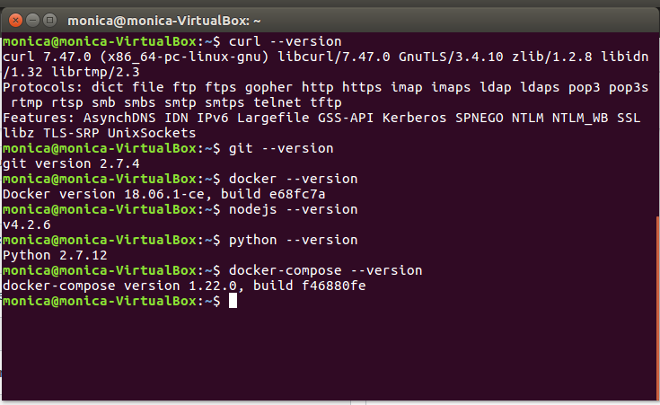

1. The following commands were used:

* Curl- sudo apt install curl
* Pyhton- It was already in the required version
* Node- sudo apt-get install nodejs

sudo apt-get install npm

* Go- sudo apt-get update

sudo apt-get -y upgrade

wget <https://d1.google.com/go/go1.10.3.linux-amd64.tar.gz>

sudo tar -xvf go1.10.3.linux-amd64.tar.gz

sudo mv go /usr/local

here the set path is supposed to be set.

* Docker- curl -fsSL <https://download.docker.com/linux/ubuntu/gpg> | sudo apt-key add –
* Docker Compose-  sudo curl -L ”https://github.com/docker/compose/releases/download/1.22.0/docker-compose-$(uname -s)-$(uname -m)" -o /usr/local/bin/docker-compose
* After the docker is installed successfully, the system was shut down and then started again for the changes to be made.

1. Now, enter into the first network directory which was created and give the command: ./byfn.sh -m generate
2. This command generates the certificates required for the first network and to see what have been generated give the following command:

cd crypto-config

ls

If the genesis block and all the channels are generated, then it means that the it is created successfully.

The following image is the output for the given commands:

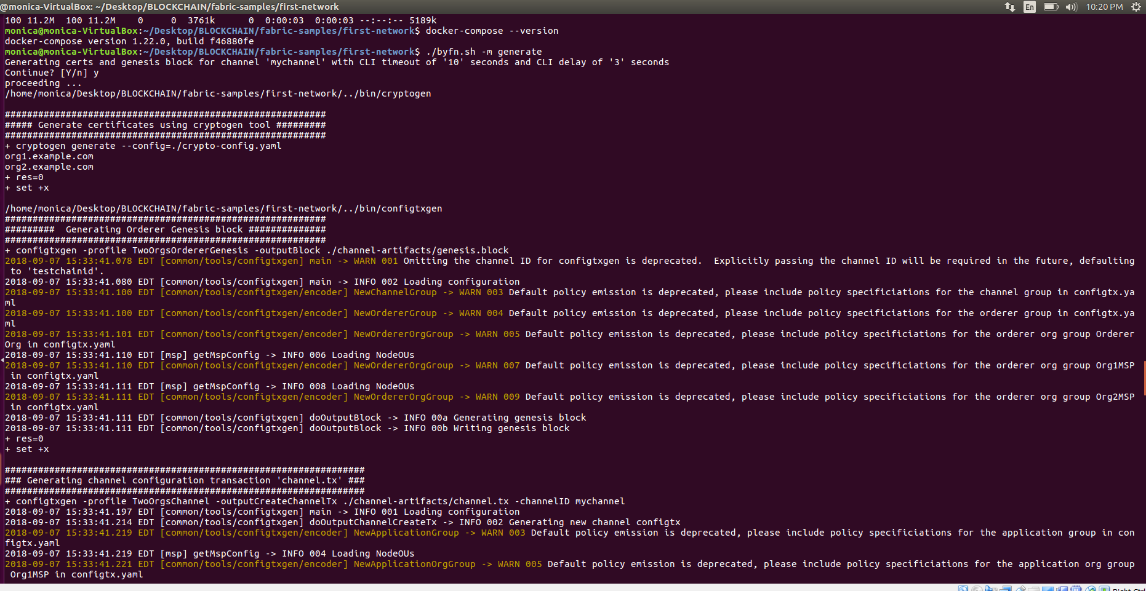

1. To create the first network, the following command is used:

$ ./byfn.sh -m up

If all the drivers have been installed and the START and END appears, it means that the first network is built successfully.

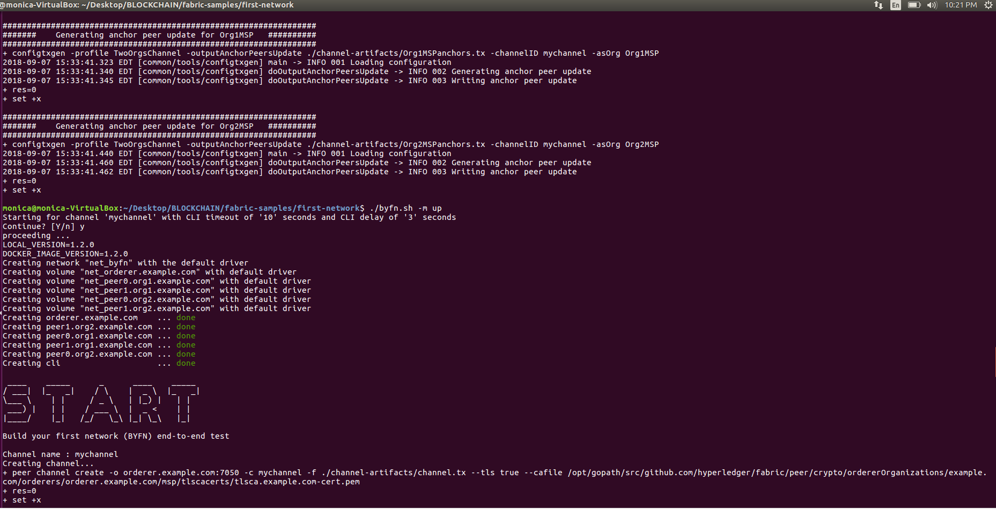

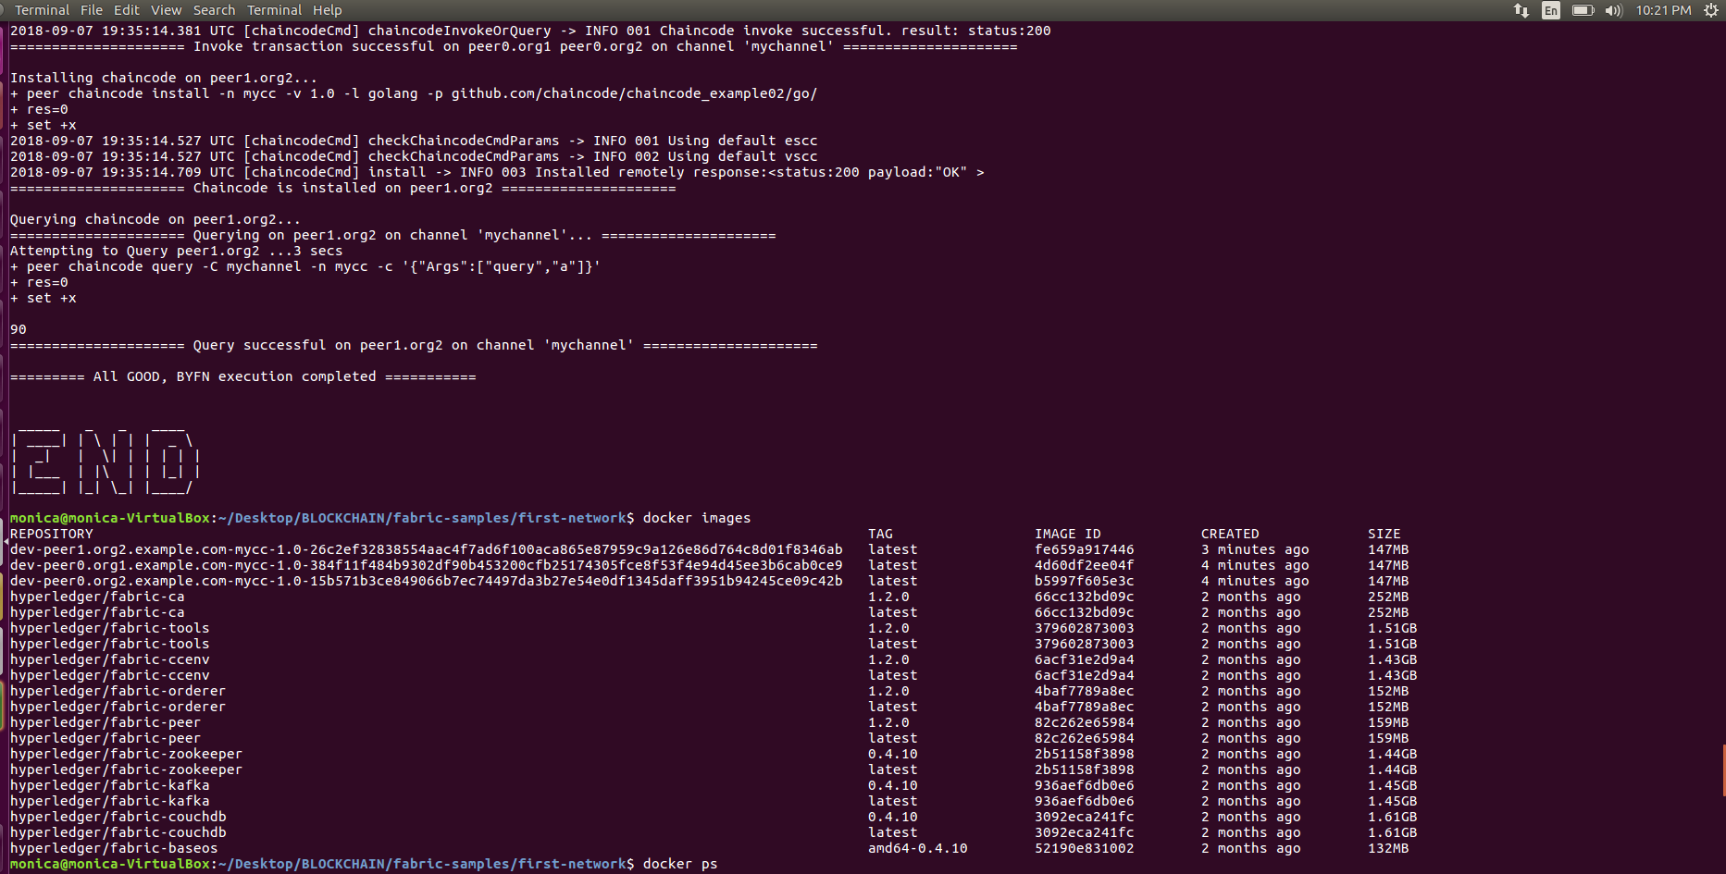

In the above image, the docker images generated are shown.

1. The peers generated are shown in the following image. To bring down the created network executed the following command:

$ ./byfn.sh -m down

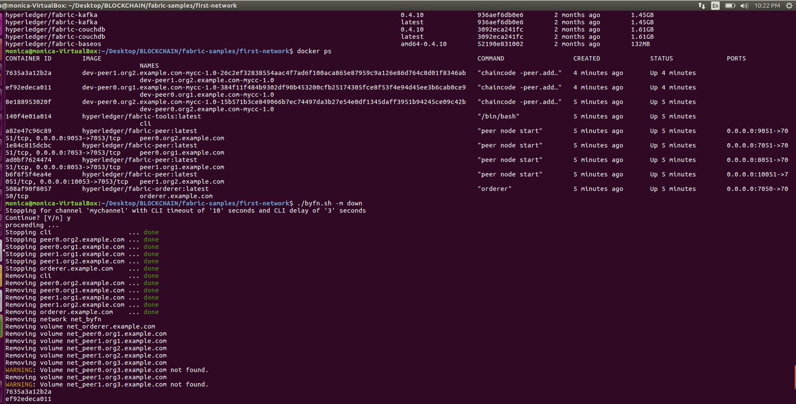

1. The following image shows that the images which were generated have been discarded:

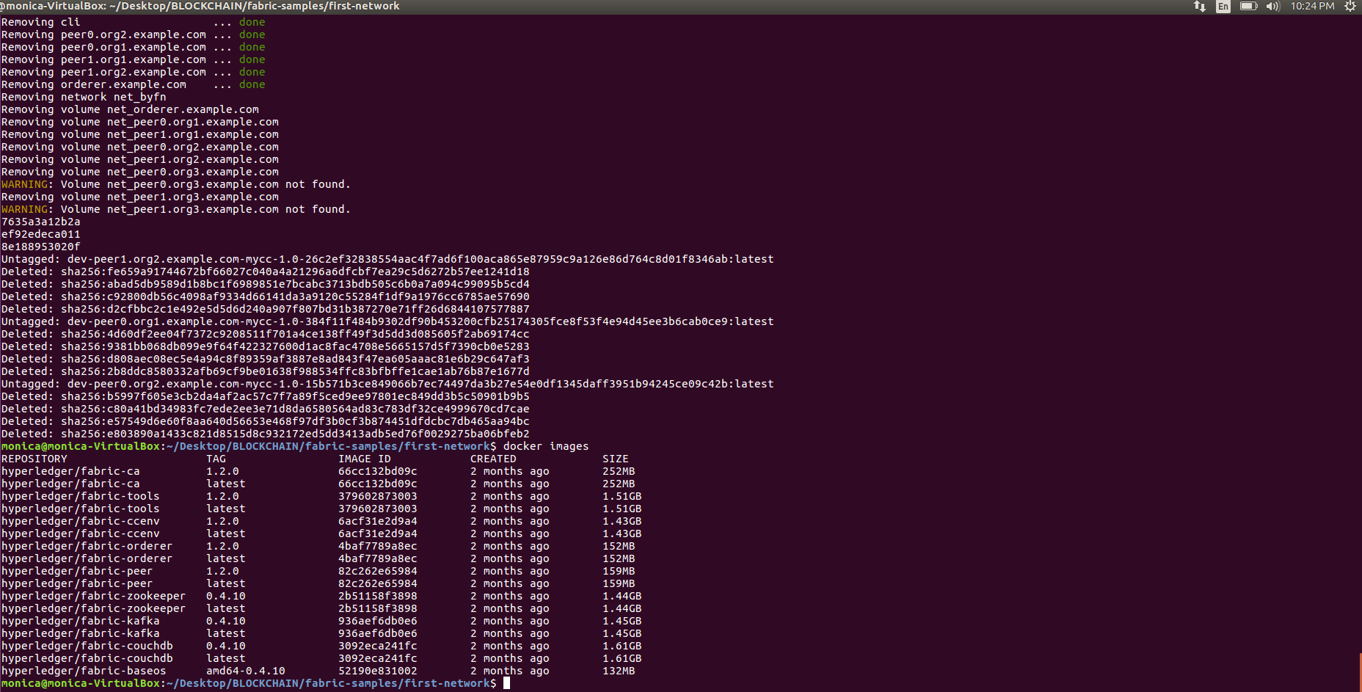

In the github, a new account was created and a repository labelled “Hyperledger” has been created. The link is: <https://github.com/monicanethagani/Hyperledger/tree/master>