Intro to VHDL

ECGR 5146

Project 1

Micro Controller

Designing, implementing, and testing

March 26th, 2018
Micro-Controller

Introduction

In this project we are implementing a micro-controller that satisfies the requirements given. We used the implementation design requirements as guidelines to implement our own modules, and we changed in some parts in order to reach a working product.

Main steps of followed in our project:

- Requirements analysis

- High level design and Components definition

- Components design

- Components testing

- Project integration

- Integration Testing

- Software Flashing and product Validation

Requirements Analysis:

In this phase we took our time to understand the product requirements and gathering questions and finding answers. We had internal discussions, discussions with other groups, and discussions with our professor. All these discussions and readings were very useful to understand and move forward.

High level design and Components definition:

In this phase we divided the product into the following modules, and planned the strategy of integration and modes of operations:

Components definitions:

We had the following main modules defined:

- Stage Counter

- Register File

- ALU

- Old ALU for previous lab (Re-used module)

  - Decoder to translate the new (2-bits) operators into the old (4-bits) operators

- Decoder

- Memory

Integration Strategy:

In this phase we planned to integrate all modules as entities used in the main file, connected together through signals, MUXs, and main control registers like immediate and IR registers.

Modes of Operation
We have 2 modes for operation, the micro-controlled decides the mode according to an input signal. It controls the modes using 2 MUXs as described below:

- Flashing Mode:

- In this mode, we force the memory address to have data from standard logic vector input, and dataout signal takes data from another standard logic vector input.

- The memory is set to Write.

- At each clock, we have to provide the memory with address and data to store at this

address.

  - Data and addresses shall be provided at the clock falling edge.

- Running Mode:

  - In this mode the memory address is connected to address_bus, and dataout is connected to dBus.

- This is the normal mode of running, it is consisting of 3 stages:

  - Fetch Instruction Stage:

This stage is divided into 3 clock cycles, in which:

    - Set address select value

    - Get data from memory

    - Store data in the IR

  - Fetch Immediate Value Stage:

This stage is divided into 3 clock cycles, in which:

    - Set address select value

    - Get data from memory

    - Store data in the immediate

  - Execution Stage:

This stage is consisting of 4 clock counts that are executed in a controlled order according to the IR value and the decode_logic module.

Components Design:

Decoder (decode_logic):

This module is used to translate the IR into control signals in order to control the ALU operations, Registers read/write, memory read/write, PC value, memory access and memory address select.

We added the following signals to the provided module in order to make it operate as per our design:

- Stage and Phase signal, both signals are used to add a timing control over the control signals. For example, if we want to execute the command:

SW R1 0x40

This command means to do the following commands in order:

  - Read value of R1

  - Put R1 on dbus

  - Select immediate value (0x40) as source of address bus
- Set the memory to write

The 4 steps above are all included in the stage 2 of execution. We can’t use them all at the same time, as we need to prepare the data first to write the right data in the right address.

- Mode signal: to control mode of operation and control the memory read/write signal.

Also as kind of optimization, to avoid adding an extra clock in each stage where we are addressing memory, we decided to make an exception and have the address select to be triggered on the falling edge not the rising edge as the default for other signals.

Decoder output signals and implementation:

- addrsel: As mentioned before it is working on falling edge

it is a MUX that is controlled by a simple logic combining the op1op2 value from the IR, Stage value, and phase value.

addrsel <= "00" when reset = '1' else
"10" when op1op2 = "0100" and stage = "10" else
"10" when op1op2 = "0101" and stage = "10" else
"01" when op1op2 = "1101" and stage = "10" and phase = "00" else "01" when op1op2 = "1110" and stage = "10" else "00";

- irload: This signal is controlling the timing to load the IR. It allows the IR load only in stage 0 at phase 2.
- imload: This signal control loading values in the immediate register. It depends on the MSb of the IR value. If it is 1, it will be set to 1 at stage 1, phase 2
- regsel: This value is used to choose the source to write into the register file. It is depending on the value of op1op2, and it allows writing only at stage 2, phase 2.

regsel <= "00" when reset = '1' else
regsel01 when stage = "10" and phase = "10" else
"00";
regsel01 <= "01" when op1op2 = "0110" else
"10" when op1op2 = "1100" else
"10" when op1op2 = "0100" else
"11" when op1op2 = "0000" else
"11" when op1op2 = "0001" else
"11" when op1op2 = "0010" else
"11" when op1op2 = "0011" else
"00";

- dwrite: This signal controls the writing into register file. It depends on the op1op2, and on the phase and stage as follows:

dwrite <= '0' when | reset = | '1' else |  | else
dwr01 when stage |  | = | "10" and (phase = "01" or phase = "10") | else
dwr02 when stage |  | = | "10" and phase = "11" else
'0'; | dwr01 <=
with op1op2 select | dwr01 <=
'1' when | "0110" | "1100" | "1110",
'0' when | others;
with op1op2 select | dwr02 <= |  | "0000" | "0001" | "0010" | "0011" | "0100",
 | '1' when
 | '0' when |  | others;
- aluop: it controls which operator to use in the ALU, it depends on op2 value.

- readwrite: it sets the memory to write in case of flashing mode, or in normal case, it depends on the value of op1op2.
- pcsel: selects the source for PC, either immediate register in stage 2 or PC+1 in stages 0 and 1.
- pcload: controls loading PC value. It is a function of negative flag, zero flag, stage, op1op2 as follows:

pcload <= '0' when reset = '1' else
'1' when stage = "00" and phase = "00" else
op1(1) when stage = "01" and phase = "00" else
(not op1(0) and op1(1) and pcld01) or (op1(0) and op1(1) and op2(0) and op2(1)) when stage = "10" else

'0';

with op2 select pcld01 <=
zero when "00",
not zero when "01",

not zero and not negative when "10",
negative when "11",
'0' when others; -- we have 9 values for each input.

- sregsel: it simply the value of Rs from IR, it is used to select register for sbus in the register file.

- dregsel: it simply the value of Rd from IR, it is used to select register for dbus in the register file.

ALU Module:

We used the same ALU from last lab, but we did a simple decoder and we used the generic map to put the register size to only 8 bits.

Decoder is mapping the functionality from op2 value into the 4 bits of old ALU operator.

Register File:

The register file has four registers (8-bits) in which:

- R0 stores the pointer of the next sum to be added,

- R1 stores the sum,

- R2 stores the immediate value

- R3 is used as a temporary register.

When the clock pulse is in rising mode:

- Each register gets the value from the dval according to the dregsel value when dwrite is enabled. The dwrite signal can either be 1 or 0. When dwrite=’1’, it means that dwrite is enabled and the value gets written in the register and when dwrite=’0’, dwrite is disabled no value is written in the register.

- When the dwrite signal is enabled, the value from dval is stored in one of the registers based on the dregsel value. When:

o dregsel= ”00”, the value is stored in R0 o dregsel=”01”, the value is stored in R1 o dregsel=10”, the value is stored in R2 o dregsel=”11”, the value is stored in R3

- The value stored in one of the registers is then sent to the dbus and sbus as an 8-bit data based on the dregsel and sregsel data respectively. When:
o dregsel and sregsel=”00”, the value from R0 is sent o dregsel and sregsel=”01”, the value from R1 is sent o dregsel and sregsel=”10”, the value from R2 is sent o dregsel and sregsel=”11”, the value from R3 is sent
- The eight bits of the dbus are ORed and negated to give a signal ‘zero’

- The most significant bit of the dbus becomes the ‘negative’ signal.

- The sbus and dbus values are then loaded into the ALU.
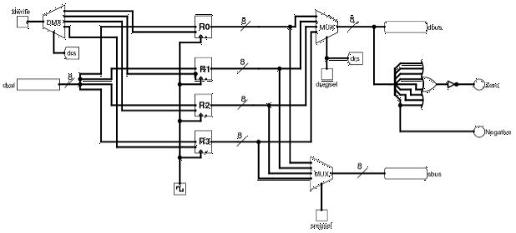

Stage Counter:

The stage counter (2bit counter) updates the stage from 0 to 2. When stage 3 is encountered, the stage counter should reset to 0 and again start up-counting. The stage counter has two tasks:

- Phase- For every clock rising, the phase starts incrementing from 00 to 10 for stages 00 and 01 and when the stage 10 is reached, the phase increments till from 00 to 11 and then resets to 00
- Stage- There are three stages in the proposed design, where the counter updates from 00 to 10 according to the phase

For the increment, unsigned variable is converted to a standard vector and is then incremented. Both the stage and phase should reset to 00 when the reset signal is enabled.

Memory / RAM
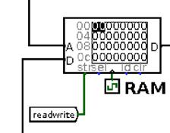

An 256byted memory was implemented with 8bit data bus and 8bit memory bus. This 256bytes is common to store both data and instruction.

The memory/RAM has two inputs, one output and one control signal. Address bus from the Addrsel Mux, Dataout bus from the dbus and the readwrite control pin respectively.

The readwrite control pin determines if the RAM should be written or to be read at that clock cycle. The readwrite = 1 means Write into the RAM and readwrite = 0 means Read from the RAM. The read data will be put on the Datain bus which inturn id connected to the regsel mux.

The RAM is declared as an array with the “ Type “ declaration. 256 arrays and each element is 8bit long. The sensitivity list has Clock and Reset. Whenever the reset signal is triggered, the first element in the RAM array is put on the datain bus. All the operations are carried out at the rising edge of the clock. The RAM element is accessed by the following statement

ram(to_integer(unsigned(address)))

Component Testing:

In this phase we had separate testing using test benches for all the above modules.

Modules are working as expected, we found at first some bugs in decode_logic and stage counter then we fixed them.

Below we are going to illustrate the different results for the different modules:

Stage Counter:
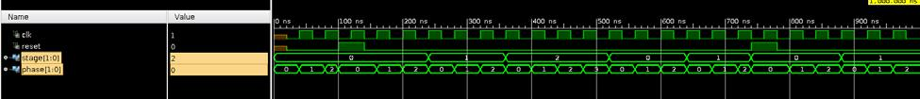

Register file:
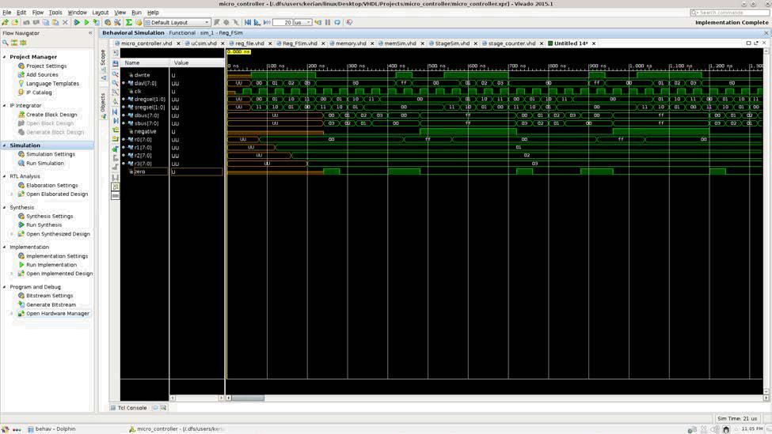

ALU Testing

The ALU does four operations according to the aluop signal.

- AND when aluop is 00 o OR when aluop is 01 o ADD when aluop is 10 o SUB when aluop is 11

Two 8bit data is used as the inputs along with one 8bit result as output. The aluop is also an input which tell the ALU which operation should be carried out.

The following is the test output wavefom.
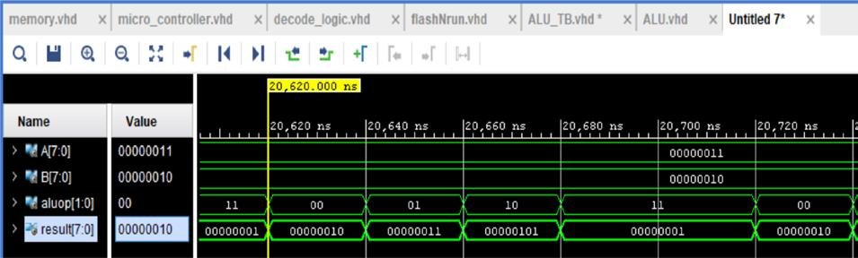

Memory:
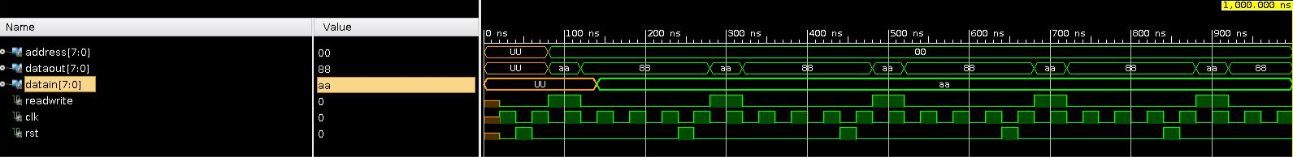

Decoder:
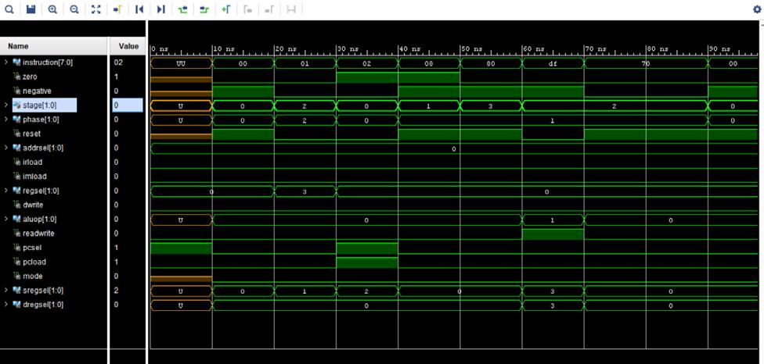

Project integration and integration Testing:

In this phase we had an entity from each module gathered together connected by signals.

We defined PC, IR, and immediate registers and used MUXs for address select, mode operations, PC select, and register file dval select. We also in this phase added the PC adder as well as a simple PC + 1 statement input the PC select MUX.

Integration Testing was the hardest phase, as in this phase we had to deal with timing diagrams and timing analysis, and this is the phase we did all the tough decisions of how many phases in stages, and having the address select triggered by falling edge.

Product Validation and final results:

We created a file to add the following list of numbers:

06, 05, 04, 03, 02, e4, 07

The total for those numbers is FF.

We also tried it with 7 down to 0 and we got 1c which is right.
Below is step by step debugging with pictures:

Color code is:

Dark blue: IR and PC

Light blue: 4 registers of the register file

White: memory at address 0x40

Flashing state:
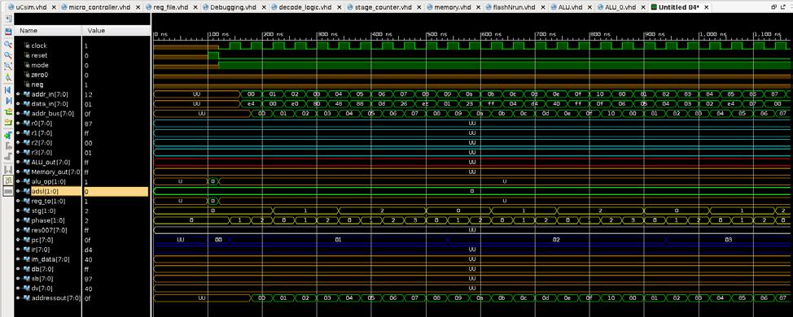

Done with flashing, reset the uC and start the code:
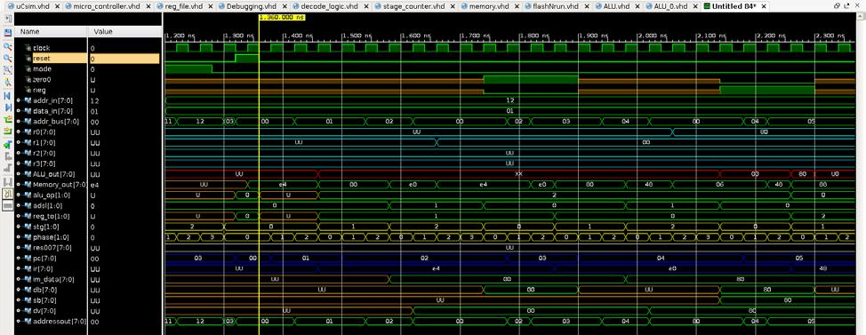
Loading R1 with 0, then R0 with 0x80 then R2 with data from R0 address (06):
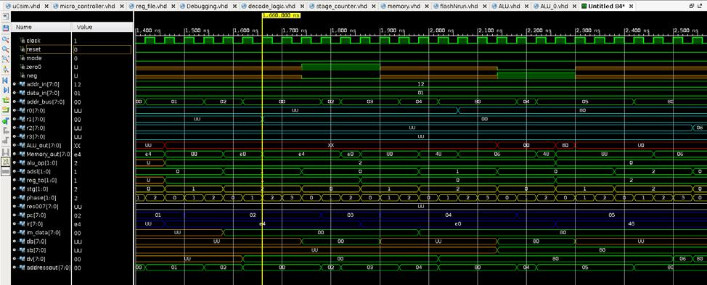

Adding values, update R1, put 1 in R3 to increment address:
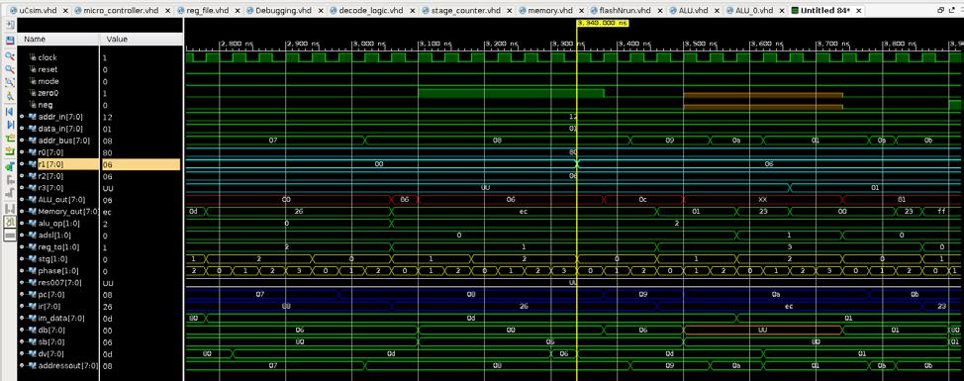

Increment Address and looping:
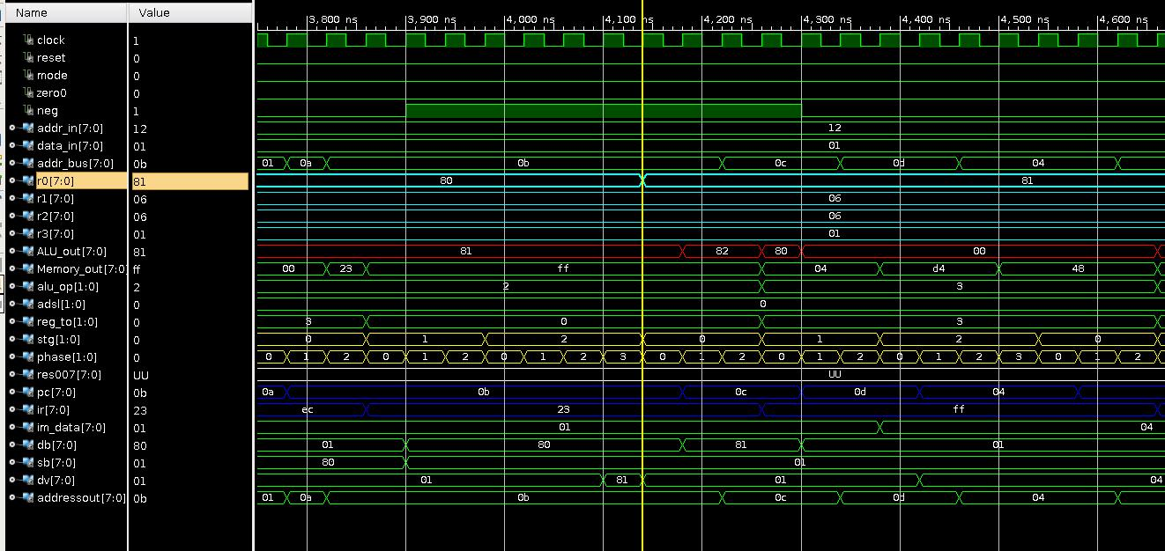

When number 0 is found in memory, stop looping and jump:
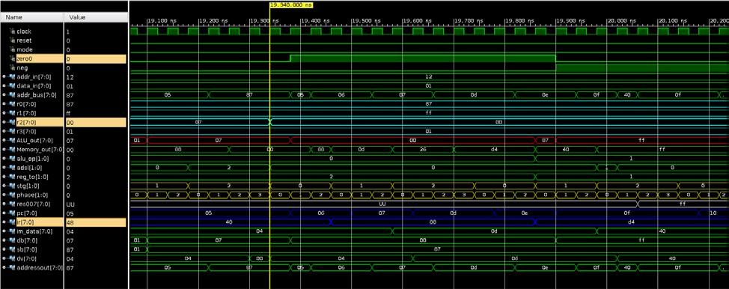

Update address 0x40 with sum (0xff):
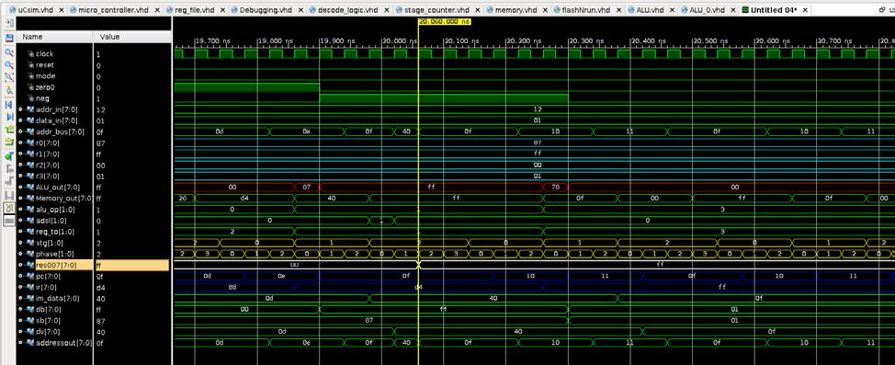

Loop forever:

