ECE 5146/4146 Introduction to VHDL

Spring 2018

Final Project

UART & micro Controller

System

April 13th, 2018
Contents:

- Introduction

- Implementation and design

- Simulations and results
Introduction:

Our project is a full connected computing system that consists of a UART and micro-controller. It is consisting of

- a Host Computer with a Terminal (we used a software called CoolTerminal to be able to see Hexadecimal values as well as the ASCII values).
- Zybo Board with the following implemented on FPGA:

- Micro-controller

- FIFO with FIFO controller

- UART Tx

- UART Rx

  - Baud Generator

The system has 4 modes of operations:

- Mode 0: Processing Mode: in this mode, the processor is running with full control of the RAM memory.

- Mode 1: Flashing Mode: in which the Terminal from the Host Computer sends data over UART through FIFO to RAM in form of Address-Data alternation. There is a system responsible to guide the received bytes to be used as data or address, it is a simple 1-bit counter.

- Mode 2: Reading RAM Mode: This Mode reads the whole RAM in sequence to the Terminal.

- Mode 3: Reading Register Files to the Terminal.

Modes are changed using Switches 2 and 3. We can also see the system status through the 4 LEDs that allows us to know when Rx is done, Tx is done, FIFO is Full, or FIFO is empty.
Design and Implementation:

The system is divided into 5 main modules integrated together, in this section we will go through the 5 modules in a brief.

- The MicroController:

In this module, we used last project with adjustment to modes of operation. We already had the processing mode and the flashing mode implemented in the micro-controller, we added the reading from RAM mode and Reading from RF mode.

Implementing these modes needed adjustments in the main file where we integrated our micro-processor system and the decoder file where the all control systems are there.

We also adjusted the RAM to have hard coded in it the sentence “Hello World!!!!” in order to use it as

simple Hello World Program in order to test the Tx part of the UART.

- FIFO with FIFO Controller:

FIFO is used as a buffer for the speed difference between the micro-controller clock and the Baud Rate used. We implemented a 32 entries FIFO with 8-bits entry size. We chose this size to try to avoid getting Full in simple operations, but it gets full anyway whenever we start in mode 2. The FIFO is controlled by a FIFO control system with the following control signals:

  - Read Request: input signal that requests single read from FIFO

  - Write Request: input signal that requests single write to FIFO

  - Read Address: the address to read – controlled by read request and empty flag

  - Write Address: the address to write – controlled by write request and full flag

  - FIFO EMPTY: output flag indicating when the FIFO is empty

  - FIFO FULL: output flag indicating when the FIFO is full

Our design is to have an internal flag that is set once Write address reach the maximum and reset once the read address reaches the maximum address. If both addresses are the same, if the flag is set, then the FIFO is full, if it is not set, then it is empty.

- UART Tx:

We designed this module to check for data availability from the FIFO empty flag, if FIFO is not empty, it reads 1 byte from FIFO (using Tx Done as the Read Request Signal) and counts the S_Ticks for 31 counts (number of samples used, please refer to Baud Generator for more information). Every 31 counts, it will send 1 bit. Starting with ‘0’ as start bit, and ending by a ‘1’ as stop bit. The idle case of the Tx is sending 1’s.

Tx has the following cases:

  - Idle: sending 1’s and waiting for empty flag

  - Start: sending start bit then go to sending data

  - Sending Data, using the idea of a shift register by sending a bit by a time, starting from the LSB first till MSB then go to the end state

- End: sending the stop bit and either go back to idle or go back to start as per the value of

empty.

- the first one was using external Baud Generator and calculating the average of Samples by reading all samples per each received bit then counting the number of 1’s and the number of 0’s to check which one is higher, and determinate accordingly the received bit value. In case both of them are the same, (which is a rare case) we then go to check the MSB and decide according to it. This design had a timing problem and changing of next and current register values had a conflict between counting on clock and S_tick. So, we went to the next design.

- The second design[1] is a design that we saw online at a website called nandland.com. it is similar

idea but instead of using clock, and s_tick, it does the baud rate calculation internally, and divide the clock by a value (we used 434) to have s_tick and use the new value as system clock for the whole Rx module. It doesn’t do the averaging thing, instead, it just read the value at the middle sample.

Both of them have the following states:

  - Idle: waiting for a 0 bit to be received

  - Start: if 0 is received, then count 7 samples to make sure it is really a 0, and then if it is a 0, go to data state

  - Data: using a shift register, and counting samples to get new bits then go to end state

  - Receive the stop bit, wait for a 1 to be delivered.

- Baud Generator:

This module is simply a counter that divides the clock into lower frequency clock. In our case, the system is 50MHz, and we needed 115200 sampling rate. Hence, we needed to count 434 counts for each s_tick. However, as we are using a multi-samples system for error checking and adjustments, we decided to use 31 samples, as 31 gave us the lowest division error: 50M / (31 x 115200) = 14.00089 but 50M / (16 x 115200) = 27.1267. As we need to count a decimal number not a floating point number.
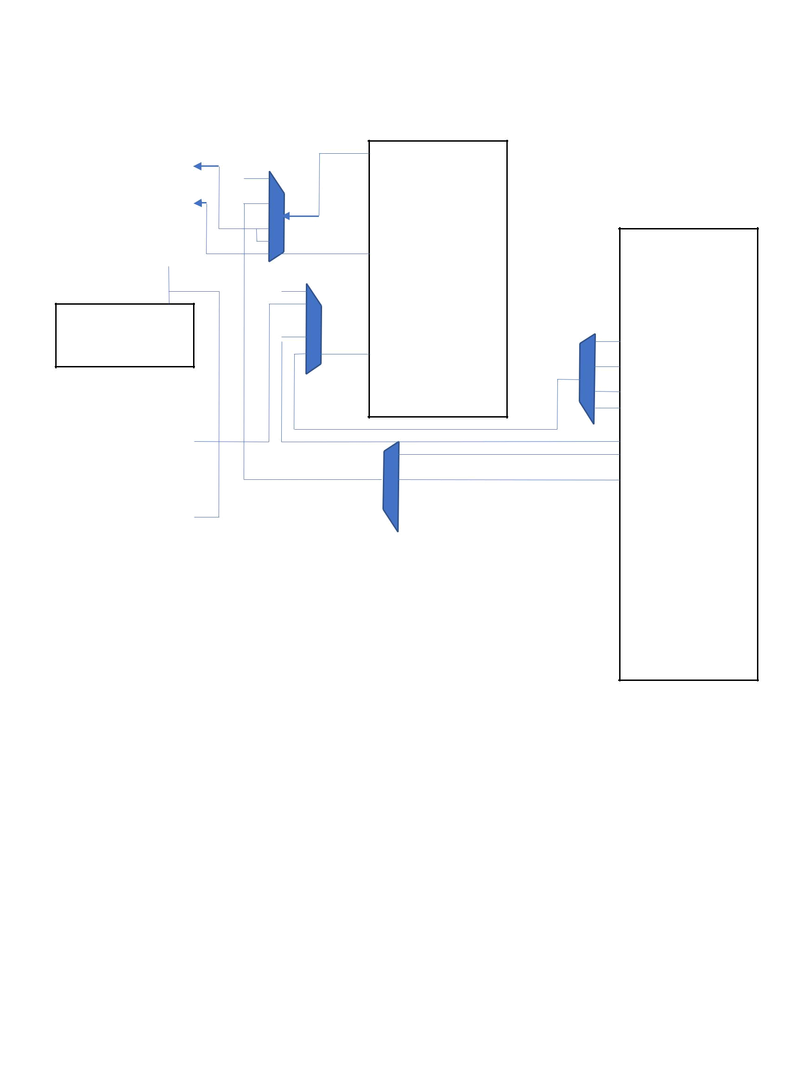
After Having all modules ready and tested separately, we started integration phase and had the modules connected as follows:

Tx | i/p data
 | tx done
>clk | Empty
rst | S_tick

>clk s_t

B.G.

Rx | o/p data
 | rx done
>clk
rst | S_tick

Dout

Rd_rqst

Empty

Full

FIFO

Wr_rqst

Din

>clk
rst

Alternator

uC

Reg counter

R0

R1

R2
R3

Mem_out

Data_in

Addr_in

Res007

Mode

> clk

rst

Results:

As simulation for Mode 1 (Flashing) please refer to image below:
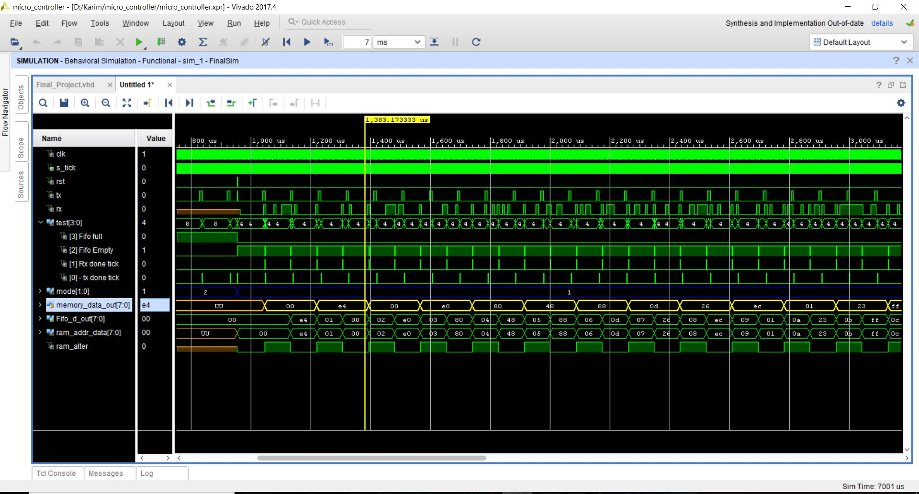

Having the memory data out is the data to memory received by the receiver. However, it only includes data without addresses, as seen in Fifo data out it has addresses and data: ex: in address 04 there is 48 yjrn in 05 there is 88, in memory we can see 48 then 88.

Below is magnified image for the s_tick and clock:
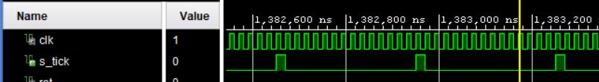

Below is magnified part of status leds:
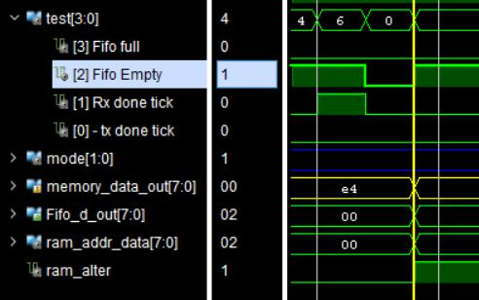

Also, a magnified part of addresses with mode 0 where the Program counter is incrementing the memory address
Using CoolTerm, we tried sending lots of data, we had suffered a lot to get the data sent received, and I think this is because of timing adjustments between Zybo and computer. Finally we tried sending 77 at sampling rate of 31 and 14 clk counts and below is the result:
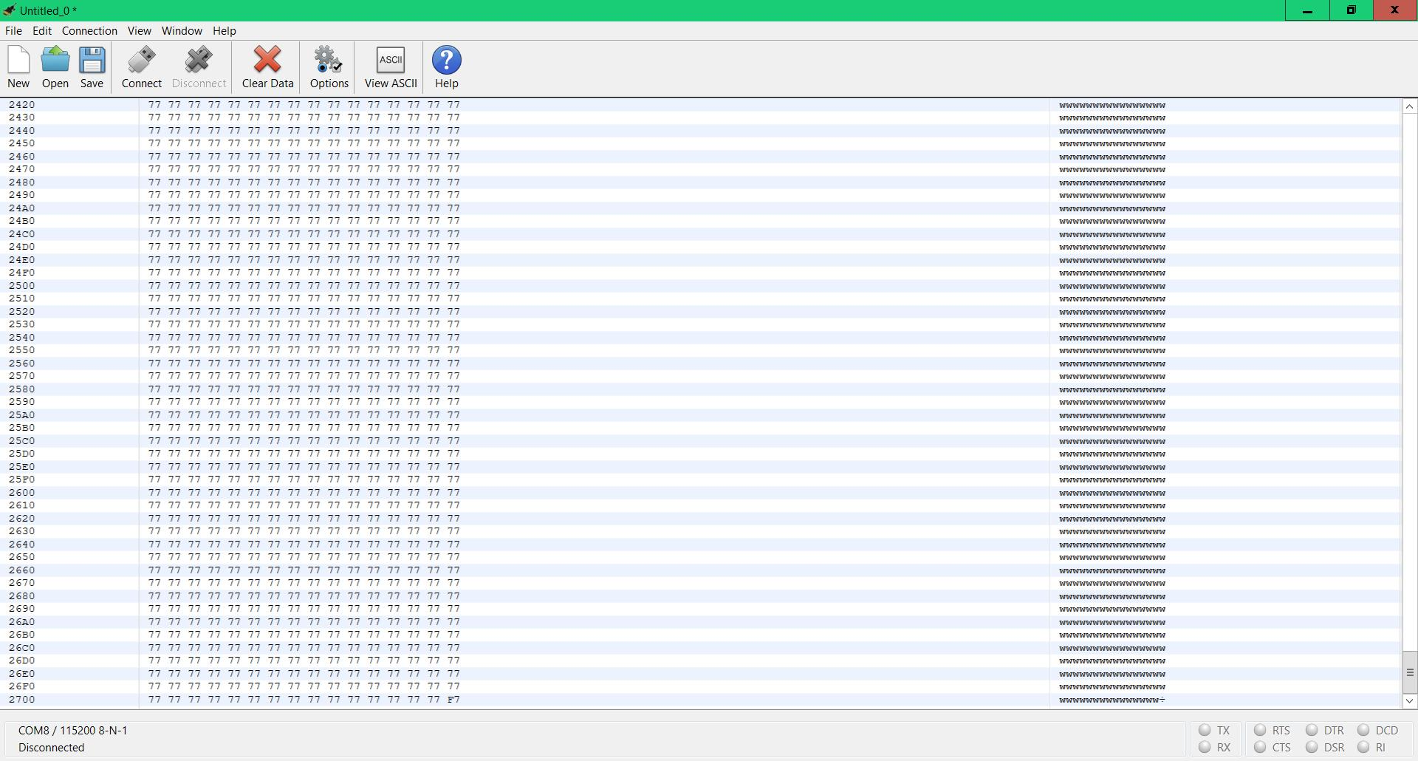

For Tx, we tried simulating Sending the stored Hello World from memory and below what we got:
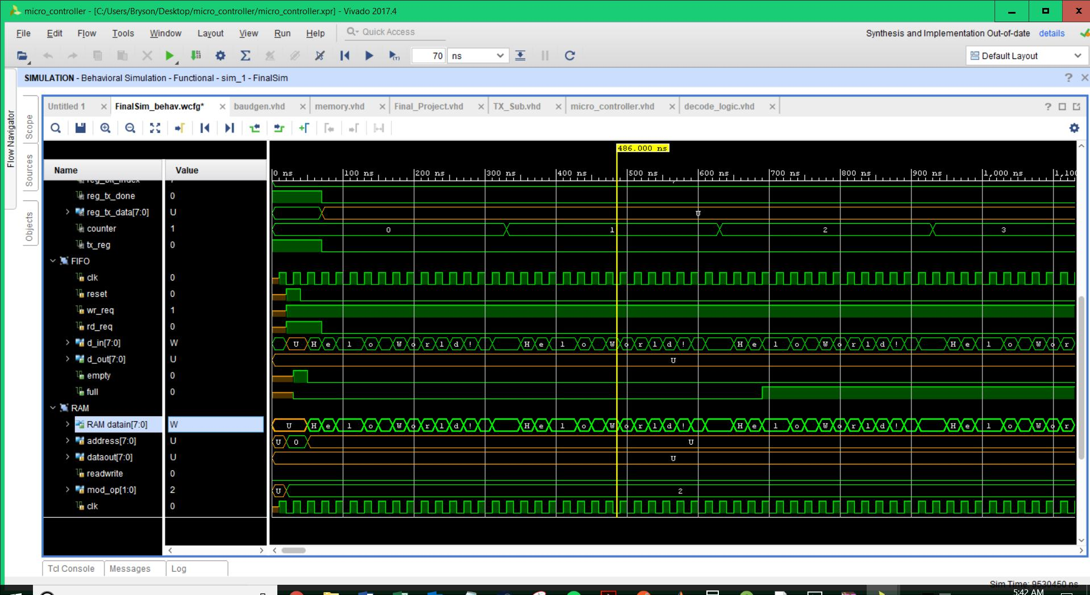

in the image above we have Hello World as RAM values, and we have it transmitted in FIFO preparing to send it.

Image below shows from FIFO to Tx:

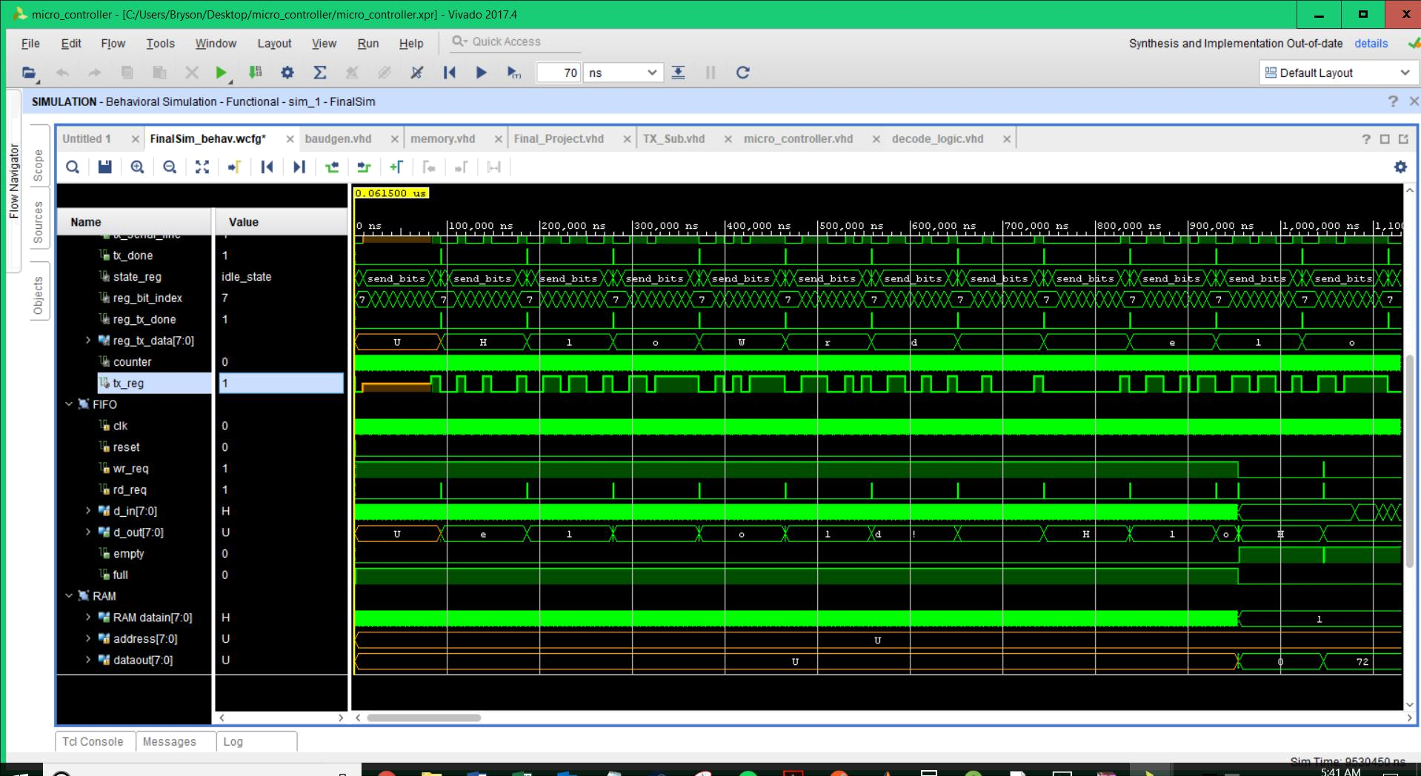

As a conclusion: Hardware implementation is much harder than simulation, as simulation may neglect the fact of clock rate accuracy, and this may repeat reading many bits or skip a bit while reading. Many times on hardware testing we received 8 bits in which one repeated bit, or we received 8 bits that the data is compressed. We tried varying sampling rates from 13 to 248. The 248 was losing lots of data.

We believe further adjustment maybe done using oscilloscope to have better tuning.

