**About us**

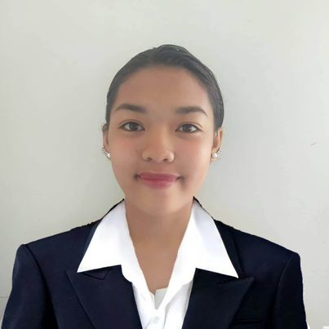

Angela Manla

Chief Executive Officer of the Company

Angela is responsible or ensuring that the business operates at a profit and meets its goals.

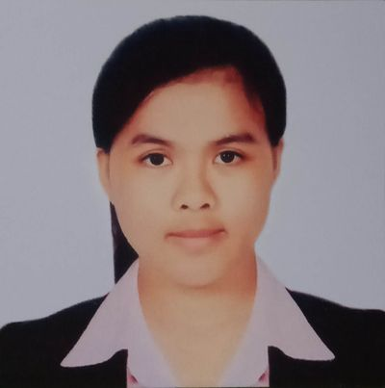

Joeffel Ruado

Business Development

Joeffel is responsible for developing and maintaining relationships with other companies.

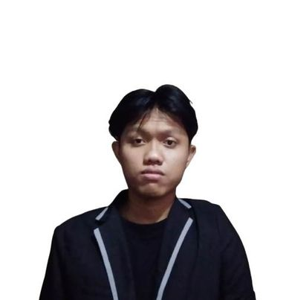

Ryan Mark Yugo

Marketing Manager

Ryan Mark is is often responsible for planning and tracking the budget of their entire department, one segment, or an individual marketing campaign .

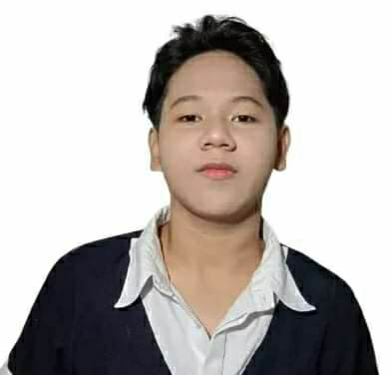

Ariel Abueme

Accounting Manager

Ariel is often responsible for providing accurate financial data and recommendations based on their findings.

**Mission**

smart mobile zone follows a simple business philosophy: to devote its talent and technology to creating superior products and services that contribute to a better global society. To achieve this, Smart mobile zone sets a high value on its people and technologies.

**Vision**

Providing individuals with cutting-edge technology that improves their daily lives and links them to the outside world is our ambition for our mobile business. We work hard to design tools that are not only effective and powerful, but also simple to use

**Location**

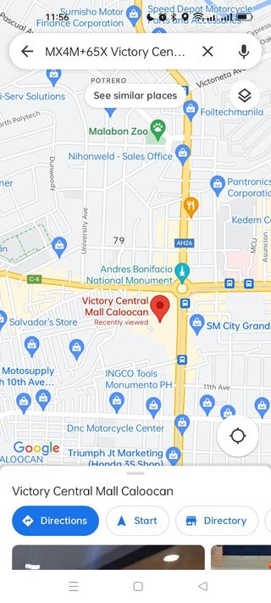

**you can come to pick your orders at our shop and browse more of our product**

**Victory Central Mall Caloocan, MX4M+65X, Caloocan, 1408 Metro Manila**

**Contact us**

**Name:**

**Email:**

**Your message here :**

**Submit :**

**Email:SmartMobilePhoneInc.@gmail.com**

**Mobile number :09511492945**

**Facebook: smartmobilezone**

**Instagram:**  **smartmobilezone**

**Twitter:** **smartmobilezone**

**Victory Central Mall Caloocan, MX4M+65X, Caloocan, 1408 Metro Manila**

**3rd floor.**

**© 2023 All rights reserved | Smart Mobile zone**