**Capstone_Stage 1**

Table of Contents

Description 1

Intended User 2

Features 2

User Interface Mocks 2

Screen 1 2

Screen 2 3

Key Considerations 6

How will your app handle data persistence? 6

Describe any edge or corner cases in the UX. 6

Describe any libraries you’ll be using and share you're reasoning for including them. 7

Describe how you will implement Google Play Services or other external services. 7

Next Steps: Required Tasks 7

Task 1: Project Setup 7

Task 2: Implement UI for Each Activity and Fragment 7

Task 3: 7

Task 4: 7

Task 5: 8

**GitHub Username**: monicawissa

Hang In

# Description

Imagine the situation when you are living in noise place and you need to study for you exams ,How to get a solution for that ? Hang In app is right place to find the nearest co-working spaces and get details and reviews for each and every one of them   
 you can call them to book the place before go and to check if there is space for you you also can share the place with your colleague and visit their website .

# Intended User

We target every student need to study in nearest quiet place.

# Features

List the main features of your app. For example:

* Find quiet nearby coworking space
* Each place details include rating, address, phone number, images, distance from your current location, website, user reviews, working hours, price level
* Fast & Accurate Results
* Works all over the world
* Add places to Favorite list
* Share the place with your friends (WhatsApp, Facebook, Email etc).
* View the working hours of each place
* App is written solely in the java programming language.
* User Account
* Google places API
* Firebase Authentication
* Adding UI Widget

# User Interface Mocks

## Screen 1

-in this screen (splash Activity) where I get the location of the user

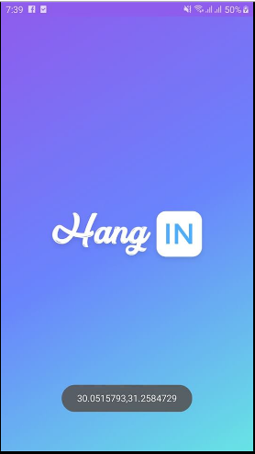

## Screen 2

-in this Screen(Login Activity) with Firebase authentication, user can log in with his own account,by google or facebook ,if he hasn't any account he can register

So he can access the app and start find the nearest co-working space.

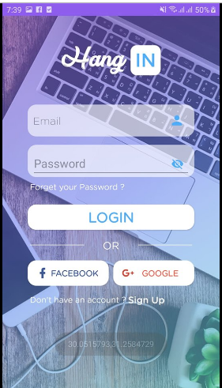

**Screen 3**

-In this screen (Registration activity), if the user didn’t have an account, he can register a new one .

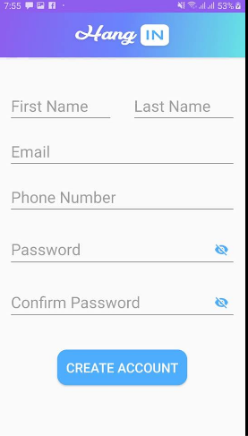

**Screen 4**

-in this screen(Main activity ) user can find the nearest co-working space ,showing if its open or closed and access the details for each of them .

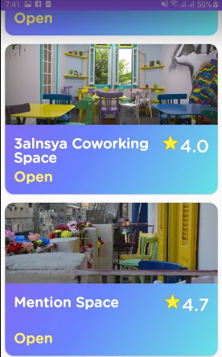

**Screen 5**

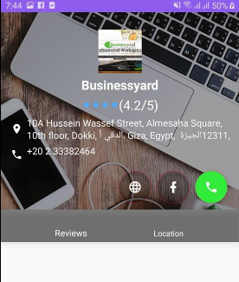

**Screen 6**

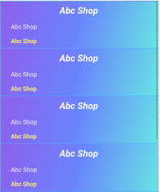

Show an widget in home screen with list of the favorite places , by adding the adrees and phone number to call them any time

Also will Add intent service with widget

# 

# Key Considerations

### How will your app handle data persistence?

-My app can handle data beginning: firebase Authentication for authenticates users with email and password and phone .etc...

-Also will handle the registration data with firebase database.

- I added all strings to strings.xml file and allow the RTL support.

How the app will support accessibility?

-I added android:focusable="true" into the layout to avoid missing data and make the app more accessibility .

### Describe any edge or corner cases in the UX.

-if the user logged in with email and password and close the app , if he back again he will open the app directly without asking for username and password again , and it is with firebase on state listener to check the current situation if the user signed out or not .

### Describe any libraries you’ll be using and share you're reasoning for including them.

* All versions of gradle and android studio are stable.
* Picasso will be used for image loading.
* Material Design support library.
* Butterknife for data/method binding
* Firebase authentication,database

### Describe how you will implement Google Play Services or other external services.

1-I used "Google Maps location service" to be able to use Google maps and track location for helping the user to find the co-working space.

2- I Used "Firebase service" to be able to get features of the firebase like: firebase authentication, firebase database, firebase storage and more ….

1-I used "Google places" to be able to find the nearest co-working space.

# Next Steps: Required Tasks

## Task 1: Project Setup

First of all I start with adding libraries beginning from Google places api , then firebase to be able to use their features .

* Configure libraries (Google places ,Google Maps, Firebase, Retrofit, etc…)

## Task 2: Implement UI for Each Activity and Fragment

First of all start with design Wire Frame for the app , then start implement it with XML.

* Build UI for SplashScreen Activity.
* Build UI for Log In Activity
* Build UI for MainActivity
* Build UI for Registration Activity.
* Build UI for Details Place
* Build UI for Google Maps Activity.
* Build UI for Widget Activity.

## Task 3:

The third task is to get our device location using GPS service .

And to login, if the user didn’t have an account, he can register a new one .

## Task 4:

The fourth task is to show the user the nearest co-working spaces .

Show the details of each place with call option and sharing the website .

## Task 5:

The fifth task is adding Sign out button to let the user signing out from the app.

Adding UI Widget activity for users.