Provide two examples of Inner joins. For your examples, show the contents of each table, then show the results of the join.

Using Inner Joins:

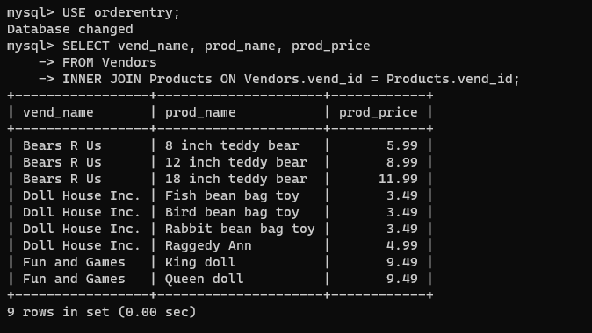

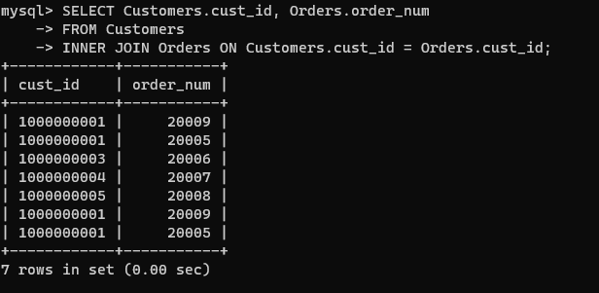

Would any other SQL statement provide the same results? Yes see below

