

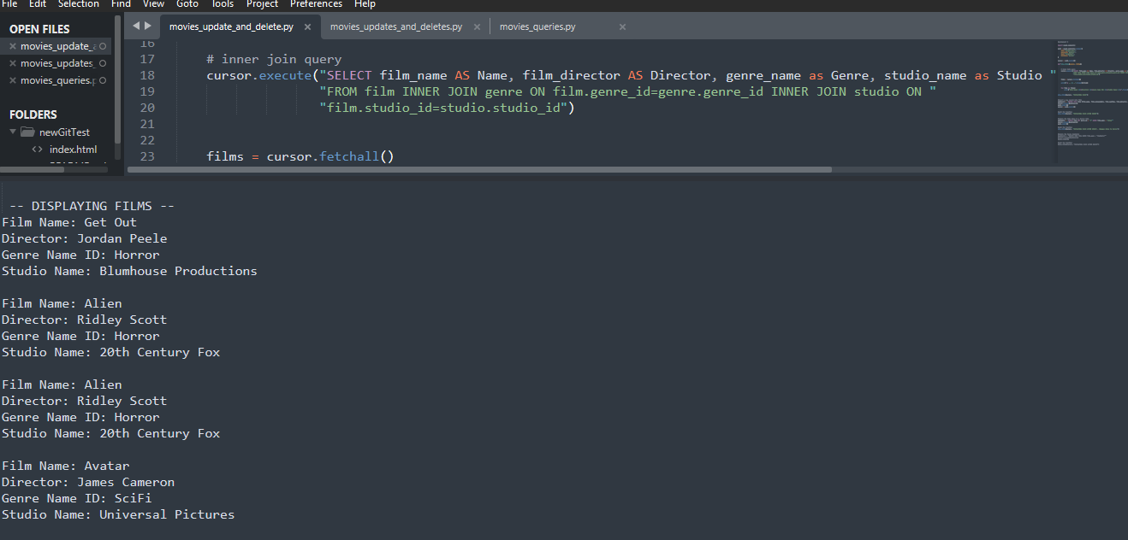

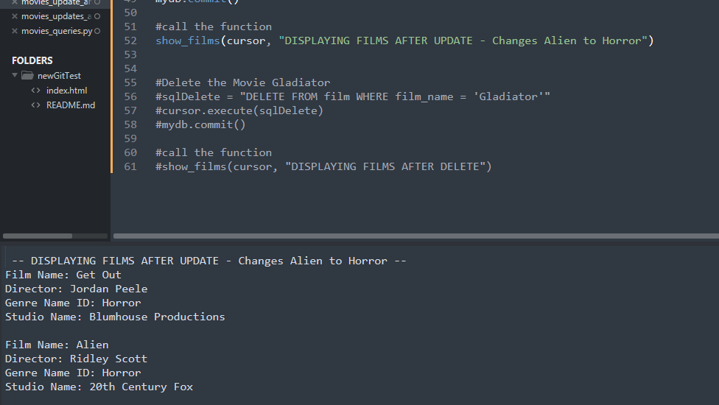

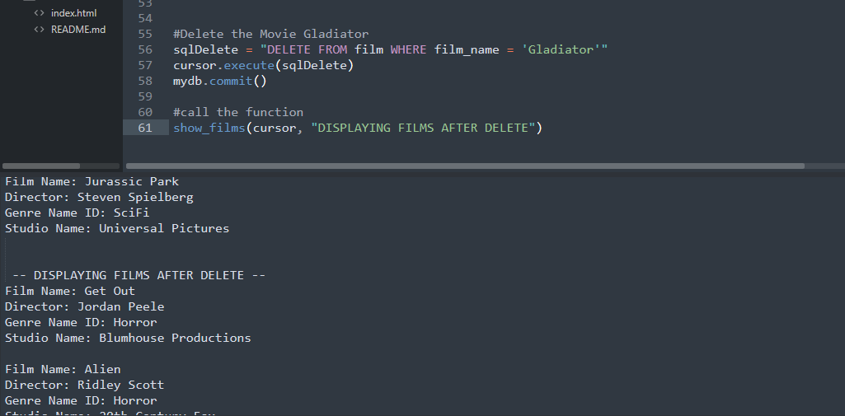

-- DISPLAYING FILMS --

Film Name: Get Out

Director: Jordan Peele

Genre Name ID: Horror

Studio Name: Blumhouse Productions

Film Name: Alien

Director: Ridley Scott

Genre Name ID: Horror

Studio Name: 20th Century Fox

Film Name: Alien

Director: Ridley Scott

Genre Name ID: Horror

Studio Name: 20th Century Fox

Film Name: Avatar

Director: James Cameron

Genre Name ID: SciFi

Studio Name: Universal Pictures

Film Name: Avatar

Director: James Cameron

Genre Name ID: SciFi

Studio Name: Universal Pictures

Film Name: Avatar

Director: James Cameron

Genre Name ID: SciFi

Studio Name: Universal Pictures

Film Name: Avatar

Director: James Cameron

Genre Name ID: SciFi

Studio Name: Universal Pictures

Film Name: Avatar

Director: James Cameron

Genre Name ID: SciFi

Studio Name: Universal Pictures

Film Name: Avatar

Director: James Cameron

Genre Name ID: SciFi

Studio Name: Universal Pictures

Film Name: Avatar

Director: James Cameron

Genre Name ID: SciFi

Studio Name: Universal Pictures

Film Name: Avatar

Director: James Cameron

Genre Name ID: SciFi

Studio Name: Universal Pictures

Film Name: Avatar

Director: James Cameron

Genre Name ID: SciFi

Studio Name: Universal Pictures

Film Name: Avatar

Director: James Cameron

Genre Name ID: SciFi

Studio Name: Universal Pictures

Film Name: The Help

Director: Tate Taylor

Genre Name ID: SciFi

Studio Name: Universal Pictures

Film Name: The Help

Director: Tate Taylor

Genre Name ID: SciFi

Studio Name: Universal Pictures

Film Name: The Help

Director: Tate Taylor

Genre Name ID: SciFi

Studio Name: Universal Pictures

Film Name: The Help

Director: Tate Taylor

Genre Name ID: SciFi

Studio Name: Universal Pictures

Film Name: Jurassic Park

Director: Steven Spielberg

Genre Name ID: SciFi

Studio Name: Universal Pictures

Film Name: Jurassic Park

Director: Steven Spielberg

Genre Name ID: SciFi

Studio Name: Universal Pictures

Film Name: Jurassic Park

Director: Steven Spielberg

Genre Name ID: SciFi

Studio Name: Universal Pictures

-- DISPLAYING FILMS AFTER INSERT --

Film Name: Get Out

Director: Jordan Peele

Genre Name ID: Horror

Studio Name: Blumhouse Productions

Film Name: Alien

Director: Ridley Scott

Genre Name ID: Horror

Studio Name: 20th Century Fox

Film Name: Alien

Director: Ridley Scott

Genre Name ID: Horror

Studio Name: 20th Century Fox

Film Name: Avatar

Director: James Cameron

Genre Name ID: SciFi

Studio Name: Universal Pictures

Film Name: Avatar

Director: James Cameron

Genre Name ID: SciFi

Studio Name: Universal Pictures

Film Name: Avatar

Director: James Cameron

Genre Name ID: SciFi

Studio Name: Universal Pictures

Film Name: Avatar

Director: James Cameron

Genre Name ID: SciFi

Studio Name: Universal Pictures

Film Name: Avatar

Director: James Cameron

Genre Name ID: SciFi

Studio Name: Universal Pictures

Film Name: Avatar

Director: James Cameron

Genre Name ID: SciFi

Studio Name: Universal Pictures

Film Name: Avatar

Director: James Cameron

Genre Name ID: SciFi

Studio Name: Universal Pictures

Film Name: Avatar

Director: James Cameron

Genre Name ID: SciFi

Studio Name: Universal Pictures

Film Name: Avatar

Director: James Cameron

Genre Name ID: SciFi

Studio Name: Universal Pictures

Film Name: Avatar

Director: James Cameron

Genre Name ID: SciFi

Studio Name: Universal Pictures

Film Name: Avatar

Director: James Cameron

Genre Name ID: SciFi

Studio Name: Universal Pictures

Film Name: The Help

Director: Tate Taylor

Genre Name ID: SciFi

Studio Name: Universal Pictures

Film Name: The Help

Director: Tate Taylor

Genre Name ID: SciFi

Studio Name: Universal Pictures

Film Name: The Help

Director: Tate Taylor

Genre Name ID: SciFi

Studio Name: Universal Pictures

Film Name: The Help

Director: Tate Taylor

Genre Name ID: SciFi

Studio Name: Universal Pictures

Film Name: Jurassic Park

Director: Steven Spielberg

Genre Name ID: SciFi

Studio Name: Universal Pictures

Film Name: Jurassic Park

Director: Steven Spielberg

Genre Name ID: SciFi

Studio Name: Universal Pictures

Film Name: Jurassic Park

Director: Steven Spielberg

Genre Name ID: SciFi

Studio Name: Universal Pictures

-- DISPLAYING FILMS AFTER UPDATE - Changes Alien to Horror --

Film Name: Get Out

Director: Jordan Peele

Genre Name ID: Horror

Studio Name: Blumhouse Productions

Film Name: Alien

Director: Ridley Scott

Genre Name ID: Horror

Studio Name: 20th Century Fox

Film Name: Alien

Director: Ridley Scott

Genre Name ID: Horror

Studio Name: 20th Century Fox

Film Name: Avatar

Director: James Cameron

Genre Name ID: SciFi

Studio Name: Universal Pictures

Film Name: Avatar

Director: James Cameron

Genre Name ID: SciFi

Studio Name: Universal Pictures

Film Name: Avatar

Director: James Cameron

Genre Name ID: SciFi

Studio Name: Universal Pictures

Film Name: Avatar

Director: James Cameron

Genre Name ID: SciFi

Studio Name: Universal Pictures

Film Name: Avatar

Director: James Cameron

Genre Name ID: SciFi

Studio Name: Universal Pictures

Film Name: Avatar

Director: James Cameron

Genre Name ID: SciFi

Studio Name: Universal Pictures

Film Name: Avatar

Director: James Cameron

Genre Name ID: SciFi

Studio Name: Universal Pictures

Film Name: Avatar

Director: James Cameron

Genre Name ID: SciFi

Studio Name: Universal Pictures

Film Name: Avatar

Director: James Cameron

Genre Name ID: SciFi

Studio Name: Universal Pictures

Film Name: Avatar

Director: James Cameron

Genre Name ID: SciFi

Studio Name: Universal Pictures

Film Name: Avatar

Director: James Cameron

Genre Name ID: SciFi

Studio Name: Universal Pictures

Film Name: The Help

Director: Tate Taylor

Genre Name ID: SciFi

Studio Name: Universal Pictures

Film Name: The Help

Director: Tate Taylor

Genre Name ID: SciFi

Studio Name: Universal Pictures

Film Name: The Help

Director: Tate Taylor

Genre Name ID: SciFi

Studio Name: Universal Pictures

Film Name: The Help

Director: Tate Taylor

Genre Name ID: SciFi

Studio Name: Universal Pictures

Film Name: Jurassic Park

Director: Steven Spielberg

Genre Name ID: SciFi

Studio Name: Universal Pictures

Film Name: Jurassic Park

Director: Steven Spielberg

Genre Name ID: SciFi

Studio Name: Universal Pictures

Film Name: Jurassic Park

Director: Steven Spielberg

Genre Name ID: SciFi

Studio Name: Universal Pictures

-- DISPLAYING FILMS AFTER DELETE --

Film Name: Get Out

Director: Jordan Peele

Genre Name ID: Horror

Studio Name: Blumhouse Productions

Film Name: Alien

Director: Ridley Scott

Genre Name ID: Horror

Studio Name: 20th Century Fox

Film Name: Alien

Director: Ridley Scott

Genre Name ID: Horror

Studio Name: 20th Century Fox

Film Name: Avatar

Director: James Cameron

Genre Name ID: SciFi

Studio Name: Universal Pictures

Film Name: Avatar

Director: James Cameron

Genre Name ID: SciFi

Studio Name: Universal Pictures

Film Name: Avatar

Director: James Cameron

Genre Name ID: SciFi

Studio Name: Universal Pictures

Film Name: Avatar

Director: James Cameron

Genre Name ID: SciFi

Studio Name: Universal Pictures

Film Name: Avatar

Director: James Cameron

Genre Name ID: SciFi

Studio Name: Universal Pictures

Film Name: Avatar

Director: James Cameron

Genre Name ID: SciFi

Studio Name: Universal Pictures

Film Name: Avatar

Director: James Cameron

Genre Name ID: SciFi

Studio Name: Universal Pictures

Film Name: Avatar

Director: James Cameron

Genre Name ID: SciFi

Studio Name: Universal Pictures

Film Name: Avatar

Director: James Cameron

Genre Name ID: SciFi

Studio Name: Universal Pictures

Film Name: Avatar

Director: James Cameron

Genre Name ID: SciFi

Studio Name: Universal Pictures

Film Name: Avatar

Director: James Cameron

Genre Name ID: SciFi

Studio Name: Universal Pictures

Film Name: The Help

Director: Tate Taylor

Genre Name ID: SciFi

Studio Name: Universal Pictures

Film Name: The Help

Director: Tate Taylor

Genre Name ID: SciFi

Studio Name: Universal Pictures

Film Name: The Help

Director: Tate Taylor

Genre Name ID: SciFi

Studio Name: Universal Pictures

Film Name: The Help

Director: Tate Taylor

Genre Name ID: SciFi

Studio Name: Universal Pictures

Film Name: Jurassic Park

Director: Steven Spielberg

Genre Name ID: SciFi

Studio Name: Universal Pictures

Film Name: Jurassic Park

Director: Steven Spielberg

Genre Name ID: SciFi

Studio Name: Universal Pictures

Film Name: Jurassic Park

Director: Steven Spielberg

Genre Name ID: SciFi

Studio Name: Universal Pictures

[Finished in 409ms]