By Monika kumari

EDA Project -Python
Retail Business Performance
Analysis Dataset

Introduction
This is dataset download for Kaggle website. This project focus on analyzing Retail Business Performance Analysis Dataset using python libraries like (pandas, Numpy, matplotlib and seaborn) and Create attractive visualization. this dataset combine have four different table like product, customer, sales and store. find demanding category, high revenue generated category,monthly & yearly sales and profits etc

Data information
Product Details table
--product details table-using info function I explained of dataset columns names,data type and missing values. product details table contain 50000 records and 8 columns. In the product table 4str type columns and 2float type cloumns. all data type of columns are correct and no null values escape colour column name.
--using discribe() function, I analyized statical summery of numerical columns(in the dataset only has two numaric columns).the average price of cost_price 42.5 and list_price 105.1 .the range of cost_price 5-80 and list_price 10-199. in this table mean and median values are very close.
Customer Details table
--customer details table= contain 25000 records and 5 columns . In the table most data type is correct and have 1 int and 4 str data type columns. all columns complete data expect email has 469 missing values.
--customer details table has mean values of age is 42.4 and range 16-69. mean and median value very close.

Sales Details table
--sales table contain 50000 records and 7 columns. all columns data type is correct expect date has str dtype. mostly columns contain complete data but customer_id has 1844 and discount has 2583 missing values, returned columns contain numerical but have text value 1 mean yes and 0 mean no.
in sales details table has three columns statical summery quantity,discount and returned.the average values of quantity 2.5 ,discount 0.05 and 0.09.data range of quantity 1-4, discount 0-0.3 and returned 0-1.
Store Details table
--in store details table contain 5 records only and 4 columns. in this data has no wrong dtypes and missing values.
store details table mean values of store_size_m2 has 486 and range is 179-950 meters. stander deviation is 336.

Data Cleaning Steps
-In product details table column colour have 990 missing values fills with forward fill ().
-In product details table of category columns wrote this symbol ??? of unknown category and I replaced this ??? to unknown through replace ().
- have 496 missing values but not need cleaning because not major uses. evenly find customer information from customer id.
- in gender columns of customer details table unknown gender fill this symbol??? I replaced to unknown.
-In sales table missing values of customer id fill with fill unknown customer id and discount missing values fill with 0
Key insights
-Total transactions recorded: 50,000
-Total revenue generated: 12.46M
-Total profit generated: 712.9K
-Average customer age: 43 years
-2023 was the highest revenue-generating year, while 2021 had the lowest revenue.
-May recorded the highest monthly revenue, whereas February recorded the lowest.
-Accessories was the top-performing category in terms of both revenue and profit.
-White-coloured products generated the highest revenue among all colors.
-Product returns were relatively low, indicating good customer satisfaction.
-Supplier_B contributed the highest number of transactions and revenue.
-Lisbon was the highest revenue and profit-generating city.
-Lisbon Flagship Store generated the highest revenue among all stores.
-The analysis suggests focusing on high-performing categories, suppliers, and locations to maximize future revenue and profitability.

Dashboard
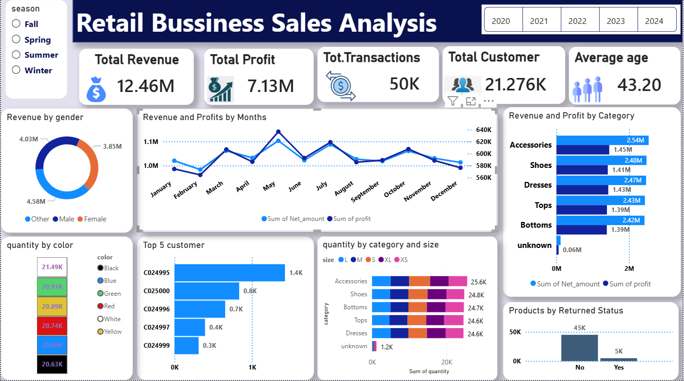
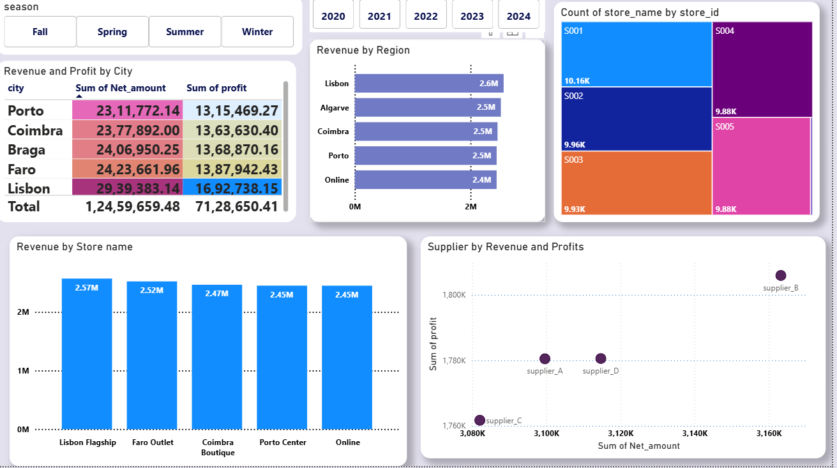

Retail Business Sales Analysis Dashboard
- Developed an interactive Power BI dashboard to analyze retail sales performance, customer behavior, product trends, and profitability.
- Total Revenue reached 12.46M with a Total Profit of 7.13M across 50K transactions and 21.3K customers.
- Analyzed sales and profit trends by month, category, region, store, supplier, gender, and season.
- Identified top-performing categories such as Accessories and Shoes, contributing the highest revenue and profit.
- Compared store-wise and city-wise performance to highlight key revenue-generating locations.
- Evaluated product return patterns, customer demographics, and quantity sold by color and size.
- Implemented interactive filters and slicers for dynamic business insights and decision-making.

