**Where is the best location for our newly opened apartment?**

# Introduction

## 1.1. Project Background Statement

We are looking for a place to start up our new apartment in Texas. Texas is growing very fast recently. A lot of constructions are ongoing here and there. New apartments, new restaurants can be found anywhere in Texas. As an individual who have lived in Texas for almost five years, I really feel the development of the State. As a third-populated state in the US, living in Texas is very comfortable and relaxed. The traffic is good here as well as the public transportation system. As the expanding economy and population of Texas, the demand of new apartment is increasing dramatically. Therefore, we believe that a new apartment business in Texas will be profitable and worth investing.

## 1.2. Project Target Statement

In this project, we are going to use Foursquare API to get information and analysis the data we obtained, to make a decision where (which city in Texas) will be the new apartment located.

# Data Collection

In the data collection section, I am going to grab cities’ information from internet, including city name, population, household income, criminal rate, etc. Also the numbers of parks, markets, schools, hospitals might be considered in this work or future.

Following are the web links for cities’ information:

https://www.tsl.texas.gov/ref/abouttx/popcity32010.html

https://www.indexmundi.com/facts/united-states/quick-facts/texas/median-household income/cities#table

https://www.indexmundi.com/facts/united-states/quick-facts/texas/average-commute-time/cities#table

http://www.usa.com/rank/texas-state--crime-index--city-rank.htm?hl=&hlst=&wist=&yr=&dis=&sb=ASC&plow=&phigh=&ps=

The following table is the first few rows of the cities in Texas with their populations, household incomes, mean travel time, and criminal indexes:

Table 1. Population, household income, mean travel time, and crime index of top 20 cities in TX

# 

From table 1, I observe that the most populated city in TX is Huston, and then San Antonio, Dallas, Austin, and Fort Worth. The information shown here is consistent with the information for web, therefore, the generation of this table is faultless.

# Data Analysis

Basing on the data I collected for the cities in TX state, there are 4 major concerns, population, household income, mean travel time, and crime index. Apparently, large population, high household income, low travel time, and low crime index will make the new-built apartment more likely profitable. Therefore, in the following analysis, I am going to sort out the most appropriate place to build a new apartment.

Table 2. the most appropriate cities (top 5) for building a new apartment

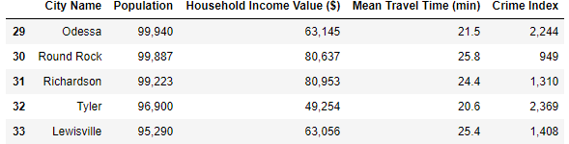

Basing on the information from table 2, there are 5 potential options, Odessa, Round Rock, Richardson, Tyler, and Lewisville. The highest population among them is 99940 from Odessa, and the wealthiest household city is Richardson, the safest city is Round Rock, and the least travel time city is Tyler.

By studying the linear relationship between city population and its travel time, household income, and criminal index, a better understanding will be gained. And a good estimation or prediction will be achieved for helping us to choose the right size of a city to live.

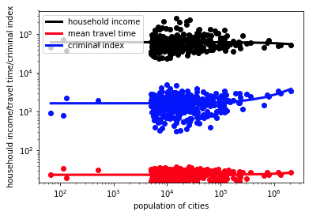

Figure 1. linear relationship between population and household income, travel time, and criminal index.

# Result Discussion

As the data analysis sections shown, I achieve the top 5 candidates for building a new apartment, they are Odessa, Round Rock, Richardson, Tyler, and Lewisville. The highest population among them is 99940 from Odessa, and the wealthiest household city is Richardson, the safest city is Round Rock, and the least travel time city is Tyler. As figure 1 shown, most of the cities have populations in the range of 104 to 105 order of magnitude. And the linear regression result shows that household income, travel time, and criminal index have a linear relationship with population. Most Then, by further analyzing the relationship among population, household income, mean travel time, and criminal index, I am able to pick up the most suitable one, Round Rock.

# Future Work

In the future work, the number of hospitals, parks, and other entertainments are willing to be considered to determine which city is the best location for a new apartment. Also, after choosing the city, a more specific analysis basing on the city itself are necessary to choose where is the right location for a new apartment in this chosen city. In this specific analysis, more information around each district need to be analyzed. And it will be a very interesting topic too.