import pandas as pd

import numpy as np

import matplotlib.pyplot as plt

from sklearn.linear_model import LogisticRegression

from sklearn.preprocessing import StandardScaler

from sklearn.model_selection import train_test_split

# Sample dataset (replace with your dataset)

data = pd.DataFrame({

    'Age': np.random.randint(18, 80, size=100),

    'BMI': np.round(np.random.uniform(15, 40, size=100), 1),

    'BP Systolic': np.random.randint(90, 180, size=100),

    'BP Diastolic': np.random.randint(60, 120, size=100),

    'Cholesterol': np.random.randint(100, 300, size=100),

    'Disease': np.random.choice([0, 1], size=100)  # Binary target variable

})

# Splitting the dataset into features and target variable

X = data.drop('Disease', axis=1)

y = data['Disease']

# Standardize the features

scaler = StandardScaler()

X_scaled = scaler.fit_transform(X)

# Split data into training and testing sets

X_train, X_test, y_train, y_test = train_test_split(X_scaled, y, test_size=0.3, random_state=42)

# Fit Logistic Regression model

logreg = LogisticRegression(random_state=42)

logreg.fit(X_train, y_train)

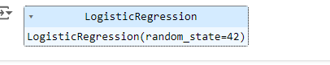

# Get coefficients

coefficients = logreg.coef_[0]

features = X.columns

# Plot coefficients

plt.figure(figsize=(10, 6))

plt.barh(features, coefficients)

plt.xlabel('Coefficient Value')

plt.ylabel('Feature')

plt.title('Logistic Regression Coefficients')

plt.show()

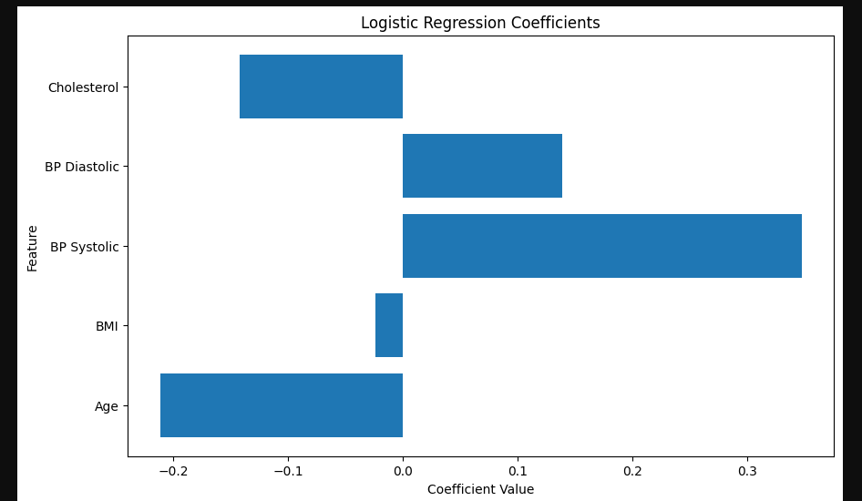

from sklearn.tree import DecisionTreeClassifier, plot_tree

# Fit Decision Tree model

tree = DecisionTreeClassifier(random_state=42)

tree.fit(X_train, y_train)



# Plot the Decision Tree

plt.figure(figsize=(20, 10))

plot_tree(tree, feature_names=X.columns, class_names=['No Disease', 'Disease'], filled=True, fontsize=10)

plt.title('Decision Tree')

plt.show()

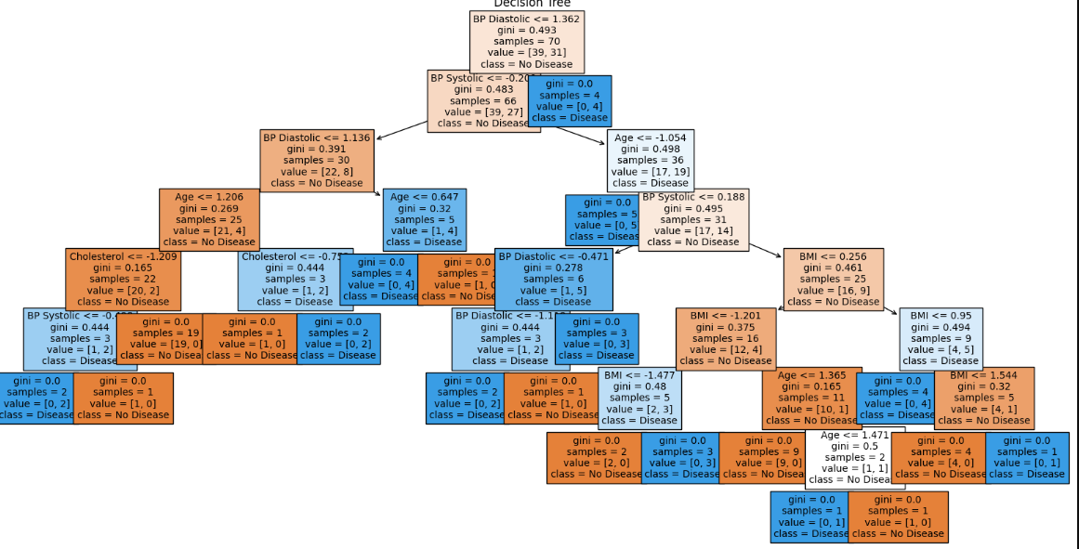

from sklearn.ensemble import RandomForestClassifier

forest = RandomForestClassifier(random_state=42)

forest.fit(X_train, y_train)



# Get feature importances

importances = forest.feature_importances_

indices = np.argsort(importances)[::-1]

# Plot feature importances

plt.figure(figsize=(10, 6))

plt.title('Random Forest Feature Importances')

plt.barh(range(X.shape[1]), importances[indices], align='center')

plt.yticks(range(X.shape[1]), [features[i] for i in indices])

plt.xlabel('Feature Importance')

plt.show()

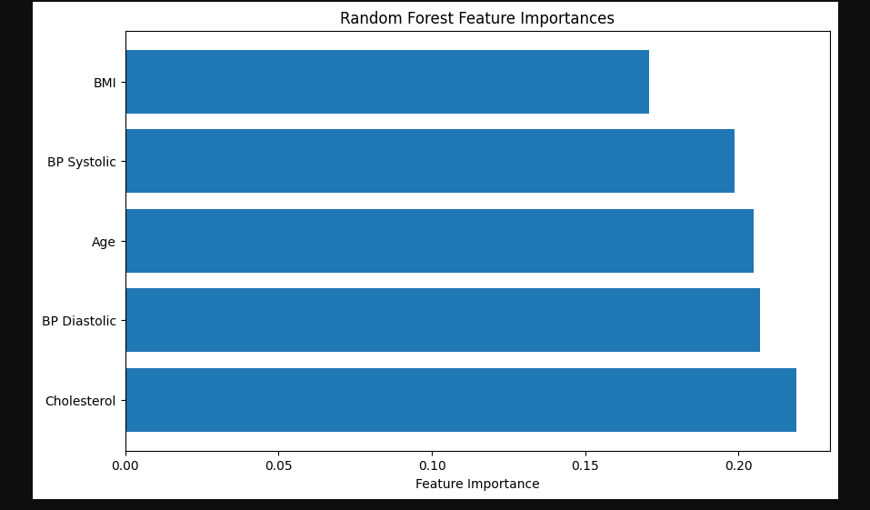

from sklearn.svm import SVC

# Fit Linear SVM model

svm = SVC(kernel='linear', random_state=42)

svm.fit(X_train, y_train)



# Get coefficients

svm_coefficients = svm.coef_[0]

# Plot coefficients

plt.figure(figsize=(10, 6))

plt.barh(features, svm_coefficients)

plt.xlabel('Coefficient Value')

plt.ylabel('Feature')

plt.title('Linear SVM Coefficients')

plt.show()

