|  |
| --- |
| A person pushing a shopping cart down the aisles of a grocery store |
| WiSECART: The Smart Shopping Cart Helping Supermarkets Defeat Online Shopping |
| |  |  |  | | --- | --- | --- | |  |  |  | |

# Introduction

## Overview

Traditional, physical supermarkets are being challenged by online shopping, and recently by crisis of pandemic. This report proposes a solution to the CEO/CMO/CIO/COO of supermarket chains to speed up the way their stores serve customers, by adopting a smart shopping cart with an integrated indoor-locatable mobile terminal which helps customers checkout without queueing, navigate quicker in the stores, and get better understanding of the goods without physically touching them, minimizing the risk of exposure to spreading pandemics. In addition, with this solution, traditional stores are able to conduct behavioral analytics based on indoor localization data, make better in-store recommendations to customers, and optimize the supply chain. With customer experience improved, the smart shopping cart helps increasing the number of customers served per hour as well as the amount of purchase per visit, and therefore leads to more profit.

## Challenges to Supermarkets

Supermarkets have been the primary place people buy various of supplies. However, in the recent years an increasing share of the retail market has been taken by the fast-growing online shopping businesses (Ali, 2020). The recent COVID-19 pandemic even accelerated such transitioning. By comparing the more traditional supermarkets with the emerging cyber shopping, a few areas in the supermarkets with room for improvement can be identified.

**Slow checkout.** The checkout process of traditional supermarkets is time-consuming. Everything picked by the customers into the shopping cart has to be taken again for scanning at the cashier’s counter, which often results in long queues. The stores have to hire a large number of cashiers to boost this process, adding to its operating cost, while the barcode scanning will be the ultimate bottleneck to the throughput of the whole store. In online shopping, the bill is calculated while the customer picks the merchandise into the virtual basket, and checkout is just a click away.

**Slow movement and picking.** The supermarkets can have very complex floorplan and merchandise display, which make it difficult for customers to quickly find the product they want, compare similar products and make decisions. The customers are likely to wander in the store without purchasing, slowing down the indoor “traffic”, and thus making the store more crowded. In recent public hygienic crisis, the supermarket management is forced to limit the number of people permitted in the store to practice social distancing. Therefore, supermarkets need to help the customers in the store move faster in order to increase the throughput of service.

**Lack of targeted advertisement.** While online shopping websites can deliver advertisements to each individual customer tailored for their preferences by changing the arrangement of search results or making recommendations as they shop, traditional supermarkets can only send correspondence to registered loyalty program participants before they come to the store.

**Lack of in-store customer tracking.** Online advertisements can be based on not only the history of customers’ purchase, but also the way they browse the catalog. Such analysis reveals what products the customers took a look at but did not purchase, constituting an important perspective on their preferences. In traditional stores, however, the “browsing history” is missing because there is no customer positioning and tracking system. It would help optimizing the arrangement of displayed merchandise and the floorplan if the movement of customers can be tracked and linked with their identity.

Traditional supermarkets were born with such disadvantages. The profitability can be improved if the shopping experience in traditional stores are streamlined using the most advanced technologies, some borrowed from the emerging online shopping businesses. There have been a number of attempts made by traditional supermarkets to address these problems. Giant Eagle is found to have set up self-scan and checkout counters in selected shops to reduce the demand for cashiers. Walmart, in some countries, have developed a scan-as-you-pick scheme to allow the customers scan the barcodes with their mobile phones at the shelf. However, there have not been a perfect solution: the self-checkout area is often crowded; most people also find it annoying taking their personal phone frequently out of their pocket, unlocking, and opening an app just for scanning one item. In addition, up to now, effectively delivering targeted advertisement and recommendations based on customer behavior is still a problem for the marketing and customer relationship teams. It is still necessary for the industry to try self-improvements.

## Re-imagining the In-Store Shopping Experience

While most supermarkets tried to keep customers dwelling in the shop for longer time, we will focus instead on improving the efficiency of shopping. The rapid development of mobile devices and in the past decade has made it possible to turn every shopping cart into a smart cart, by integrating a smart terminal (with wireless connectivity, touch screen, and barcode scanner) in it.

In the following parts of the report, we will explain how the smart shopping cart allows supermarkets to collect indoor position and “browsing history” of each customer to allow better recommendations based on analytics. It will help customers to navigate, compare, and pick more quickly, buy more and checkout fast, thus increasing the capability of supermarkets serving customers and making profit from them.

# Proposal and Design

The key function is shown in Figure 1. The in-store infrastructure comprises a wireless connected smart terminal and an indoor positioning system which locates and tracks each wireless terminal.

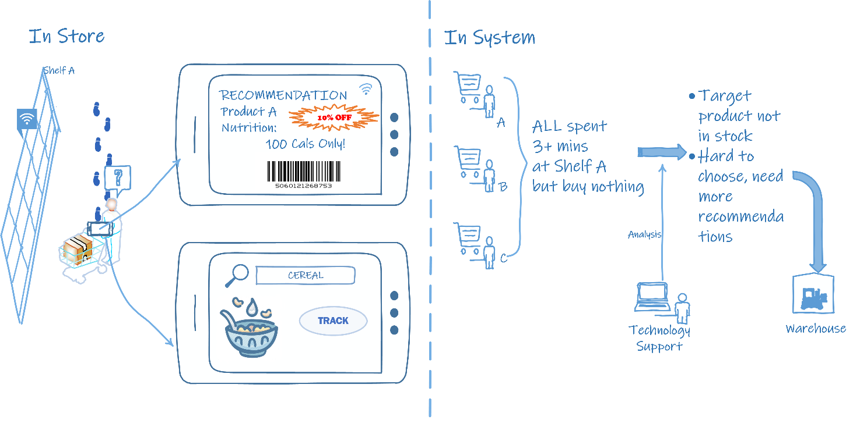

Figure 1 Positioning and behavioral discovery

## In Store Functions

### Tracking

All items’ locations in the supermarket are labeled, and the information is stored in the dataset. The wireless connected smart terminal can load the data, which means customers are able to search the item they would like to purchase and locate it by using the smart terminal. The customer can follow the map on the screen, and once the customer is almost arriving in the region where the item is placed, the smart terminal will beep to let the customer notice the item, which is shown in Figure 2. Meanwhile, the indicator light of the item on the shelf will turn on to help the customer to find it immediately.

Figure 2 Tracking Function

### Recommendation

When a customer stops in front of a shelf and remains there for more than 1 minute, the wireless connected smart terminal will recognize that the customer may need some recommendations. It will auto verify the information of items on the shelf, figure out which one may be the best-matched item for the customer, and provide the recommendation on the screen, based on the dataset in the system, and the history purchase records in the customer’s advantage card.

Besides, the recommendation information will not only include the special offer of the item but also show the nutrition of the product (Figure 3), which means customers do not need to touch the product and look through the nutrition facts on the back of it. This feature realizes the less-touching in-store shopping, which reduces the possibility of customers being exposed to coronavirus. Additionally, customers can check the nutrition facts of products by scanning the barcode using the smart terminal embedded in the shopping cart.

Figure 3 Recommendation and Nutrition Fasts

### Self-checkout

The smart terminal also has the self-checkout function (Figure 4 Self-checkout Function) that customers can use the laser scanner on the terminal to scan barcodes and pay for products by themselves to avoid contacting cashiers. It will help to decrease the danger level of being infected COVID-19 during the time now. Additionally, when utilizing the self-checkout function on the terminal, customers can eliminate the risk of using cash, which is considered might transmit the coronavirus (Taylor, 2020). For the produce which may not have barcodes on (e.g. fruits and vegetables), there will be a self-service scale which customers can use to weigh the produce and scan the barcodes it generates to add it into their shopping cart on the smart terminal.

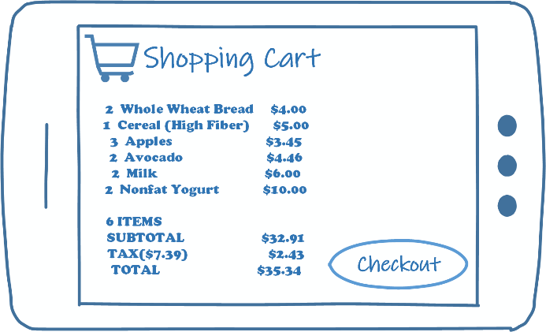

Figure 4 Self-checkout Function

### Shopping List Function

Customers can also log in their advantage card account and add products into the online shopping cart on the supermarket website to merge their shopping list into the shopping cart on the terminal by using the same account. This function will not only help them to note the products they require and check the stock of products but also save the time they spend in the supermarket because they only need to pick up items in the shopping cart and pay.

## In System Function

The smart terminal collects and stores the data customers generated in the supermarket and sends it to the system dataset. When the data shows that some customers stopped in front of the same shelf for a few minutes but finally purchased nothing on that shelf, it seems that some problems happened, which impacted the sales. At this time, it needs the Technology Support department to do some data analysis to find out whether it is due to the lack of recommendations there which made the customers had a hard time to choose the product they would like to buy, or it is because the target product they preferred was out of stock that they could not find it on the shelf. If it is the former, the technology supporter needs to provide more recommendations based on the dataset; if the latter, they need to notify the warehouse to consider stocking other products of the same category with better online reviews.

# Vulnerability

There are chances that people might forget to scan the item and simply keep things in the cart or some intentionally do shoplift, as its self-checkout and no cashier is involved. This kind of behavior still can be handled by implementing sensors at the exit gates. So, when a customer exits the store, a green light on the smart cart will indicates that their order is completed and customer paid for everything whereas if something goes wrong, the light turns red, and a store employee is summoned (McFarland, 2019). To further prevent mistakes in scanning, an in-cart camera with AI-based image recognition can be employed to monitor and recognize each item placed in the shopping cart.

The total cost of making the smart cart with high technology features will be costly as compared to the traditional style shopping cart. The large-scale store can easily bear the prices to make their stores up and running, especially for today’s world with the ongoing pandemic condition and to keep their customers and employee safe.

# Prototype

We can use an Amazon-style recommendation system which uses the past sales data, indoor positioning system and location- based ads to evaluate a smart cart model and to enhance precision by system analysts and users. In this process we design a ubiquitous computing system which aims at providing an improved experience for customers at a supermarket. By using ethnographic, the grocery shopping processes can be explored to understand the whole processes with details.

# Metrics

There should always be a balance between short term impacts and long-term objectives which require a solid measurement framework to attribute a success in the business. So, our short term and long-term goals are below.

**Short term**: Keeping in mind the COVID-19 situation, we are expecting that in about 2 months stores are equipped with smart carts. This will help customers to buy groceries in more hygienic and contactless environment, this will assure that the business will be open during current pandemic situation and experience increase in sales per customer per hour. It is possible because with the help of our smart cart, customers will get the recommendations to buy the product and direction where to get them in the store, which will help them to buy all the stuff in less time.

**Long term**: With this smart and improve grocery shopping, we could bring people back into stores who liked physical shopping, but hated things like standing in line or having to search the shelves for items, so the long-term goal is to increase the number of customers served per hour. More number of customers, more sale and high revenue.

# Timeline

To implement the full feature smart cart will take at least 12 months with all the manufacturing, testing, analysis and approvals for the smart carts. But keep in mind the COVID-19 ongoing situation, it is possible to build the hardware and implement the essential features to the smart cart in the minimum timeframe to benefit the society with the smart carts.

To achieve this, we can use Agile Methodology and have to increase the number of resources.

The concepting and prototyping with the past data approximately will take 1 months. The manufacturing of the smart terminal and integrating them with the cart should be completed in a fast tracked way, so that our model is ready in 2 months to be test on few store employees and check whether there is any flaw, if found out any problem in the model then revise it and again test, which can take up to 1 months to get the optimum result. If everything works fine, then the model is ready to serve the customers to fulfill the need of grocery shopping with more precautions in this pandemic situation. Once we check how it works for general customers with essential build in features. On success of this phase our model can be enhanced based on behavioral analytics with diverse city trends and among variety of customers.

# Conclusions

With all the above-mentioned features smart cart will surly save time for customers and make shopping easy. Supermarket management will be able to analyze the shopping behaviors of various customers to arrive at valuable business insights and management team will have the ability to predict the rate of sales of all individual products and make the stock available is based on the ongoing customer requirements. Overall, this smart cart will guarantee that the customers will have the greatest shopping experience and they visit the physical supermarket stores more than doing online shopping. The most amazing thing is all this can be implemented without an overhaul or a change in operations, other than adding these carts, the store can run as usual. Smart card system that fits today's needs and those of tomorrow, is the best way to increase the profit for supermarket stores by providing convenient and advance shopping experience

Acknowledgements

This is a course project of ISYS 623 of Duquesne University in Spring 2020. We sincerely thank Dr. Hartzel for the instructions and help in developing the idea and documenting/presenting the work.

References

Ali, F., (2020, Mar. 3). A decade in review: Ecommerce sales vs. retail sales 2007‑2019. <https://www.digitalcommerce360.com/article/e-commerce-sales-retail-sales-ten-year-review/>

Taylor, C. (2020). *China is sterilizing cash in an attempt to stop the coronavirus spreading*. Retrieved from CNBC: <https://www.cnbc.com/2020/02/17/coronavirus-china-disinfects-cash-in-a-bid-to-stop-virus-spreading.html>

McFarland, Matt, (2019, Dec. 23), These smart shopping carts will let you skip the grocery store line, *CNN Business*, <https://www.cnn.com/2019/12/23/tech/smart-shopping-cart/index.html>