

Business Template

Subject areas
Logo / Image

Contents
1 Business Description 3
1.1 Business background 3
1.2 Problems. Current Situation 3
1.3 The benefits of implementing a database. Project Vision 3
2 Model description 3
2.1 Definitions & Acronyms 3
2.2 Logical Scheme 3
2.3 Objects 3

Business Description

Business background
The auction house sells antiques and artwork through auctions. Sellers provide items, and buyers place bids to purchase them. Each auction is recorded with details like date, location, and items sold. Before bidding, each item is assigned a lot number. Employees manage the process, ensuring bids, sales, and payments are documented. A person or firm can act as both a seller and a buyer in different auctions. After the auction, the final sale price and buyer details are recorded.

Problems. Current Situation
No centralized system to track sellers, buyers, auctions, and transactions.
Poor record-keeping of bid history, causing disputes.
No automated payment tracking, leading to manual work.
No structured way to track employee participation in auctions.

the Benefits of implementing a database. Project Vision
Tracking Management: Easily manage items, auctions, and transactions.
Employee Management: Organizes staff assignments for smoother operations.
Automated benefit as: Reduces errors and simplifies bid recording.
Financial benefit: Securely stores sales and payments for accurate reporting.

Model description

Definitions & Acronyms
Definitions:
- Users: Individuals as sellers, buyers, or both
- Sellers: Provide items for auction
- Buyers: Place bids and purchase items
- Auctions: Events where items are bid on
- Items: Antiques or artwork for auction
- Categories: Groups classifying items
- Bids: Offers placed by buyers
- Sales: Completed transactions
- Payments: Records of buyer payments
- Addresses: Auction location details
- Employees: Staff managing auctions
- Auction Employees: Tracks staff roles in auctions
Acronyms:
- PK: Primary Key (unique record identifier)
- FK: Foreign Key
- ENUM: Predefined set of values
- DATETIME: Date and time
- UNIQUE: No duplicate values

Logical Scheme
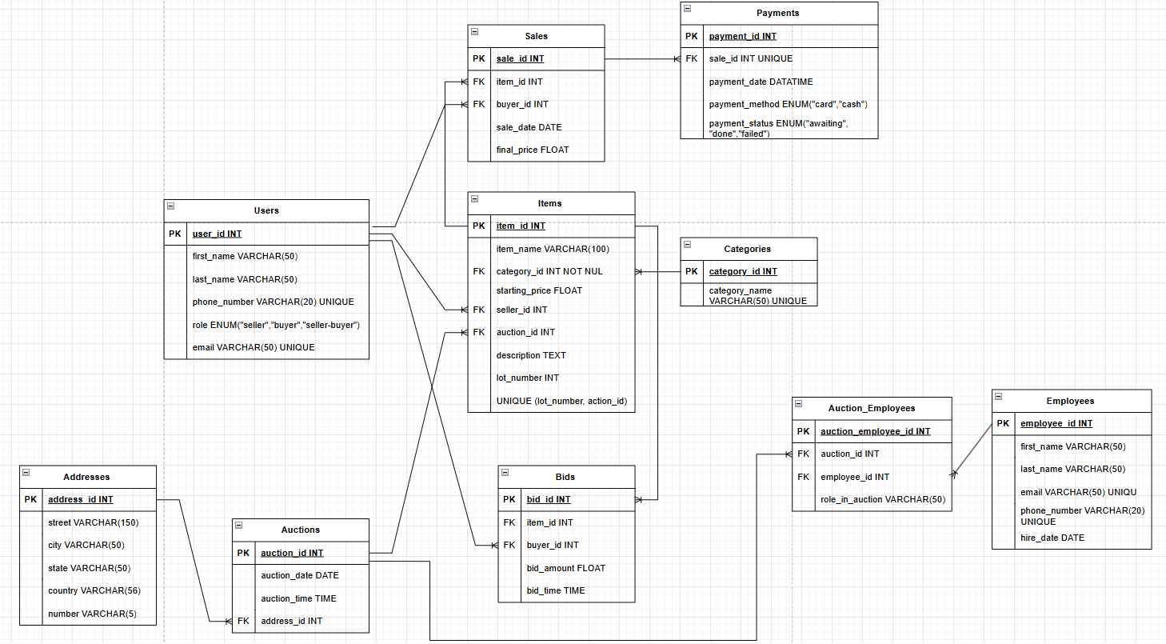

Objects

Table Description:
Users: Stores information about individuals who can act as sellers, buyers, or both.
Addresses: Stores location details for auctions.
Auctions: Records auction event details.
Items: Stores details of antiques and artwork up for auction.
Categories: Categorize items into different groups.
Bids: Tracks all bids placed during auctions.
Sales: Track of completed transactions where item is sold.
Payments: Stores details of payments made by buyers after completing bids.
Employees: Stores information on employees.
Auction_Employees: Tracks employee assignments to specific auctions.

Table Name | Field name | Field Description | Data Type
Users | user_id | PRIMARY KEY, AUTO_INCREMENT | INT
Users | first_name | NOT NULL | VARCHAR(50)
Users | last_name | NOT NULL | VARCHAR(50)
Users | email | NOT NULL UNIQUE | VARCHAR(50)
Users | role | NOT NULL | ENUM
Users | phone_number | NOT NULL UNIQUE | VARCHAR(20)
Addresses | address_id | PRIMARY KEY, AUTO_INCREMENT | INT
Addresses | street | NOT NULL | VARCHAR(150)
Addresses | city | NOT NULL | VARCHAR(50)
Addresses | country | NOT NULL | VARCHAR(56)
Addresses | number | NOT NULL | VARCHAR(5)
Auctions | auction_id | PRIMARY KEY, AUTO_INCREMENT | INT
Auctions | auction_date | NOT NULL | DATE
Auctions | auction_time | NOT NULL | TIME
Auctions | address_id | FK REFERENCES Addresses(address_id), NOT NULL | INT
Items | item_id | PRIMARY KEY, AUTO_INCREMENT | INT
Items | item_name | NOT NULL | VARCHAR(100)
Items | starting_price | NOT NULL | FLOAT
Items | seller_id | FK REFERENCES Users(user_id), NOT NULL | INT
Items | description | NULL | TEXT
Items | category_id | FK REFERENCES Categories(category_id), NOT NULL | INT
Items | auction_id | FK REFERENCES Auctions(auction_id), NOT NULL | INT
Items | lot_number | UNIQUE (lot_number ,auction_id) | INT
Categories | category_id | PRIMARY KEY, AUTO_INCREMENT | INT
Categories | category_name | UNIQUE, NOT NULL | VARCHAR(50)
Bids | bid_id | PRIMARY KEY, AUTO_INCREMENT | INT
Bids | item_id | FK REFERENCES Items(item_id), NOT NULL | INT
Bids | buyer_id | FK REFERENCES Users(user_id), NOT NULL | INT
Bids | bid_amount | NOT NULL | FLOAT
Bids | bid_time | NOT NULL | DATETIME
Sales | sale_id | PRIMARY KEY, AUTO_INCREMENT | INT
Sales | item_id | FK REFERENCES Items(item_id), UNIQUE, NOT NULL | INT
Sales | buyer_id | FK REFERENCES Users(user_id), NOT NULL | INT
Sales | final_price | NOT NULL | FLOAT
Sales | sale_date | NOT NULL | DATE
Payments | payment_id | PRIMARY KEY, AUTO_INCREMENT | INT
Payments | sale_id | FK REFERENCES Sales(sale_id), UNIQUE, NOT NULL | INT
Payments | payment_method | (“Card”, “Cash”), NOT NULL | ENUM
Payments | payment_status | (“awaiting”, “done”, “failed”), NOT NULL | ENUM
Payments | payment_date | NOT NULL | DATE
Employees | employee_id | PRIMARY KEY, AUTO_INCREMENT | INT
Employees | first_name | NOT NULL | VARCHAR(50)
Employees | last_name | NOT NULL | VARCHAR(50)
Employees | email | UNIQUE, NOT NULL | VARCHAR(50)
Employees | phone_number | UNIQUE, NOT NULL | VARCHAR(20)
Employees | hire_date | NOT NULL | DATE
Auction_Employees | auction_id | PRIMARY KEY, AUTO_INCREMENT | INT
Auction_Employees | employee_id | FK REFERENCES Employees(employee_id), NOT NULL | INT
Auction_Employees | role_in_auction | NOT NULL | VARCHAR(50)

Users and Items → A User (Seller) can list multiple Items for auction.
Users and Bids → A User (Buyer) can place multiple Bids on different Items.
Users and Sales → A User (Buyer) can win multiple Sales.
Users and Reviews → A User can leave multiple Reviews on different Items.
Auctions and Items → Each Auction has multiple Items.
Items and Bids → Each Item can receive multiple Bids.
Items and Sales → Each Item is sold only once.
Sales and Payments → Each Sale has one Payment.
Employees and Auctions → Employees can work at multiple Auctions.
Addresses and Auctions → Each Auction takes place at one Address.

