03/04/2020--MYSQL QUERY

91. Find the average amount from the Orders table.

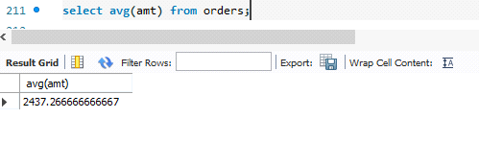

92. What would be the output from the following query?

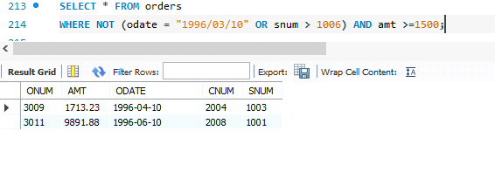

93.Find all customers who are not located in San Jose and whose rating is above 200.

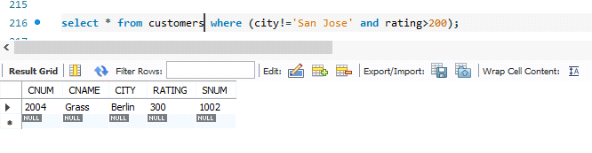

94. Give a simpler way to write this query :

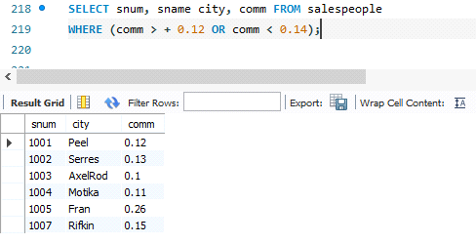

95.Evaluate the following query :

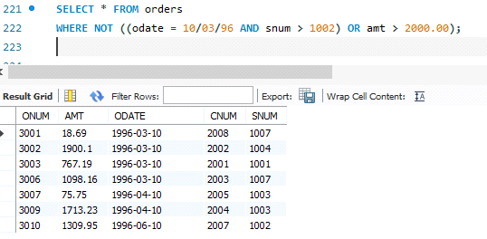

96.Which salespersons attend to customers not in the city they have been assigned to?

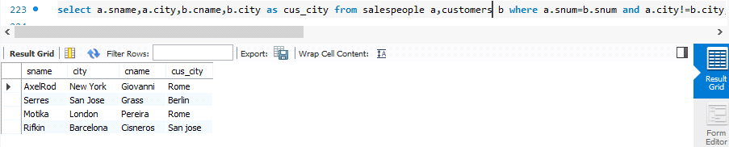

97 .Which salespeople get commission greater than 0.11 are serving customers rated less than 250?

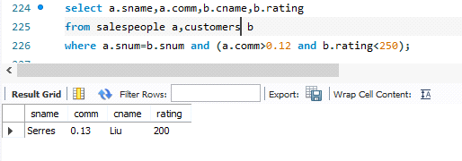

98. Which salespeople have been assigned to the same city but get different commission percentages?

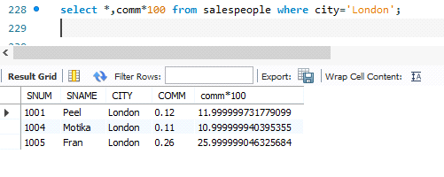

99. Which salesperson has earned the most by way of commission?

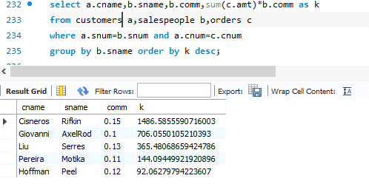

100. Does the customer who has placed the maximum number of orders have the maximum rating?

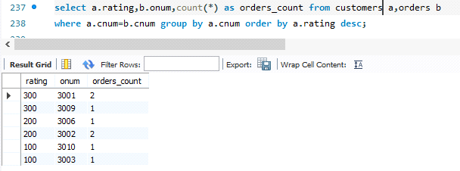

101. Has the customer who has spent the largest amount of money been given the highest rating?

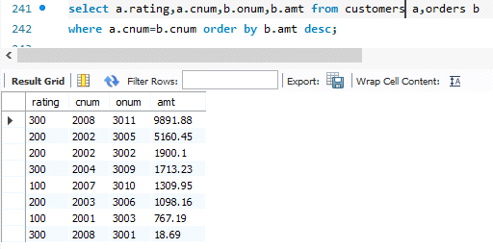

102.List all customers in descending order of customer rating.

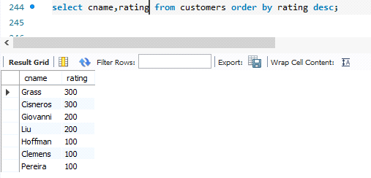

103. On which days has Hoffman placed orders?

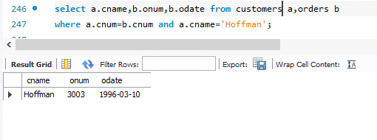

104. Do all salespeople have different commissions?

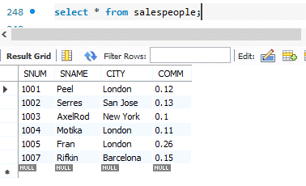

105.Which salespeople have no orders between 10/03/1996 and 10/05/1996?

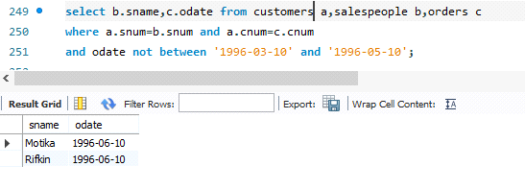

106. How many salespersons have succeeded in getting orders?

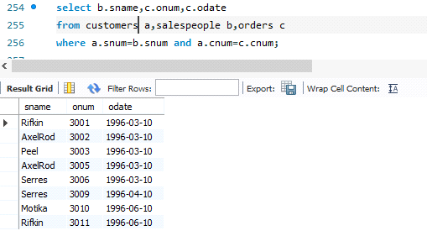

107.How many customers have placed orders?

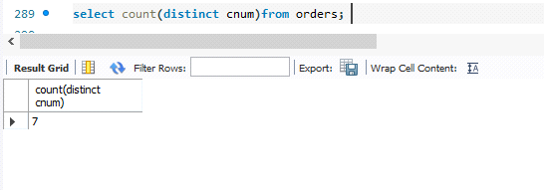

108On which date has each salesperson booked an order of maximum value?

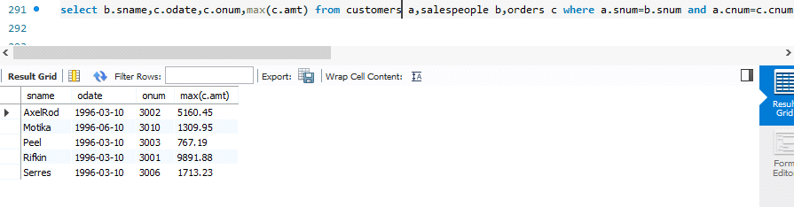

109Who is the most successful salesperson?

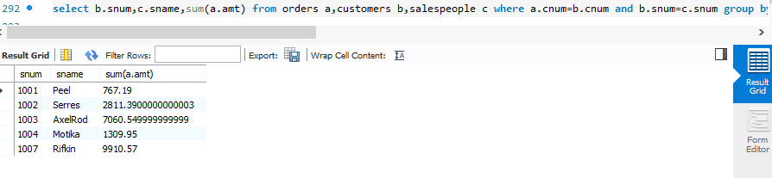

110.Who is the worst customer with respect to the company?

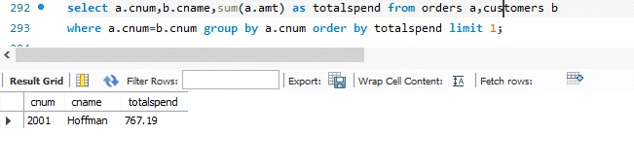

111.Are all customers not having placed orders greater than 200 totally been serviced by

salespersons Peel or Serres?

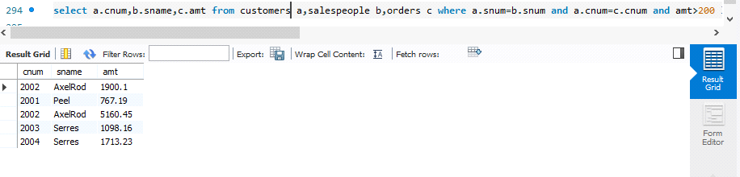

112.Which customers have the same rating?

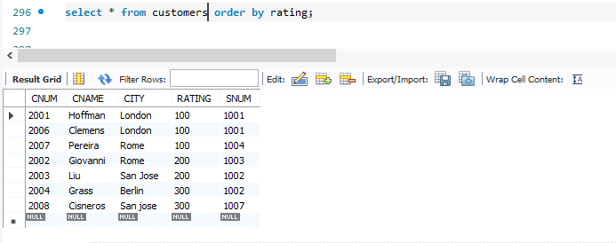

113.Find all orders greater than the average for October 4th.

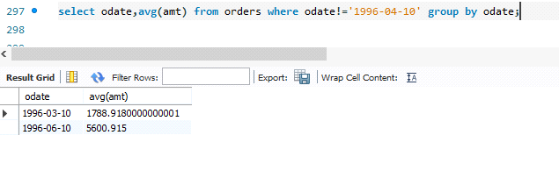

114.Which customers have above average orders?

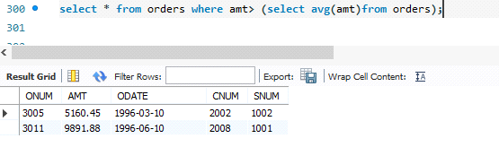

115.List all customers with ratings above San Jose’s average.

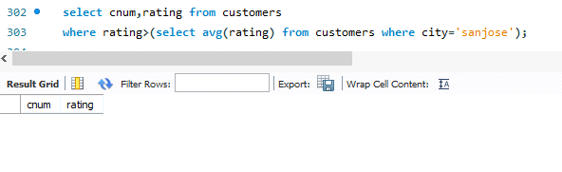

116. Select the total amount in orders for each salesperson for whom the total is greater than the amount of the largest order in the table.

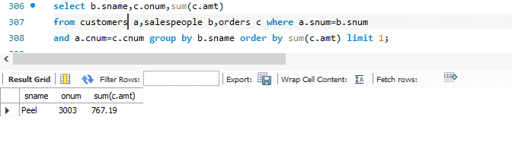

117.Give names and numbers of all salespersons who have more than one customer.

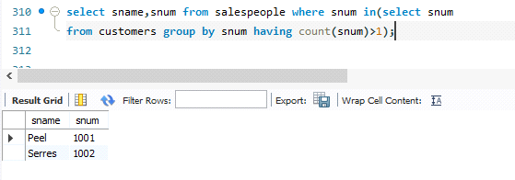

118. Select all salespersons by name and number who have customers in their city whom they don’t service

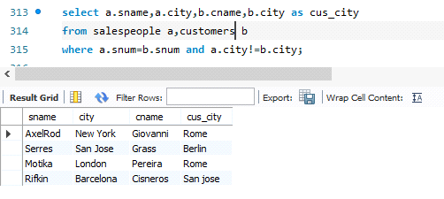

119.Which customers’ rating should be lowered?

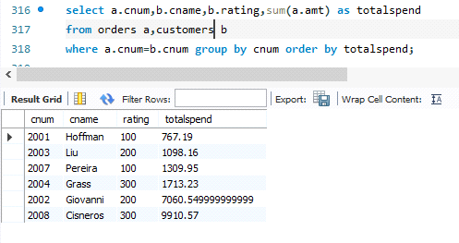

120. Is there a case for assigning a salesperson to Berlin?

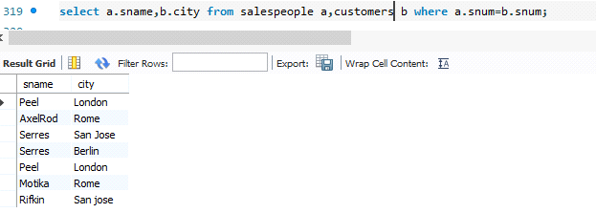

123.Which is the date, order number, amt and city for each salesperson (by name) for the maximum order he has obtained?

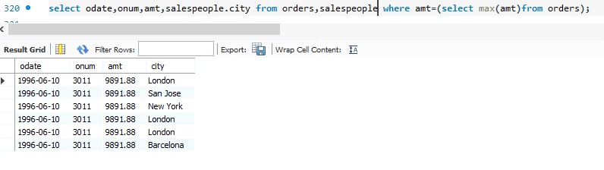

124. Which salesperson(s) should be fired?

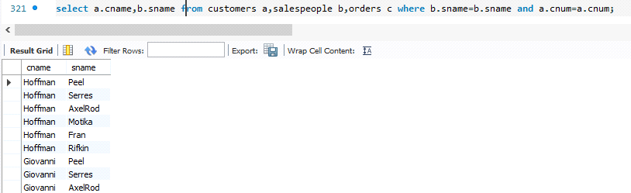

125.What is the total income for the company?

