Software Engineering Tools Lab

Assignment 3

2020BTECS00205

Monika chitrakathi

Module 3- GitHub

Q 1. Create a repository on GitHub named SET Lab and add files into it (you can add implementation files of previous assignment) perform below operations on it. (Add screenshot as an answer to every question)

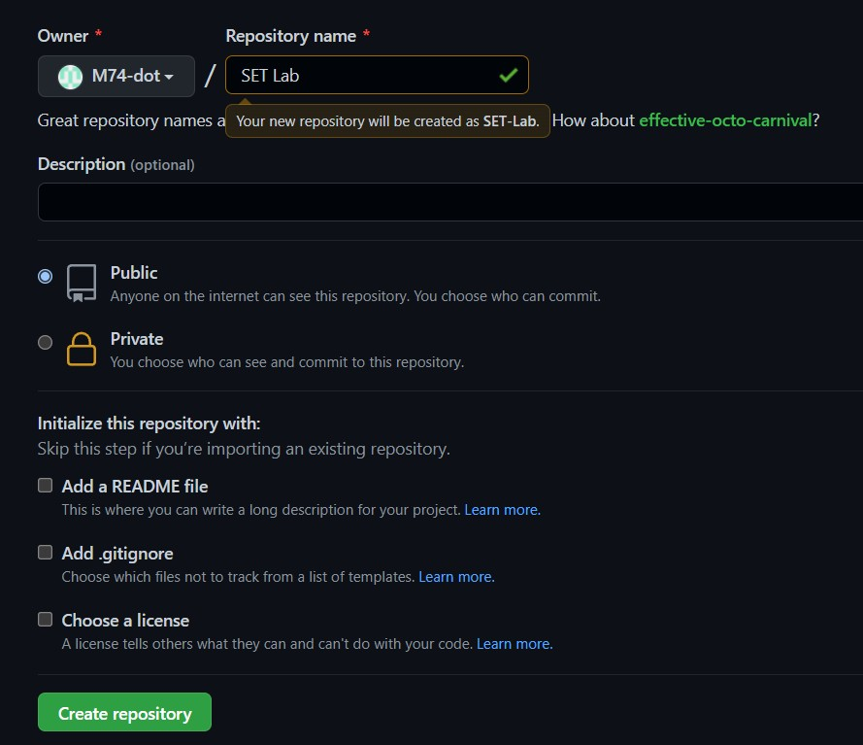

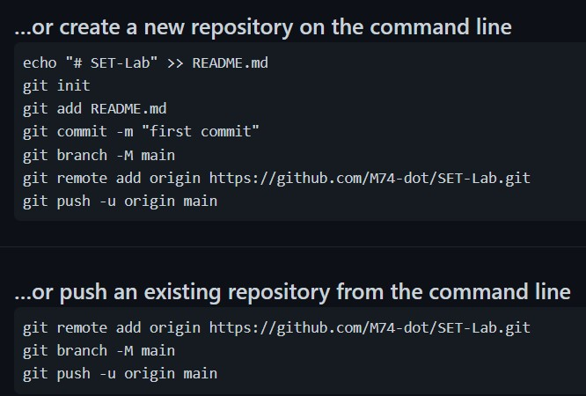

1. Perform commit on added files

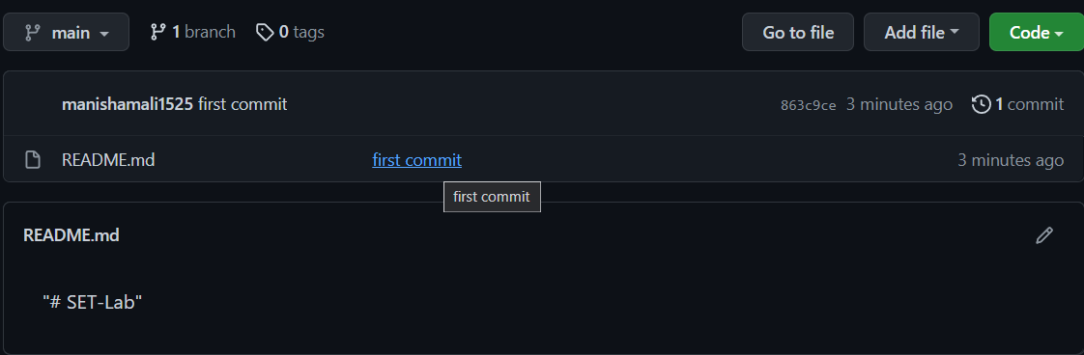



1. Perform update to the existing files (show history)
2. Create another branch

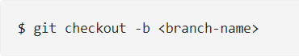

1. Create pull request

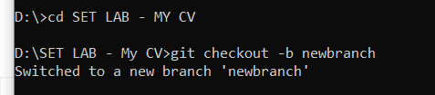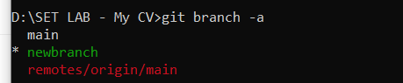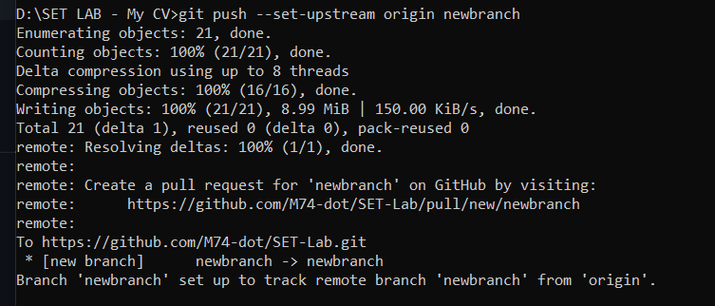

1. Perform merging of both branches

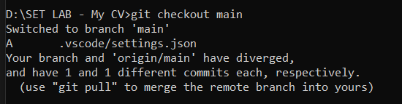

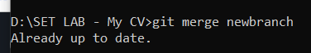

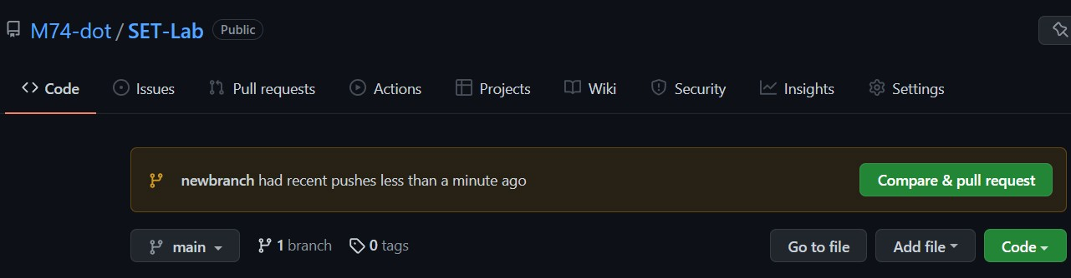

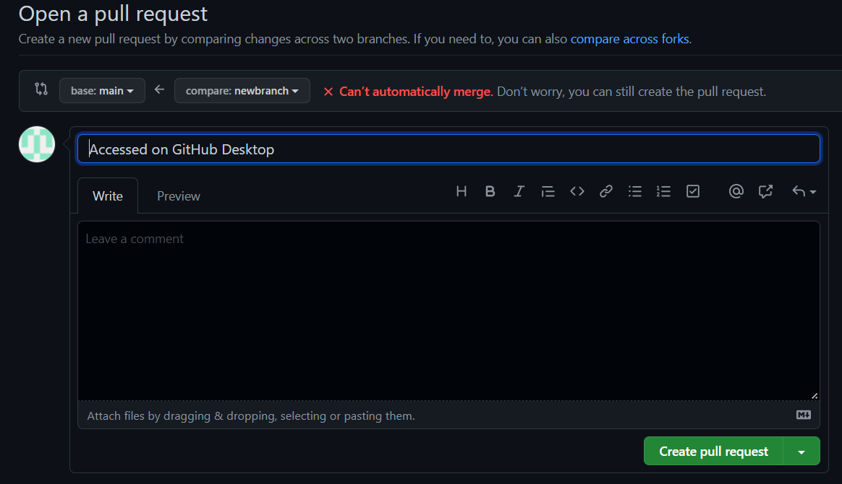

1. Perform Fork operation

Q 2. For the diagram given below create a GitHub repository and perform operations given in the diagram. (Perform commit operations as given)(Add screenshots as an answer to this question)

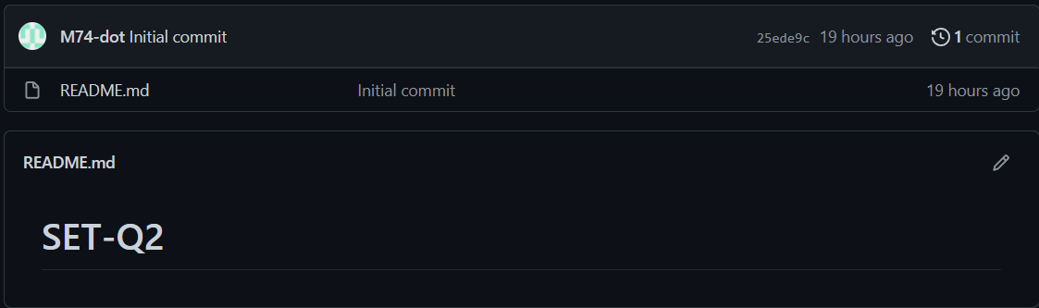



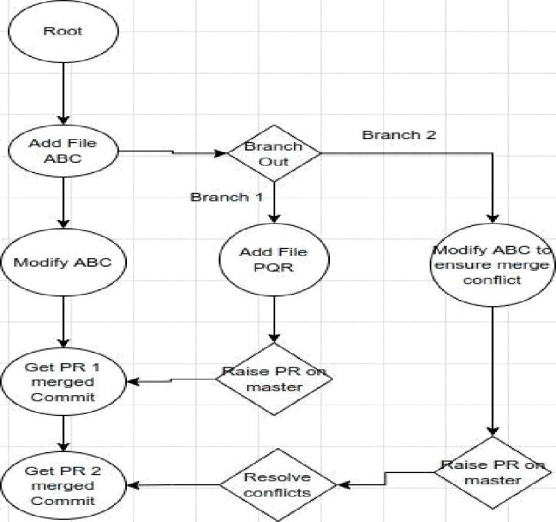

Raw Blame %

Commit changes

Modified ABC File

*O•* Commit direnly to the

branch.

}§ Create a new branch for this commit and start a pull request.

Commit changes





Commit new file

Created PQR

O• Commit directly to the • Dranch.

}§ Create a new branch for this commit and start a pull request.

 Compare & pull request



Merge pull request #1 from M74-dot/branch2

Updated ABC by branch2

Cancel



Pull request successfully merged and closed

Delete branch

Write F - -

Q 3. What is GitHub desktop? How to install GitHub on local machine? Install GitHub on your local machine and access repository created in question no 1 (add screenshots).

GitHub Desktop is **an application that enables you to interact with GitHub using a GUI** instead of the command line or a web browser

You can push to, pull from, and clone remote repositories with GitHub Desktop, and use collaborative tools such as attributing commits and creating pull requests

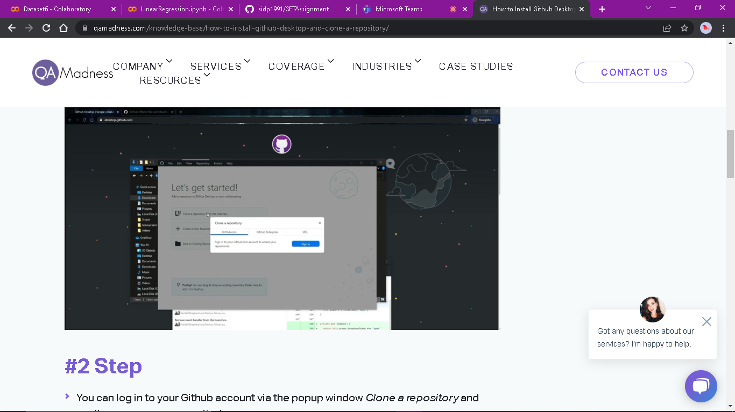

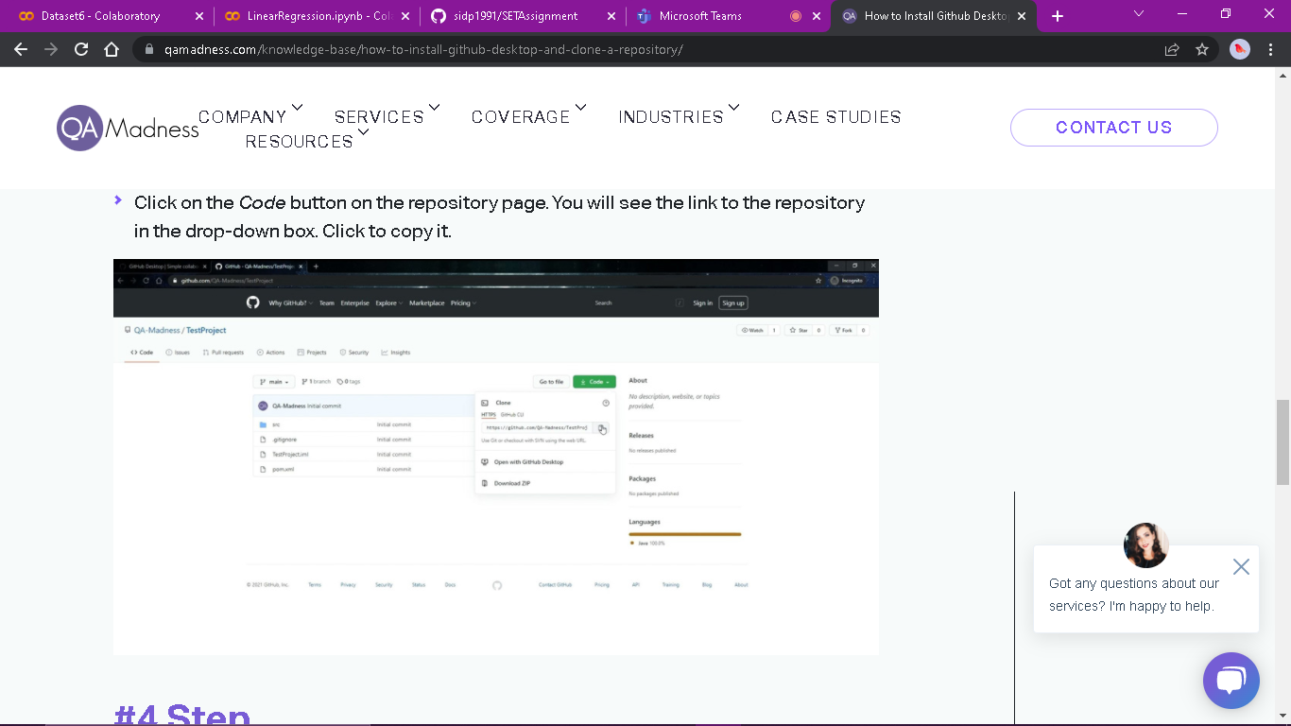

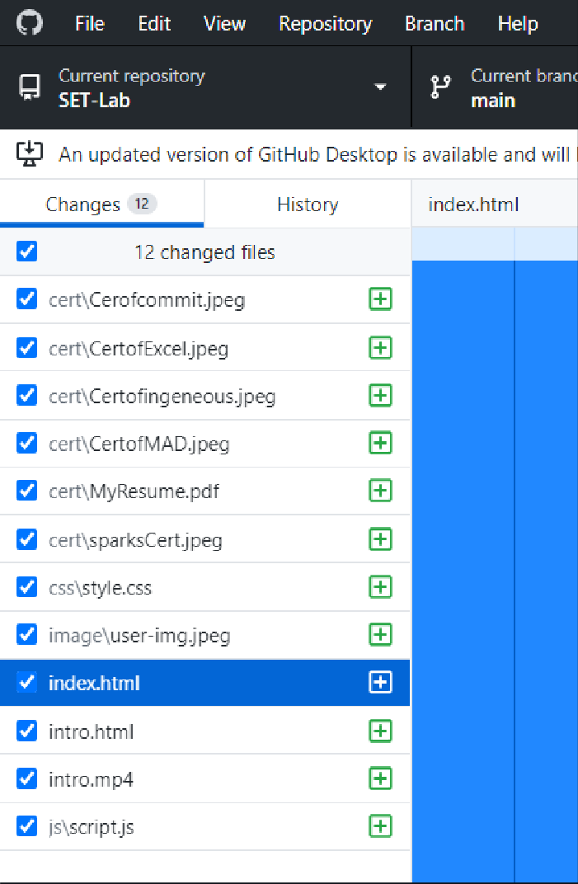

I have installed GitHub desktop on my PC.

Q 4. Differentiate in between GitHub, Git and GitLab.

GitHub

* GitHub is not open source.
* It allows users to have unlimited free repositories.
* GitHub allows users to have free private repository but with a maximum of three collaborators.

It is owned by Microsoft Corporation

* There is a limited private repository.
* It supports only Git version control.
* GitHub is a service
* GitHub is a graphical user interface
* GitHub is hosted on the Web
* GitHub is maintained by Microsoft.
* GitHub is focused on centralized source code hosting.
* GitHub is a hosting service for Git repositories.
* GitHub was launched in 2008.
* GitHub includes a free-tier and pay-for-use tier.

GitHub provides a Desktop interface named GitHub Desktop.

Git

Git is a software.

Git is a command-line tool.

Git is installed locally on the system.

Git is focused on version control and code sharing.

Git is a version control system to manage source code history. Git was first released in 2005.

Git is open-source licensed.

Git provides a Desktop interface named Git Gui.

GitLab

* GitLab is Open Source for community edition.
* It allows users to make public repository.
* GitLab also provides free private repository. It is owned by GitLab Inc.
* GitLab is available with many bugs and it makes the user experience sloppy.
* It is difficult to manage code reviews for first-timers.

Q 5. Go to this <https://github.com/sidp1991/SETAssignment>

GitHub repository add your code file (question no 2 solved in assignment no 2) in this repository, then open file [Student assignment updates.txt](https://github.com/sidp1991/SETAssignment/blob/main/Student%20assignment%20updates.txt) present in above repository and update your details such as Name and PRN and then perform commit( need to create pull request with appropriate comments). (Attach screenshots of this activity)

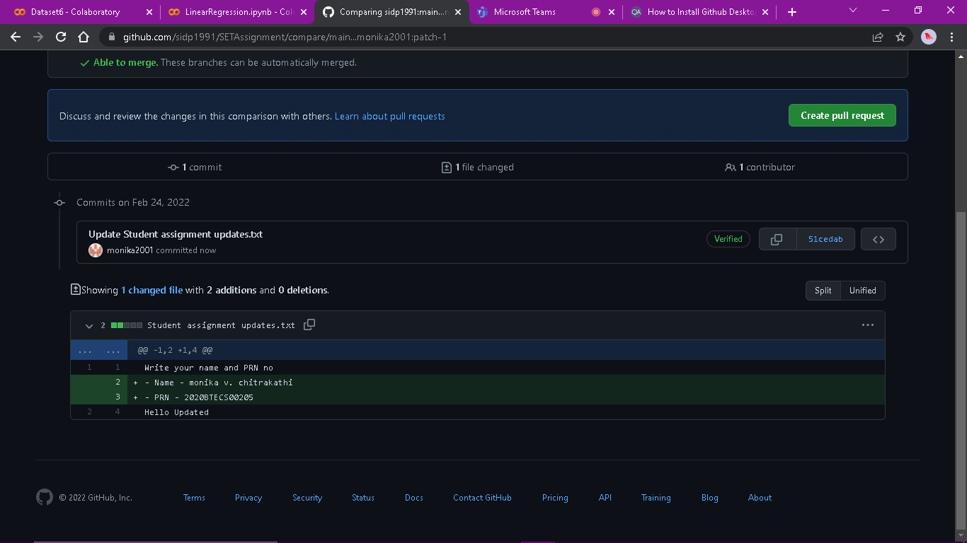



Updated Student File

@ Allow edits by maintainers

Create pull request

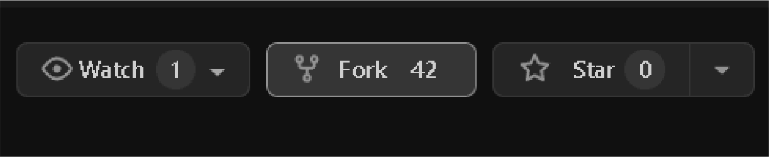



Public

Code

Wiki

— d g on Feb 22

Updated Student File 448

Filters -

:maln

: patch - 1

{'j 46 Op

You opened

#48 opened 4 minutes ago by M74-dot

