CS 556 Assignment Report
Evaluating Network Switch Scheduling Algorithms
Name | Challagondla Monika
Roll No. | 220101029
Course | CS 556

1. Problem Statement
Modern network switches must forward packets across multiple input and output ports simultaneously at high speed. The fundamental challenge is scheduling — deciding, in each time slot, which packet to forward — while obeying the constraint that each output port can receive from at most one input, and each input can send to at most one output at a time.
This assignment simulates and evaluates three scheduling strategies on a 3×3 crossbar switch using a fixed 18-packet trace:
- Standard FIFO Queuing — subject to Head-of-Line (HoL) blocking.
- VOQ with Exhaustive Optimal Search — theoretical minimum service time.
- iSLIP Algorithm — a practical, hardware-friendly approximation.
The objective is to observe the cost of HoL blocking, compare total service times across all three methods, and analyse queue-drain behaviour through visualisation.

2. Theory: Virtual Output Queuing (VOQ) and HoL Blocking

2.1 Head-of-Line (HoL) Blocking
In a standard FIFO architecture each input port maintains a single queue. Only the packet at the absolute head of that queue may be considered for forwarding in any given time slot. This creates a well-known performance bottleneck called Head-of-Line (HoL) blocking.
HoL blocking occurs when the head packet is destined for a busy (or contended) output port, even though packets further back in the same queue could immediately use idle output ports. Those packets are blocked — they cannot bypass the head packet.
In this simulation the effect is significant. At t = 0, input port I0 holds packets p1 (→ O0) and p2 (→ O1). If p1 cannot be forwarded because O0 is contested by multiple inputs, p2 is also stalled even when O1 is free. This cascades: arrivals at t = 1–5 pile up behind unresolved head packets, inflating the backlog and pushing total service time to 11 time slots.

2.2 Virtual Output Queuing (VOQ)
VOQ eliminates HoL blocking by replacing the single FIFO queue at each input with N separate sub-queues — one per output port. In a 3×3 switch each input maintains three VOQs, giving nine independent queues in total.
With VOQ, a packet waiting for a contended output no longer blocks packets destined for free outputs at the same input port. Scheduling becomes a bipartite matching problem: find a valid matching between inputs and outputs at each time slot such that neither side is matched more than once. The exhaustive optimal search tests every valid matching at every step to find the globally minimum service time, achieving 7 time slots — a 36 % improvement over FIFO.

3. Theory: iSLIP Scheduling Algorithm
Exhaustive search is computationally infeasible in real hardware due to its exponential complexity. The iSLIP algorithm is a practical approximation that runs in O(N) per iteration and is directly implementable in hardware logic.

3.1 iSLIP Phases (per time slot)
- Request — every input port with a non-empty VOQ sends a request to each corresponding output port.
- Grant — each output port that received one or more requests picks one input using a round-robin pointer initialised to 0. It sends a grant to that input.
- Accept — each input that received one or more grants accepts one grant using its own round-robin pointer and notifies the chosen output.

3.2 Significance of Desynchronised Pointers
After each time slot both input and output round-robin pointers advance to one position beyond the last accepted or granted port (modulo N = 3). This desynchronisation is the key to iSLIP's fairness: it prevents any single input-output pair from monopolising the switch across consecutive slots and ensures starvation-free operation over time.
In this simulation iSLIP achieves a total service time of 8 time slots — only 1 slot above the theoretical optimum — confirming that the algorithm is near-optimal in practice for the given trace.

4. Data Visualisation & Analysis

4.1 Graph 1 — Total Service Time Comparison
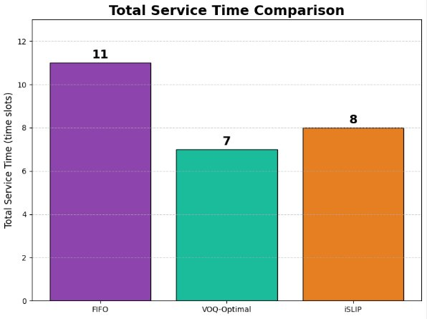
Figure 1: Bar chart comparing total service time (time slots to fully drain the switch) for FIFO, VOQ-Optimal, and iSLIP.

4.2 Graph 2 — Backlog over Time
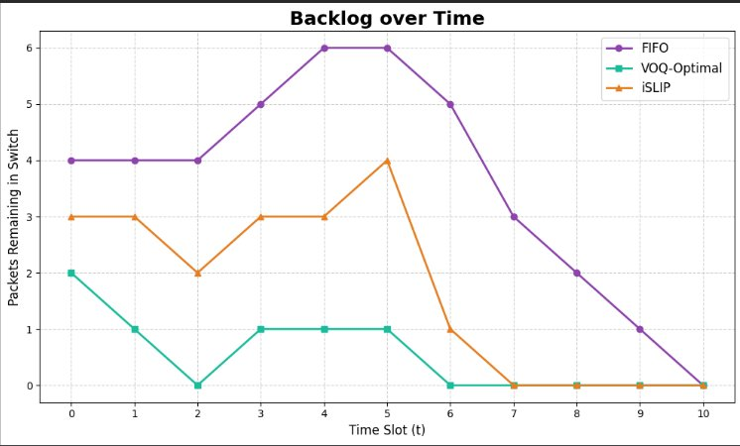
Figure 2: Line graph showing packets remaining in the switch at each time slot for all three algorithms.

4.3 Written Analysis
FIFO (11 time slots): The FIFO backlog rises steeply, reaching a peak of 6 packets at t = 4 and t = 5 before declining slowly. HoL blocking is the root cause. At t = 0, contention on O0 blocks p1 (I0 → O0), which in turn blocks p2 (I0 → O1) even when O1 is idle. Packets p6 (t = 1), p8 and p9 (t = 2), p10 and p11 (t = 3), and the burst p13–p18 (t = 4–5) all arrive while earlier head-of-line packets remain unresolved, inflating the queue and extending service time to 11 slots.
VOQ-Optimal (7 time slots): The optimal algorithm maintains a low, steadily decreasing backlog — dipping to 0 at t = 2 before settling near 1 packet from t = 3 to t = 6. By exhaustively searching all valid bipartite matchings, it maximises parallelism at every step. With no HoL blocking, packets behind a contended destination do not delay others, and the switch clears in the minimum possible 7 slots.
iSLIP (8 time slots): iSLIP closely tracks the optimal curve throughout. Its starting backlog of 3 packets at t = 0 reflects a slightly suboptimal first matching, where round-robin pointers initialised to 0 produce a less parallelised grant-accept round than the exhaustive search. The 1-slot penalty versus optimal arises from isolated cases where pointer positions grant to a suboptimal input. Nevertheless, the backlog remains consistently below FIFO, confirming that the VOQ architecture — not the choice of scheduling algorithm — is the dominant performance factor.

5. Code Repository
The complete simulation source code for all parts — FIFO queuing, VOQ-Optimal exhaustive search, iSLIP, and the data visualisation scripts — is available in the GitHub repository below. The repository is documented with step-by-step instructions for running each script.

Repository: https://github.com/monika2240/CS-556-Assignment

CS 556 · Challagondla Monika · Roll No. 220101029

