Manage Installed Services

Task 1 – Check SSHD Service Status
Use the systemctl command to check the status of the sshd service on your Linux system and write down whether it is active, inactive, or failed.
IMPORTANT COMMAND
systemctl status sshd
STEPS
1. Open the terminal.
2. Run: systemctl status sshd
3. Check the line beginning with Active:.
RESULT / OBSERVATION
active (running) = The sshd service is currently running.
inactive (dead) = The sshd service is not currently running.
failed = The service encountered an error or failed to start.
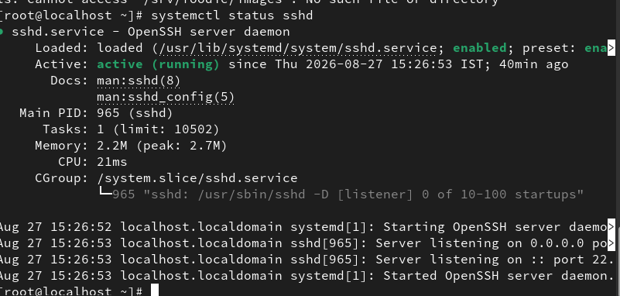

Task 2 – Start and Stop Nginx
Start the nginx service using systemctl, then immediately stop it. After each action, verify the status and note the changes.
Hint: Use 'sudo systemctl start nginx' and 'sudo systemctl stop nginx'.
IMPORTANT COMMANDS
rpm -q nginx
dnf install nginx -y
systemctl start nginx
systemctl is-active nginx
systemctl stop nginx
systemctl is-active nginx
STEPS
1. Check whether nginx is installed: rpm -q nginx
2. If it is not installed, install it: dnf install nginx -y
3. Start nginx: systemctl start nginx
4. Verify: systemctl is-active nginx
5. Stop nginx: systemctl stop nginx
6. Verify again: systemctl is-active nginx
RESULT / OBSERVATION
After starting nginx, the status should be active.
After stopping nginx, the status should be inactive.
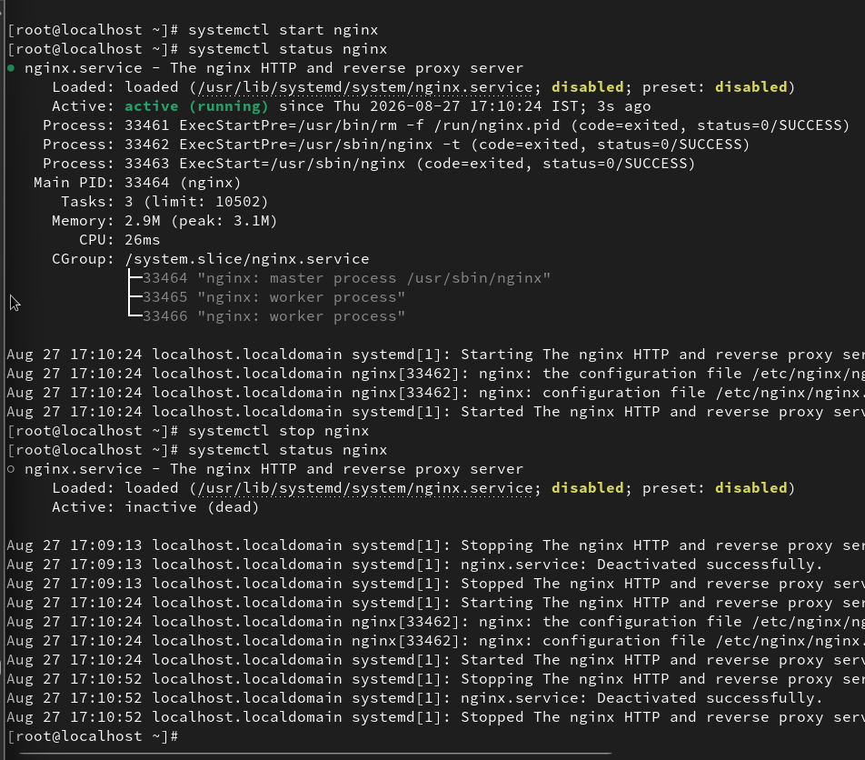

Task 3 – Enable Cron Service at Boot
Enable the cron service to start automatically on boot, then reboot your system and confirm that the service is running after reboot.
IMPORTANT COMMANDS
systemctl enable crond
systemctl start crond
systemctl is-enabled crond
systemctl is-active crond
reboot
IMPORTANT NOTE
On RHEL, the cron service is called crond.
STEPS
1. Enable the service: systemctl enable crond
2. Start the service: systemctl start crond
3. Confirm it is enabled: systemctl is-enabled crond
4. Confirm it is running: systemctl is-active crond
5. Reboot the system: reboot
6. After reboot, log in and run:
sudo -i
systemctl is-enabled crond
systemctl is-active crond
RESULT / OBSERVATION
The expected result after reboot is:
enabled
active
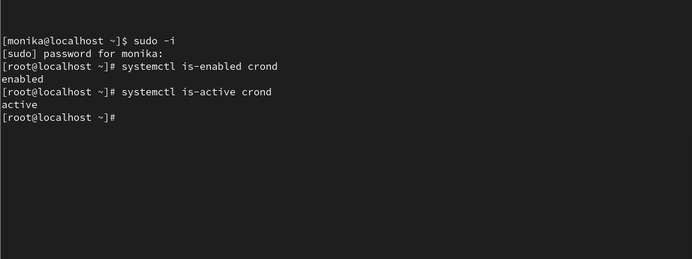

Task 4 – List Running Services and Identify Networking Service
List all currently running services using systemctl and identify any service related to networking (like NetworkManager or networking). Write the current status of that service.
IMPORTANT COMMANDS
systemctl list-units --type=service --state=running
systemctl list-units --type=service --state=running | grep -i network
systemctl is-active NetworkManager
STEPS
1. List all running services.
2. Find networking-related services using grep.
3. On RHEL, check NetworkManager with:
systemctl is-active NetworkManager
RESULT / OBSERVATION
NetworkManager.service is a networking-related service.
If the output is active, the service is currently running.
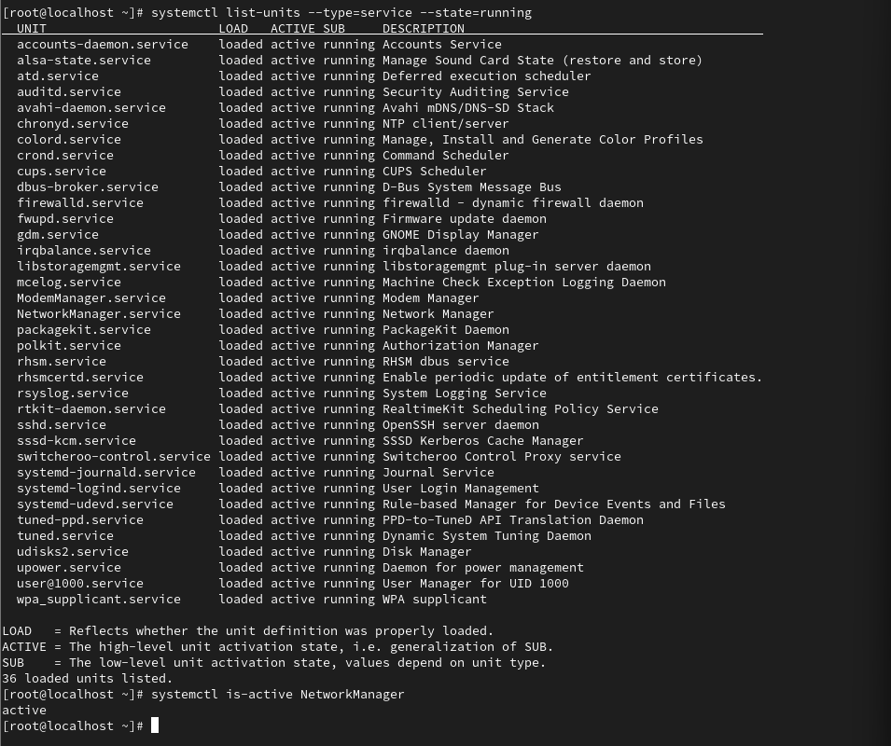

Task 5 – Troubleshoot Firewall for Spotify Web Scenario
Simulate a real-world scenario: Imagine you are troubleshooting why Spotify Web cannot stream music on your Linux machine. Use systemctl to check if the firewall (ufw or firewalld) service is running, and if it is, disable it temporarily. Document each command used and the result.
Constraint: Only disable the firewall if you are on a safe, non-production environment.
IMPORTANT COMMANDS
systemctl is-active firewalld
systemctl stop firewalld
systemctl start firewalld
STEPS
IMPORTANT: Perform this only on a safe lab, VM, or non-production system.
1. Check whether firewalld is active:
systemctl is-active firewalld
2. If the result is active, temporarily stop it:
systemctl stop firewalld
3. Verify the status:
systemctl is-active firewalld
4. After testing, start the firewall again:
systemctl start firewalld
5. Verify again:
systemctl is-active firewalld
RESULT / OBSERVATION
Example sequence:
active = firewall running
inactive = firewall temporarily stopped
active = firewall started again
