12. Introduction to Linux Services – Apache Web Server

Task 1 — Install Apache Web Server
Question:
Install the Apache web server on your Linux machine using the package manager (apt or yum), and confirm the installation by running the command to check its version.
Content:
Apache is a popular open-source web server used to serve websites and web applications. On RHEL 8, the Apache package is called httpd and is installed using the dnf package manager.
Commands:
sudo dnf install httpd -y
httpd -v
Result:
Apache HTTP Server was installed successfully and its version was displayed using the httpd -v command.
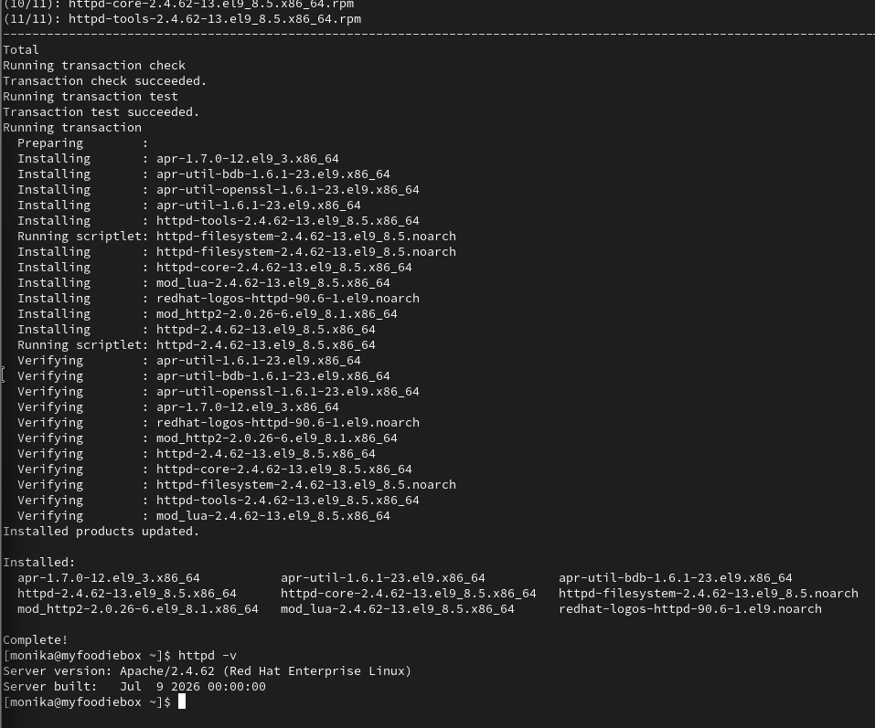

Task 2 — Start Apache and Verify Its Status
Question:
Start the Apache service using systemctl, then use systemctl status to verify it is running.
Content:
After installation, the Apache service was started using systemctl. The service status was then checked to confirm that Apache was active and running.
Commands:
sudo systemctl start httpd
sudo systemctl status httpd
Expected result:
Active: active (running)
Result:
The Apache web server was started successfully and its running status was verified. 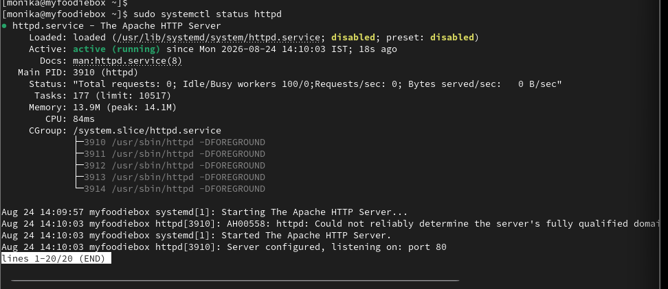

Task 3 — Stop, Start and Restart Apache
Question:
Stop and restart the Apache service using systemctl, and observe the difference between stop, start, and restart commands.
Content:
The stop command terminates the running Apache service. The start command starts Apache when it is stopped. The restart command stops and starts the service again, which is commonly used after changing Apache configuration.
Commands:
sudo systemctl stop httpd
sudo systemctl status httpd
sudo systemctl start httpd
sudo systemctl status httpd
sudo systemctl restart httpd
sudo systemctl status httpd
Difference:
stop — Stops the Apache service.
start — Starts the Apache service.
restart — Stops and starts Apache again, applying configuration changes when required.
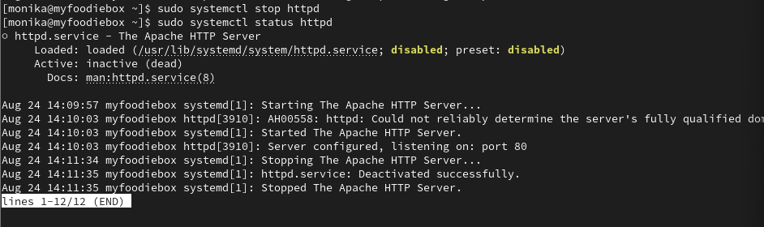

Task 4 — Verify Apache in a Browser
Question:
Open your browser and access http://localhost or your Linux machine's IP address to verify that the Apache default web page is displayed.
Content:
After starting Apache, the default Apache web page was accessed through a web browser. The browser was opened and the address http://localhost was entered when testing from the Linux machine itself.
For testing from another machine, the RHEL VM's IP address can be used:
http://IP_ADDRESS
The Apache default test page confirms that the web server is running and accepting HTTP requests.
Result:
The Apache default page was displayed successfully in the browser.
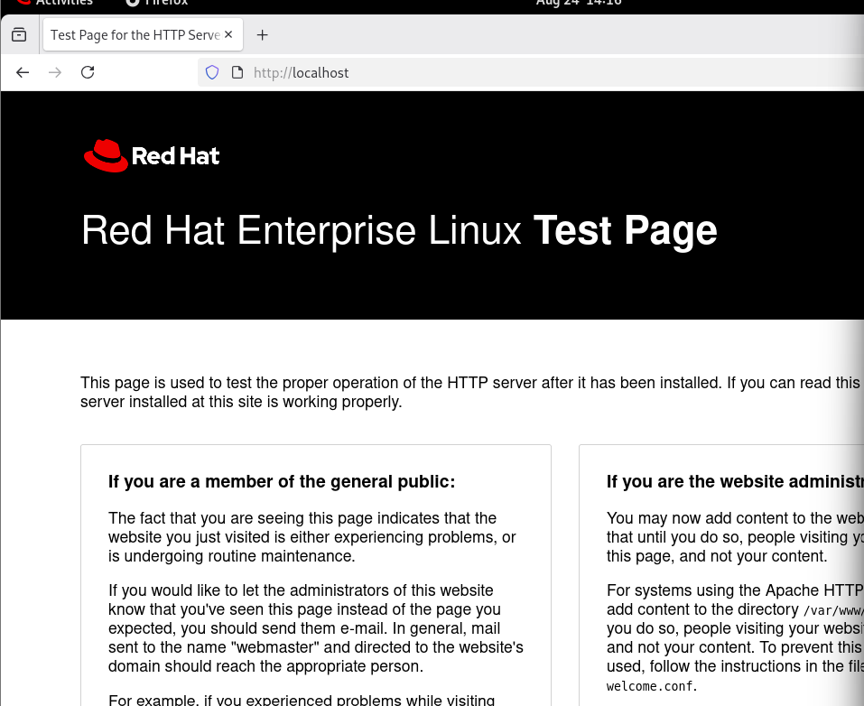

Task 5 — Apache vs Nginx Comparison
Question:
Write a short comparison (3–4 lines) between Apache and Nginx web servers, mentioning one key use-case for each based on your research.
Content:
Apache is a flexible web server with a large module ecosystem and is commonly used for traditional websites and applications that require features such as .htaccess. Nginx is designed for high performance and efficient handling of many simultaneous connections, making it commonly used as a reverse proxy, load balancer, and high-traffic web server. Apache is often chosen for flexibility and compatibility, while Nginx is often chosen for performance and efficient resource usage.

