Assignment -3

Task 1 — Create Two Users and a Group
Question
Create two new users on your Linux system named musicfan and moviebuff, then create a new group called playlist and add both users to this group.
Procedure
First, create the musicfan user:
sudo useradd musicfan
Create the moviebuff user:
sudo useradd moviebuff
Create the playlist group:
sudo groupadd playlist
Add musicfan to the playlist group:
sudo usermod -aG playlist musicfan
Add moviebuff to the playlist group:
sudo usermod -aG playlist moviebuff
Verify the group membership:
id musicfan
id moviebuff
Expected Result
The output should show that both musicfan and moviebuff are members of the playlist group.
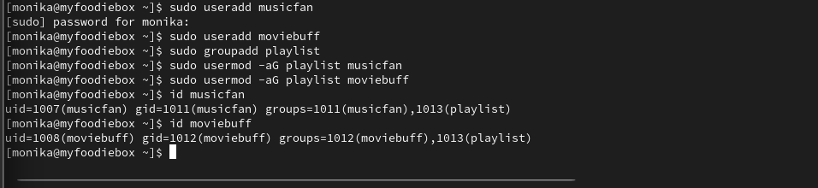
Result
The two users, musicfan and moviebuff, were created successfully. The playlist group was created, and both users were added to the group successfully.

Task 2 — Create and Restrict spotify_shared
Question
Inside your home directory, create a folder called spotify_shared. Set its permissions so only users in the playlist group can read and write files inside it, but others cannot access it.
Procedure
Create the directory inside the home directory:
mkdir ~/spotify_shared
Change the group ownership of the directory to playlist:
sudo chown :playlist ~/spotify_shared
Set permissions so that the owner and group have full access, while others have no access:
chmod 770 ~/spotify_shared
Verify the permissions:
ls -ld ~/spotify_shared
Permission Explanation
The permission 770 means:
- Owner: Read, write and execute
- Group: Read, write and execute
- Others: No permissions
The playlist group can therefore access and modify files inside the directory, while users outside the group cannot access it.
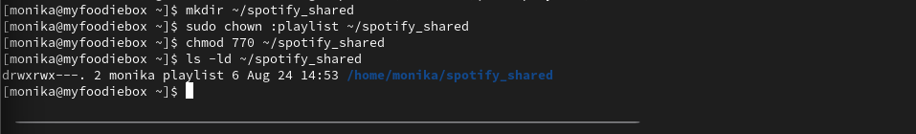
Result
The spotify_shared directory was created successfully. Its group ownership was changed to playlist, and access was restricted to the owner and members of the playlist group.

Task 3 — Create and Secure top_songs.txt
Question
Place a text file named top_songs.txt inside spotify_shared. Change its ownership so that musicfan is the owner and playlist is the group, then set permissions so only the owner can edit, group members can read, and others have no access.
Procedure
Create the file:
sudo touch ~/spotify_shared/top_songs.txt
Change the owner to musicfan and the group to playlist:
sudo chown musicfan:playlist ~/spotify_shared/top_songs.txt
Set the required permissions:
sudo chmod 640 ~/spotify_shared/top_songs.txt
Verify the ownership and permissions:
ls -l ~/spotify_shared/top_songs.txt
Permission Explanation
The permission 640 means:
- Owner (musicfan): Read and write
- Group (playlist): Read only
- Others: No access
Therefore, musicfan can edit the file, members of the playlist group can read the file, and users outside the group cannot access it.
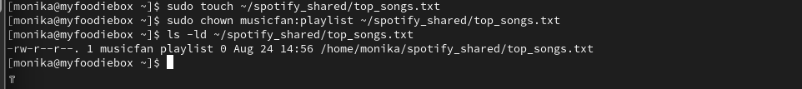
Result
The top_songs.txt file was successfully created. The owner was set to musicfan, the group was set to playlist, and the permissions were configured as required.

Task 4 — Test Access as moviebuff
Question
Simulate a scenario where moviebuff tries to access top_songs.txt. Switch to the moviebuff user and attempt to open and edit the file. Describe what happens and explain why based on the permissions you set.
Procedure
Switch to the moviebuff user:
su - moviebuff
Try to read the file:
cat /home/monika/spotify_shared/top_songs.txt
Because moviebuff is a member of the playlist group, the user should have read permission for the file.
Now try to edit the file:
nano /home/monika/spotify_shared/top_songs.txt
Type some test text, for example:
Test edit by moviebuff
Try to save the file using:
Ctrl + O → Enter

