Managing SELinux (Basics)
Task 1: Check Current SELinux Status
Objective:
Check the current SELinux status using the getenforce and sestatus commands.
Commands:
getenforce
sestatus
Observation:
Write the output of both commands and explain whether SELinux is Enforcing, Permissive, or Disabled.
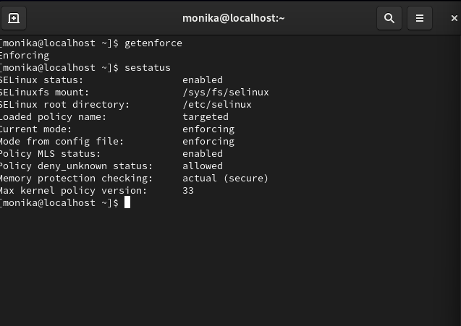

Task 2: Temporarily Switch SELinux to Permissive Mode
Objective:
Temporarily change SELinux from enforcing mode to permissive mode and test file creation in /var/www/html.
Commands:
getenforce
sudo setenforce 0
getenforce
sudo touch /var/www/html/selinux-test.txt
ls -l /var/www/html/selinux-test.txt
Return SELinux to enforcing mode:
sudo setenforce 1
getenforce
Observation:
Note any difference in errors, permissions, or behavior between enforcing and permissive modes.
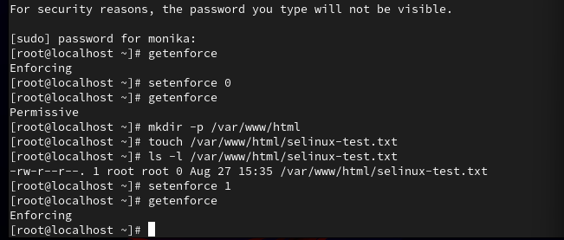

Task 3: View and Change SELinux Security Context
Objective:
Display SELinux security contexts for files in /var/www/html and change the type of one test file to httpd_sys_content_t.
Commands:
ls -lZ /var/www/html
sudo touch /var/www/html/foodie.txt
ls -Z /var/www/html/foodie.txt
sudo chcon --type=httpd_sys_content_t /var/www/html/foodie.txt
ls -Z /var/www/html/foodie.txt
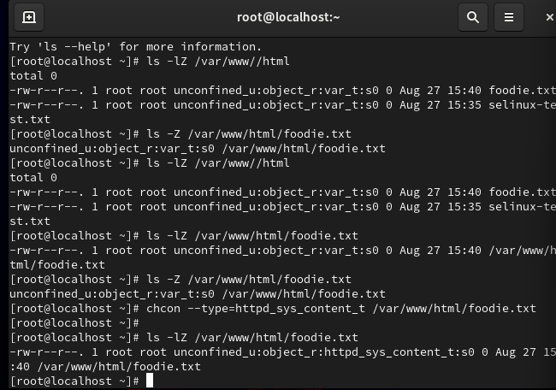

Task 4: Analyze SELinux Denials for Food Review Blog Image Upload
Scenario:
A user is unable to upload images to /srv/foodie/images for a food review blog.
Commands used to prepare and inspect the directory:
sudo mkdir -p /srv/foodie/images
sudo touch /srv/foodie/images/test-image.jpg
ls -ldZ /srv/foodie/images
ls -lZ /srv/foodie/images
Check recent SELinux denials:
sudo grep AVC /var/log/audit/audit.log | tail -20
Analyze denials:
sudo ausearch -m AVC -ts recent | audit2why
sudo ausearch -m AVC -ts recent | audit2allow
If a custom policy module is appropriate:
sudo ausearch -m AVC -ts recent | audit2allow -M foodie_upload
sudo semodule -i foodie_upload.pp
Alternative recommended approach:
Use an appropriate SELinux file context for web-server writable content, for example httpd_sys_rw_content_t, when the application genuinely requires the web server to write to the directory.
Example:
sudo chcon -R -t httpd_sys_rw_content_t /srv/foodie/images
ls -ldZ /srv/foodie/images
