MariaDB – Practical Tasks

Task 1 – Install and Verify MariaDB
Question
Install MariaDB on your Linux system and verify the installation by running the command to check the MariaDB server version.
Commands Used
sudo dnf install mariadb-server -y
sudo systemctl start mariadb
sudo systemctl enable mariadb
mariadb --version
Result
MariaDB was successfully installed and the server version was verified using the mariadb --version command.
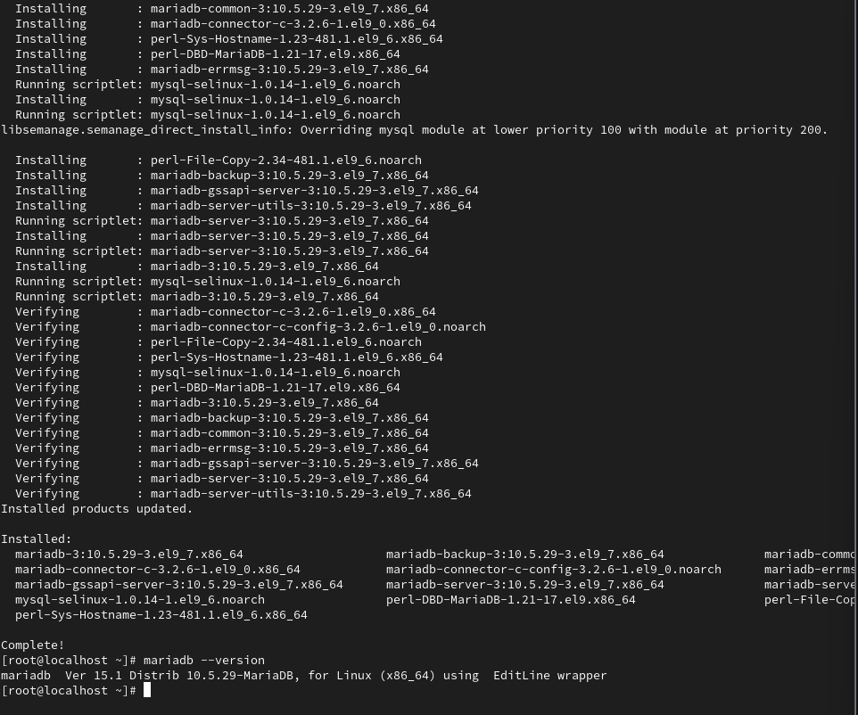

Task 2 – Create Database, Table, and Insert Records
Question
Create a new MariaDB database named foodie_app and a table restaurants with columns id (INT, primary key), name (VARCHAR), cuisine (VARCHAR), and rating (FLOAT). Insert 3 sample restaurant records.
Commands Used
sudo mariadb
CREATE DATABASE foodie_app;

USE foodie_app;

CREATE TABLE restaurants (
id INT PRIMARY KEY,
name VARCHAR(100),
cuisine VARCHAR(100),
rating FLOAT
);

INSERT INTO restaurants (id, name, cuisine, rating)
VALUES
(1, 'Pizza Palace', 'Italian', 4.5),
(2, 'Spice Garden', 'Indian', 4.2),
(3, 'Sushi World', 'Japanese', 3.9);

SELECT * FROM restaurants;
Result
The foodie_app database and restaurants table were successfully created. Three sample restaurant records were inserted successfully.
- 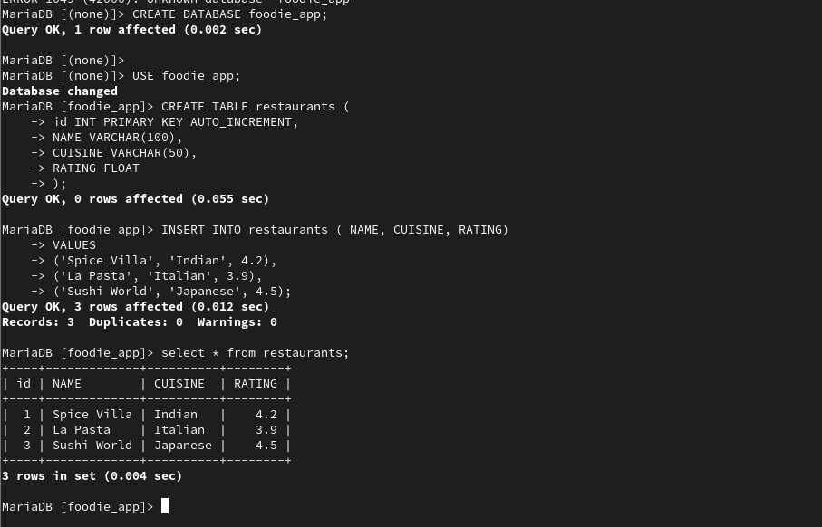

Task 3 – Find Restaurants with Rating Greater Than 4.0
Question
Write and execute a SQL query in MariaDB to find all restaurants in the foodie_app database with a rating greater than 4.0 and display their name and cuisine.
SQL Query
USE foodie_app;

SELECT name, cuisine
FROM restaurants
WHERE rating > 4.0;
Result
The query displays all restaurants whose rating is greater than 4.0, showing only their name and cuisine.
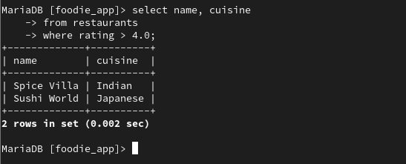

Task 4 – Grant Permissions to zomato_user
Question
Grant SELECT and INSERT permissions on the foodie_app database to a new MariaDB user named zomato_user with password zomato123, then test the permissions by connecting as that user and inserting a new restaurant.
Step 1 – Create the User
Log in as the MariaDB root user:
sudo mariadb
Create the user:
CREATE USER 'zomato_user'@'localhost' IDENTIFIED BY 'zomato123';
Step 2 – Grant Permissions
GRANT SELECT, INSERT ON foodie_app.* TO 'zomato_user'@'localhost';
Apply the privileges:
FLUSH PRIVILEGES;
Step 3 – Connect as zomato_user
Exit MariaDB:
EXIT;
Connect using the new user:
mariadb -u zomato_user -p
Enter the password:
zomato123
Step 4 – Insert a New Restaurant
USE foodie_app;

INSERT INTO restaurants (id, name, cuisine, rating)
VALUES (4, 'Pasta House', 'Italian', 4.1);
Verify the record:
SELECT * FROM restaurants;
Result
The zomato_user account was successfully created with SELECT and INSERT permissions on the foodie_app database. The user was able to connect and insert a new restaurant record successfully.
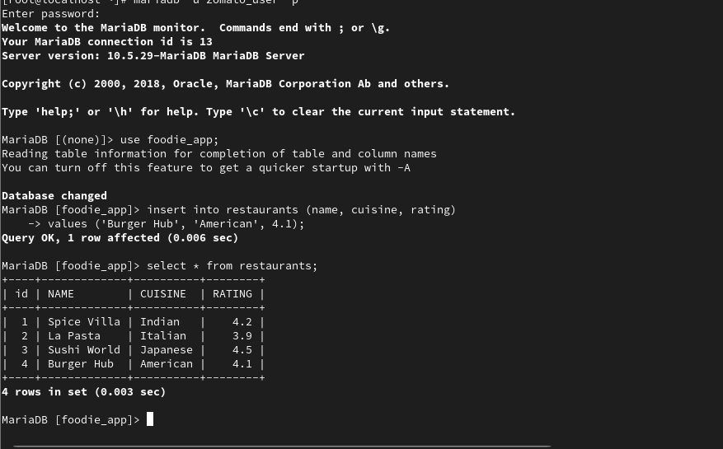
Task 5 – Update Italian Restaurant Ratings Using AI
Question
Use ChatGPT or Copilot to generate a SQL query that updates the rating of all restaurants with cuisine 'Italian' to 4.5 in your MariaDB table, then run the query and verify the update.
Hint
Paste your prompt and the AI-generated query in your submission along with the
Verify the Update
SELECT * FROM restaurants
WHERE cuisine = 'Italian';
Result
All restaurants with the cuisine Italian were successfully updated to a rating of 4.5. The update was verified using a SELECT query.
