Assignment 2 – Hosting a Static Website

Task 1 — Install Apache and Verify the Default Page
Question:
Install Apache or Nginx on your Linux server and verify the installation by accessing the default web page via your browser.
Content:
Apache is a web server used to deliver web pages to clients. In this assignment, Apache is used on RHEL 8. The Apache package is called httpd and can be installed with dnf.
Commands:
sudo dnf install httpd -y
sudo systemctl enable --now httpd
httpd -v
The default Apache page can be tested from the RHEL VM by opening:
http://localhost
Result:
Apache was installed and started successfully, and the default web page was verified in the browser.
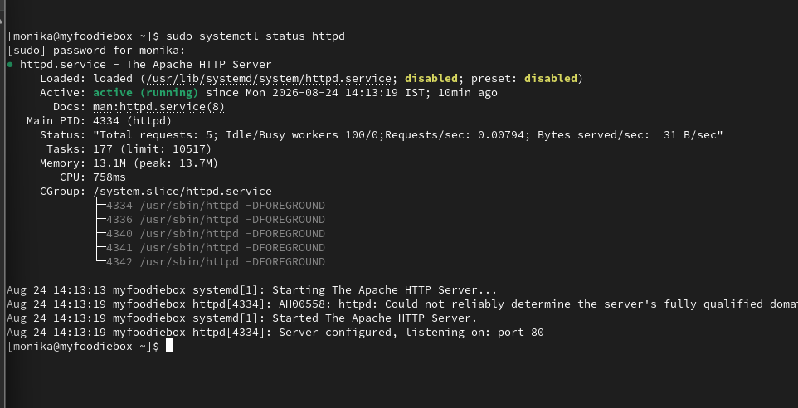

Task 2 — Create the myflipkart Website
Question:
Create a folder named myflipkart in your web server's root directory and place an index.html file inside it that displays "Welcome to MyFlipkart Deals!".
Content:
A directory named myflipkart was created under Apache's document root. On RHEL, Apache's default document root is /var/www/html. An index.html file was created inside the folder with the required welcome message.
Commands:
sudo mkdir -p /var/www/html/myflipkart
sudo nano /var/www/html/myflipkart/index.html
HTML content:
<!DOCTYPE html>
<html>
<head>
<title>MyFlipkart Deals</title>
</head>
<body>
<h1>Welcome to MyFlipkart Deals!</h1>
</body>
</html>
Save the file and exit nano.
Result:
The myflipkart directory and custom index.html page were created successfully.
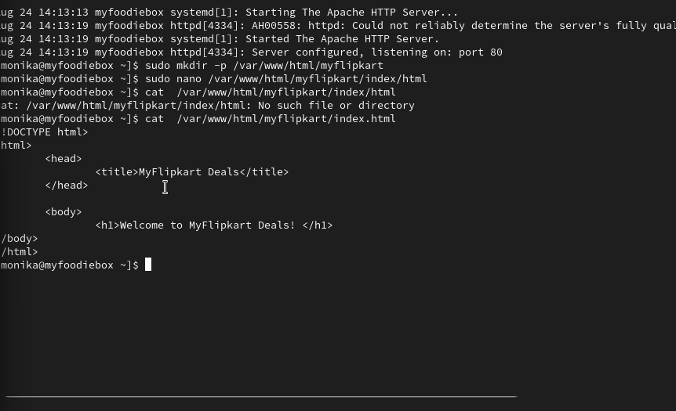

Task 3 — Configure Apache to Display the Custom Page
Question:
Update your web server configuration so that visiting http://localhost/myflipkart shows your custom index.html page instead of the default server page.
Content:
Apache can use an Alias directive to map a URL path to a directory on the server. A separate Apache configuration file was created for the myflipkart site.
Create the configuration file:
sudo nano /etc/httpd/conf.d/myflipkart.conf
Add:
Alias /myflipkart /var/www/html/myflipkart
<Directory /var/www/html/myflipkart>
Require all granted
DirectoryIndex index.html
</Directory>
Save and exit.
Test the Apache configuration:
sudo apachectl configtest
If the result is:
Syntax OK
reload Apache:
sudo systemctl reload httpd
Then open:
http://localhost/myflipkart
Result:
The custom MyFlipkart page was displayed through the /myflipkart URL.

Task 4 — Add a Favicon
Question:
Add a favicon to your static site by placing a favicon.ico file in the correct location and updating your HTML to reference it.
Content:
A small image was prepared and saved or renamed as favicon.ico. The favicon file was placed inside the myflipkart directory so that the browser could access it.
The expected file location is:
/var/www/html/myflipkart/favicon.ico
Update index.html:
sudo nano /var/www/html/myflipkart/index.html
Add this line inside the <head> section:
<link rel="icon" type="image/x-icon" href="favicon.ico">
The final HTML should contain the title and favicon reference.
After saving the file, refresh:
http://localhost/myflipkart
Result:
The static website was updated with a favicon reference.

