Introduction to Firewalld – Practical Tasks & Steps

Task 1 – Install, start, and verify firewalld
QUESTION:
Install firewalld on your Linux system, start the service, and verify its status using systemctl and firewall-cmd commands.
HOW TO DO:
1. Install firewalld:
sudo dnf install firewalld -y
2. Start firewalld:
sudo systemctl start firewalld
3. Enable it to start automatically after reboot:
sudo systemctl enable firewalld
4. Check the service status:
sudo systemctl status firewalld
5. Verify with firewall-cmd:
sudo firewall-cmd --state
Expected result:
- systemctl status should show “active (running)”.
- firewall-cmd --state should show “running”.
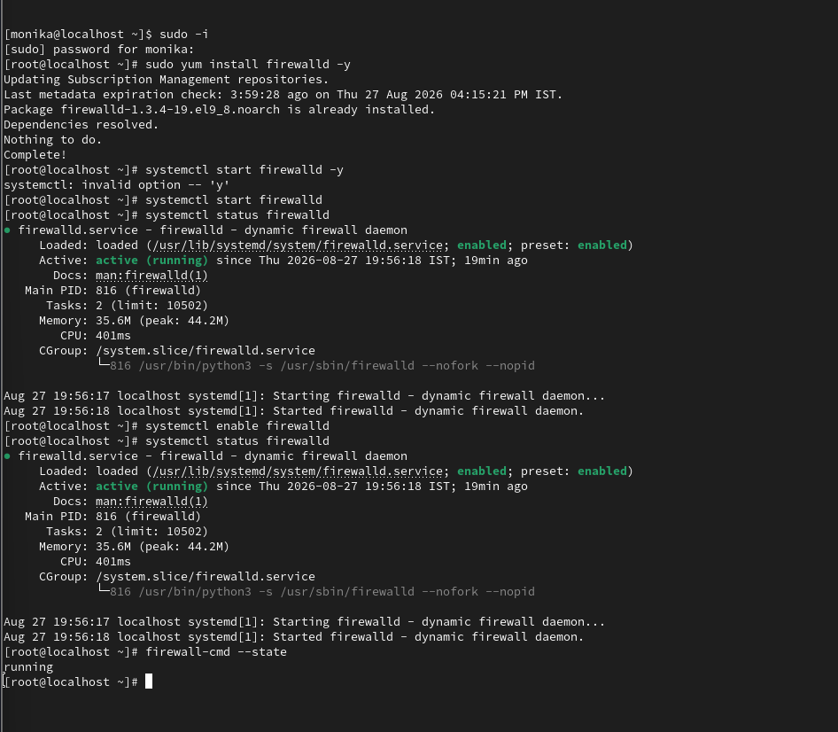

Task 2 – Allow HTTP port 80
QUESTION:
Add a new rule to firewalld to allow incoming HTTP (port 80) traffic, then use firewall-cmd to confirm the rule is active.
Hint: Use the --permanent and --reload options to make changes persistent.
HOW TO DO:
1. Add HTTP permanently:
sudo firewall-cmd --permanent --add-service=http
2. Reload firewalld so the permanent change becomes active:
sudo firewall-cmd --reload
3. Confirm HTTP is allowed:
sudo firewall-cmd --list-services
4. You can also check the port directly:
sudo firewall-cmd --list-ports
Expected result:
- “http” should appear in the services list.
- Port 80 is allowed through the HTTP service.
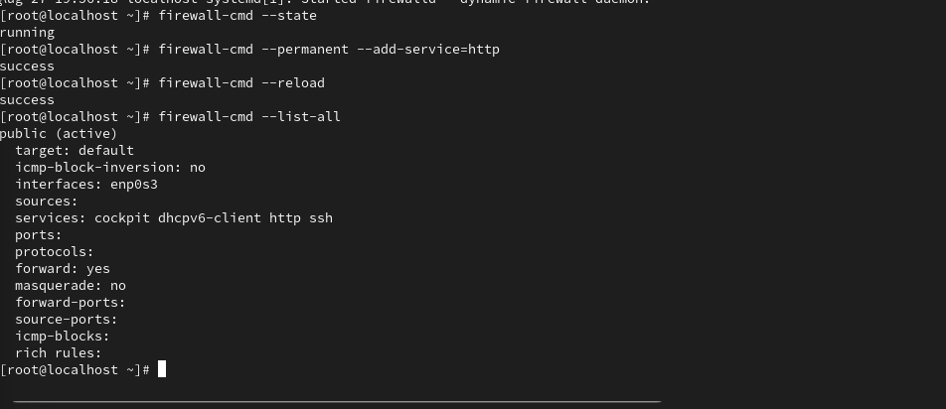

Task 3 – Temporarily block port 8080 and test
QUESTION:
Temporarily block all incoming traffic on port 8080 using firewalld, then test by attempting to access a simple web server (e.g., Python's http.server) running on that port.
HOW TO DO:
1. Start a simple web server on port 8080 in Terminal 1:
python3 -m http.server 8080
2. In another terminal, first test that the server works locally:
curl http://127.0.0.1:8080
3. Block incoming TCP traffic on port 8080 temporarily (do NOT use --permanent):
sudo firewall-cmd --add-rich-rule='rule family="ipv4" port port="8080" protocol="tcp" drop'
4. Check the active rich rules:
sudo firewall-cmd --list-rich-rules
5. Test from another machine/VM using the Linux VM's IP address:
curl http://<VM-IP>:8080
The connection should be blocked/dropped.
IMPORTANT:
- This rule is runtime-only because --permanent was not used.
- To remove the temporary rule before it disappears:
sudo firewall-cmd --remove-rich-rule='rule family="ipv4" port port="8080" protocol="tcp" drop'
6. Stop the Python server with Ctrl+C when finished.
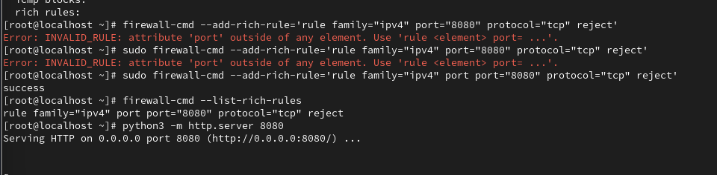

Task 4 – List active zones and public-zone rules
QUESTION:
List all currently active firewalld zones and display the services and ports allowed in the public zone.
HOW TO DO:
1. List active zones:
sudo firewall-cmd --get-active-zones
2. Display everything allowed in the public zone:
sudo firewall-cmd --zone=public --list-all
3. If you only need allowed services:
sudo firewall-cmd --zone=public --list-services
4. If you only need allowed ports:
sudo firewall-cmd --zone=public --list-ports
Expected result:
You should see the active zone(s), interfaces assigned to them, and the services/ports currently allowed in the public zone.
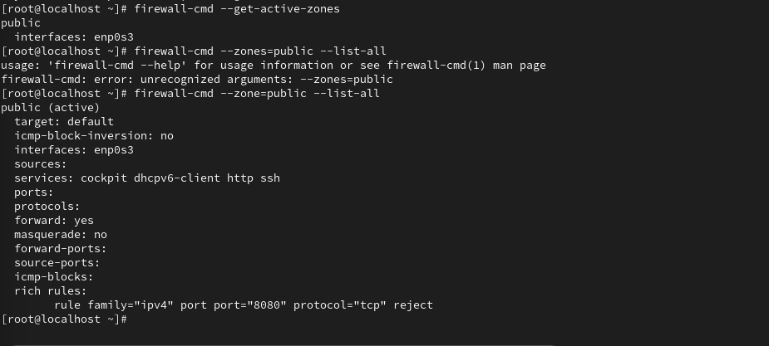

Task 5 – Remove the HTTP port 80 rule
QUESTION:
Remove a custom rule you added earlier (such as the HTTP port 80 rule) and verify that the change has taken effect using firewall-cmd.
HOW TO DO:
1. Remove the permanent HTTP service rule:
sudo firewall-cmd --permanent --remove-service=http
2. Reload firewalld:
sudo firewall-cmd --reload
3. Verify that HTTP is no longer listed:
sudo firewall-cmd --zone=public --list-services
4. Also verify port 80 is not explicitly listed:
sudo firewall-cmd --zone=public --list-ports

