Automation with Crontab

Task 1 – Three Real-Life Uses
1. Automatic Backups
Crontab can automatically back up important files at a scheduled time, reducing the risk of data loss.
2. Log Cleanup
Crontab can automatically remove or archive old log files, helping save disk space.
3. System Monitoring
Crontab can periodically run monitoring scripts to check system resources and services.

Task 2 – Daily Playlist Update
Crontab entry:
0 2 * * * /home/yourusername/update_playlist.sh
0 = minute; 2 = hour (2:00 AM); the three * fields mean every day of month, every month, and every day of week; the final field is the script path.

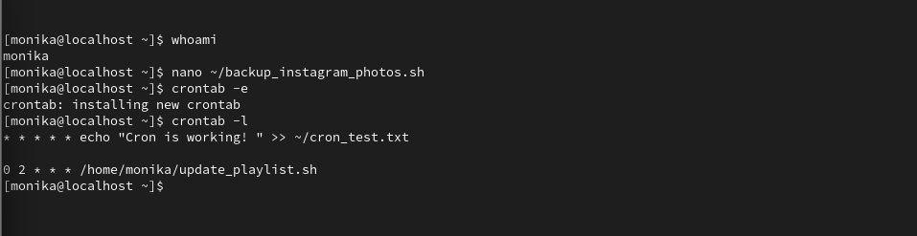

Task 3 – Create Instagram Photos Backup Script
Replace yourusername with your actual Linux username.
nano ~/backup_instagram_photos.sh
Paste:
#!/bin/bash
SOURCE="/home/yourusername/InstagramPhotos"
BACKUP_BASE="/home/yourusername/Backups"
BACKUP_DIR="$BACKUP_BASE/InstagramPhotos_$(date +%Y-%m-%d)"
mkdir -p "$BACKUP_DIR"
cp -a "$SOURCE"/. "$BACKUP_DIR"/
echo "Backup completed: $(date)"
echo "Backup location: $BACKUP_DIR"
Save with Ctrl+O, Enter, then Ctrl+X.
chmod +x ~/backup_instagram_photos.sh
Test it:
~/backup_instagram_photos.sh
Verify:
ls -l ~/Backups/

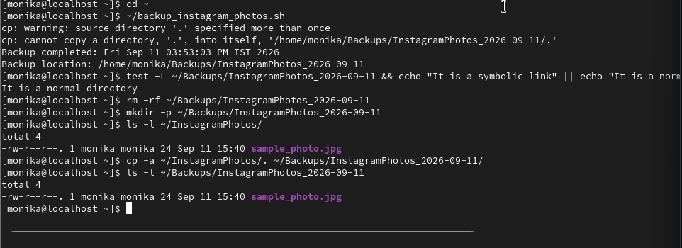

Task 4 – Schedule Every Sunday at 11:30 PM
Open crontab:
crontab -e
Add:
30 23 * * 0 /home/yourusername/backup_instagram_photos.sh >> /home/yourusername/backup_log.txt 2>&1
30 = minute; 23 = 11 PM; * * = every day/month; 0 = Sunday. >> appends output to the log, and 2>&1 sends errors to the same log.
Verify:
crontab -l

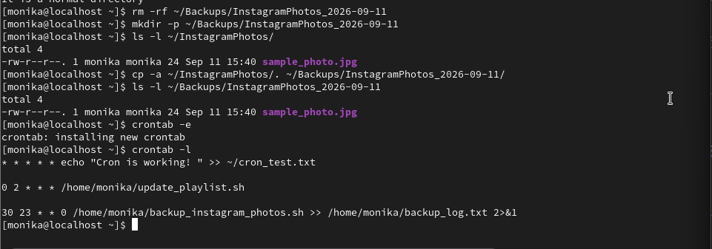

Task 5 – Show Last 5 Log Lines
After the scheduled backup runs:
tail -n 5 ~/backup_log.txt
This displays the last five lines as proof that the backup and logging worked.
