Secure Shell (SSH) – Practical Tasks

Task 1 – Install and Verify OpenSSH Server
Full Question:
Install the OpenSSH server package on your Linux system and verify that the sshd service is running by connecting to localhost using the ssh command.

Commands / Steps:
sudo dnf install openssh-server -y
sudo systemctl start sshd
sudo systemctl enable sshd
sudo systemctl status sshd
ssh localhost

Result / Screenshot:
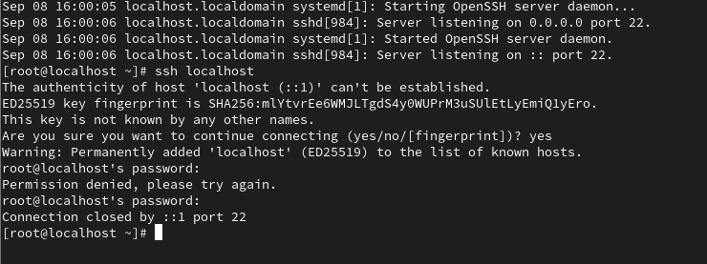

Task 2 – Generate SSH Key Pair
Full Question:
Generate a new SSH key pair using ssh-keygen, and add your public key to the ~/.ssh/authorized_keys file of your user account to enable key-based authentication.

Commands / Steps:
ssh-keygen -t ed25519
ls -la ~/.ssh
cat ~/.ssh/id_ed25519.pub >> ~/.ssh/authorized_keys
chmod 700 ~/.ssh
chmod 600 ~/.ssh/authorized_keys
chmod 600 ~/.ssh/id_ed25519
chmod 644 ~/.ssh/id_ed25519.pub
cat ~/.ssh/authorized_keys

Result / Screenshot:
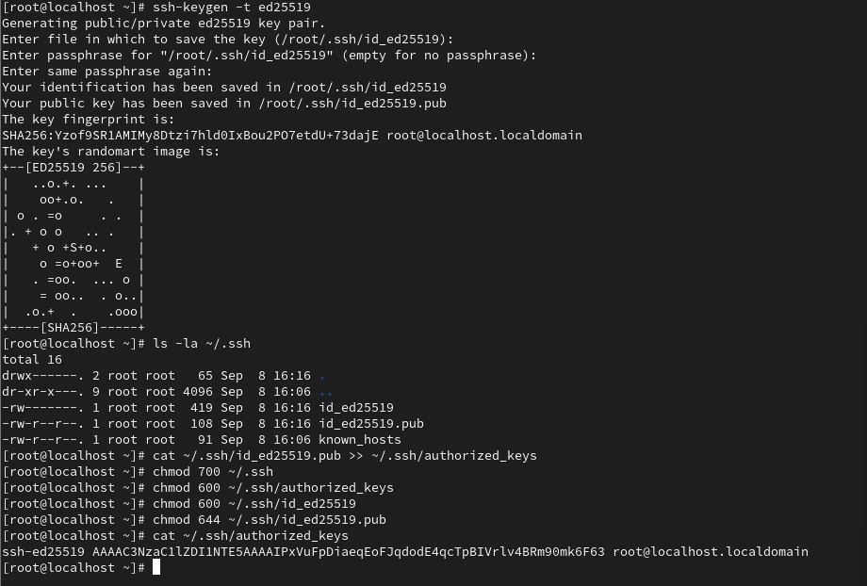

Task 3 – Disable Password Authentication
Full Question:
Edit the /etc/ssh/sshd_config file to disable password authentication by setting PasswordAuthentication no, then restart the sshd service and test that you can only log in using your SSH key.

Commands / Steps:
sudo cp /etc/ssh/sshd_config /etc/ssh/sshd_config.backup
sudo nano /etc/ssh/sshd_config
sudo sshd -t
sudo systemctl restart sshd
sudo systemctl status sshd
ssh -i ~/.ssh/id_ed25519 localhost

Result / Screenshot:
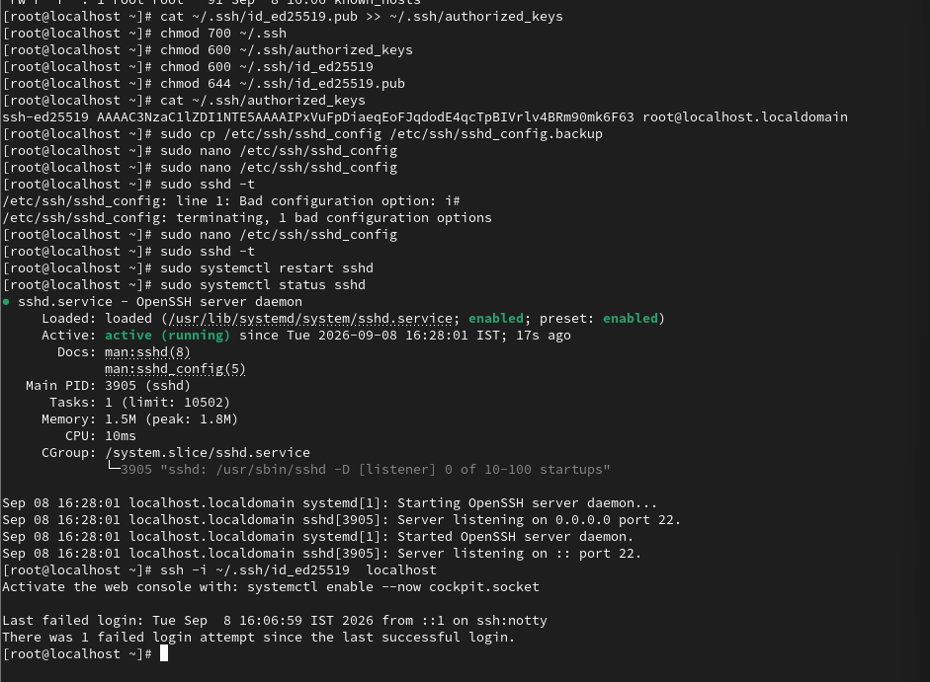

Task 4 – Document SSH Configuration
Full Question:
Document each step you took to configure SSH key-based authentication and disable password login, including the exact commands and configuration changes you made.
Hint: Use screenshots or command outputs to support your documentation.

Commands / Steps:
OpenSSH installation
Starting and enabling sshd
Generating an SSH key pair
Adding the public key to authorized_keys
Setting correct permissions
Changing /etc/ssh/sshd_config to PasswordAuthentication no
Testing configuration with sudo sshd -t
Restarting sshd
Testing key-based login

Result / Screenshot:

