Firewall Configuration

Task 1 – Install and Verify Firewall
On RHEL 9, UFW may not be available in the currently enabled repositories. Use the native firewalld service as the RHEL equivalent.
sudo dnf install firewalld -y
sudo systemctl enable --now firewalld
sudo systemctl status firewalld
sudo firewall-cmd --state
Expected: Active: active (running) and firewall-cmd --state returns running.

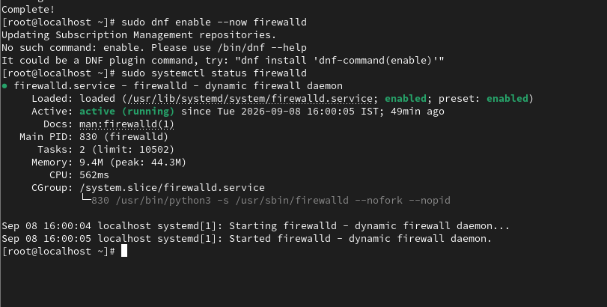

Task 2 – Allow Incoming SSH
If connected through SSH, allow SSH before applying restrictive rules to avoid losing the connection.
sudo firewall-cmd --permanent --add-service=ssh
sudo firewall-cmd --reload
sudo firewall-cmd --list-all
Verify that ssh appears under services. Firewalld zones normally reject unsolicited incoming traffic that is not explicitly allowed.

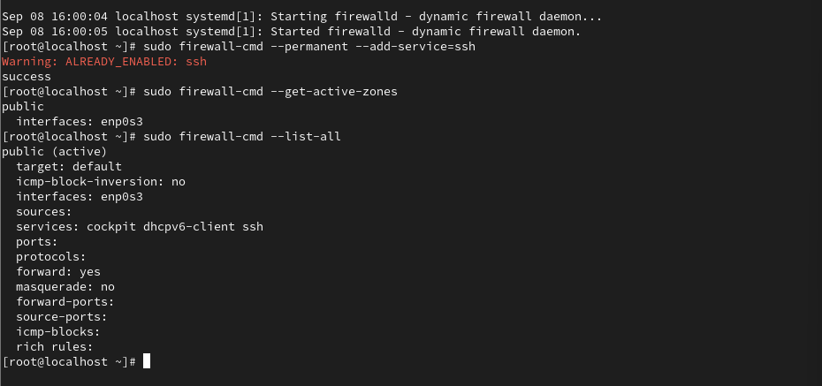

Task 3 – Outbound HTTP/HTTPS
The assignment requires outgoing TCP ports 80 and 443 to be allowed and other outbound traffic to be blocked. On RHEL firewalld, outbound filtering is more complex .

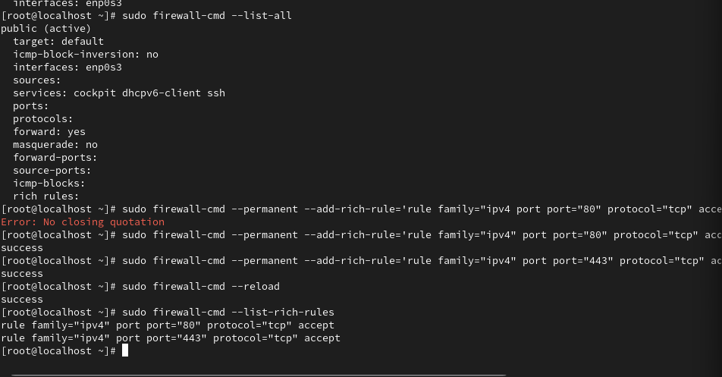

Task 4 – Save Active Firewall Rules
sudo firewall-cmd --list-all
sudo firewall-cmd --list-all > firewall_rules.txt
cat firewall_rules.txt
This saves the active firewall configuration to firewall_rules.txt.

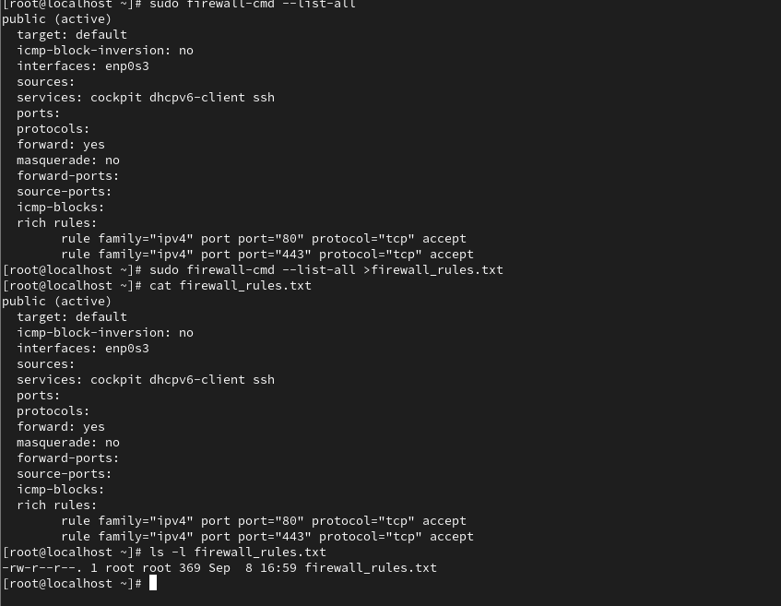

Task 5 – Impact on a Local Web Server
A restrictive firewall improves security by preventing unwanted network connections. If a Zomato-style development server listens on a port such as 8080, outside access will be blocked unless that port is explicitly allowed. HTTP/HTTPS traffic on ports 80/443 can be permitted when required. Therefore, firewall rules should allow only the ports needed by the application.

