PENETRATION TESTING PRACTICAL ASSIGNMENT

Task 1: Install Nmap and Scan the Local Network
Aim: Install Nmap, discover active devices on a network you own or are authorized to test, and save the output to scan_results.txt.
Steps:
- Download Nmap from the official site: https://nmap.org/download.html and install it for Windows. Install Npcap if the installer prompts you.
- Open Command Prompt (press Win + R, type cmd, and press Enter).
- Run ipconfig and find the IPv4 address and subnet mask for your active Wi-Fi or Ethernet adapter.
- For a /24 network, use the matching network address. Example only: if your address is 192.168.1.10 with subnet mask 255.255.255.0, the subnet is 192.168.1.0/24.
- Run the scan below, replacing the example subnet with your own authorized subnet:
nmap -sn 192.168.1.0/24 -oN scan_results.txt
The -sn option performs host discovery without a port scan. The -oN option saves normal-format output to scan_results.txt.
To view the saved file, run: type scan_results.txt
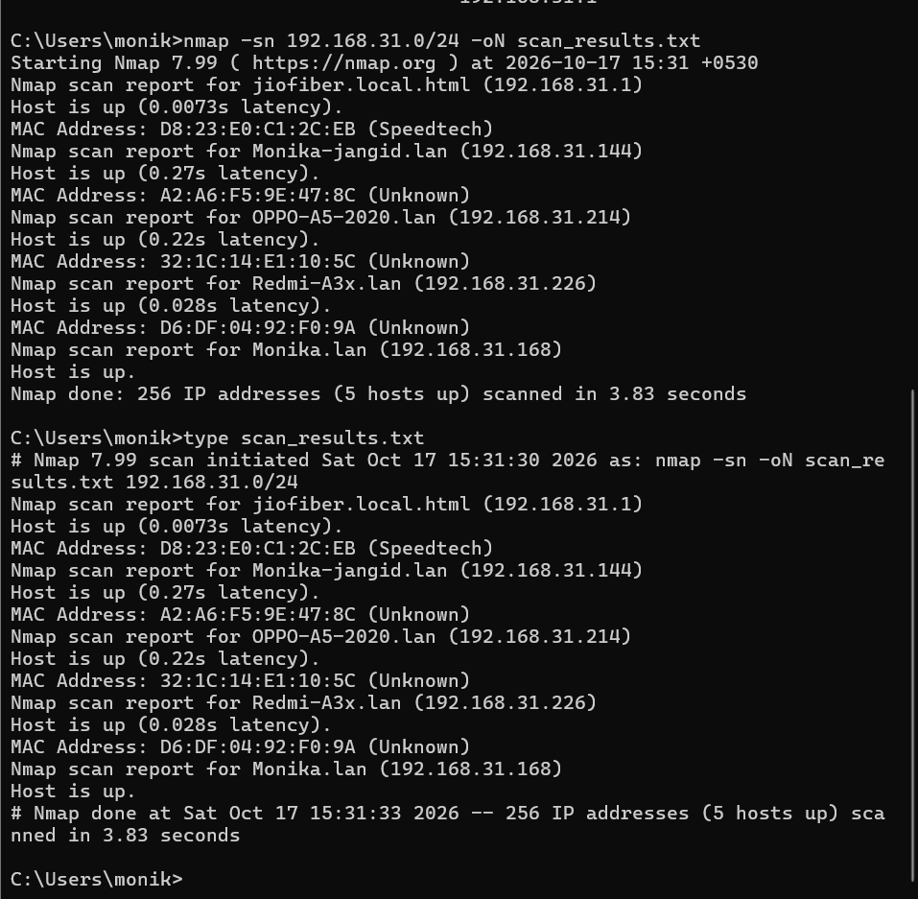

Task 2: Reconnaissance of a Popular App (Theory)
Selected app: Instagram
During the reconnaissance phase, a penetration tester assessing Instagram would gather publicly available information about its domain names, subdomains, website technologies, public-facing services, and security-related HTTP headers. The tester might review public documentation, privacy policies, login and password-recovery workflows, and publicly disclosed vulnerabilities to understand the application's attack surface. Information about third-party integrations may also be reviewed. All activities must remain within the approved scope and must not attempt to access private user information or accounts.

Task 3: Port Scan of the Approved Nmap Test Server
Only scan the explicitly approved test target, scanme.nmap.org, and follow the target's usage limits. Run Command Prompt as Administrator if needed for a SYN scan.
nmap -sS scanme.nmap.org
Review the PORT / STATE / SERVICE table and record only the ports shown as open in your actual scan. Results may change over time; do not copy example port numbers.

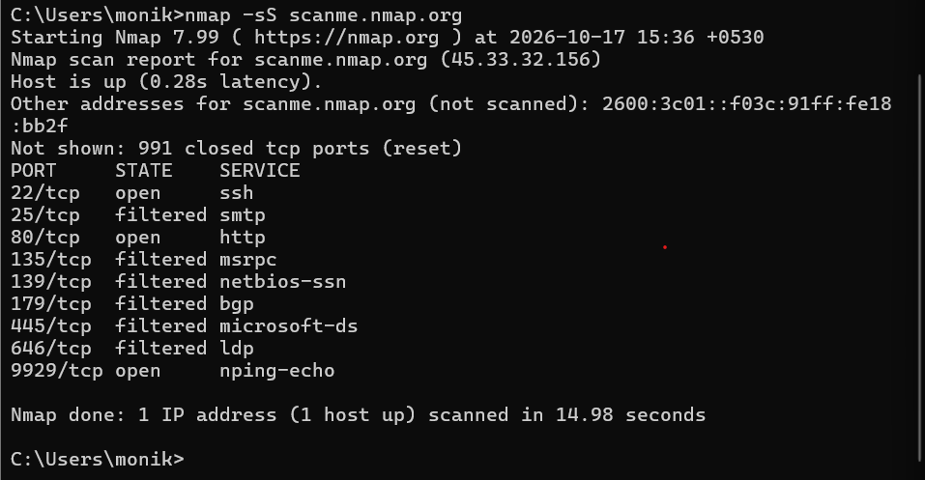

Task 4: Client-Style Scan Report
Complete the bracketed fields using your real scan output. Do not claim a vulnerability unless you verified it.
- Objective: A basic network discovery and port scan was performed using Nmap on authorized targets.
- Local network findings: The scan discovered [number] active hosts on the authorized local subnet.
- Port scan findings: The approved test server showed [number] open ports: [list actual ports and services].
- Security observations: Open ports indicate services that may require further review; an open port alone does not prove a vulnerability.
- Potential risks: Unnecessary exposed services, outdated software, or weak configurations may present risks if confirmed during further assessment.
- Recommendations: Review whether each exposed service is required, apply security updates, and restrict access where appropriate.
- Conclusion: The scan provided an initial view of active hosts and exposed services. Additional authorized testing is needed to validate vulnerabilities.

