METHODS OF FOOTPRINTING
Task 1 – Find the IP Address Using nslookup
Where: Windows laptop → Command Prompt. No extra software is needed.
1. Open Command Prompt. Press the Windows key, type cmd and open Command Prompt.
2. Find the IP address. Type nslookup www.flipkart.com and press Enter. Read the Address value in the answer section. More than one IP may appear.
3. Find mail servers. Type nslookup -type=MX flipkart.com and press Enter. MX records show mail servers.
4. Find name servers. Type nslookup -type=NS flipkart.com and press Enter. NS records show the domain's name servers.
5. Save evidence. Take a screenshot showing the commands and their results.
Example: DNS answers can change by location and time. Public DNS sources have shown www.flipkart.com using an Akamai hostname and IP addresses such as 23.202.230.223 and 23.202.230.213. Your own result may differ because large websites use content-delivery networks.
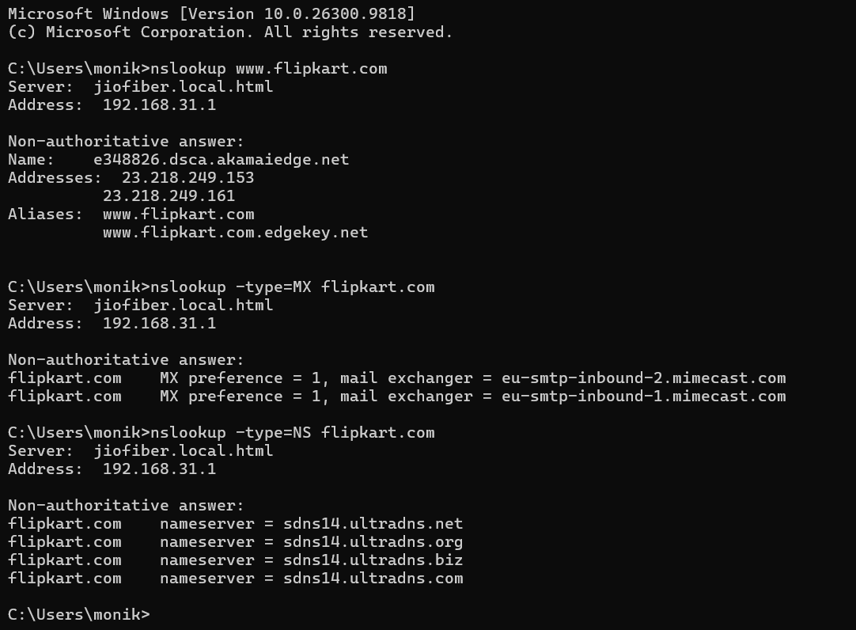

Task 2 – Google Dorking (Privacy-Safe Method)
Where: Open https://www.google.com/ .
1. Find your official college domain. Use the website address shown on your college's official website. Do not guess it.
2. Search Google. Enter site:instagram.com "YOUR-COLLEGE-NAME" and press Enter. Replace the quoted words with your college name.
3. Refine the search. Try site:instagram.com "YOUR-COLLEGE-NAME" official or add the name of an official department or club.
4. Review results. Choose only pages clearly identified as official college, department or institutional accounts.
5. Record up to three results. Write the public organization/page name and URL. If fewer than three official pages appear, record only those you can verify.
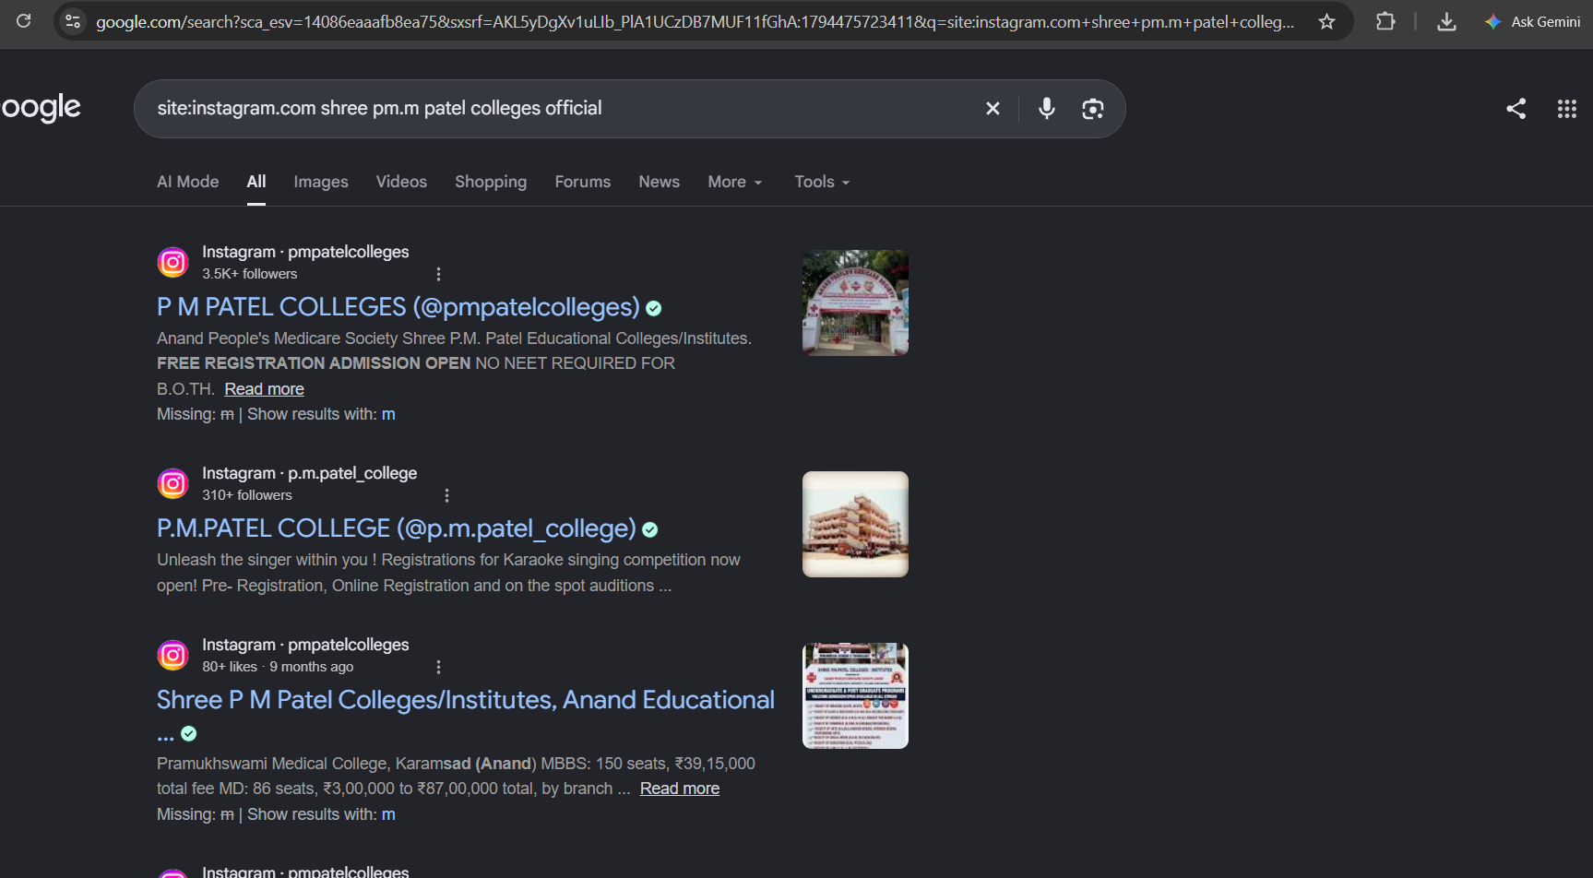

Task 3 – WHOIS Lookup for zomato.com
Where: Open https://www.whois.com/whois/zomato.com in Chrome.
1. Open the lookup page. Visit the WHOIS link above.
2. Check the domain. Make sure the page is showing zomato.com.
3. Find registration date. Look for Registered On, Created or Creation Date.
4. Find country. Look under Registrant Contact or Country.
5. Find organization. Look for Registrant Organization. If hidden or not displayed, write Not publicly displayed. Do not guess.
6. Save evidence. Record the details shown and take a screenshot.

Example summary from public lookup records
- Domain: zomato.com
- Registration date: 24 February 2006.
- Registrant country: India (IN).
- Registrant organization: The current public .com lookup may not display this field. The registrar, 101domain GRS Limited, is not the domain owner.
- Company context: Zomato's official terms identify the legal entity as Eternal Limited (formerly Zomato Limited). This is the company's legal name, not necessarily the exact WHOIS registrant field.
WHOIS details can be privacy-redacted and may change. Report what your lookup page actually shows.

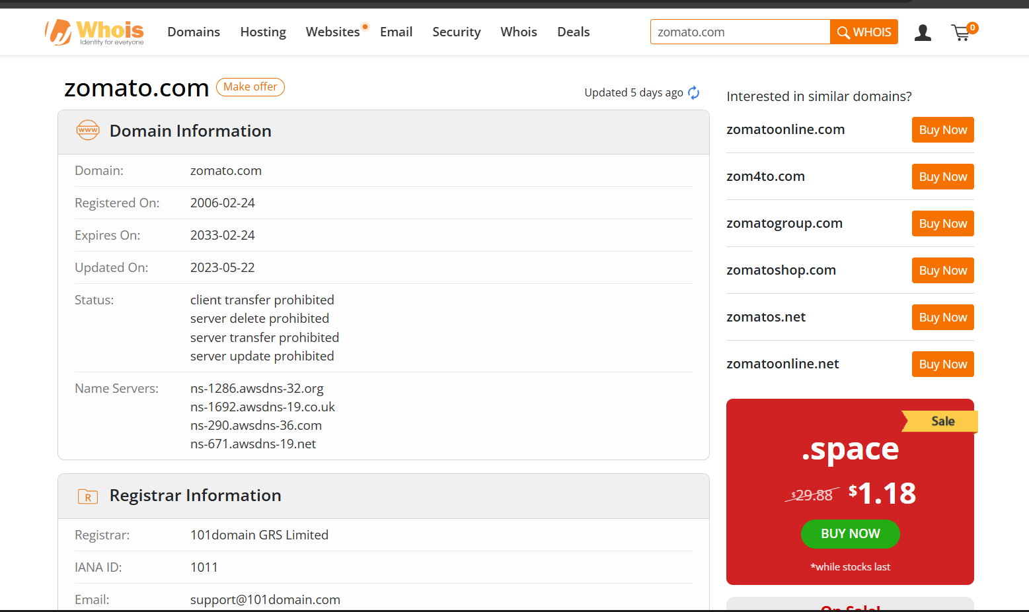

Task 4 – Find Public Subdomains of myntra.com
Where: Open https://crt.sh/ in Chrome. This site searches public Certificate Transparency logs.
1. Open crt.sh. Visit https://crt.sh/.
2. Search the domain. Enter %.myntra.com in the search box and press Enter. If needed, try myntra.com.
3. Review results. Look at certificate Common Name and Subject Alternative Name (SAN) fields.
4. Identify hostnames. Write down distinct names ending in .myntra.com. Remove duplicates and do not include myntra.com itself.
5. Understand the result. A certificate record proves that a hostname appeared in a public certificate; it does not prove that it is currently active.
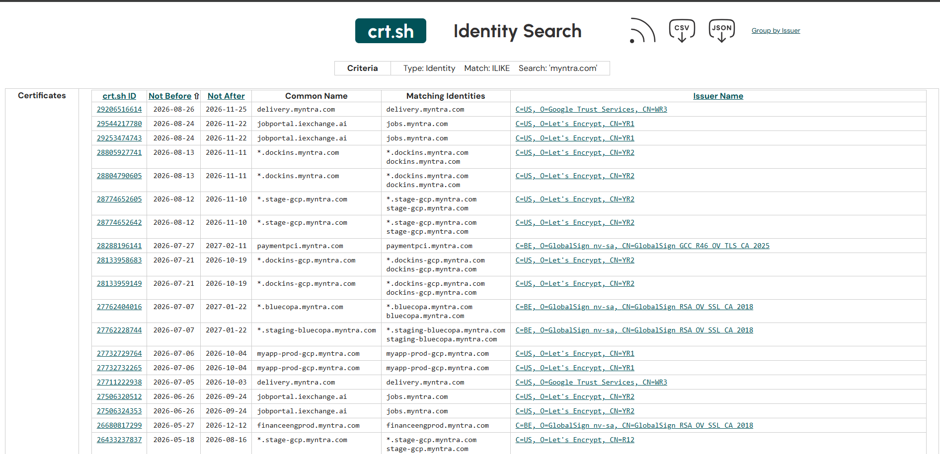

Task 5 – Record a Short Screen Capture (Maximum 2 Minutes)
1. Open Command Prompt. Press Windows key, type cmd and open it.
2. Start recording. Open Snipping Tool, choose Record, select New and select the area. If Record is unavailable, use an approved screen recorder.
3. Run DNS lookup. Type nslookup www.paytm.com and press Enter.
4. Explain the output. Say that nslookup asks DNS for the IP address and the answer shows the name and address returned.
5. Show name servers. Type nslookup -type=NS paytm.com and press Enter.
6. Stop and save. Stop the recording and save it as Footprinting_DNS_Lookup.mp4. Keep it under 2 minutes.
7. Review the video. Make sure the command and result are readable and no personal information is visible.


