GOOGLE ADVANCED SEARCH OPERATORS

Task 1 – Find Java interview-question PDFs on GeeksforGeeks
Where: Google Search.
Run these three queries one by one:
- site:geeksforgeeks.org filetype:pdf Java interview questions
- site:geeksforgeeks.org "Java interview questions" filetype:pdf
- site:geeksforgeeks.org Java interview questions (PDF OR filetype:pdf)
Steps:
- Open Google and paste the first query. Press Enter.
- Check whether each result is actually a PDF and is hosted on geeksforgeeks.org.
- Open suitable results. Confirm the PDF loads and contains Java interview questions.
- Repeat with the other two queries. Record all three exact queries.
- Take a screenshot of the results and copy three verified PDF URLs if available.

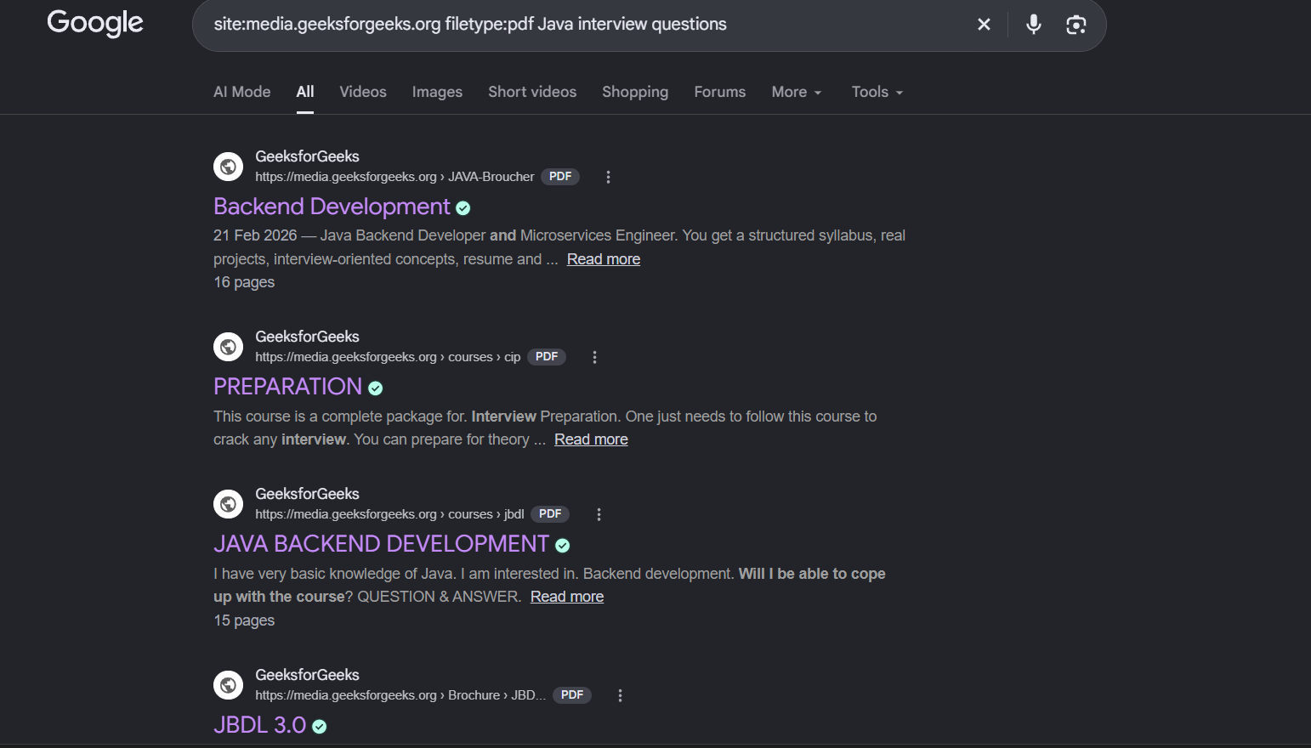

Task 2 – Search HackerOne Instagram bug-bounty reports updated in 2023
Important: The assignment specifically asks for pages updated in 2023, not reports from the past year. Use the 2023 date range requested by the task.
Try this query:
site:hackerone.com Instagram inurl:reports
Then apply Google’s date filter:
- On the results page, select Tools.
- Open the time/date dropdown (often labelled “Any time”).
- Choose Custom range.
- Set From: 01/01/2023 and To: 12/31/2023, then apply.
- Open results and check that the page is on hackerone.com and concerns Instagram.
- Record the exact query and the date filter. Take a screenshot showing the results and date range if possible.

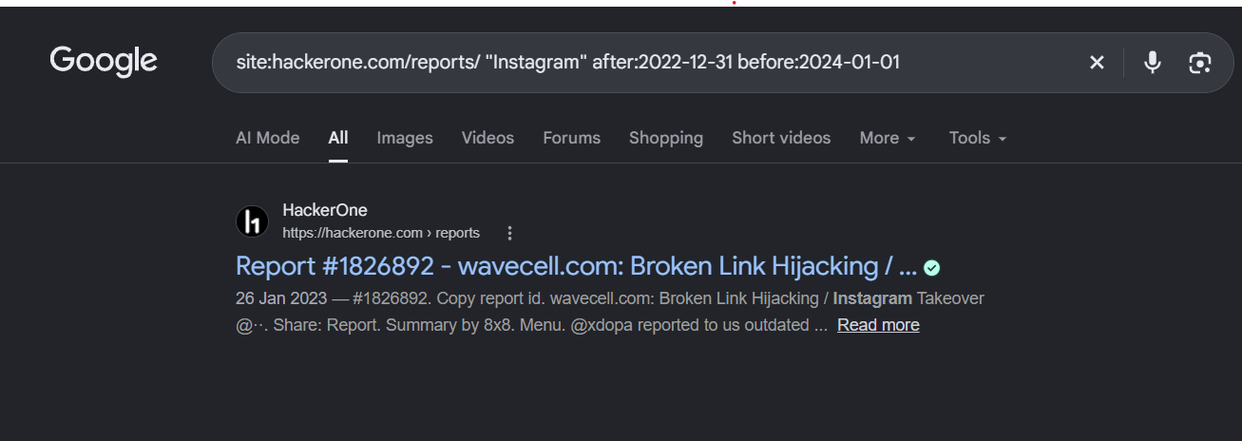

Task 3 – Find Flipkart coupon URLs, excluding “expired”
Where: Google Search.
Query:
site:flipkart.com inurl:coupon -expired
You can also try:
site:flipkart.com inurl:coupons -expired
Steps:
- Paste the first query into Google.
- Look for pages on flipkart.com with “coupon” or “coupons” in the URL.
- Open a result and check that it is a genuine Flipkart page and does not describe an expired offer.
- Record the exact query and one or more verified URLs. Take a screenshot.

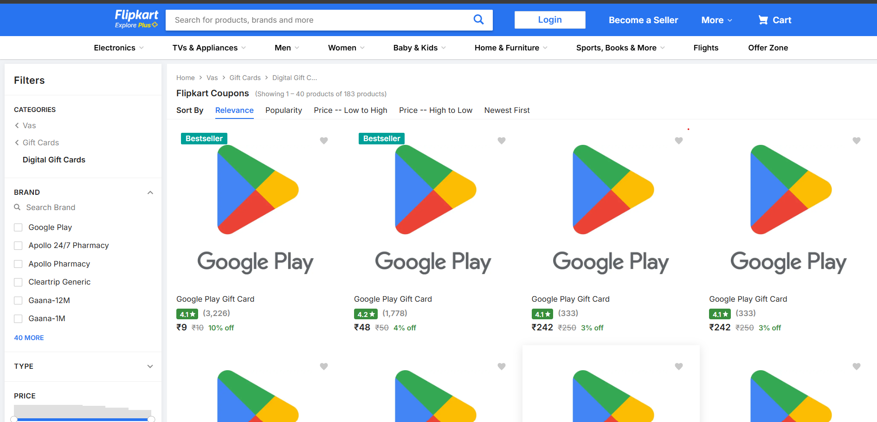

Task 4 – IPL cricket match highlights in public Google Drive folders
Safety and copyright note: IPL match highlights are copyrighted video content. Do not search for, download, or share unauthorized copies in public Drive folders. Instead, demonstrate the search-operator concept using official, authorized IPL/BCCI broadcaster sources or use the instructor-approved sample folder if one has been provided.
For a safe search-operator demonstration, you may run these queries to locate official viewing sources:
- IPL official match highlights
- site:youtube.com/@IPL IPL match highlights
If your instructor requires Google Drive folder syntax specifically, ask them to provide an authorized training folder or a non-copyrighted sample dataset. Do not submit a random public Drive folder containing unlicensed match footage. Explain that site:drive.google.com and filetype:mp4 target files, not necessarily folders; Google indexing does not reliably identify folder contents.

Task 5 – Safe fintech security research queries (privacy-safe alternative)
Three safe queries you can use:
- Paytm security incident data breach report
- site:paytm.com security contact responsible disclosure
- site:phonepe.com security vulnerability disclosure
Steps:
- Choose one of the three safe queries and search it on Google.
- Open an official company security page or a reputable public incident report.
- Do not copy, download, publish, or test any exposed email addresses or credentials.
- Record the exact query, the type of source found (official security page or public incident report), and the source URL


