SCANNING NETWORK

Task 1: Install Nmap and Scan the Local Wi-Fi Network

Procedure and Commands
- Download Nmap for Windows from the official website: https://nmap.org/download.html
- Install it using the installer. Open Command Prompt (CMD).
nmap --version
Use this command to view the computer's network configuration:
ipconfig
Find the active Wireless LAN adapter Wi-Fi section. Note its IPv4 Address, Subnet Mask, and Default Gateway. For example only, if the IPv4 address is 192.168.1.10 and the subnet mask is 255.255.255.0, scan:
nmap -sn 192.168.31.0/24
Replace 192.168.31.0/24 with the correct network range for your own Wi-Fi. Do not copy the example range unless it matches your network.
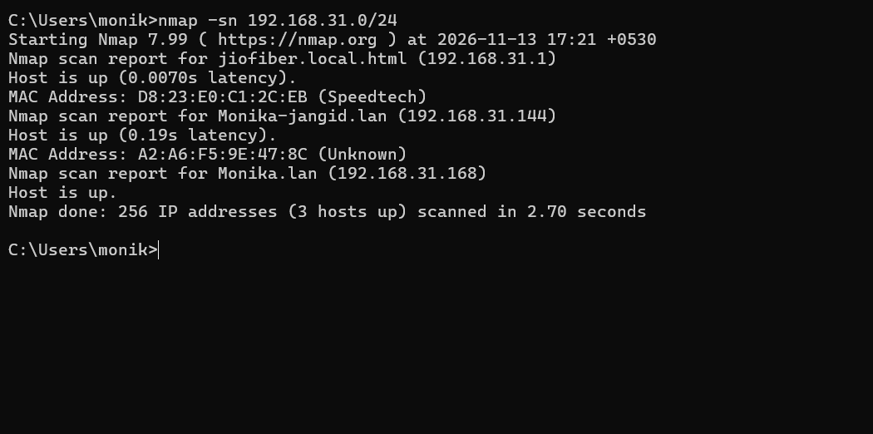

Task 2: Display and Identify Devices Using arp -a

Command and Procedure
arp -a
- Open Command Prompt and run the command.
- Find the Internet Address and Physical Address columns.
- Record at least two entries that appear in your own ARP output. Do not use sample or invented addresses. 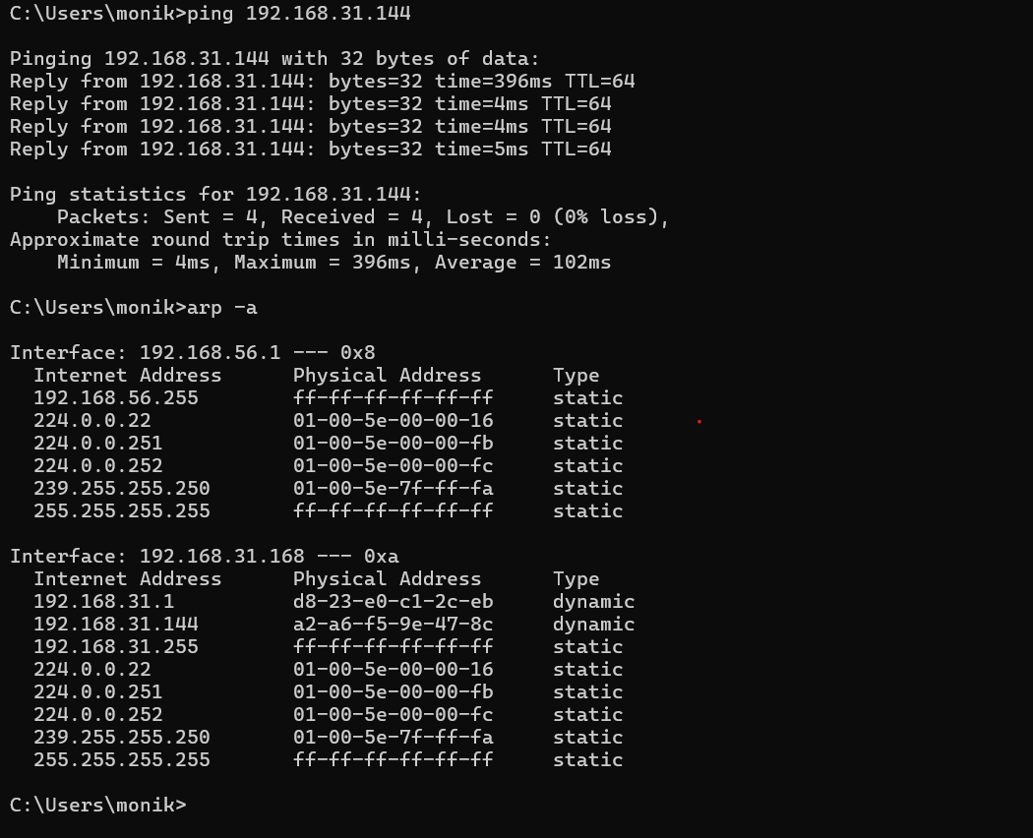

Task 3: Scan Your Own Computer for Common Ports

Command and Procedure
nmap -sV -p 22,80,443 127.0.0.1
The -p option selects the ports. The -sV option asks Nmap to identify the service/version where possible. Record the actual state shown by your scan. If Nmap reports a port as filtered or does not list it, do not automatically label it closed.
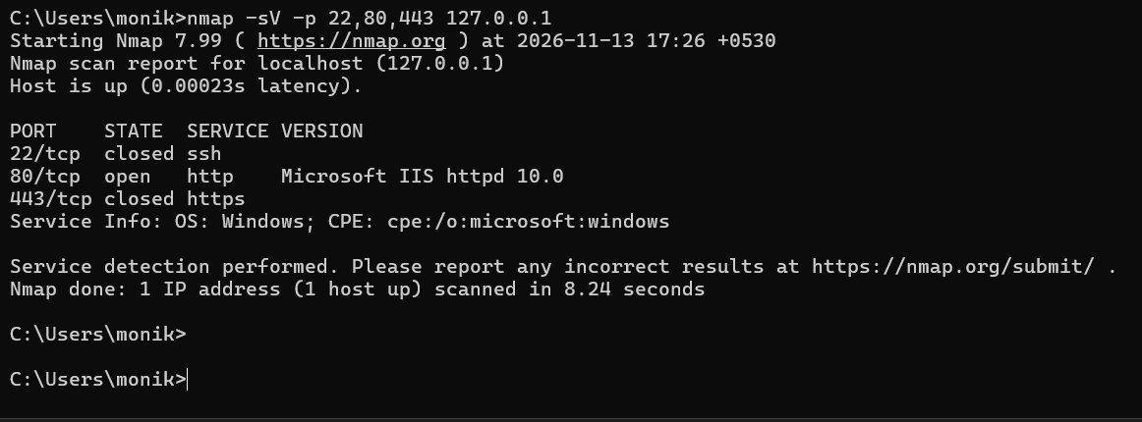

Task 4: Scan the Authorized Nmap Test Host

Theory / Explanation
Nmap provides scanme.nmap.org as a public test host for learning and testing Nmap. This task uses that explicitly provided test host, not an unrelated website or server. An open port indicates that a service is accepting connections, but an open port alone does not prove that the service is vulnerable. A proper security assessment also considers software versions, configuration, patch status, and authorization.

Command and Procedure
nmap -sV scanme.nmap.org
The command scans the default set of common ports and attempts service/version detection. The host's available ports can change, and network conditions may affect results. Only report the ports shown in your own scan.
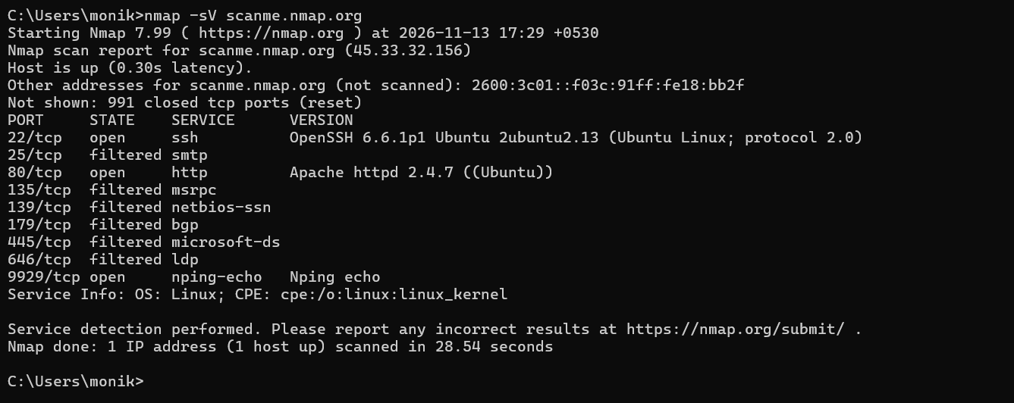

Task 5: Display Only Open Ports and Their Services

Command and Procedure
nmap --open -sV scanme.nmap.org
This command scans the provided test host, displays open ports, and attempts to identify their services and versions. Compare the output with Task 4. Results may vary between scans.
ap.org/
C:\Users\monik>nmap --open -sV scanme.nmap.org
Starting Nmap 7.99 ( https://nmap.org ) at 2026-11-13 17:31 +0530
Nmap scan report for scanme.nmap.org (45.33.32.156)
Host is up (0.33s latency).
Other addresses for scanme.nmap.org (not scanned): 2600:3c01::f03c:91ff:fe18:bb2f
Not shown: 991 closed tcp ports (reset), 6 filtered tcp ports (no-response)
Some closed ports may be reported as filtered due to --defeat-rst-ratelimit
PORT STATE SERVICE VERSION
22/tcp open ssh OpenSSH 6.6.1p1 Ubuntu 2ubuntu2.13 (Ubuntu Linux; protocol 2.0)
80/tcp open http Apache httpd 2.4.7 ((Ubuntu))
9929/tcp open nping-echo Nping echo
Service Info: OS: Linux; CPE: cpe:/o:linux:linux_kernel

Service detection performed. Please report any incorrect results at https://nmap.org/submit/ .
Nmap done: 1 IP address (1 host up) scanned in 18.00 seconds

C:\Users\monik>

