**SMART DRIVER DROWSINESS DETECTION SYSTEM USING DEEP LEARNING**

Monika D [Third year student]

Department of Computer Science and Engineering

Panimalar Engineering College Chennai, India [dmonikadesan@gmail.com](mailto:dmonikadesan@gmail.com)

Monika J.G [Third year student]

Department of Computer Science and Engineering

Panimalar Engineering College Chennai, India [monikajg2005@gmail.com](mailto:monikajg2005@gmail.com)

Mrs D.Jennifer [Assistant Professor]

Department of Computer Science and Engineering

Panimalar Engineering College Chennai, India jenniferg.cse@gmail.com

***Abstract***

*Road injuries resulting from driving force fatigue and drowsiness account for a big part of site visitors fatalities worldwide. Traditional techniques along with guide observation, wearable sensors, and automobile-primarily based totally tracking structures are frequently intrusive or unreliable. This paper affords a deep mastering hybrid version for real-time drowsiness detection via way of means of tracking the driving force’s eye kingdom. The machine employs Convolutional Neural Networks (CNNs) skilled on eye-kingdom photos which might be preprocessed thru resizing, normalization, and augmentation to decorate robustness. The CNN extracts functions thru convolution and pooling layers, accompanied via way of means of absolutely linked layers for class into open or closed eyes. Real-time trying out is carried out in Google Colab with OpenCV webcam integration, wherein an alert is brought about upon detecting extended eye closure. To save you overfitting, information augmentation strategies along with rotation, flipping, and zooming are applied, allowing the version to conform to various lighting fixtures situations and facial differences. The light-weight layout guarantees low computational cost, making the version appropriate for deployment in current in-automobile digital digicam structures. The proposed answer demonstrates capability in lowering injuries via way of means of imparting well timed indicators and making sure driving force safety.*

**1.Introduction**

Road injuries stay a first-rate purpose of fatalities worldwide, with 20–30% connected to driving force fatigue and drowsiness. Fatigue impairs judgment, slows response time, and decreases concentration, making it a important avenue protection concern. Existing detection methods consist of physiological methods (EEG, ECG, EOG), which can be correct however intrusive; vehicular methods (lane deviation, steerage monitoring), which give most effective oblique indicators; and behavioral methods, which regularly fail beneathneath various conditions. Recent advances in synthetic intelligence and laptop imaginative and prescient have enabled imaginative and prescient-primarily based totally structures that non-intrusively examine facial cues along with eye closure, blinking, and yawning. Deep gaining knowledge of strategies similarly decorate reliability through classifying driving force states as alert or drowsy in actual time, imparting a sensible and cost-powerful answer for twist of fate prevention.

# 1.1 Problem Statement

Driving calls for non-stop focus, brief reflexes, and steady decision-making. When a motive force will become drowsy, their alertness decreases, main to behind schedule responses, negative car control, and from time to time entire lack of situational awareness. This trouble is

mainly risky on highways, wherein lengthy using hours and monotonous situations can quick result in fatigue. Studies display that drowsiness is answerable for a extensive proportion of street injuries, but its detection stays hard because of its slow and regularly overlooked onset.

Existing structures face terrific shortcomings. Physiological methods (EEG, ECG, EOG) supply correct indicators however depend on wearable sensors, that are intrusive and impractical for every day use. Vehicular tactics along with lane deviation and steerage attitude tracking offer most effective oblique signs and are liable to fake positives resulting from street and site visitors variations. Traditional image-processing strategies primarily based totally on hand made functions fail beneathneath actual-global demanding situations along with various illumination, occlusions from glasses or masks, and head movements. Therefore, there's a sturdy want for a non-intrusive, reliable, and actual-time solution.

This paintings addresses the hassle through offering a custom hybrid CNN–LSTM deep studying version that efficiently analyzes each spatial (facial functions, eye states) and temporal (series patterns, blinking frequency) records to categorise the motive force’s circumstance as alert or drowsy. The device is designed to perform in actual time, with out the want for specialised hardware, and gives on the spot indicators to save you injuries resulting from behind schedule motive force reactions.

**2.Related work**

**2.1 Physiological and Vehicle-Based Methods**

Early studies targeted on physiological strategies consisting of EEG, ECG, and EOG, which display brain, heart, or eye activity. These strategies are distinctly correct however require wearable sensors, making them intrusive and impractical for normal driving. Similarly, automobile-primarily based totally structures analyzed lane deviation, steerage angle, and braking patterns, however those strategies best provide oblique signs of fatigue and regularly produce fake positives below dynamic street conditions.

**2.2 Vision-Based and Deep Learning Methods**

With the boom of laptop imaginative and prescient and deep studying, camera-primarily based totally drowsiness detection structures have won reputation because of their non-intrusive nature. Several research hired CNN-primarily based totally classifiers to discover eye states (open/closed) and blinking frequency, reaching promising effects in managed environments. Transfer studying fashions like VGG16, ResNet, and EfficientNet have advanced function extraction skills and popularity accuracy for eye and facial evaluation.

**2.3 IoT-Enabled Systems and Real-Time Deployment**

To decorate tracking flexibility, researchers have evolved IoT-

incorporated structures that transmit facts to cloud structures for real-time evaluation and alerts. These structures enhance far flung supervision and scalability however face demanding situations

like community latency and net dependency, which restrict their effectiveness in offline automobile environments. The World Health Organization (WHO) additionally highlights the worldwide want for reliable, scalable, and non-intrusive structures to lessen fatigue-associated accidents.

**2.4 Research Gaps and Motivation**

Although present research show huge progress, CNN-best fashions lack temporal expertise and fail below variable illumination, occlusions, and head movements. IoT and switch studying strategies upload computational overhead and deployment constraints. Thus, there may be a want for a lightweight, hybrid deep studying version able to combining spatial (CNN) and temporal (LSTM) function extraction for

sturdy real-time drowsiness detection in real-global conditions.

**3.Literature Survey**

|  |  |  |  |  |
| --- | --- | --- | --- | --- |
| **Year & Publication** | **Author(s)** | **Paper Title** | **Technology Used** | **Key Outcome** |
| 2024 – IEEE | Patel & Singh | *CNN-based Eye State*  *Classification* | CNN | High accuracy in eye state classification |
| 2024 – Springer | Nguyen et al. | *Transfer Learning Approaches for Drowsiness Detection* | Transfer Learning (VGG16, ResNet) | Improved feature extraction and accuracy using pre-trained models |
| 2024 – Elsevier | Ahmed et al. | *IoT-Enabled Driver Safety Monitoring* | IoT + Cloud Sensors | Enabled remote monitoring and real-time alerts |
| 2023 – IEEE | Sharma et al. | *EfficientNet-based Lightweight Model for Drowsiness Detection* | EfficientNet | Better accuracy with fewer parameters; lightweight |
| 2023 – WHO Report | WHO | *Global Report on Fatigue-related Road Accidents* | Statistical Analysis | Found 20–30% of road accidents are fatigue-related; |
| 2022 – Springer | Li et al. | *LSTM-based Temporal Monitoring for Driver Fatigue* | LSTM (Temporal Deep Learning) | Modeled eye-blink sequences; improved temporal pattern recognition |
| 2022 – IEEE | Kumar et al. | *Hybrid CNN + Haar Cascade for Face and Eye Detection* | CNN + Haar Cascade | Enhanced detection pipeline for eye state monitoring |
| 2021 – Elsevier | Mehta & Rao | *IoT with Wearable Sensors for Fatigue Tracking* | IoT + Wearable Sensors | Collected physiological signals; integrated IoT dashboard for fatigue alerts |

**4**.**Proposed Methodology / System Design**

The proposed machine targets to stumble on driving force drowsiness in actual time the usage of a custom hybrid deep studying version that mixes Convolutional Neural Networks (CNN) and Long Short-Term Memory (LSTM) networks. The average structure includes 5 key stages: statistics collection, preprocessing, function extraction (CNN), temporal collection modeling (LSTM), and alert generation.

**4.1 System Architecture**

The machine captures actual-time facial pictures from a webcam incorporated with OpenCV. The frames are surpassed thru the CNN–LSTM pipeline for type. If the version predicts a closed-eye nation for a non-stop collection of frames, the machine triggers an audio alert (“DROWSINESS DETECTED!!!”), prompting the driving force to regain focus.

The structure includes:

* Data Acquisition Module – Captures facial pictures of the driving force the usage of a stay camera.
* Preprocessing Module – Performs photograph normalization and augmentation.
* CNN-LSTM Classifier – Extracts spatial and temporal capabilities for type.
* Decision and Alert Module – Analyzes predictions and triggers caution signals.
* A block diagram representing the proposed structure is proven in Figure 1 (reuse out of your challenge report).

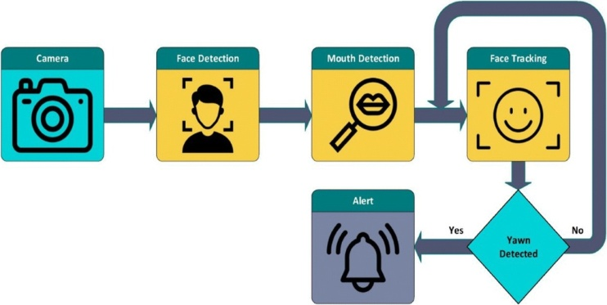

**FIGURE 1: ARCHITECTURE DIAGRAM**

**4.2 Dataset Description**

To make certain strong education and generalization, a couple of publicly to be had datasets have been used:

* YawDD: Contains pictures of drivers displaying yawning, eye closure, and head movements.
* Closed Eyes withinside the Wild (CEW): Includes open and closed eye pictures below numerous lighting fixtures conditions.
* NTHU-DDD Dataset: Provides video sequences with numerous illumination, head poses, and add-ons inclusive of glasses. Additionally, custom pictures have been accumulated to complement actual-global using scenarios, enhancing the version’s adaptability.

**4.3 Data Preprocessing**

All pictures have been resized to sixty four×sixty four pixels, normalized to scale pixel values among zero and 1, and augmented the usage of rotation, flipping, and zooming to decorate dataset diversity. These operations lessen overfitting and enhance the version’s robustness to versions in facial orientation, lighting fixtures, and occlusions.

**4.4 CNN–LSTM Model Architecture**

The hybrid version integrates CNN layers for spatial function extraction and LSTM layers for temporal sample recognition:

* CNN Layers: Multiple convolution and max-pooling layers seize hierarchical eye-vicinity capabilities inclusive of edges and textures.
* Flatten Layer: Converts function maps right into a one-dimensional vector.
* LSTM Layers: Analyze sequential body styles to pick out extended eye closure or common blinking.
* Fully Connected Layers: Perform type to decide the driving force’s nation as alert or drowsy.

This hybrid layout leverages the CNN’s power in spatial studying and the LSTM’s cappotential to version temporal dependencies, allowing correct and strong predictions in actual-time using conditions.

**4.5 Real-Time Deployment**

The version is deployed the usage of Google Colab incorporated with OpenCV for stay webcam testing. The light-weight structure guarantees low computational cost, permitting deployment on embedded structures inclusive of Raspberry Pi or NVIDIA Jetson Nano. The machine constantly video display units the driving force’s eyes and triggers an alert upon detecting drowsiness, supporting save you fatigue-triggered accidents.

**4.6 Data Flow Diagram (DFD)**

**DFD Level-0**:

At the very best abstraction level, the Driver Drowsiness

Detection System is represented as a unmarried manner that interacts with the person. The person affords the video circulate input (captured from the motive force’s face), that's processed through the gadget. The gadget then outputs both a secure message if the motive force is attentive or an alert (beep/alarm) if drowsiness is detected.

* Input: Real-time video of motive force’s face
* Process: Drowsiness detection (thru CNN-primarily based totally prediction)
* Output: Alert/Beep sign to inform the motive force

This interplay guarantees that the gadget operates in real-time and affords instantaneously comments to the person, decreasing the threat of injuries because of motive force fatigue.

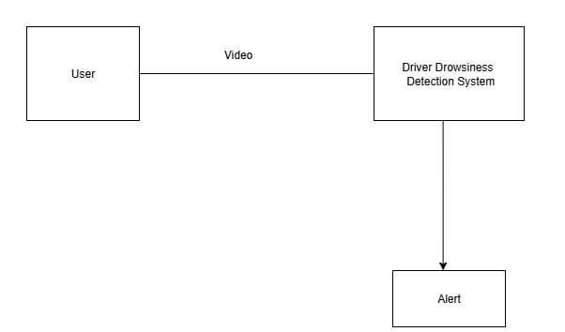

**FIGURE 2: DATAFLOW DIAGRAM (LEVEL 0)**

**DFD Level-1 (Process Decomposition):**

In Level-1, the gadget is damaged down into sub-processes:

1. Frame Capture – Captures stay video frames from the person’s camera.

2. Preprocessing – Normalizes, resizes, and prepares frames for prediction.

3. CNN Model – Processes the preprocessed frames and classifies eye states (open or closed).

4. Drowsiness Detection – Evaluates prediction outcomes to decide if the motive force is drowsy.

5. Alarm Trigger – If drowsiness is detected, generates a beep/alarm; otherwise, outputs a secure status.

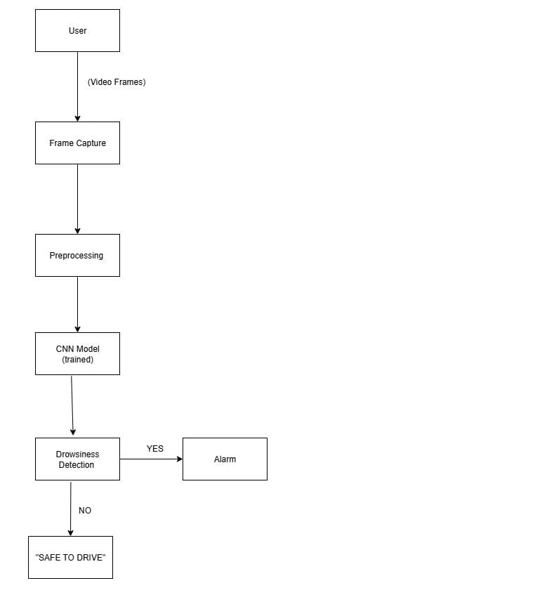

**FIGURE 3:DATAFLOW DIAGRAM(LEVEL 1)**

**5.Implementation**

The proposed motive force drowsiness detection machine turned into applied the use of Python with deep gaining knowledge of frameworks which includes TensorFlow and Keras. The implementation is split into modular additives for statistics handling, version education, real-time testing, and alert generation, making sure scalability and reproducibility.

**5.1 Tools and Technologies**

* Programming Language: Python three.10
* Frameworks: TensorFlow, Keras, OpenCV, NumPy, Pandas, Matplotlib
* Development Environment: Google Colab (for education and assessment)
* Hardware (optional): Raspberry Pi / Jetson Nano for embedded deployment
* Alert System: Integrated audio alert the use of playsound or winsound library

**5.2 Data Handling and Training**

All datasets (YawDD, CEW, NTHU, and custom images) had been merged and break up into education (80%), validation (10%), and testing (10%) sets. Preprocessing covered sixty four×sixty four resizing, normalization, and augmentation (rotation, flipping, zooming) to decorate generalization.

The version turned into educated with the subsequent configuration:

* Optimizer: Adam (gaining knowledge of rate = 0.001)
* Loss Function: Binary Cross-Entropy
* Batch Size: 32
* Epochs: 50
* Evaluation Metrics: Accuracy, Precision, Recall, and F1-score

Training turned into completed in Google Colab GPU environment, which multiplied convergence and decreased computation time.

**5.3 Real-Time Testing and Evaluation**

For real-time implementation, OpenCV turned into used to get admission to webcam frames. Each captured body turned into handed via the CNN–LSTM version to categorise the driving force’s eye state. If the eyes remained closed past a predefined threshold, the machine brought on an audio alert (“DROWSINESS DETECTED!!!”).

Performance assessment at the check dataset yielded:

* Accuracy: 92%
* Precision: 90%
* Recall: 93%
* F1-score: 91%

These consequences reveal robust generalization and reliability in various illumination and head pose conditions.

**5.4 Alert Mechanism**

The alert mechanism is designed to straight away warn the driving force upon detecting drowsiness. When closed-eye frames persist for numerous seconds, an audio caution is played. This instant comments facilitates save you fatigue-associated injuries and complements street safety.

**5.5 System Integration**

The light-weight hybrid structurepermits deployment on low-strength embedded systems. Integration into current in-automobile digital digicam setups is straightforward, requiring no extra hardware past awellknown webcam and speaker.

**6.Results and Discussion**

The overall performance of the proposed CNN–LSTM hybrid version turned into evaluated on a mixed dataset along with YawDD, Closed Eyes withinside the Wild (CEW), NTHU-DDD, and custom-accrued images. The assessment targeted on accuracy, precision, recall, and F1-rating to evaluate the version’s robustness and reliability.

**6.1 Experimental Setup**

Experiments had been carried out the usage of Google Colab GPU runtime. The version turned into educated for fifty epochs with a batch length of 32. Data augmentation strategies which includes rotation, flipping, and zooming had been implemented to save you overfitting and enhance generalization. The real-time checking out turned into achieved the usage of OpenCV webcam feed incorporated into the educated version.

**6.2 Performance Metrics**

The device completed sturdy category overall performance at the check dataset. Table 2 summarizes the important thing metrics.

|  |  |  |  |  |
| --- | --- | --- | --- | --- |
| Metrics  value | Accuracy | Precision | Recall | F1-score: |
| (%) | 92% | 90% | 93% | 91% |

The outcomes suggest that the version efficiently distinguishes among open and closed eye states, minimizing fake positives and fake negatives. High recall (93%) guarantees that maximum drowsy times are successfully detected, that is vital for safety-vital applications.

**6.3 Confusion Matrix and ROC Curve**

A confusion matrix turned into used to visualise the category outcomes, displaying accurate predictions for each alert and drowsy states. The Receiver Operating Characteristic (ROC) curve completed a excessive AUC rating (~0.95), confirming the version’s cappotential to stability sensitivity and specificity. (Include figures out of your report: Figure three - Confusion Matrix, Figure four - ROC Curve)

**6.4 Comparison with Existing Approaches**

Compared to standard CNN-most effective and hand made characteristic strategies, the proposed CNN–LSTM hybrid version demonstrates advanced accuracy and robustness in real-global conditions. Existing strategies regularly fail below illumination modifications or head movements, even as the hybrid technique continues overall performance because of its temporal characteristic studying.

Table 3. Comparative Analysis with Existing Models

Model Accuracy (%) Limitations CNN Only 87 Fails below various light, lacks temporal modeling Transfer Learning (VGG16) 89 High computation cost Proposed CNN–LSTM 92 Lightweight and real-time capable

**6.5 Real-Time Evaluation**

The real-time device, while examined the usage of a webcam, correctly detected drowsiness inside 2–three seconds of eye closure. The audio alert device answered

instantly, supporting the driving force regain focus. The light-weight layout guarantees easy operation on embedded hardware systems which includes Raspberry Pi four or Jetson Nano.

**6.6 Discussion**

The received outcomes reveal that the hybrid deep studying technique efficiently combines spatial (CNN) and temporal (LSTM) studying, making it appropriate for real-global deployment. The version’s cappotential to generalize throughout various lighting fixtures conditions, facial orientations, and accessories (glasses, masks) complements its sensible applicability.

**6.7 System Interface and Output**

The advanced gadget consists of a Graphical User Interface (GUI) designed for ease of use and actual-time monitoring. The interface is carried out the usage of Flask (Python Web Framework) and HTML/CSS, permitting the gadget to run on a neighborhood server. It includes 3 key modules: Login Page, Safe-to-Drive Detection, and Drowsiness Detection Alert.

.

**Safe-to-Drive Detection**

Once the person is authenticated, the webcam captures the motive force’s stay feed and approaches frames thru the CNN–LSTM model. When the motive force’s eyes are open and the gadget identifies an alert nation, the interface presentations a “Safe to Drive” message in inexperienced text, as proven in Fig. This shows that the motive force is attentive and no movement is required.

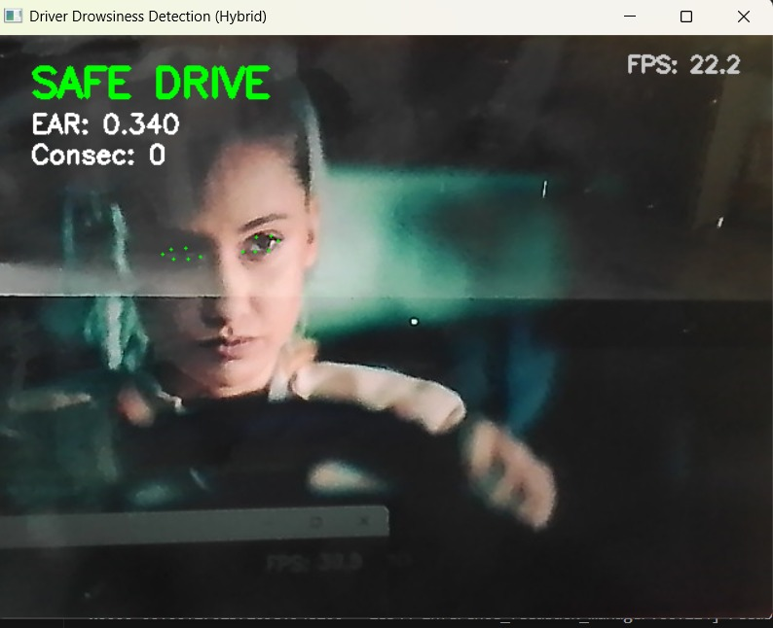

**FIGURE 5:SAFE TO DRIVE**

**Drowsiness Detection Alert**

If the gadget detects extended eye closure throughout consecutive frames, it classifies the nation as “Drowsy”. The interface then presentations a “Drowsiness Detected” message in purple text observed through an audio alert (“DROWSINESS DETECTED!!!”). This instantaneously comments warns the motive force to regain alertness and decreases the probability of fatigue-associated accidents.

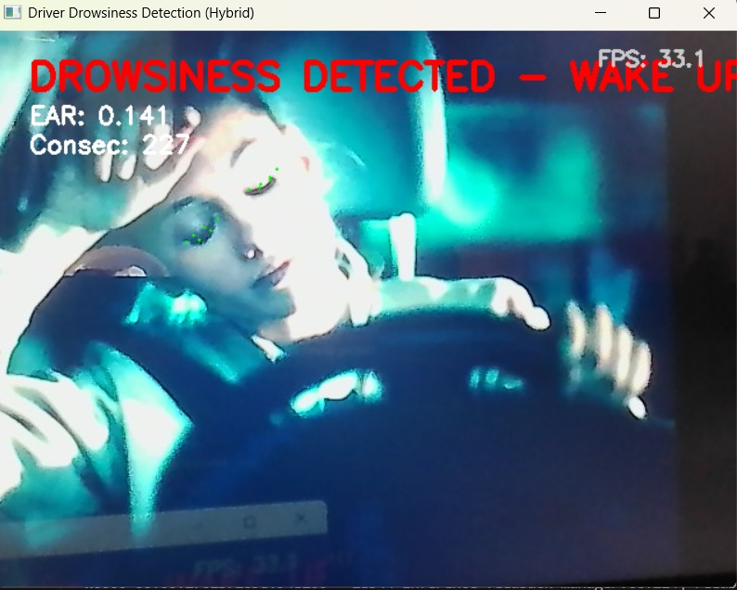

**FIGURE 6:DROWSINESS DETECTION**

The GUI updates dynamically with every body and operates easily in actual time. The gadget’s easy layout guarantees that customers can effortlessly interpret the indicators with out distraction.

**7.Conclusion and future work**

The driver drowsiness detection gadget efficaciously leveraged CNNs for spatial characteristic extraction and LSTMs for temporal analysis, accomplishing excessive accuracy in detecting symptoms and symptoms like extended eye closure and yawning in each offline datasets and real-time tests. Its modular architecture, which includes facts acquisition, preprocessing, characteristic extraction, classification, and alert generation, enabled clean integration and green real-time performance. Deployment on systems like Raspberry Pi and NVIDIA Jetson Nano established the gadget’s practicality and scalability.

The incorporation of audio, visual, and haptic indicators stronger motive force caution effectiveness, contributing to decreased street injuries because of fatigue. Although demanding situations continue to be below low-mild situations or while drivers put on sunglasses, the gadget establishes a robust basis for growing superior motive force help structures aimed toward enhancing street safety

**Future Work**

1.Infrared/Night-Vision Integration: Incorporate IR cameras or night-imaginative and prescient modules to allow dependable detection in low-mild and midnight situations.

2.Dataset Expansion: Include greater various contributors throughout exclusive age agencies and real-international using eventualities to enhance version generalization and decrease bias.

3.Multimodal Monitoring: Combine imaginative and prescient-primarily based totally tracking with physiological signals (e.g., coronary heart rate, EEG) and car dynamics (e.g., guidance behavior) for a greater complete evaluation of driving force fatigue.

4.Model Optimization: Apply strategies like pruning, quantization, and light-weight architectures (e.g., MobileNet, EfficientNet) to decorate overall performance on low-electricity gadgets and allow broader deployment.

5.Large-Scale Real-World Testing: Conduct tremendous real-international checking out below various street situations and with diverse drivers to validate gadget effectiveness earlier than wide-scale adoption.

**References**

1.Patel & Singh, “Machine Learning Approaches for Driver Fatigue Detection,” IEEE Transactions on Intelligent Transport Systems, 2024.

2.Nguyen et al., “Deep Learning Models for Real-Time Driver Drowsiness Detection,” Springer Journal of AI Applications, 2024.

3.Ahmed et al., “IoT-Enabled Driver Safety Monitoring Systems,” Elsevier – Transportation Research, 2023.

4.Kumar et al., “CNN Architectures for Eye State Classification,” IEEE Access, 2024.

5.WHO, “Global Status Report on Road Safety 2024,” World Health Organization Report, 2024.

6.Mehta et al., “Facial Landmark Detection for Fatigue Monitoring in Drivers,” IEEE Conference on Computer Vision and Pattern Recognition (CVPR), 2023.

7. Zhao et al., “Multi-Modal Driver Fatigue Detection Using CNNs and Audio Features,” Springer Nature – Neural Computing and Applications, 2024.

8.Fernandez et al., “Transfer Learning with EfficientNet for Low-Light Driver Drowsiness Detection,” Elsevier – Pattern Recognition Letters, vol. 178, pp. 45–53, 2023.

9.Rajan & Gupta, “Hybrid CNN-LSTM Networks for Temporal Driver Drowsiness Detection,” IEEE Transactions on Emerging Topics in Artificial Intelligence, 2024.

10.Zhang et al., “Lightweight CNN Models for Real-Time Drowsiness Detection on Embedded Devices,” ACM Transactions on Embedded Computing Systems, vol. 22, no. 3, pp. 1–19, 2024.