**Deploying a simple FASTAPI in Azure**

* **Go to portal.azure.com and sign in**

**Step 1: Create an app service on Azure**

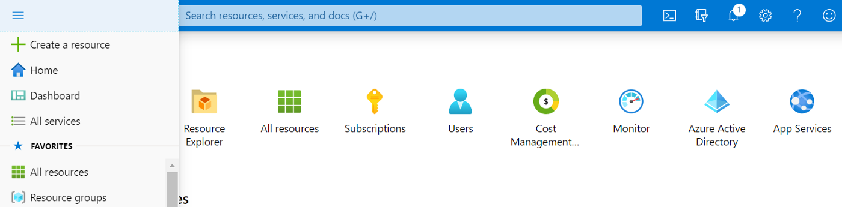

1.1 Go to portal.azure.com and sign in. Click on “**Create a resource**”

1.2 Search for “**Web App**” and click on it.(fill out the details as per your account settings)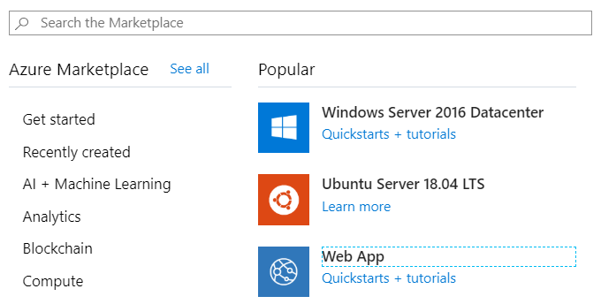1.3 Hit **Review and Create** and after the validation, hit **Create button**

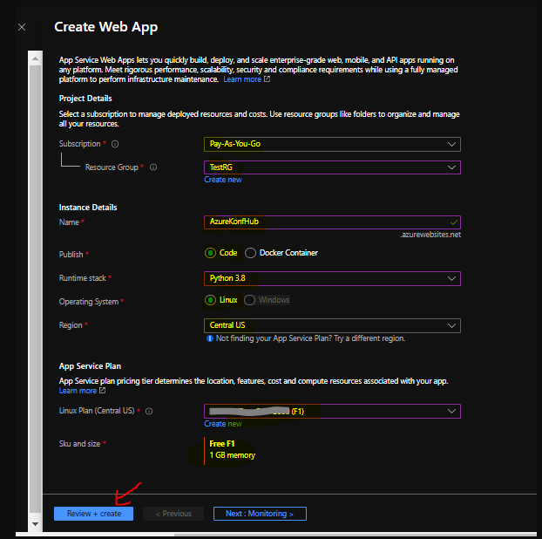

**Step 2: Configuring Deployment settings of App Service**

2.1Click on previously created **App Service**

2.3 Select **Github** as the Source Control Provider2.4 Select ‘**Kudu’** as your build provider and hit ‘**Continue’** again.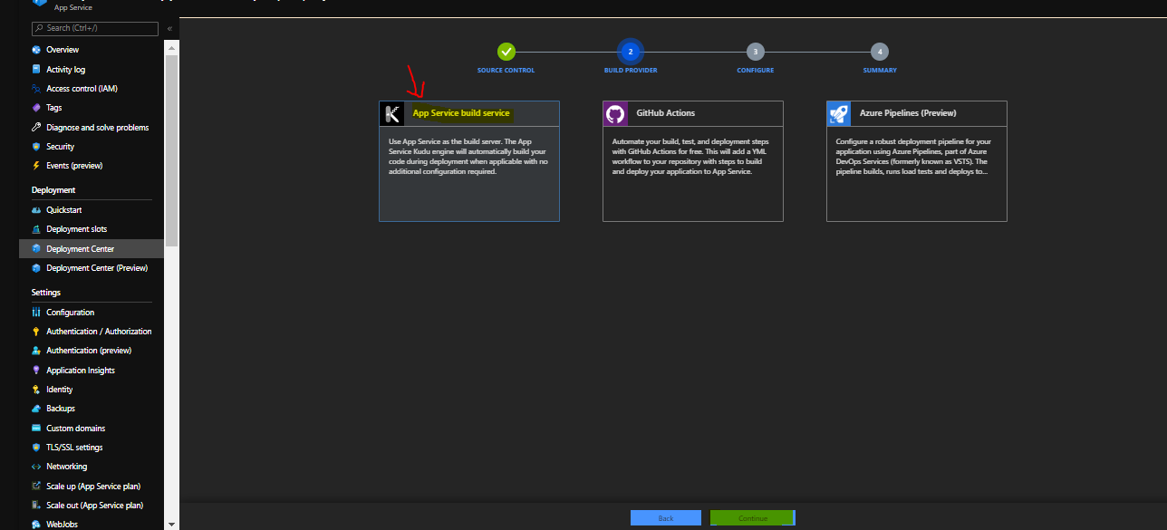

**Step 3 : You will be taken to Configure Tab to select the respective repo in your GitHub account that you want to publish to Azure App Service**

That’s how we can configure and deploy a python based web app from GitHub Repos to Azure