**ZEN CLASS – Data Modelling**

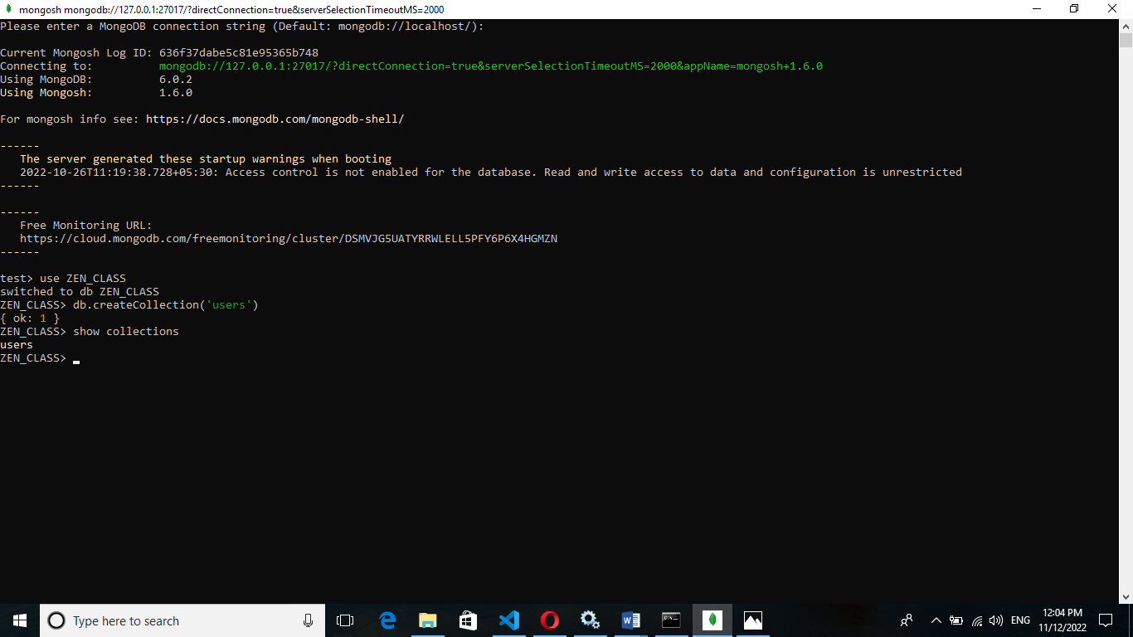

**Insert to Users Collection:**

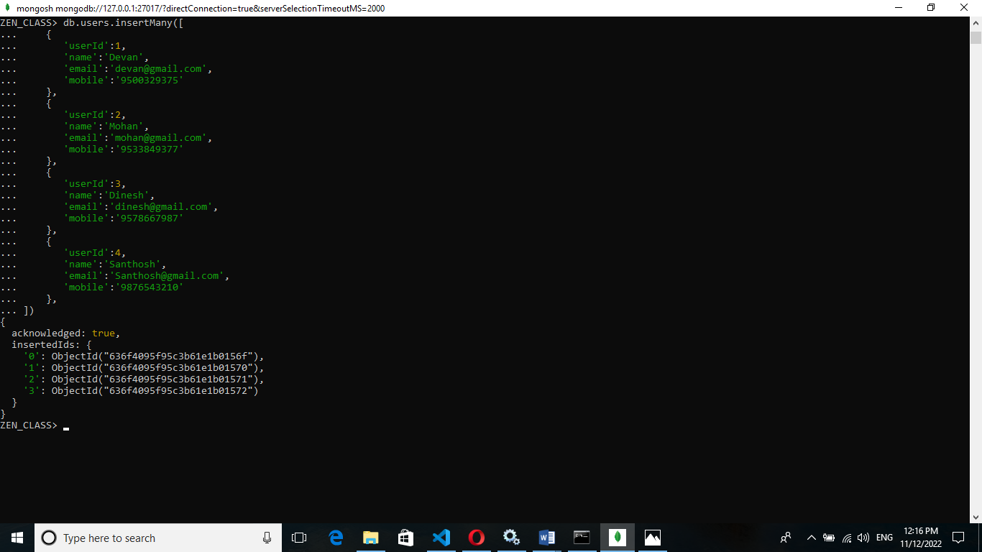

**Insert to codekata collection:**

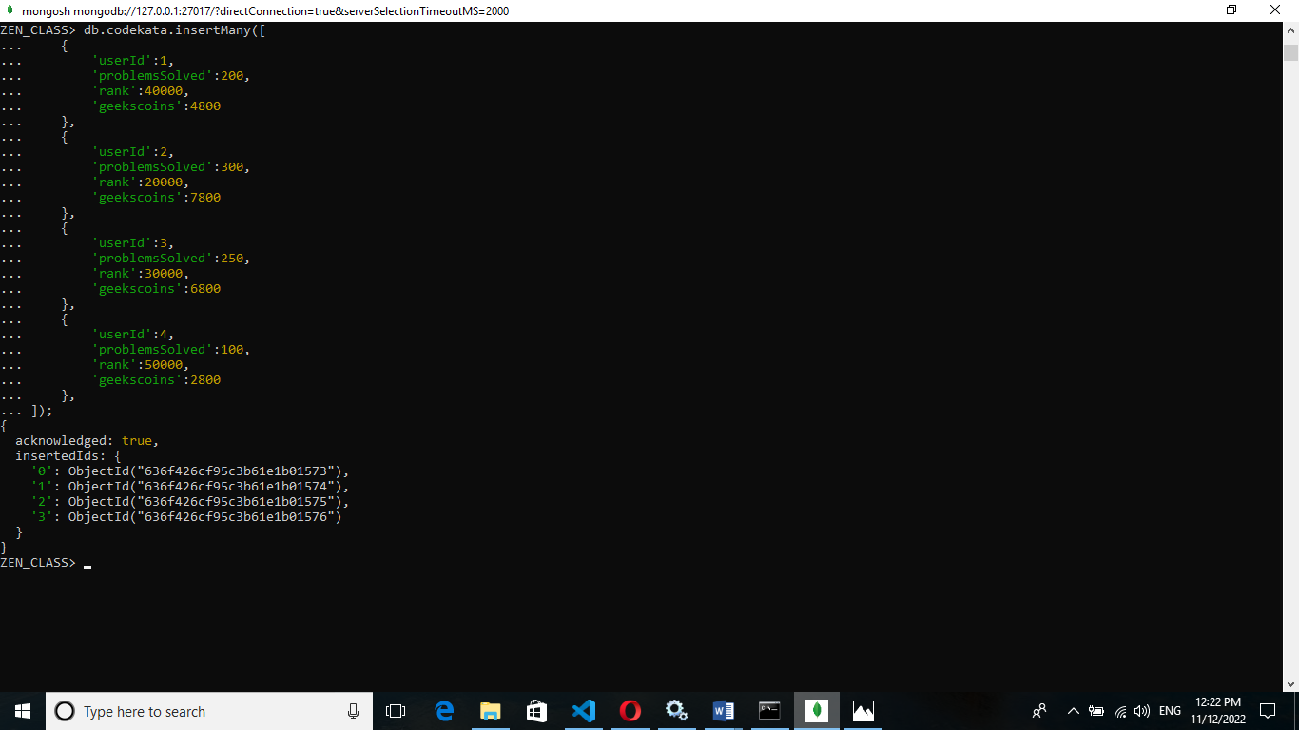

**Insert to attendance collection:**

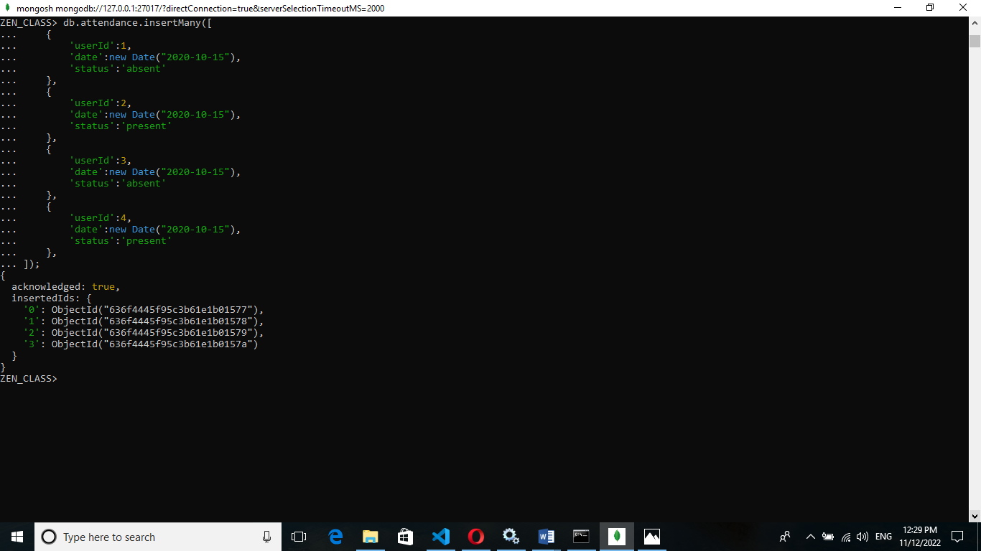

**Insert to topics collection:**

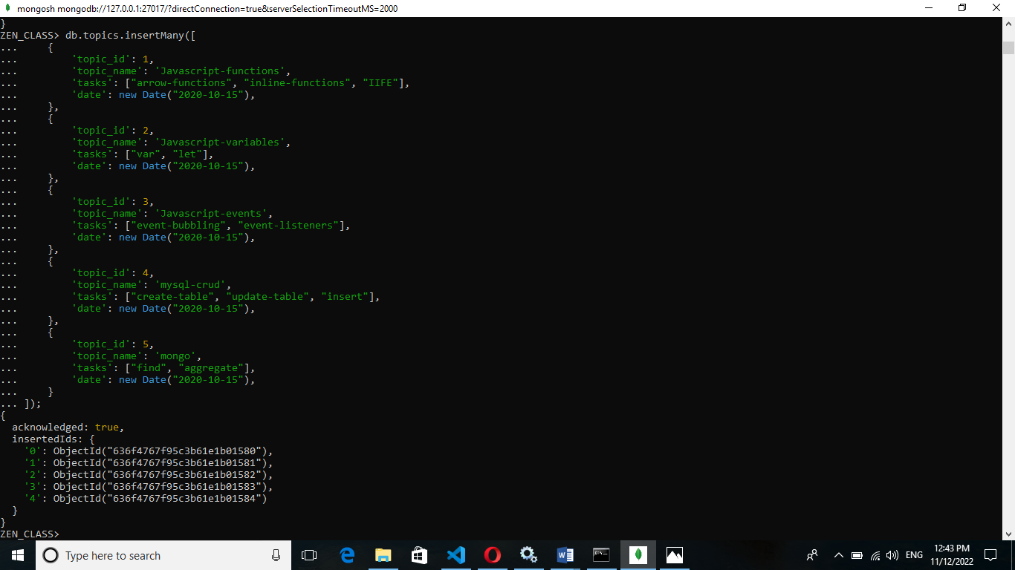

**Insert to drives collection:**

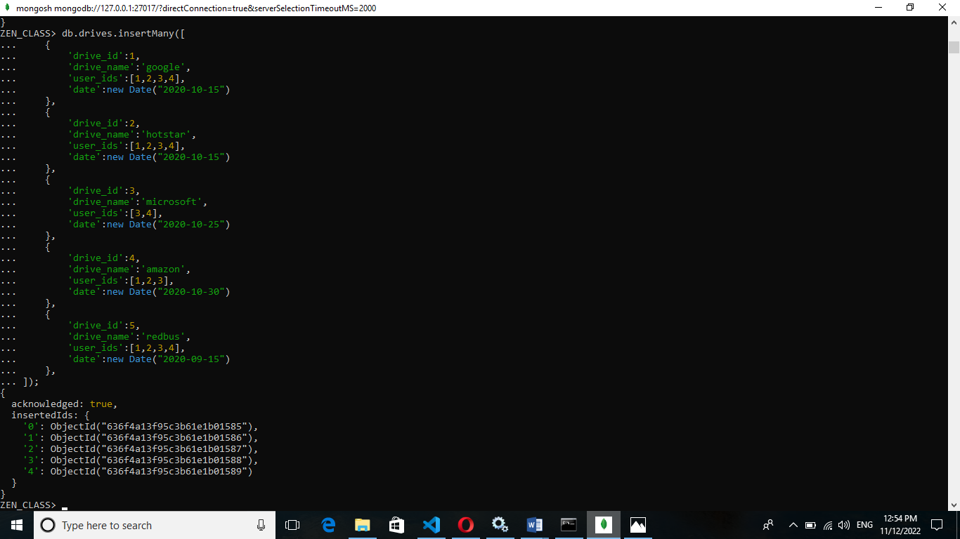

**Insert to mentors collection:**

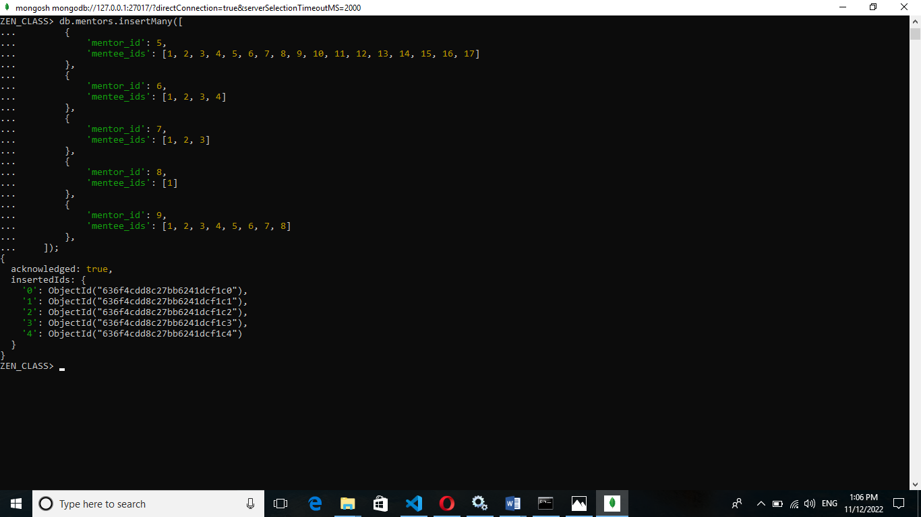

**Insert to tasks collection:**

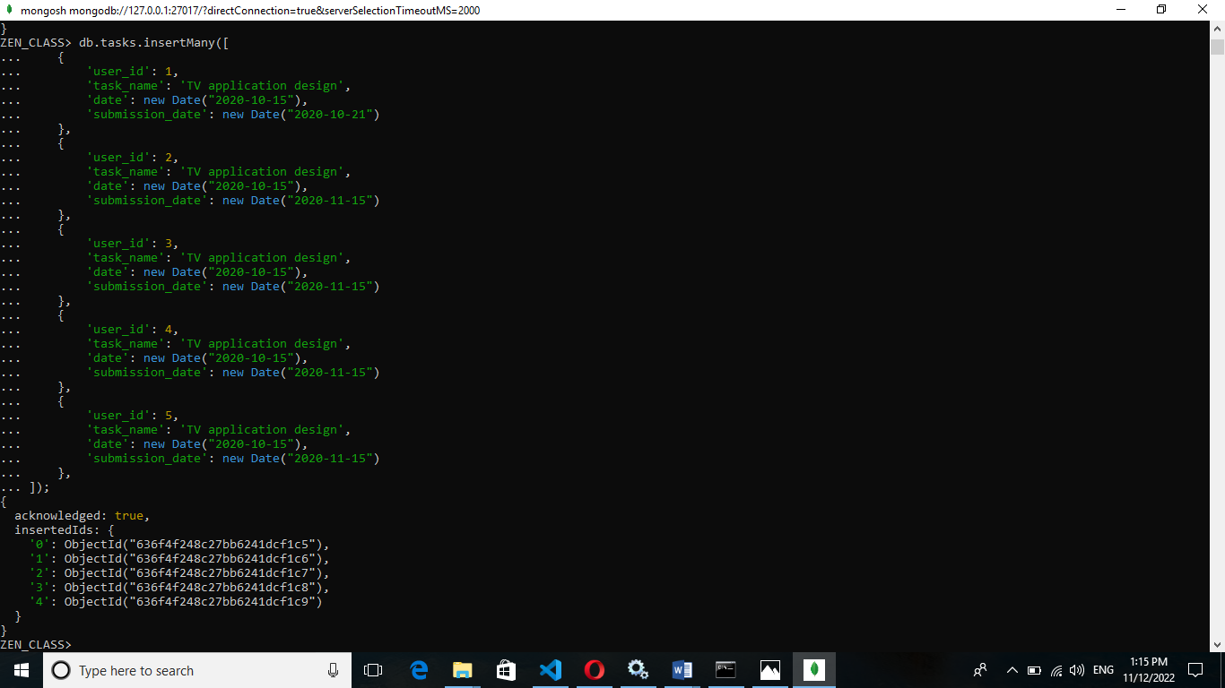

**1.Find all the topics and tasks which are taught in the month of October**

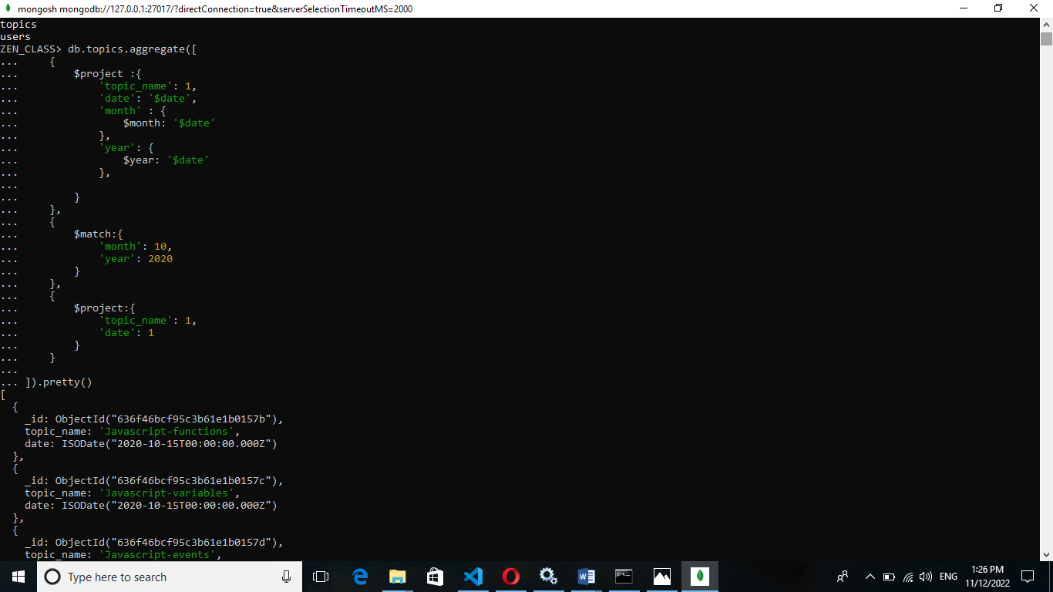

**2.Find all the company drives which appeared between 15 oct-2020 and 31-oct-2020**

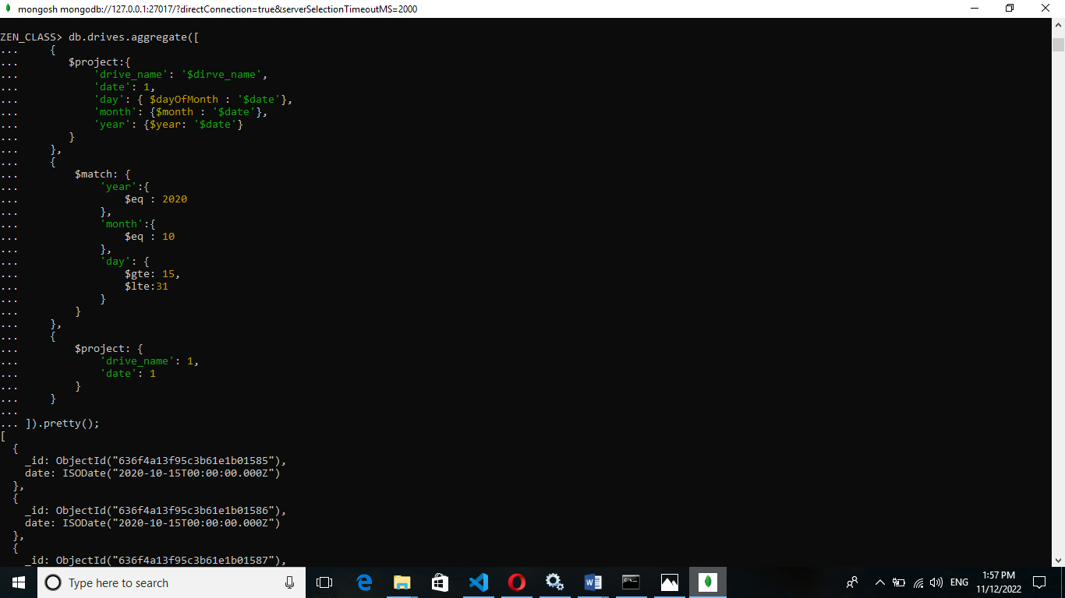

**3.Find all the company drives and students who are appeared for the placement**

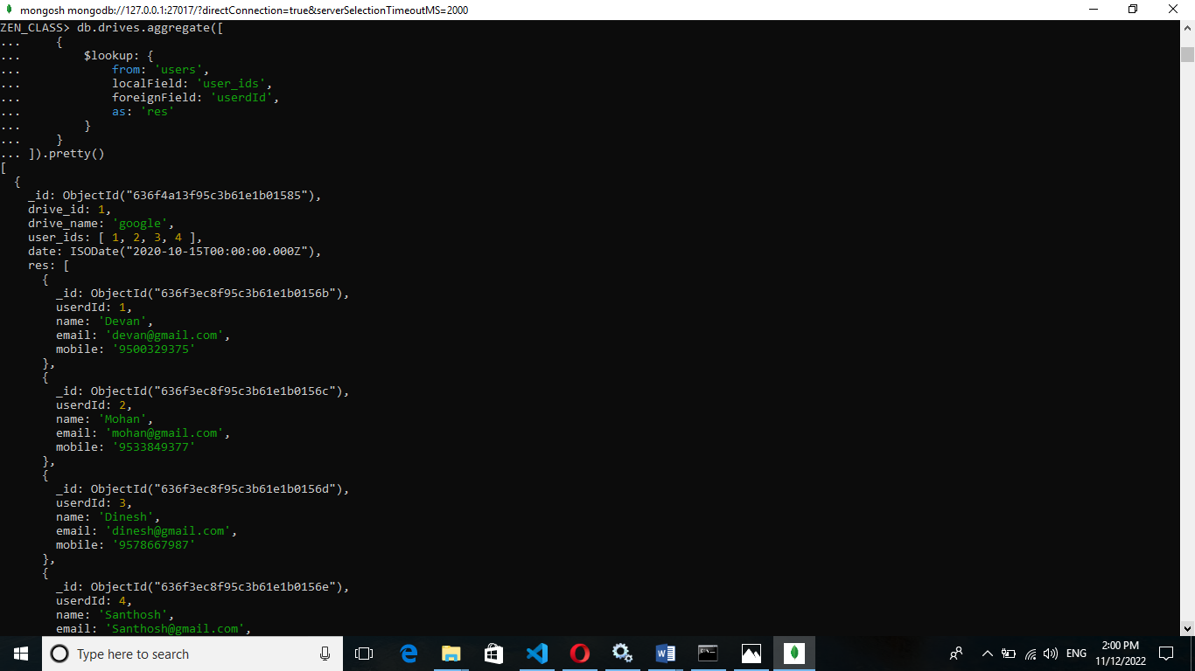

**4.Find the number of problems solved by the user in codekata**

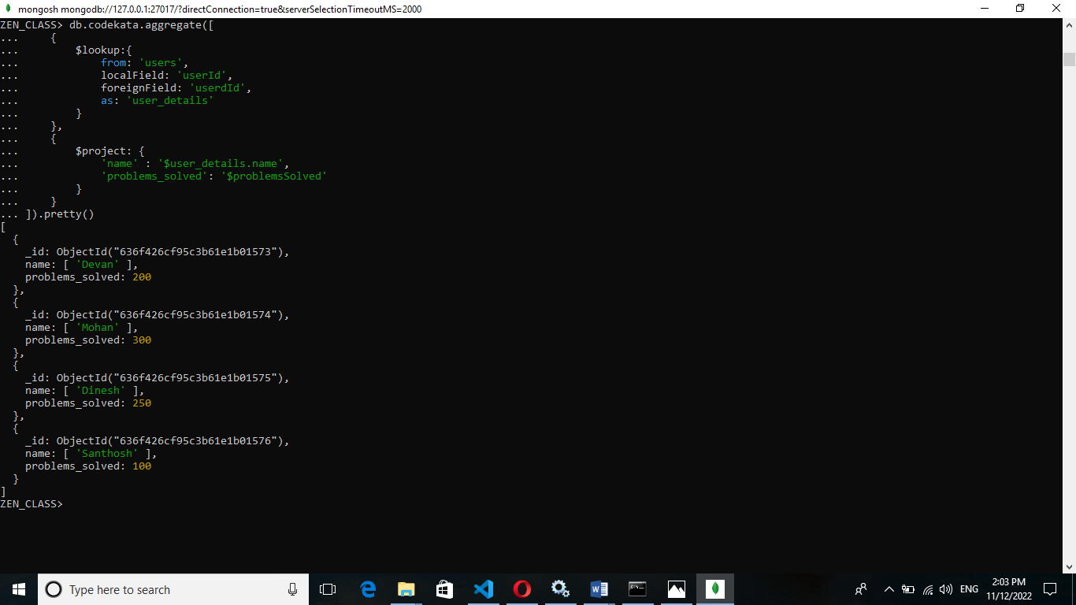

**5.Find all the mentors with who has the mentee's count more than 15**

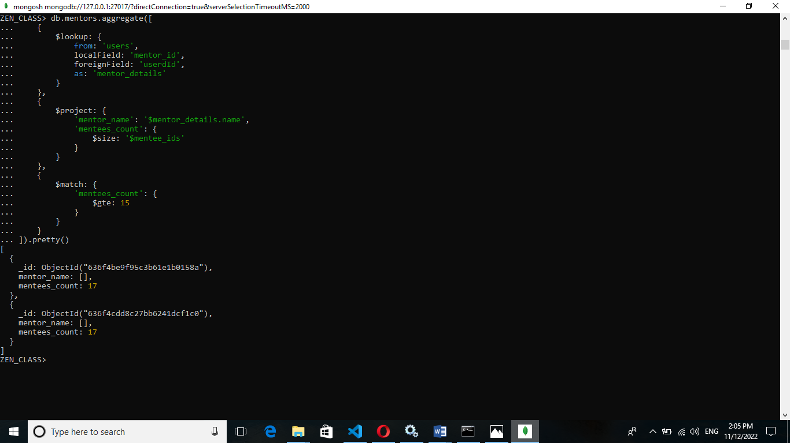

**6.Find the number of users who are absent and task is not submitted between 15 oct-2020 and 31-oct-2020**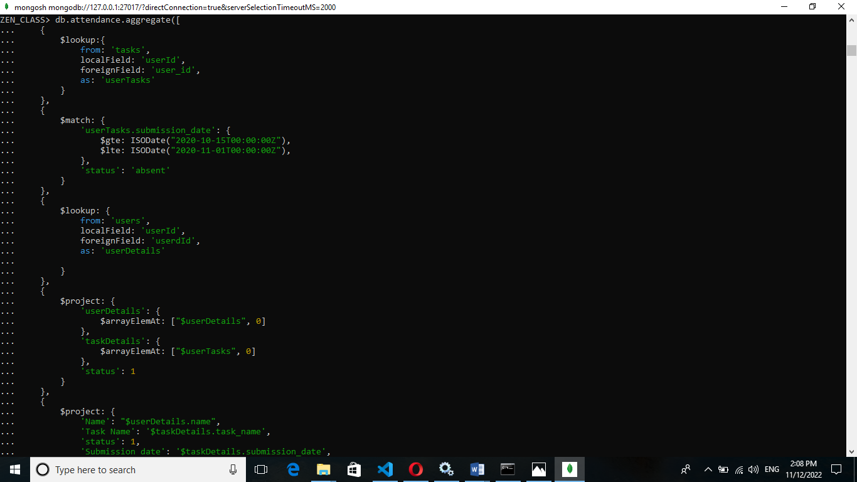

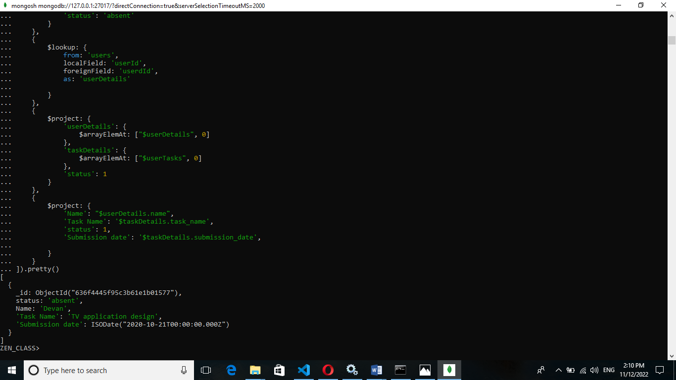

Thank You