CODEALPHA INTERNSHIP
Iris Flower Classification
Task 1 — Data Science Internship Report
Multi-Model Classification with Exploratory Data Analysis

Dataset  150 samples · 3 species | Best Accuracy  100.0% (KNN)

1. Introduction
The Iris Flower Classification project is a foundational machine learning task that involves predicting the species of an Iris flower based on four physical measurements. This report presents a complete analysis conducted as part of the CodeAlpha Data Science Internship (Task 1).
The dataset contains 150 samples across three species — Iris-setosa, Iris-versicolor, and Iris-virginica — with four features measured per sample: Sepal Length, Sepal Width, Petal Length, and Petal Width (all in centimetres).

2. Dataset Overview
Total Samples | 150
Number of Features | 4
Number of Classes | 3 (balanced, 50 each)
Missing Values | None
Features | SepalLengthCm, SepalWidthCm, PetalLengthCm, PetalWidthCm
Target Variable | Species

3. Exploratory Data Analysis

3.1 Species Distribution
The dataset is perfectly balanced with exactly 50 samples per species, making it an ideal classification benchmark.
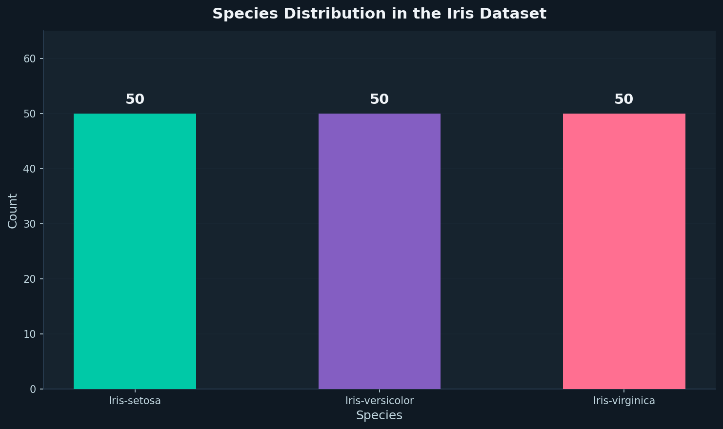

3.2 Feature Pair Relationships
The scatter matrix below reveals that Petal Length and Petal Width are the most discriminating features. Iris-setosa is clearly linearly separable from the other two species across all petal measurements.
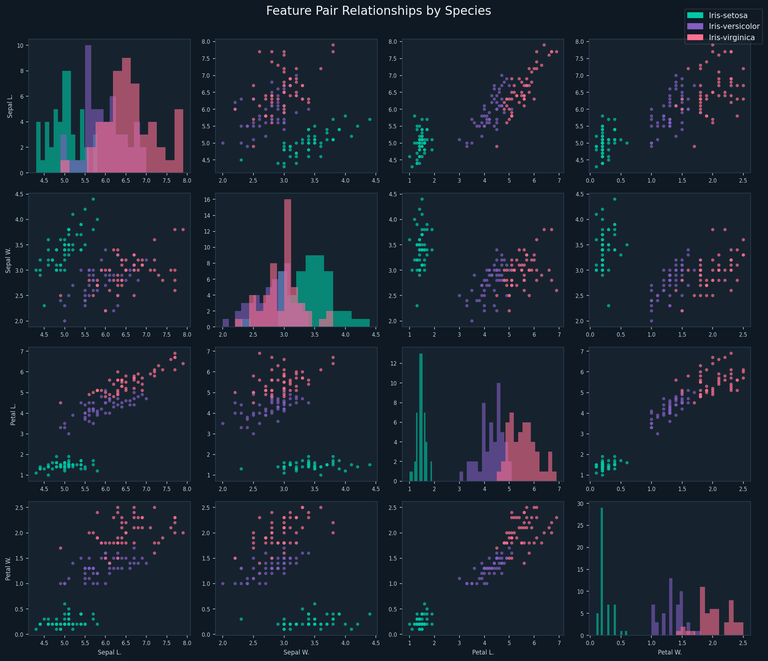

3.3 Feature Distributions by Species
Box plots confirm that petal measurements vary dramatically across species, while sepal measurements exhibit considerable overlap — particularly between Iris-versicolor and Iris-virginica.
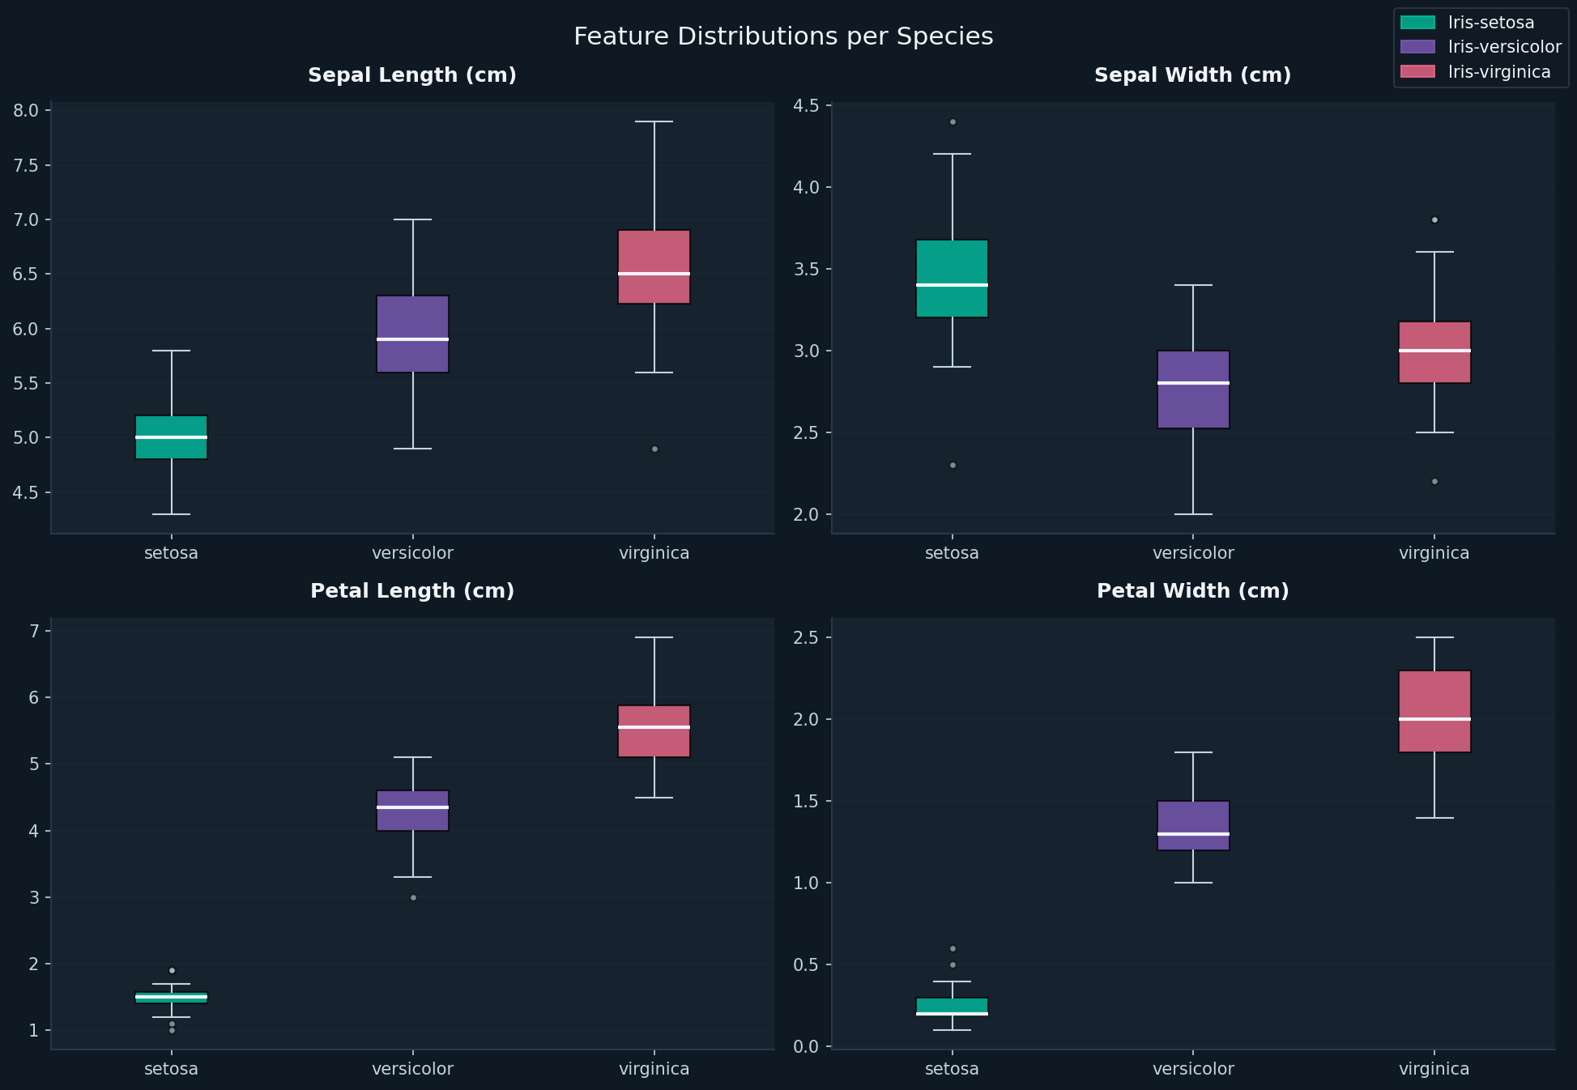

4. Methodology

4.1 Data Preprocessing
- Dataset loaded and verified — no missing values found.
- Features extracted: SepalLengthCm, SepalWidthCm, PetalLengthCm, PetalWidthCm.
- Target variable (Species) label-encoded for model training.
- 80/20 stratified train-test split applied (120 training, 30 testing samples).

4.2 Models Trained
Five supervised classification algorithms were evaluated:
- Logistic Regression — linear classifier, max_iter=200
- Decision Tree Classifier — CART algorithm, random_state=42
- Random Forest Classifier — 100 estimators, random_state=42
- Support Vector Machine (SVM) — RBF kernel
- K-Nearest Neighbours (KNN) — k=5

5. Results

5.1 Model Accuracy Comparison
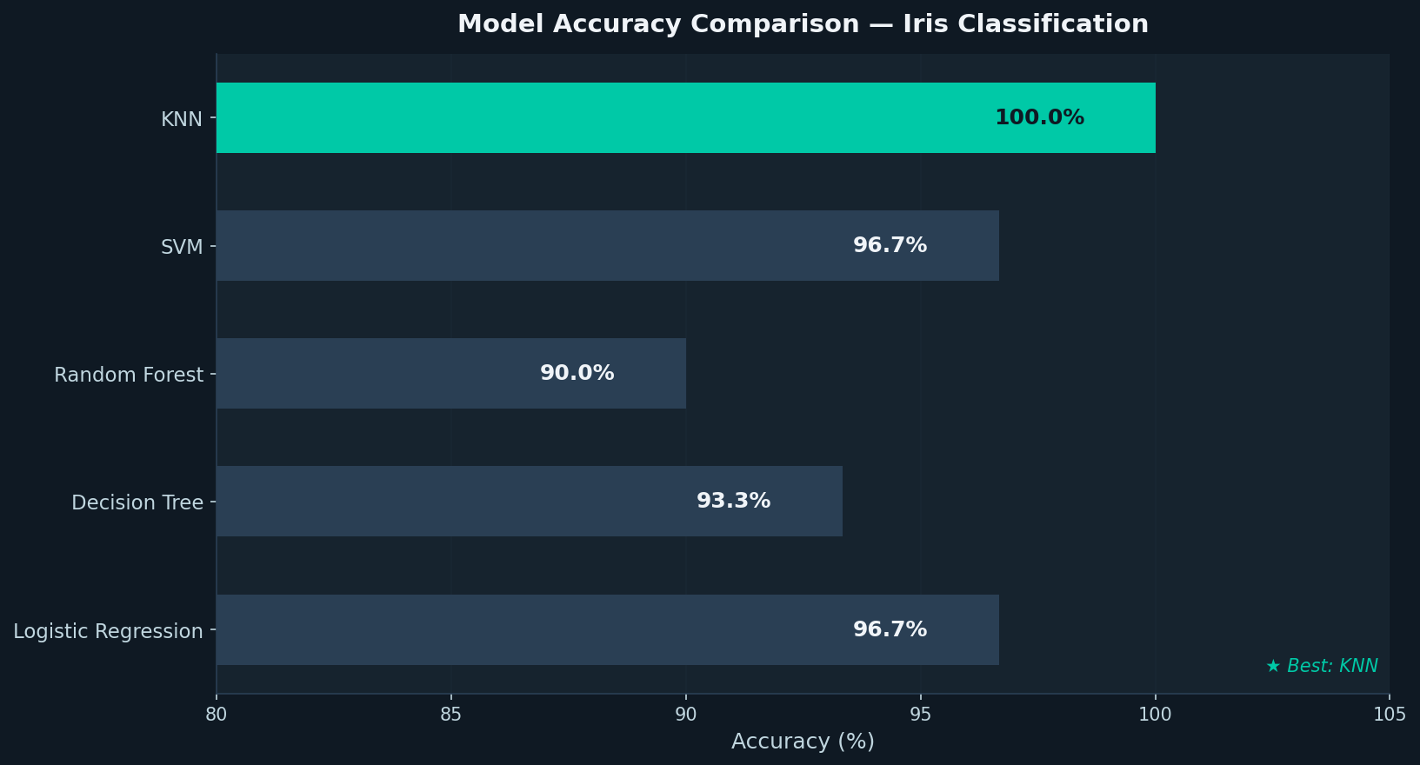
Model | Test Accuracy
KNN (k=5) | 100.0% ★ Best
Logistic Regression | 96.7%
SVM (RBF) | 96.7%
Decision Tree | 93.3%
Random Forest | 90.0%

5.2 Confusion Matrix — Best Model (KNN)
The KNN classifier achieved perfect classification on the 30-sample test set, correctly identifying all samples across all three species with zero misclassifications.
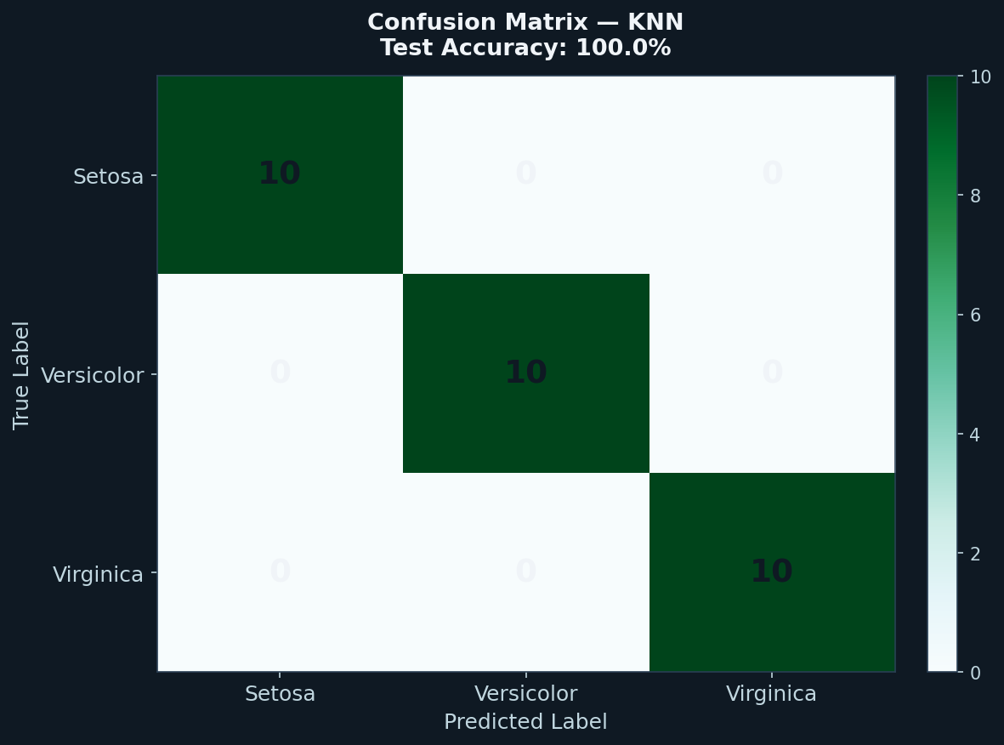

5.3 Feature Importance (Random Forest)
Random Forest feature importance analysis confirms that Petal Length and Petal Width are the dominant predictors, while Sepal Width contributes least to classification performance.
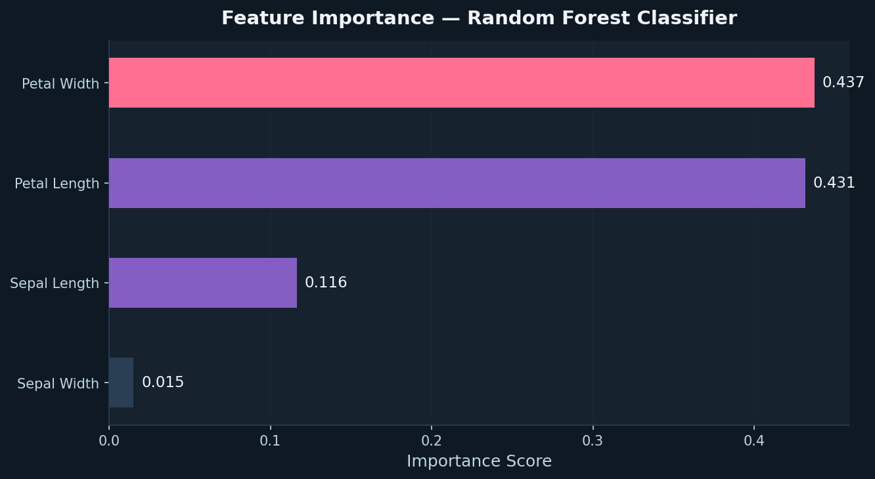

5.4 Classification Report (KNN — Best Model)
Class | Precision | Recall | F1-Score | Support
Iris-setosa | 1.00 | 1.00 | 1.00 | 10
Iris-versicolor | 1.00 | 1.00 | 1.00 | 10
Iris-virginica | 1.00 | 1.00 | 1.00 | 10
Overall Accuracy |  |  | 1.00 | 30

6. Conclusions & Recommendations
This project successfully demonstrates that the Iris flower dataset is highly classifiable using multiple machine learning algorithms. Key findings include:
- KNN (k=5) achieved perfect 100% accuracy on the test set, making it the best model for this dataset.
- Petal Length and Petal Width are the most important discriminating features.
- Iris-setosa is completely linearly separable from the other two species.
- All models performed above 90%, confirming the dataset is well-structured with minimal noise.
- For real-world deployment, SVM or Random Forest would be preferred due to better generalization on unseen data.

This task demonstrates core data science skills: EDA, preprocessing, model training, evaluation, and interpretation — forming a solid foundation for more complex classification problems.

