**Introduction to Access latest Scorecard version in your local (No Statistics)**

This document explains how to install latest  CCDA Scorecard application in local laptops/desktops.

**Pre-requisites:** Below are list of pre requisites for CCDA Score card application installation.

⦁ Apache Tomcat Server ( >= 7 version)

**Below are the steps to install Score Card application using war file:**

**Step 1:** Download .war file by using <https://github.com/siteadmin/Scorecard-Local-Instantiation/blob/master/LatestScorecardVersion/scorecard.war>  location.

**Step 2:** Copy the war file to Apache tomcat WEBAPPS folder.

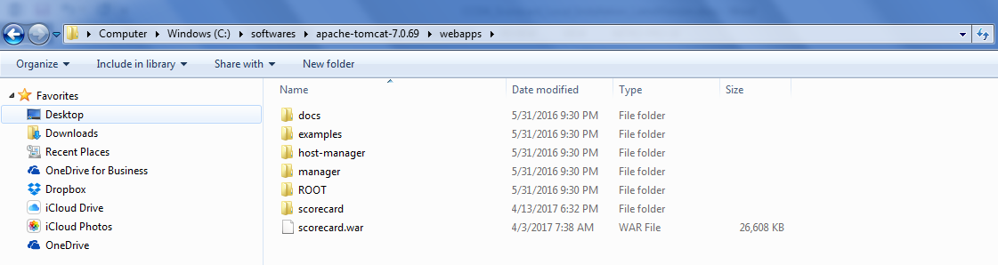

**Step 3:** Download scorecard.xml configuration file by using <https://github.com/siteadmin/Scorecard-Local-Instantiation/blob/master/LatestScorecardVersion/scorecard.xml>

**Example:**

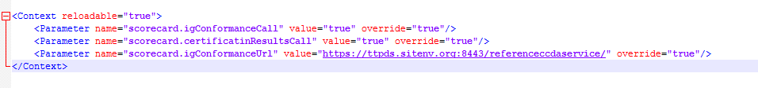

**Step 4:** Place a copy of scorecard.xml in $CATALINA_BASE/conf/[enginename]/[hostname]/. **Example:** ~/apache-tomcat-7.0.57/conf/Catalina/localhost

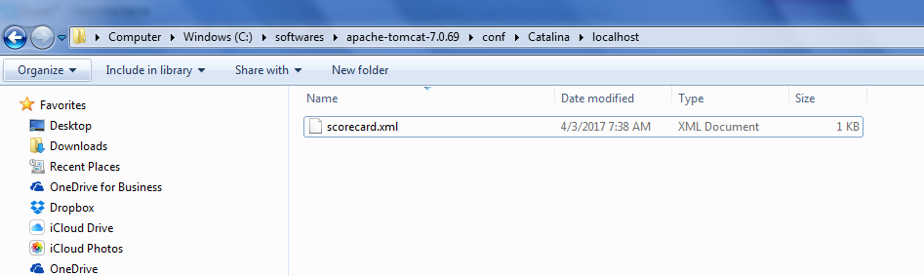

**Step 5:** Update scorecard.xml with appropriate scorecard.igConformanceUrl value.

**Example:** https://ttpds.sitenv.org:8443/referenceccdaservice/

**Step 6:** Start the server and launch scorecard application by navigating to the url

**Example:** localhost:8080/scorecard/