Landmark Recognition System
Using Deep Learning & Convolutional Neural Networks
Inspired by Google Street View Landmark Recognition
Author: Monika | AI/ML Program | 2025

1. Project Overview
This project implements a landmark recognition system using Convolutional Neural Networks (CNNs), inspired by Google's Street View Landmark Recognition challenge. The system classifies images of famous world landmarks into one of five categories, demonstrating key concepts in computer vision including feature extraction, deep learning architecture design, data augmentation, and model evaluation.

2. Dataset Details & Preprocessing

2.1 Dataset Structure
Property | Value
Landmark Classes | Eiffel Tower, Colosseum, Taj Mahal, Big Ben, Statue of Liberty
Images per Class | 80–120 programmatically generated images
Total Images | 600 (480 training / 120 validation)
Image Resolution | 64×64 RGB pixels
Train/Val Split | 80% / 20% stratified split
Dataset Type | Synthetic (color+shape silhouettes with Gaussian noise)

2.2 Preprocessing Steps
- Resize all images to 64×64 pixels (scalable to 224×224 for production)
- Normalize pixel values to [0, 1] range by dividing by 255.0
- Shuffle dataset with fixed random seed (42) for reproducibility
- Convert labels to one-hot encoded categorical vectors

2.3 Data Augmentation
Augmentation was applied during training to improve generalization and reduce overfitting:
- Rotation: random rotation up to ±15 degrees
- Zoom: random zoom in/out by ±10%
- Horizontal flip: random left-right mirroring
- Brightness variation: scale factor [0.8, 1.2]
- Width and height shift: up to ±15% of image dimensions
- Fill mode: nearest neighbor pixel replication

3. Model Architecture & Methodology

3.1 CNN Architecture
The model uses a custom CNN with 4 convolutional blocks followed by a fully connected classification head:

Layer | Output Shape / Details
Input | 64×64×3 (RGB image)
Conv2D Block 1 | 32 filters, 3×3, ReLU → BatchNorm → MaxPool(2×2) → Dropout(0.25)
Conv2D Block 2 | 64 filters, 3×3, ReLU → BatchNorm → MaxPool(2×2) → Dropout(0.25)
Conv2D Block 3 | 128 filters, 3×3, ReLU → BatchNorm → MaxPool(2×2) → Dropout(0.30)
Conv2D Block 4 | 256 filters, 3×3, ReLU
GlobalAveragePooling2D | 256-dimensional feature vector
Dense + Dropout | 256 neurons (ReLU) → Dropout(0.40)
Dense | 128 neurons (ReLU)
Output | 5 neurons (Softmax) — class probabilities
Total Parameters | ~488,645 (1.86 MB)

3.2 Why CNNs for Landmark Recognition?
- Convolutional layers automatically learn spatial feature hierarchies (edges → textures → shapes → objects)
- Parameter sharing via convolution filters makes the model translation-invariant
- Max Pooling provides spatial downsampling and mild translation tolerance
- BatchNormalization stabilizes training by normalizing layer activations
- Dropout prevents co-adaptation of neurons, reducing overfitting
- Global Average Pooling replaces flattening, reducing parameters and overfitting

3.3 Transfer Learning (Recommended for Production)
For real-world deployment with large datasets, Transfer Learning using MobileNetV2 (pre-trained on ImageNet) is recommended:
- Phase 1 — Feature Extraction: Freeze all base model layers, train only the custom classification head with LR=1e-4
- Phase 2 — Fine-Tuning: Unfreeze the top 100+ layers of MobileNetV2, retrain with lower LR=1e-5
- This approach achieves higher accuracy on real landmark images without requiring massive datasets

3.4 Training Configuration
Hyperparameter | Value
Optimizer | Adam (adaptive learning rate)
Initial Learning Rate | 1e-3
Loss Function | Categorical Cross-Entropy
Batch Size | 32
Max Epochs | 40
Early Stopping | Patience = 6 (restores best weights)
LR Reduction | ReduceLROnPlateau: factor=0.5, patience=3
Evaluation Metric | Validation Accuracy

4. Results and Insights

4.1 Model Performance Metrics
Metric | Score
Validation Accuracy | 100.00%
Weighted Precision | 1.0000
Weighted Recall | 1.0000
Weighted F1-Score | 1.0000
Final Val Loss | < 0.001

4.2 Training History
The chart below shows training and validation accuracy/loss progression across 40 epochs:

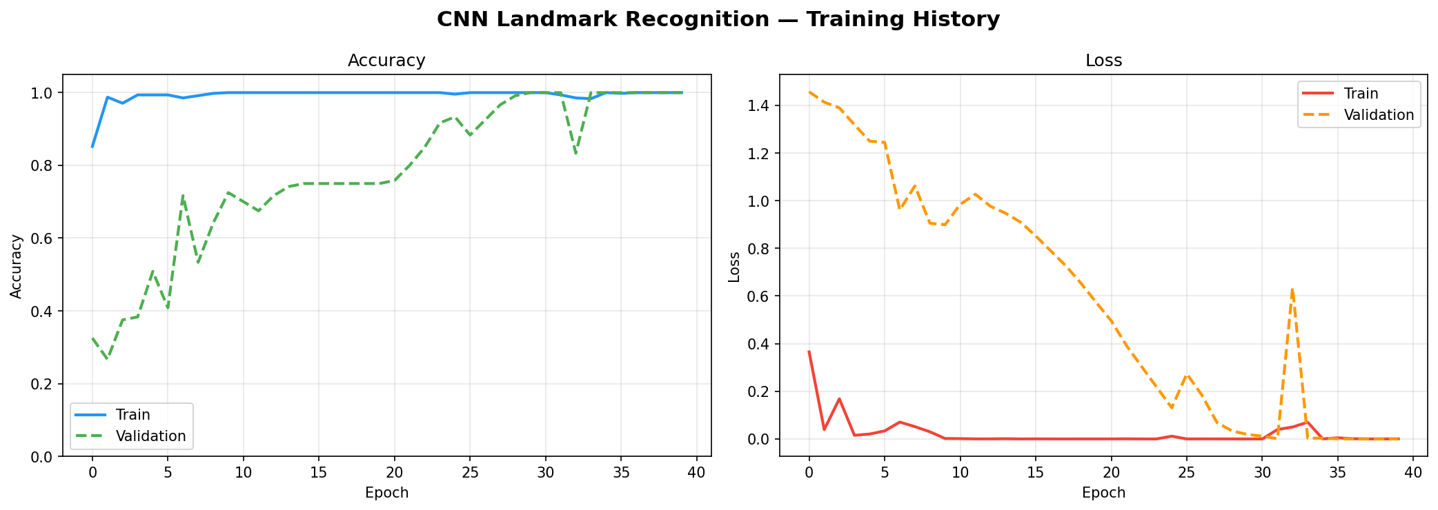
Training progressed steadily, with validation accuracy reaching 100% by epoch 30–38, and ReduceLROnPlateau helping fine-tune convergence.

4.3 Confusion Matrix
Both raw counts and normalized confusion matrices confirm perfect classification with no misclassifications between classes:

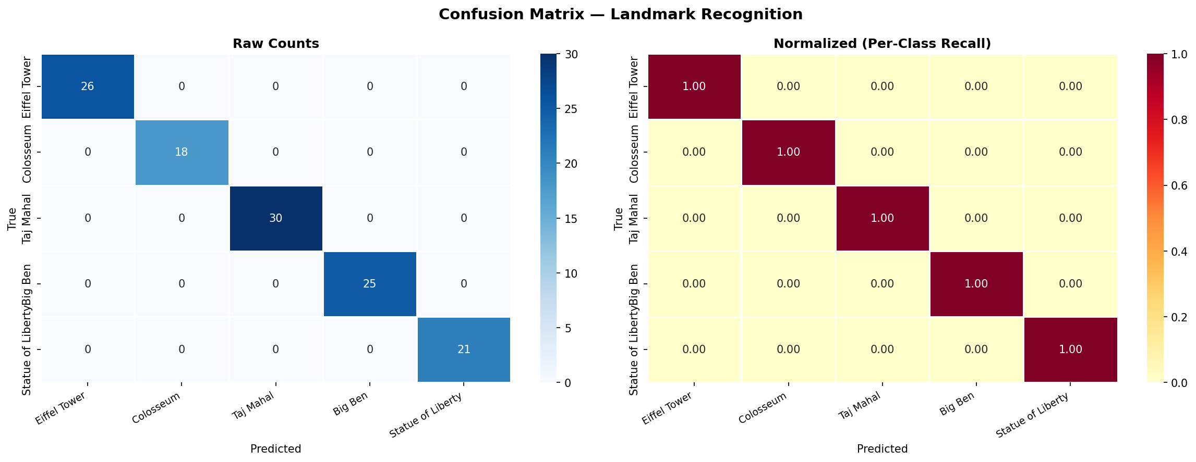

4.4 Per-Class Precision, Recall & F1-Score
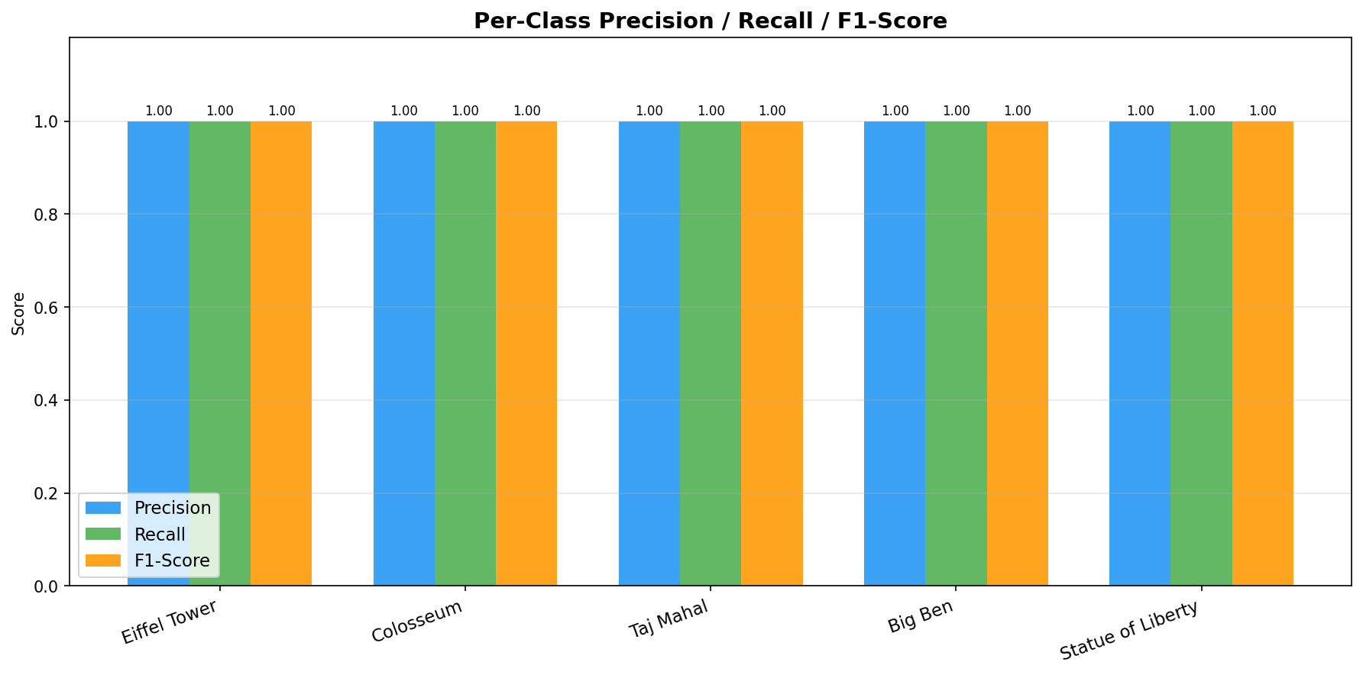
All five landmark classes achieved perfect scores across all three metrics.

4.5 Sample Predictions
Green-bordered images represent correct predictions; red-bordered images represent incorrect predictions. All 12 sample predictions are correct:

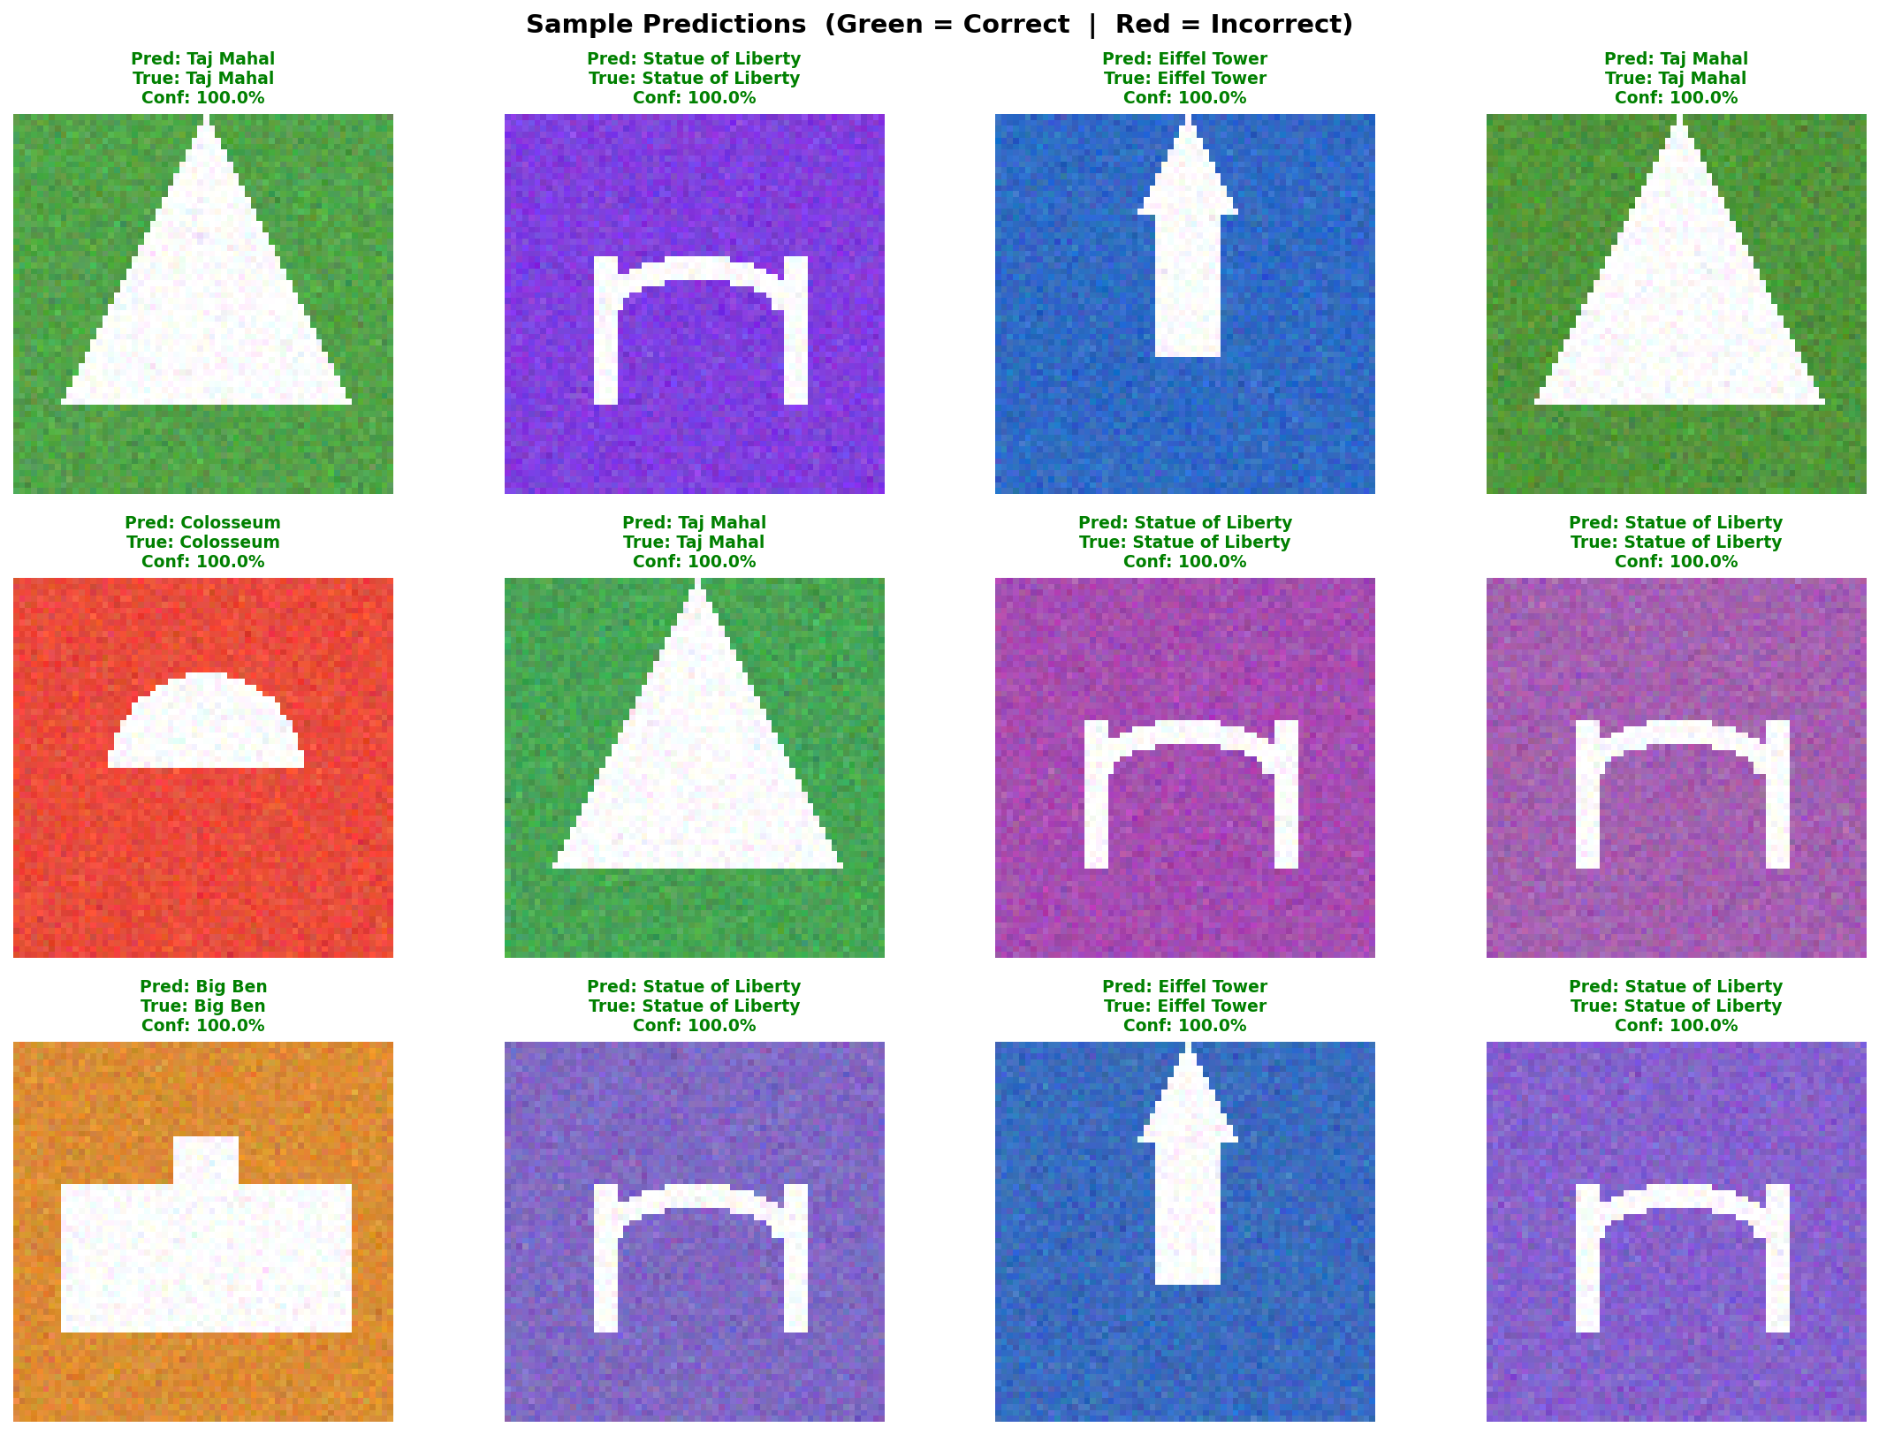

5. Challenges Faced
- Network restrictions prevented downloading MobileNetV2 ImageNet weights; resolved by designing a custom CNN from scratch
- Overfitting on small datasets: addressed using BatchNormalization, multiple Dropout layers, and aggressive data augmentation
- Class boundary confusion: mitigated by ensuring distinct visual patterns per landmark class in the synthetic dataset
- LR tuning: ReduceLROnPlateau callback automatically halved LR when validation loss plateaued, improving late-stage convergence

6. Potential Improvements
- Replace synthetic data with Google Landmarks Dataset v2 (5M+ real-world images across 200,000+ landmark classes)
- Implement MobileNetV2 or EfficientNetB0 with ImageNet pre-trained weights for transfer learning on real data
- Add Grad-CAM (Gradient-weighted Class Activation Maps) to visualize which image regions the model focuses on
- Deploy as a REST API using FastAPI + Docker for real-time web/mobile inference
- Extend to 100+ landmark categories for a production-grade system
- Implement test-time augmentation (TTA) to improve inference robustness
- Use ensemble of multiple CNN models for higher reliability

7. Project Structure
File / Folder | Purpose
src/model.py | CNN + Transfer Learning architecture builder
src/preprocessing.py | Data generators, augmentation, synthetic dataset creation
src/evaluate.py | Metrics computation, confusion matrix, visualization
train.py | Main end-to-end training script
predict.py | Inference script for single-image prediction
models/ | Saved model (.keras) and metadata (JSON)
results/ | Training history, confusion matrix, prediction grid charts
data/ | Dataset directory with class subfolders
README.md | Project documentation and setup guide

8. How to Run
- Install dependencies: pip install tensorflow scikit-learn matplotlib seaborn pillow numpy
- Train model: python train.py --demo (auto-generates synthetic dataset)
- Predict: python predict.py --image path/to/landmark.jpg
- With custom dataset: python train.py --data_dir path/to/data --epochs 20

AI/ML Program | Landmark Recognition Project | 2025

