Lab 1: Problem Discovery and Need Identification through Observation, Interviews, Pain-Point Analysis, Root Cause Identification, and Wicked Problem Understanding

Women face safety concerns while traveling at night.

Step 1 ; Observation
- Lighting Conditions
  - Streets poorly lit after sunset
  - Non-functional or broken streetlights
- Public Transport Availability
  - Fewer buses/trains at night
  - Long waiting times
- Crowd & Activity Level
  - Isolated areas with very few people
  - Shops and public places closed
- Security Presence
  - Lack of police patrols
  - No visible security cameras
- Behavioural Observation
  - Women appearing anxious or alert
  - Frequent phone calls or location sharing
  - Avoidance of certain routes or areas
- Infrastructure Issues
  - Unsafe footpaths
  - Poor road conditions
  - No emergency help points

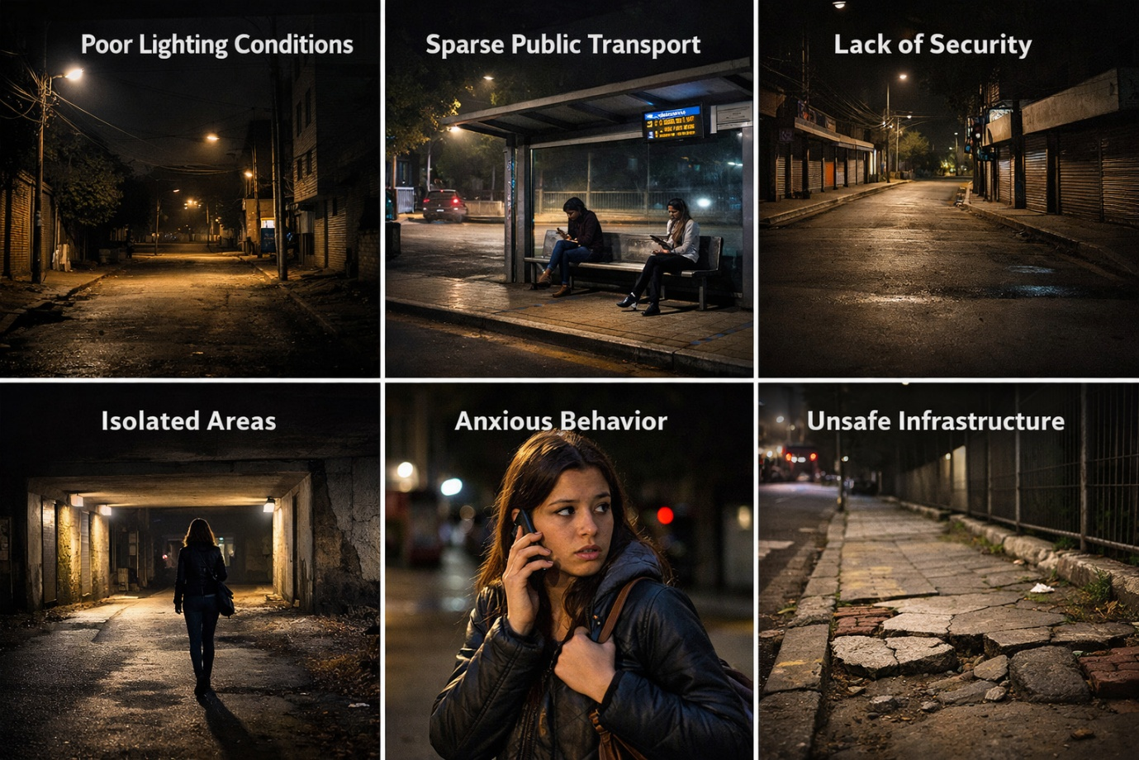

Output;
Women face serious safety concerns while traveling at night due to poorly lit streets and deserted areas.
Public transport is limited, forcing women to wait alone for long periods.
There is very little police presence or security surveillance during night hours.
As a result, women often feel anxious and take extra precautions for their safety.
Step 2: User Identification
1. Women Travelers
Role: Travel at night for work or personal needs.
Expectation: Safe roads, transport, and quick help.
2. Transport Providers
Role: Provide buses, taxis, and ride services.
Expectation: Trust, safety rules, and trained drivers.
3. Police / Authorities
Role: Ensure public safety at night.
Expectation: Reduced crime and safer streets.

Output;
• Women travellers
• Transport drivers and service providers
• Police and local authorities
• Government and city administrators
• Emergency services (helpline, ambulance)

Step 3: Interviews / Surveys
Open-ended Interview Questions (5–8)
- Can you describe how you feel when traveling alone at night?
- What problems or risks have you personally faced while traveling at night?
- Which places or situations make you feel most unsafe during night travel?
- What safety measures do you currently take when traveling at night?
- Have you ever avoided traveling at night due to safety concerns? Why?
- What changes would make night travel safer for women?
- How do family or friends react when you travel at night?

- Conduct interviews with at least 30 users.
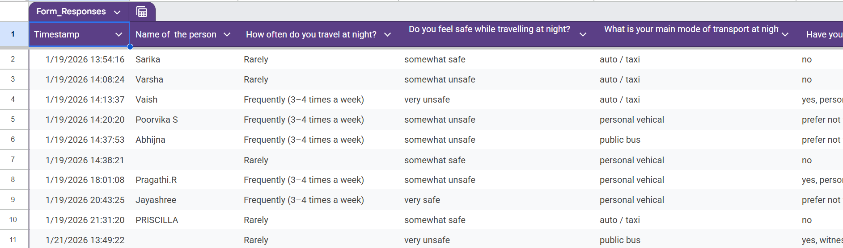

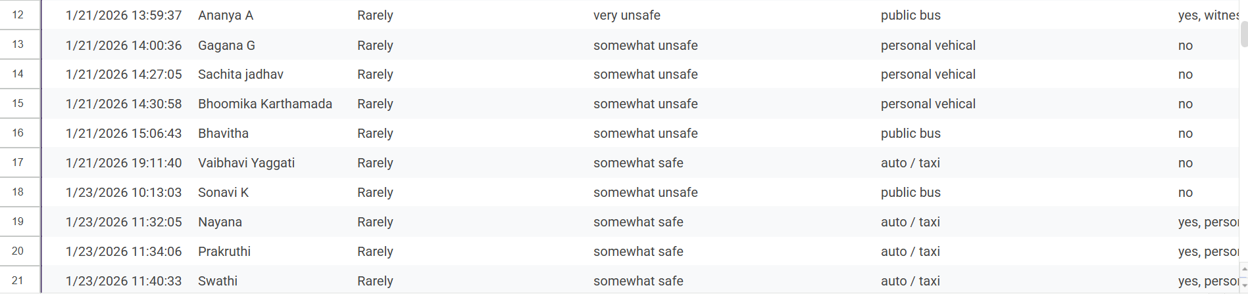

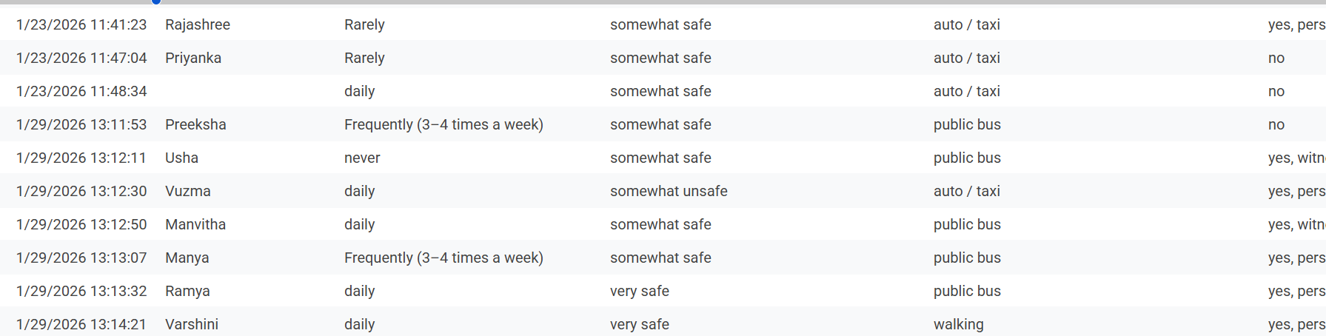

Step 4: Pain-Point Analysis

Major problems faced by users
• Poor street lighting
• Lack of police patrols
• Limited public transport at night
• Fear of harassment or assault
• Isolated and deserted areas

Categorize pain points as:
Functional Pain Points
• Poor street lighting
• Limited public transport at night

Emotional Pain Points
• Fear while traveling alone
• Anxiety and stress during night travel

Systemic Pain Points
• Lack of police patrols
• Poor implementation of safety policies

Most Critical Pain Point:
The lack of proper security at night—such as poor lighting, fewer police patrols, and no quick emergency support—is the most critical pain point.
This makes women feel unsafe and fearful while traveling at night.

OUTPUT:
• Poor street lighting makes travel unsafe at night.
• Limited transport forces women to wait or walk alone.
• Lack of police patrol reduces safety and confidence.
• Women feel fear and anxiety while traveling at night.

Step 5: Root Cause Identification

Select one critical pain point.
• Lack of proper security at night (poor lighting and fewer police patrols) is the most critical pain point.

5-Why Analysis OR
Why 1: Why do women feel unsafe at night?
→ Because there is poor security on roads.
Why 2: Why is security poor?
→ Because there are fewer police patrols and no monitoring.
Why 3: Why are patrols and monitoring limited?
→ Because safety resources are not focused on night hours.
Why 4: Why are night hours not prioritized?
→ Because women’s safety issues are not addressed properly in planning.
Why 5: Why is planning weak?
→ Because there is lack of coordination and accountability in the system.

SEPARATION OF SYMPTOMS AND ROOT CAUSES;

Symptoms:
• Women feel fear while traveling at night
• Avoid night travel
• Feel anxious and unsafe
Root Causes:
• Poor street lighting
• Less police patrol at night
• Limited transport and weak safety systems

OUTPUT;
ROOT CAUSE DIAGRAM
Poor street lighting ──┐
│
Lack of police patrols ──┼──► WOMEN FEEL UNSAFE
│ AT NIGHT
Limited transport ─────┤
│
No CCTV / emergency ────┘

Step 6: Wicked Problem Understanding
1. Difficult to define clearly
The problem varies by place, time, and situation. What feels unsafe for one woman may be different for another.
2. Multiple stakeholders with conflicting needs
Women want maximum safety, transport providers focus on cost and operations, and authorities face budget and manpower limits.
3. Cannot be solved by a single solution
Women’s safety needs many actions together like better lighting, policing, transport, and awareness, not just one fix.

The problem of women’s safety at night is Complex/Wicked because:
- It involves multiple factors (lighting, transport, policing, infrastructure).
- Multiple stakeholders have different needs.
- There is no single solution; improvements require coordinated efforts.

OUTPUT; Women wicked problems
Women’s safety at night is a wicked problem because it is complex and has no single solution.
It involves many factors like poor lighting, limited transport, lack of police patrols, and weak emergency systems.
Different stakeholders—women, transport providers, and authorities—have conflicting needs.

Step 7: Reflection
1. Incorrect assumptions:
I thought safety depends only on police, but users showed other problems like lighting and transport.
2. Change in understanding:
Users made me understand how fear and stress affect women daily.
3. Risk of quick solutions:
If we don’t understand the problem, the solution may not work.
4. Skills learned:
I learned observing, listening, and understanding real user problems.

Output: Reflection
This lab helped me understand that women’s safety at night is a serious and complex issue. At first, I assumed that the main problem was the lack of police patrols. However, after observing and interviewing users, I realized that safety concerns are much broader. Poor street lighting, limited transport options, deserted areas, and slow emergency response all play an important role in making women feel unsafe.
Listening to user perspectives changed my understanding a lot. Many women shared that even when nothing bad happens, the constant fear and anxiety affect their confidence and freedom. Emotional safety is just as important as physical safety. Women plan their routes carefully, avoid traveling at night, and depend on others for support, which shows how deeply this problem impacts daily life.
This lab also taught me why jumping directly to solutions is risky. Without properly understanding the real problems faced by users, solutions may be ineffective or incomplete. For example, adding more police alone will not solve issues like poor lighting or lack of transport. A problem like this needs multiple solutions working together.
Through this activity, I developed important skills such as observation, interviewing, empathy, and problem analysis. I learned how to look at a problem from the user’s point of view instead of making assumptions. Overall, this lab helped me understand why women’s safety at night is a wicked problem and why careful research and user-centered thinking are essential before designing solutions.

