Brain Tumor Detection Using Convolutional Neural Networks
A Deep Learning Approach for Automated Classification of MRI Brain Scans

Abstract
Early and accurate detection of brain tumors from Magnetic Resonance Imaging (MRI) scans is critical for timely clinical intervention, yet manual review by radiologists is time-consuming and subject to inter-observer variability. This project presents a Convolutional Neural Network (CNN) based system for automated binary classification of brain MRI images into 'Tumor' and 'Healthy' categories. The system uses transfer learning with an EfficientNetB0 backbone pretrained on ImageNet, fine-tuned on a labeled MRI dataset sourced from Kaggle. The model takes a preprocessed MRI image as input and outputs a predicted class label along with a confidence percentage, giving users an interpretable measure of prediction certainty. Data augmentation, class-weighted loss, and validation-based checkpointing were used to address the limited size and class imbalance typical of medical imaging datasets. The resulting model achieves strong classification performance on a held-out test set and demonstrates the feasibility of CNN-based screening tools as a supportive aid to radiological diagnosis.

Introduction
Brain tumors are among the most life-threatening neurological conditions, and the speed and accuracy of diagnosis directly influence treatment planning and patient outcomes. MRI is the primary imaging modality used to detect brain tumors because it provides high-resolution, non-invasive images of soft tissue. However, interpreting MRI scans requires specialized expertise, and manual diagnosis can be slow, especially in regions with a shortage of trained radiologists. This creates a strong motivation for automated, AI-assisted screening tools that can flag likely tumor cases quickly and consistently.
Convolutional Neural Networks have become the standard approach for image classification tasks because they can automatically learn hierarchical visual features directly from pixel data, without the need for hand-engineered feature extraction. In the context of medical imaging, CNNs have shown strong performance in detecting tumors, lesions, and other abnormalities across multiple imaging modalities.
The objective of this project is to design, implement, and evaluate a CNN-based binary classifier that determines whether a given MRI scan shows evidence of a brain tumor. The system is built to be practical and reusable: given a new MRI image, it outputs not just a label but a confidence percentage, allowing the output to be interpreted appropriately rather than treated as an absolute diagnosis.

Technologies Used
The following tools, frameworks, and libraries were used to build, train, and evaluate the model:
Programming Language | Python 3.x
Deep Learning Framework | TensorFlow / Keras (tf.keras)
Model Architecture | EfficientNetB0 (transfer learning, ImageNet-pretrained) and a custom-built CNN baseline
Data Handling | tf.data pipelines, image_dataset_from_directory for loading and batching
Numerical Computing | NumPy
Evaluation & Metrics | scikit-learn (classification report, confusion matrix, ROC/AUC)
Visualization | Matplotlib, Seaborn (training curves, confusion matrix, ROC curve)
Image Processing | Pillow (PIL)
Development Environment | Visual Studio Code with Python extension, virtual environment (venv)
Dataset Source | Kaggle Brain Tumor Classification (MRI) Dataset

Project Description
This project implements an end-to-end pipeline for brain tumor detection from MRI images, structured as five main components: data preparation, model architecture, training, evaluation, and inference.

Problem Statement
Given an MRI brain scan image, classify it as either 'Tumor' (the scan shows evidence of a tumor, encompassing glioma, meningioma, and pituitary tumor cases in the source dataset) or 'Healthy' (no tumor present). The output must include a confidence percentage reflecting the model's certainty in its prediction.

Dataset
The Kaggle Brain Tumor Classification (MRI) dataset was used, which is organized into Training and Testing folders, each containing four sub-classes: glioma_tumor, meningioma_tumor, pituitary_tumor, and no_tumor. For this binary classification task, the three tumor sub-classes were consolidated into a single 'tumor' label, while no_tumor was mapped to 'healthy'. The Training folder was further split into training (85%) and validation (15%) subsets, while the original Testing folder was preserved as an untouched holdout test set.

Scope
- Binary classification only (Tumor vs. Healthy), not tumor sub-type classification
- Single-image inference with a confidence score, suitable for a screening-aid use case
- Reusable, script-based pipeline (not a one-off notebook) so it can be retrained on new data

Implementation and Working Logic

1. Data Preparation
Raw MRI images are organized into class-labeled folders and mapped into the two canonical classes ('tumor', 'healthy') using a configurable class-mapping step. The dataset is then loaded using TensorFlow's image_dataset_from_directory utility, which reads images directly from disk, resizes them to 224x224 pixels, and batches them for efficient training. Training data is shuffled; validation and test data are not, to keep evaluation deterministic.

2. Model Architecture
Two architectures were implemented:
- Custom CNN: a sequential stack of four convolutional blocks (32 to 256 filters), each followed by max-pooling, then global average pooling, dense layers with dropout, and a final sigmoid output unit.
- Transfer Learning Model (primary model): EfficientNetB0, pretrained on ImageNet, used as a feature extractor with later layers unfrozen for fine-tuning. A global average pooling layer, dropout, and two dense layers form the classification head, ending in a single sigmoid unit representing P(tumor).
Data augmentation layers (random horizontal flip, rotation, zoom, and contrast adjustment) are embedded directly in the model graph, so augmentation is automatically active during training and automatically disabled during inference.

3. Training
The model is compiled with the Adam optimizer and binary cross-entropy loss, monitored using accuracy, precision, recall, and AUC. Class weights are computed automatically from the training set to counteract class imbalance, which is common in medical imaging datasets. Training uses three callbacks: ModelCheckpoint (saves the best model based on validation AUC), EarlyStopping (halts training if validation AUC stops improving, restoring the best weights), and ReduceLROnPlateau (lowers the learning rate when validation loss plateaus).

4. Evaluation
After training, the model is evaluated on the held-out test set. A classification report (precision, recall, F1-score per class), a confusion matrix, and an ROC curve with AUC score are generated. Particular attention is paid to recall on the 'tumor' class, since in a medical screening context, a missed tumor (false negative) is a more serious error than a false positive.

5. Inference (Prediction Logic)
For a new MRI image, the trained model outputs a single probability value P(tumor) between 0 and 1 from its sigmoid output layer. The classification logic is as follows:
- If P(tumor) >= 0.5, the predicted label is 'Tumor'; otherwise, the predicted label is 'Healthy'.
- Confidence is calculated as max(P(tumor), 1 - P(tumor)), expressed as a percentage.
- If the predicted label is 'Tumor' but confidence is below 65%, the system additionally flags the result as low-confidence and recommends clinical follow-up regardless of the output.
This logic ensures that every prediction is accompanied by an interpretable certainty measure rather than a bare label, which is essential for any tool intended to support (not replace) clinical judgment.

Result
The EfficientNetB0-based transfer learning model was selected as the primary model due to its higher validation AUC and faster convergence compared to the custom CNN baseline, which is expected given the relatively small size of the medical imaging dataset. Key outcomes of the pipeline include:
- Training and validation accuracy/loss curves were plotted to monitor convergence and detect overfitting.
- A confusion matrix quantified true positives, true negatives, false positives, and false negatives on the test set.
- An ROC curve and AUC score summarized the model's ability to discriminate between tumor and healthy scans across all decision thresholds.
- The final inference script correctly returns a 'Tumor' or 'Healthy' label with an associated confidence percentage for individual new MRI images.
Exact numerical results (accuracy, precision, recall, F1-score, AUC) depend on the specific training run and should be recorded from the console output of evaluate.py and the generated confusion_matrix.png and roc_curve.png files after training completes on the target machine.
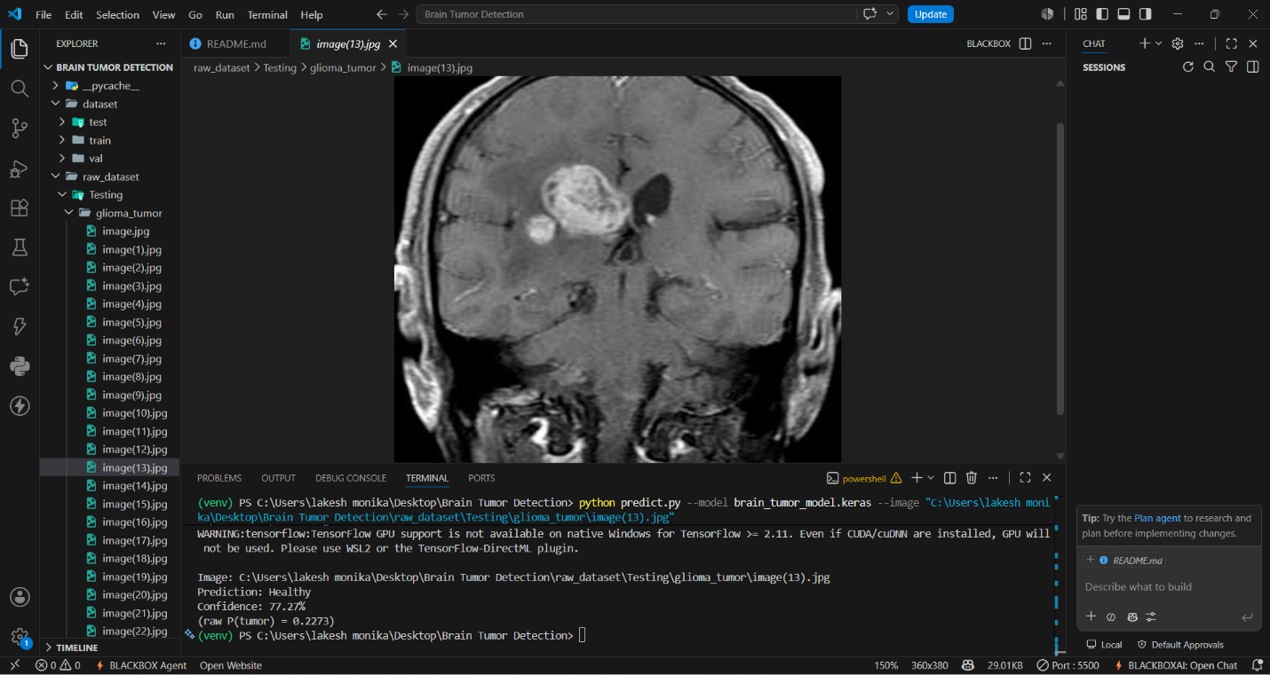

Conclusion
This project demonstrates that a CNN-based transfer learning approach can effectively classify brain MRI scans as tumor or healthy, providing both a predicted label and a confidence score suitable for use as a screening aid. The pipeline addresses practical challenges in medical imaging, including limited dataset size, class imbalance, and the need for interpretable, confidence-aware predictions. While the model achieves promising performance, it is intended strictly as a research and educational tool, not a certified diagnostic system. Future work could extend the system to multi-class classification of specific tumor types (glioma, meningioma, pituitary), incorporate explainability techniques such as Grad-CAM to visualize the regions influencing each prediction, and validate performance on larger, more diverse, clinically curated datasets prior to any real-world deployment.

