How To Measure Physical Fitness: How Fit Are You?

Updated 8/14/2022

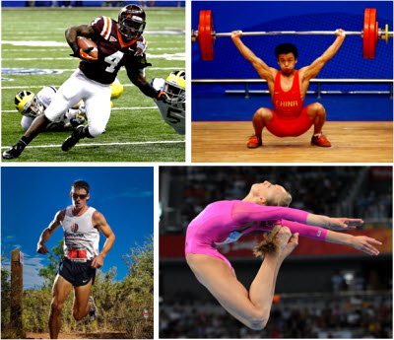

When you think of a person who is very physically fit, who do you see?

An ultra-marathoner, a sprinter, a weightlifter, a gymnast, a professional football player, or maybe a guy on the beach with a six-pack?

You may be surprised to learn that the simple question “What is Physical Fitness?” has confounded exercise physiologists and fitness organizations for decades who have tried to respond with an equally simple answer.

More recently, the answer has been reduced to the following simple definition:

***Physical Fitness is a measure of the body’s ability to function efficiently and effectively in work and leisure activities, resist hypokinetic diseases (diseases from sedentary lifestyles), and to meet emergency situations.***

Sometimes added to this definition is the ability to transmit genes to the next generation.

While this is the short answer for “What is Physical Fitness”, there is a longer and more interesting answer when you dig deeper. By looking at the individual components of physical fitness, we can get a better picture of what physically fit means in terms of how to identify it, measure it, and assert its significance.

The following are the top 10 facets of physical fitness that are adapted from sources that include President’s Council on Fitness, Sports & Nutrition, CrossFit, and the National Strength & Conditioning Association.

The first 5 facets are health-related and can be improved through proper training and the last 5 are skill related, which can be improved through practice of motor skills – aside from power #9 and speed #10, which require both.

Health-Related Physical Fitness Metrics:

1. Body Composition

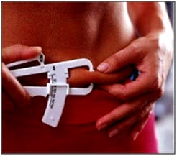

**Definition:**The relative amount of fat, muscle, bone, and other vital parts of the body.

**Measurement:**Skin fold calipers, BIA, DEXA (See: [5 Ways to Measure Body Fat Percentage](https://www.builtlean.com/5-ways-to-measure-body-fat-percentage/))

**Significance:**Of all 10 facets of physical fitness, body composition is the only non-performance metric. For this reason, it is sometimes not included in other physical fitness lists. While it is possible for an individual to have a high degree of fitness and still have excess body fat, losing body fat while retaining lean muscle [will improve all other physical fitness metrics](https://www.builtlean.com/how-to-run-faster/) given the power to weight ratio will be improved, along with other general health markers.

2. Strength

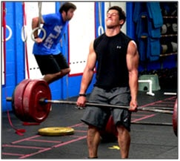

**Definition:**The ability of a muscle group to exert force

**Measurement:**Multiple tests can be completed to test more than one [movement pattern](https://www.builtlean.com/primal-movement-patterns/). Examples include max effort on exercises like the squat, bench press, or deadlift from 1-6 repetitions.

**Significance:**Strength is required to perform basic functional movements like squatting, lunging, pushing, pulling, and bending that are important in our everyday life. In addition, as we age muscle size and strength tend to decrease along with bone mass, which can be reversed with strength training.

3. Cardiovascular Fitness

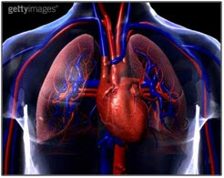

**Definition:**Ability of the circulatory systems and respiratory systems to supply oxygen during sustained physical activity.

**Measurement:**VO2 Max Test, sub-maximal YMCA Step Test

**Significance:**Improved cardiovascular increases lung capacity so the heart does not have to work as hard to pump blood to the muscles. Also important for overall heart health and prevention of lifestyle diseases.

4. Flexibility

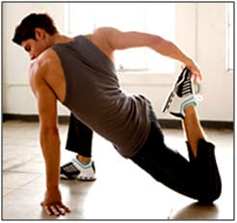

**Definition:** The range of motion at a joint

**Measurement:**There is no specific test because there are many joints in the human body, but a range of stretches can identify flexibility like the sit and reach test, shoulder reach etc.

**Significance:**The optimal range of motion about various joints has a direct effect on almost all other facets of physical fitness. For example, if one’s hip flexors are tight, that can affect the ability to reach maximum speed, or perform agility drills to maximum effect.

5. Muscular Endurance

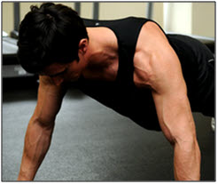

**Definition:**The ability of muscles to continue to perform repeated contractions against submaximal resistance.

**Measurement:**Given there is more than on major muscle group, testing muscular endurance requires testing each individual muscle, or group. Examples include maximum number of push-ups, sit-ups, pull-ups, and dips.

**Significance:**Performing repetitious physical activity such as gardening, raking leaves and washing your car will become less fatiguing.

Skill-Related Physical Fitness Metrics

6. Agility

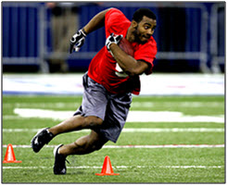

**Definition:**The ability to rapidly change the position of the entire body in time and space with speed and accuracy.

**Measurement:**Shuttle run, zig zag run test

**Significance:**Agility is not only critical in most sports such as a boxer dodging a punch, a wrestler finishing a take-down, or a running back changing on a dime could all be considered examples of agility. In addition, changing directions is a common cause of injury, so proper movement control from high levels of agility is essential.

7. Balance



**Definition:**The ability to maintain equilibrium while moving, or stationary

**Measurement:**Tests can be performed on a balance beam, or on the ground while holding various positions. Tests can be dynamic, or static.

**Significance:**Especially as we age, balance becomes increasingly important to prevent falls, which can result in serious injury. Balance is one of the most overlooked areas of fitness.

8. Coordination

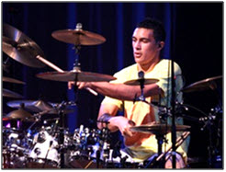

**Definition:**The ability to use the senses, such as sight and hearing, together with body parts in performing motor tasks smoothly and accurately.

**Measurement:**There are many different types of coordination, some of which require different movement patterns, muscle groups, and body positions such as juggling, dribbling a ball, or hitting an object.

**Significance:**Whether you want to play a musical instrument like the drums, or just get into your car while balancing your morning coffee, coordination is involved in many daily activities.

9. Power

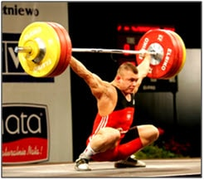

**Definition:**The ability of muscular unit or a combination of muscular units to apply maximum force in minimum time

**Measurement:**Many different tests can be employed to test power, which can also be split into various movement patterns. For example, testing power could be done by using exercises like hang cleans, or push press, the height of a vertical jump, or the amount of time it takes to sprint up a staircase. The components of power are strength and speed.

**Significance:**The ability to move a body quickly through space is very important in all sports, and is also required in daily living such as getting out of a chair, which requires not just strength, but power.

10. Speed

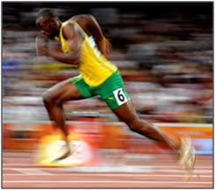

**Definition:**The ability to perform a movement within a short period of time

**Measurement:**There are many different types of speed, which including running, swimming, and speed of hand, or foot movement.

**Significance:**Some sports are based purely on speed, and most sports require speed. Speed is also helpful in everyday life, especially when you leave your wallet in a cab and need to run after it.

Other Physical Fitness Metrics to Mention:

**Stamina –**Also referred to as anaerobic capacity, the ability of body systems to process, deliver, store, and utilize energy. There are three metabolic pathways of energy (1) phosphagen (2) glycolitic, and (3) oxygen. Cardiovascular fitness relates primarily to the 3rd pathway, while stamina is primarily a measure of the first two, which are involved in speed and power related activities.

**Accuracy –**This is partly covered by the definition of agility, but accuracy refers to the ability to control movement in a given direction at a given intensity.

**Reaction Time –** Also closely related to agility, is defined as the time elapsed between stimulation and the beginning of the reaction to it. Essential in times of emergencies.

**Health, Nutrition, and Wellness –**While mental fitness, nutrition, and overall well-being are not on this list, they are integrally tied to optimal physical fitness. In fact, optimal fitness could never be achieved without adequate mental fitness and proper nutrition.

I hope this list has provided a more comprehensive view of what physical fitness is all about so you can apply it to your own exercise regimen. At the end of the day, physical fitness can help us all live longer, fuller, and happier lives.

Could you use some work on one, or a few of these facets of physical fitness?