URBANBASKET API — Test Results
Assignment: Build a RESTful API using Node.js, Express.js & MongoDB
Tool: ThunderClient | Server: http://localhost:3000
GitHub Repository Links

Main Repository:
https://github.com/monikamittal-1728/UrbanBasket

NodeJS Folder:
https://github.com/monikamittal-1728/UrbanBasket/tree/main/NodeJS

How to Setup & Start the Server

Step 1 — Clone Repository
git clone https://github.com/monikamittal-1728/UrbanBasket.git
Step 2 — Navigate to NodeJS Folder
cd UrbanBasket/NodeJS
Step 3 — Install Dependencies
npm install
Step 4 — Start the server:
npm start
Step 5 — You should see:

✅ Server is running at http://localhost:3000

MongoDB Database Screenshots
Product Collection
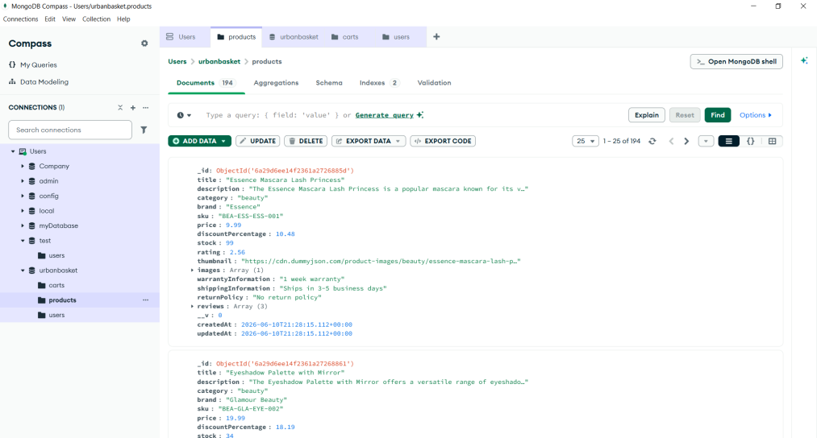

Cart Collection
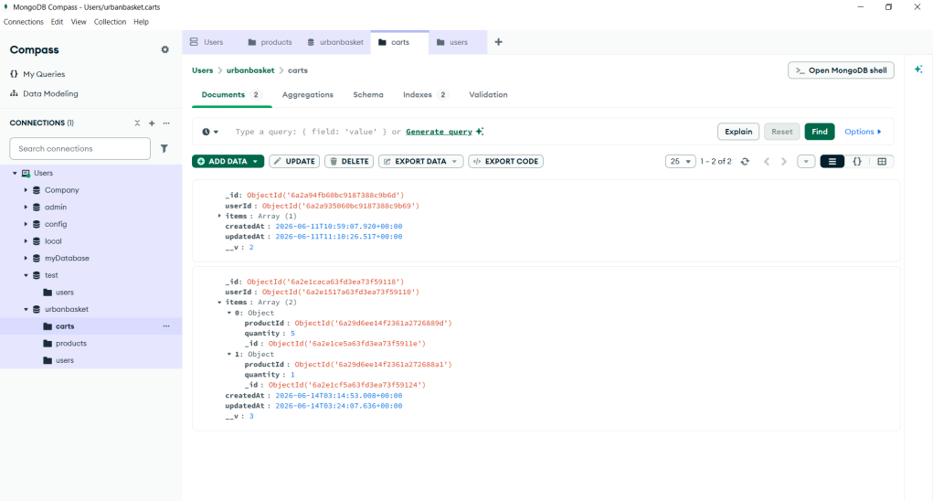

User Collection
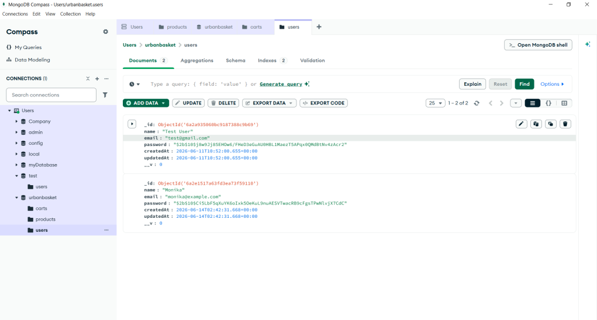
Detailed Test Cases & Screenshots

Test Case 1 : POST - User Register
Method: POST
URL: http://localhost:3000/api/auth/register
Status: 201 Created
Request Body:
{
"name":"Monika",
"email":"monika@example.com",
"password":"Password123"
}
Description:
Verify that a new user can successfully register in the application.

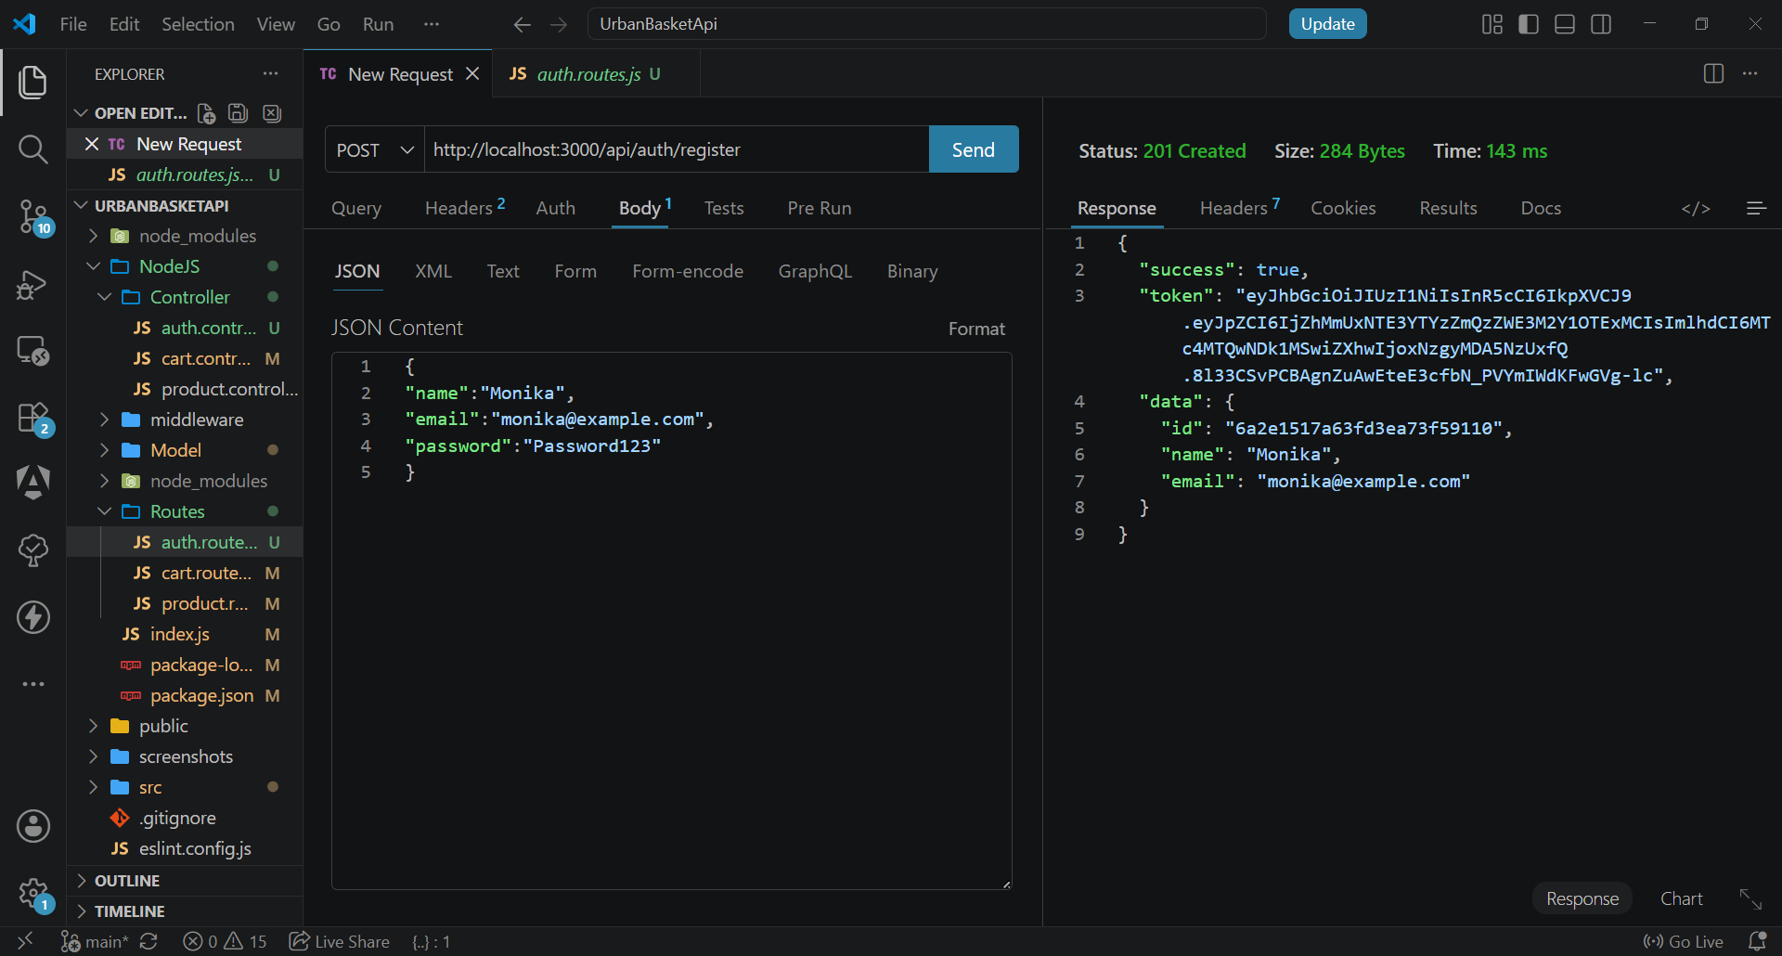

Test Case 2 : POST - User Login
Method: POST
URL: http://localhost:3000/api/auth/login
Status: 200 OK
Request Body:
{
"email":"monika@example.com",
"password":"Password123"
}
Description:
Verify that a registered user can login and receive a JWT token.

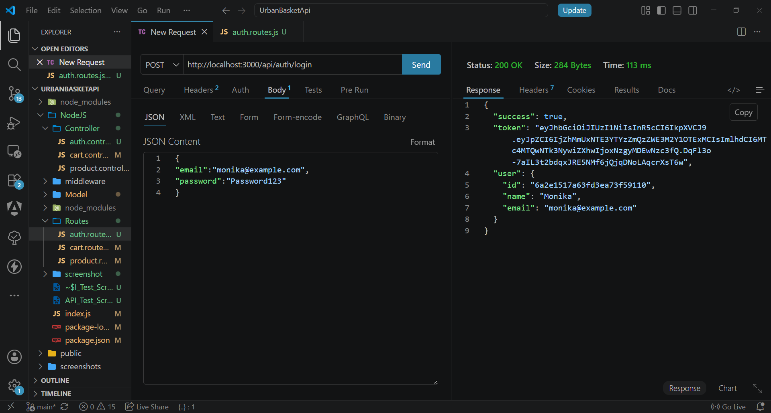

/

Test Case 3 GET - Get All Products
Method: GET
URL: http://localhost:3000/api/products
Status: 200 OK
Description:
Retrieve all products from database.

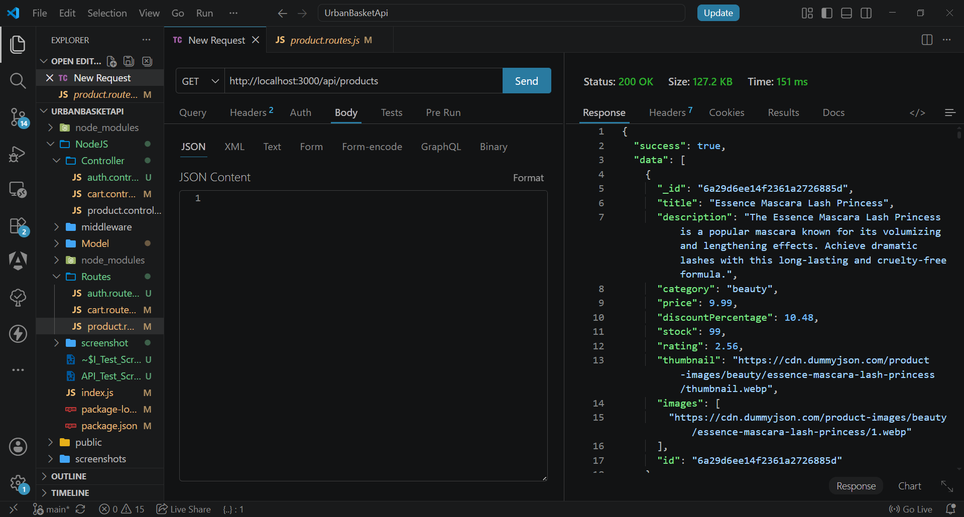

Test Case 4 GET - Get Product By ID
Method: GET
URL: http://localhost:3000/api/products/6a29d6ee14f2361a2726888d (id)
Status: 200 OK
Description:
Retrieve product details using product ID.

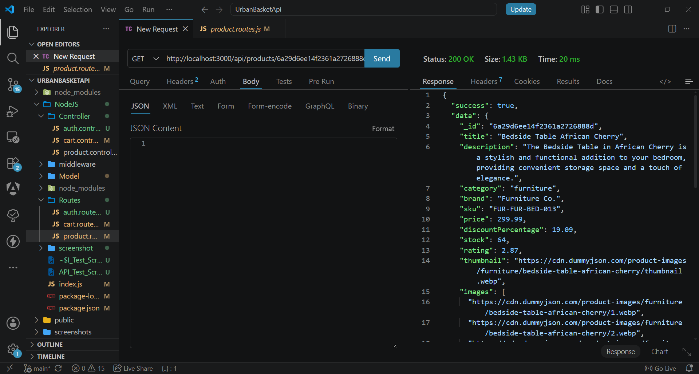

Test Case 5 GET - Get Cart
Method: GET
URL: http://localhost:3000/api/cart
Status: 200 OK
Description:
View cart items for authenticated user.

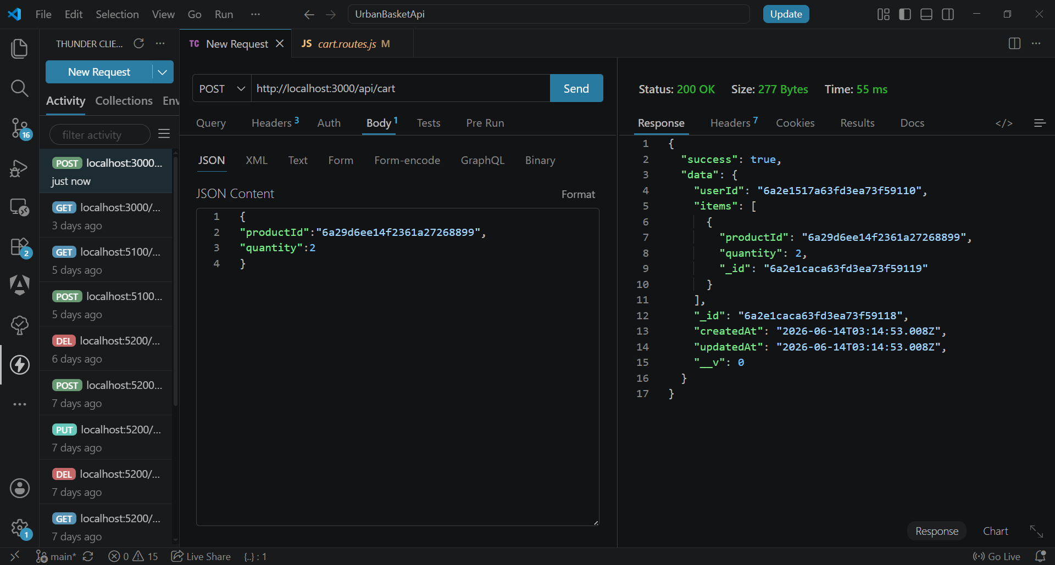

Test Case 6 POST - Add Product To Cart
Method: POST
URL: http://localhost:3000/api/cart
Status: 200 OK
Request Body:
{
"productId":"6a29d6ee14f2361a27268899",
"quantity":2
}
Description:
Add product into shopping cart.



Test Case 7 PUT - Update Cart Item
Method: PUT
URL: http://localhost:3000/api/cart/6a29d6ee14f2361a27268899
Status: 200 OK
Request Body:
{
"quantity":20
}
Description:
Update quantity of existing cart item.

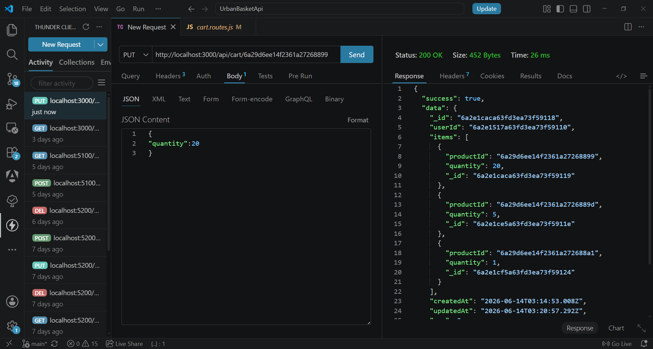

Test Case 8 DELETE- Delete Cart Item
Method: DELETE
URL: http://localhost:3000/api/cart/6a29d6ee14f2361a27268899
Status: 200 OK
Description:
Delete product from cart.

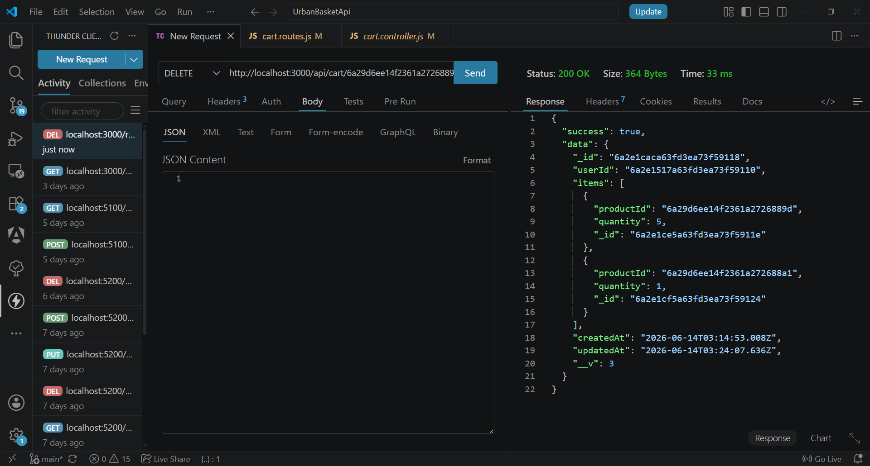

Test Case 9 GET - Invalid Product ID Validation
Method: GET
URL: http://localhost:3000/api/products/invalid6a29d6ee14f2361a2726888d
Status: 400 Invalid Product Id
Description:
Validate error handling for invalid product ID.

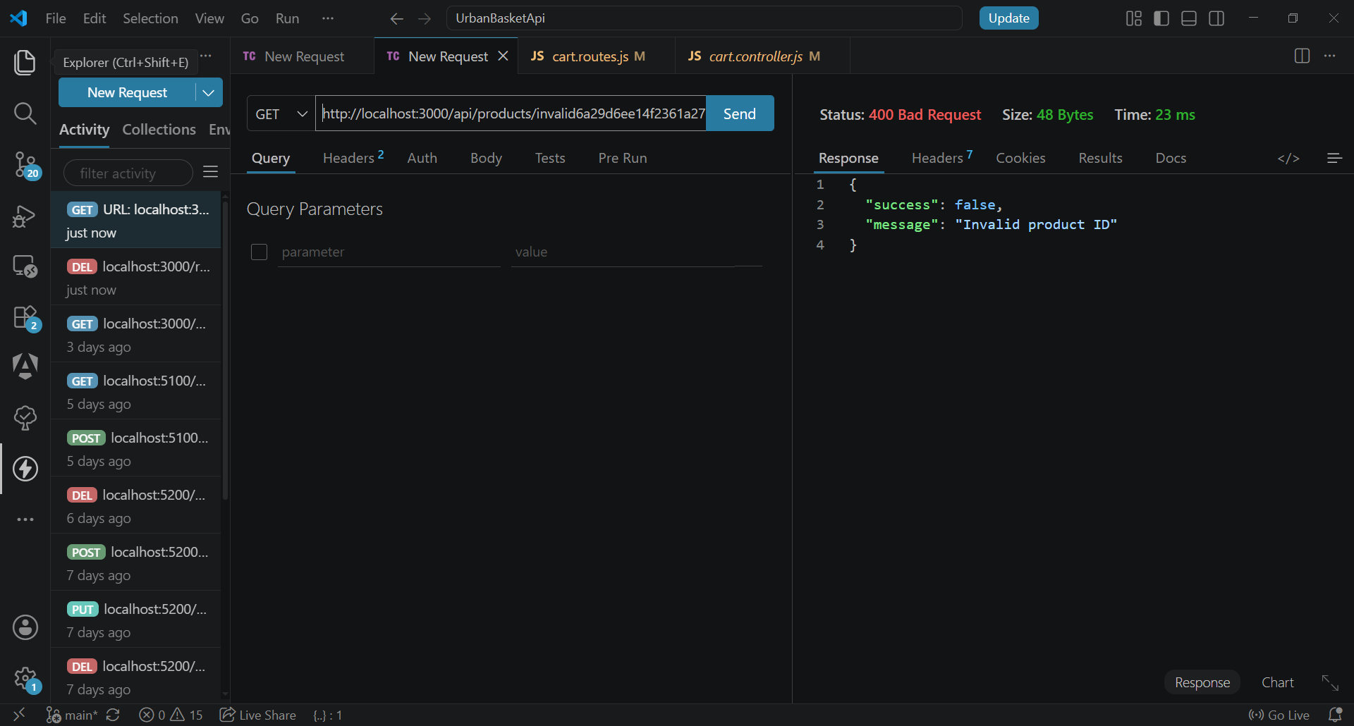

Test Case 10 GET - Unauthorized Access Validation

Method: GET
URL: http://localhost:3000/api/cart
Status: 401 No Token
Description:
Verify protected routes require authentication.

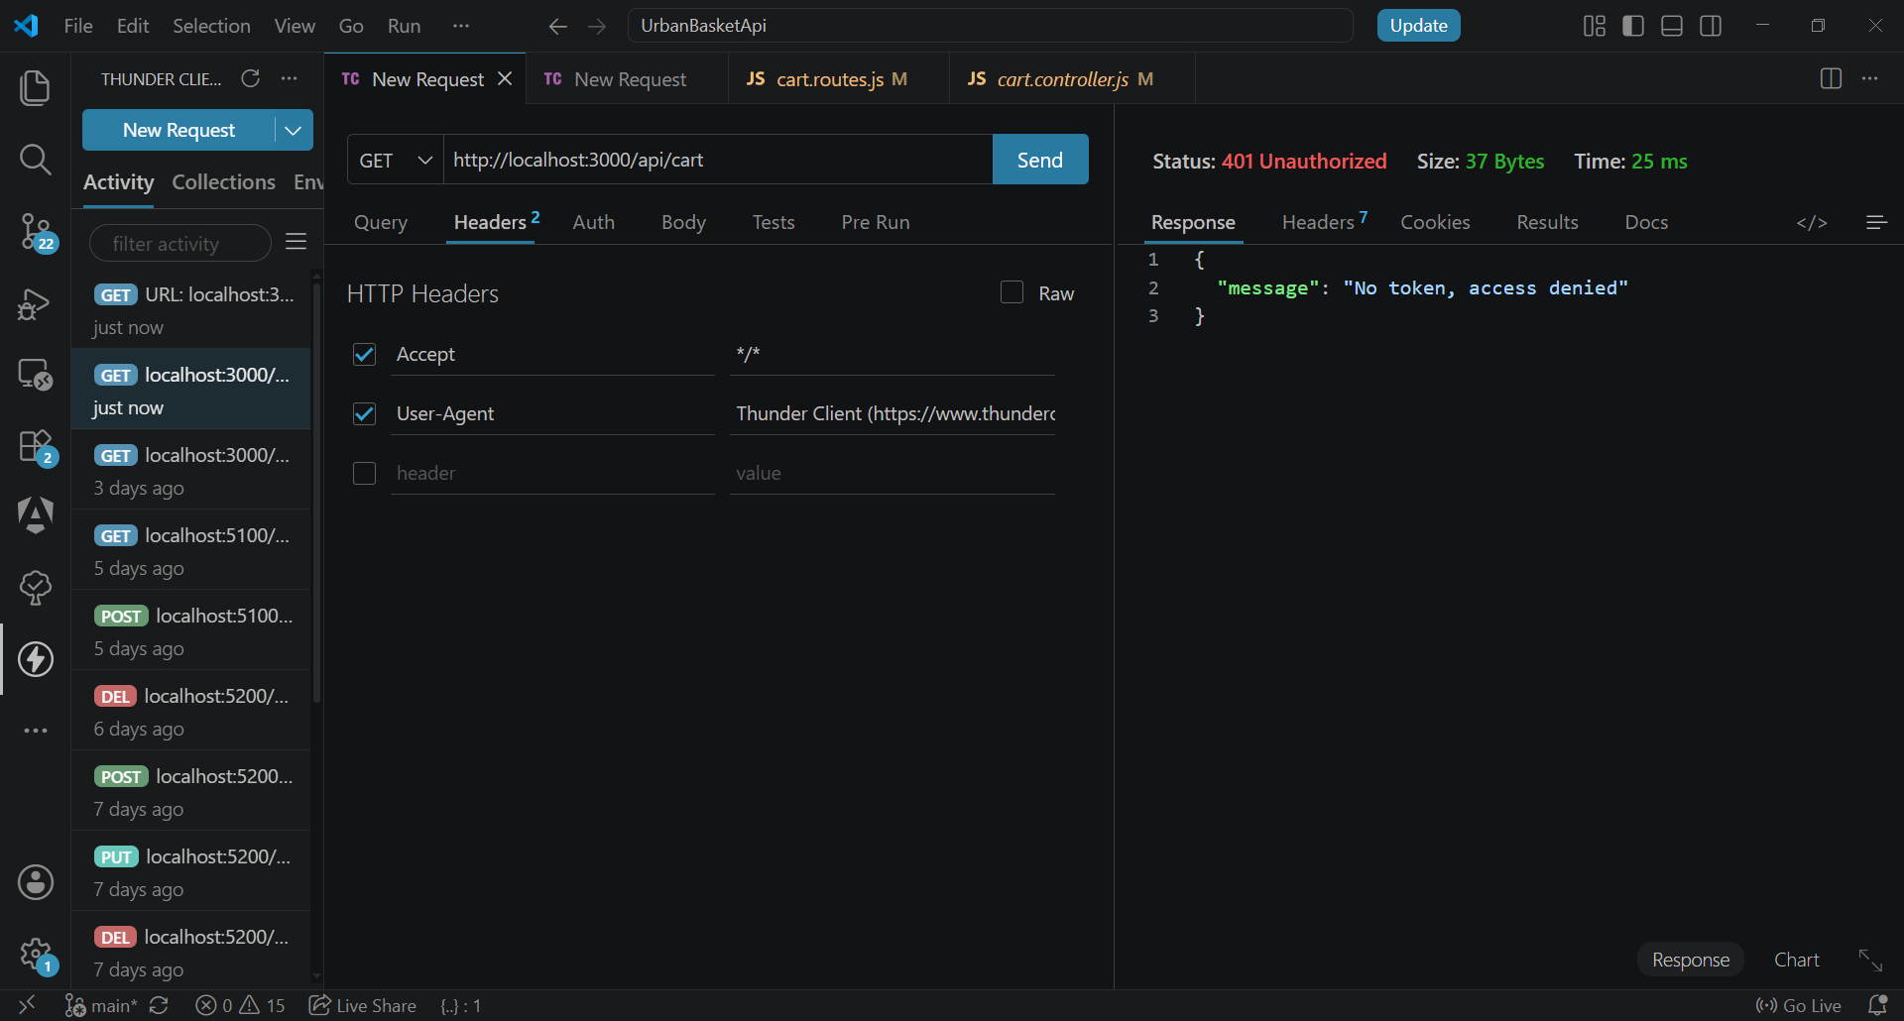

Test Case 11 GET - Invalid JWT Validation

Method: GET
URL: http://localhost:3000/api/cart
Status: 401 Invalid Token
Description:
Verify invalid JWT token cannot access protected routes.

