Git clone

Added .gitignorefile

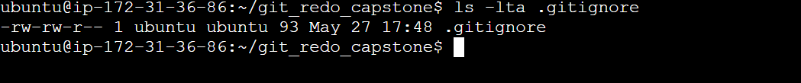

Added dockerignore file

Monitoring:

Install Grafana

Create Dashboard:

Alert creation:

Jenkins:

