GPU Accelerated Brain Tumor Detection using CNN and Custom CUDA Kernels
Abstract
A CNN-based brain tumor classifier was developed using MRI images and accelerated using CUDA programming. Custom CUDA kernels for image normalization, thresholding, naive convolution and shared-memory convolution were implemented using Numba. The project demonstrates how GPU parallelism significantly reduces execution time for image-processing tasks while maintaining good classification accuracy (82.35%).

1. Methodology
• MRI dataset preprocessing (resize to 128×128, normalization)
• CNN training using PyTorch on GPU
• Custom CUDA kernels for normalization, thresholding and convolution
• CPU vs GPU benchmarking
• Shared-memory optimization using CUDA shared memory.

2. CNN Architecture
Input (3×128×128) → Conv2D(16) → ReLU → MaxPool → Conv2D(32) → ReLU → MaxPool → Global Average Pooling → Fully Connected(64) → Dropout(0.5) → Output(1).

3. GPU Processing Pipeline
MRI Image
↓
Preprocessing
↓
CUDA Normalization
↓
CUDA Thresholding
↓
CUDA Shared-Memory Convolution
↓
CNN Classification
↓
Healthy / Tumor Prediction

4. Experimental Results
Implementation | Execution Time (ms) | Speedup
CPU | 88022.492 | 1×
Naive CUDA | 5.993 | 14688.77×
Shared-Memory CUDA | 5.944 | 14808.96×

Execution Time Comparison
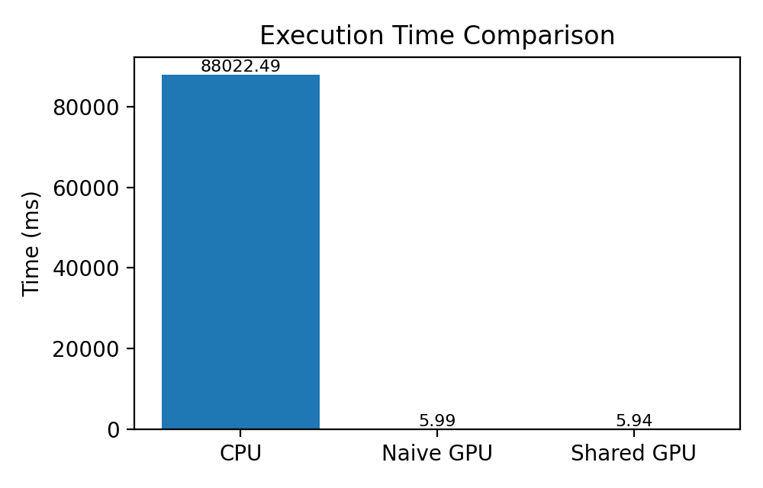
The CPU implementation required approximately 88 seconds for convolution, while both CUDA implementations completed the same task in about 6 ms. This demonstrates the effectiveness of GPU parallelism for compute-intensive image processing.

Speedup Analysis
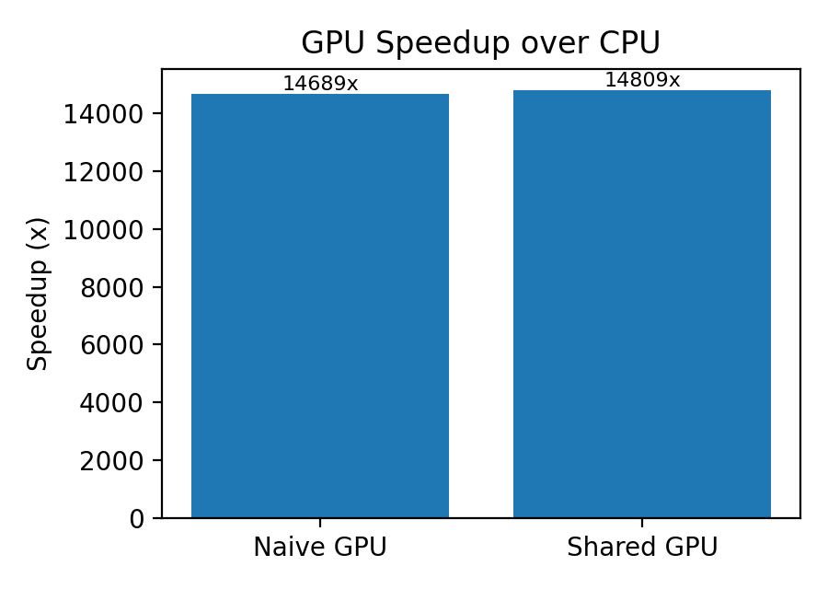
The naive CUDA kernel achieved a speedup of approximately 14,689× over the CPU implementation. The shared-memory kernel achieved a slightly higher speedup of approximately 14,809×. For a 3×3 filter, the improvement is modest because modern GPUs already cache many global memory accesses efficiently.

5. Discussion
Image normalization and thresholding involve simple pixel-wise operations, where GPU launch overhead can dominate for small images. In contrast, convolution performs multiple memory accesses and arithmetic operations per output pixel, making it highly suitable for GPU acceleration. The shared-memory implementation reduces redundant global memory accesses by storing image tiles in fast on-chip memory.

6. Conclusion
This project successfully integrates deep learning with GPU programming. A CNN achieved approximately 82.35% test accuracy for brain tumor classification. Custom CUDA kernels demonstrated substantial acceleration for image processing, with the shared-memory convolution providing the best overall performance among the implemented GPU kernels.

7. Future Work
• Evaluate deeper CNN architectures (ResNet, EfficientNet).
• Use larger convolution filters to further exploit shared memory.
• Extend to multiclass tumor classification.
• Deploy the pipeline for real-time clinical inference.

References
[1] NVIDIA CUDA Programming Guide.
[2] PyTorch Documentation.
[3] Numba CUDA Documentation.
[4] Goodfellow et al., Deep Learning, MIT Press.

