HANDWRITTEN DIGIT RECOGNITION

A Project Report Submitted in
the partial fulfillment of the requirements for the award of the degree of

BACHELOR OF TECHNOLOGY
In

DEPARTMENT OF COMPUTER SCIENCE AND ENGINEERING
By
T. Monika Sri - 2420030547
B. Snigdha - 2420030308
P. Mihika - 2420040041

Under the Esteemed Guidance of
B. Prathusha
Associate Professor

Department of Computer Science and Engineering

AY-2026–2027

Semester: Odd




K L (Deemed to be) University
DEPARTMENT OF COMPUTER SCIENCE AND ENGINEERING

Declaration

The Project Report entitled “Handwritten Digit Recognition Using K-Nearest Neighbors (KNN) and Support Vector Machine (SVM)” is a record of Bonafide work of T. Monika Sri - 2420030547, B. Snigdha – 2420030308, P. Mihika – 2420040041 submitted in partial fulfillment for the award of B. Tech in Computer Science and Engineering to the K L University. The results embodied in this report have not been copied from any other departments/University/Institute.

T. Monika Sri – 2420030547
B. Snigdha – 2420030308
P. Mihika – 2420040041
K L (Deemed to be) University
Department of Computer Science and Engineering

CERTIFICATE

This is certify that the mini project based report entitled “Handwritten Digit Recognition Using K-Nearest Neighbors (KNN) and Support Vector Machine (SVM)” is a bonafide work done and submitted T. Monika Sri - 2420030547, B. Snigdha – 2420030308, P. Mihika – 2420040041 in partial fulfillment of the requirements for the award of the degree of BACHELOR OF TECHNOLOGY in Department of Computer Science and Engineering, K L (Deemed to be University), during the academic year 2026-2027.

_____________________  Signature of the Guide  B.Prathusha  Associate Professor, CSE | _____________________  Course Coordinator  B.Prathusha  Department of CSE | _____________________  Head of the Department  Dr. P. Venkateswara Rao  Department of CSE

ACKNOWLEDGEMENT
The success in this project would not have been possible but for the timely help and guidance rendered by many people. Our wish to express my sincere thanks to all those who has assisted us in one way or the other for the completion of my project.

Our greatest appreciation to my Course Coordinator and my guide B. Prasthusha Associate Professor, Department of Computer Science and Engineering which cannot be expressed in words for her tremendous support, encouragement and guidance for this project.

We express our gratitude to Dr. P. Venkateswar Rao, Head of the Department of Computer Science and Engineering for providing us with adequate facilities, ways and means by which we are able to complete this project-based Lab.

We thank all the members of teaching and non-teaching staff members, and also who have assisted me directly or indirectly for successful completion of this project. Finally, I sincerely thank my parents, friends and classmates for their kind help and cooperation during my work.

T. Monika Sri – 2420030547
B. Snigdha – 2420030308
T. Mihika - 2420040041

Abstract
The UPI Fraud Detection and Prevention System Using Machine Learning is a Python-based project designed to identify and prevent suspicious UPI transactions. The system analyzes transaction details such as amount, time, location, receiver details, device information, and transaction history to detect unusual activities.
Machine Learning algorithms are used to classify transactions as legitimate or potentially fraudulent. When a suspicious transaction is detected, the system generates an alert and asks the user to verify it. If the user confirms the transaction, it is allowed to proceed in the simulation. If the user rejects it, the transaction is cancelled.
The system also includes user login and registration, dataset upload, transaction history, and an interactive dashboard to display fraud analysis and statistics. This project aims to improve digital payment security by detecting suspicious transactions and providing an additional verification step before completing payments.
The system uses different Machine Learning algorithms such as Logistic Regression, Decision Tree, and Random Forest to analyze transaction patterns and identify possible fraud. The dataset can be uploaded by the user in CSV format or generated using synthetic data. Data preprocessing and visualization techniques are used to clean the data, understand transaction patterns, and improve model performance. The system also displays important results such as accuracy, precision, recall, and F1-score to evaluate the model.
Additionally, the application provides a user-friendly dashboard developed using Streamlit, where users can register, log in, analyze transactions, and view their transaction history. SQLite is used to store user details and transaction records securely. Overall, this project aims to provide an additional layer of security for digital payments by identifying unusual activities, generating alerts, and allowing users to verify or reject suspicious transactions before they are completed in the simulation.

Index
S. No. | Chapters | Topics | Page.no
 |  | Acknowledgement | 4
 |  | Abstract | 5
1 | Introduction | 1.1 Background of the Project  1.2 Problem Statement  1.3 Scope of the Project  1.4 Objectives  1.5 Importance of the Application  1.6 Target Users/Audience
2 | System Requirements | 2.1 Hardware Requirements  2.2 Software Requirements  2.3 Development Tools and Frameworks
3 | Technology Stack | 3.1 Front-end – Streamlit  3.2 Application Logic – Python  3.3 Machine Learning – Scikit-learn  3.4 Image Processing – Pillow and NumPy  3.5 Data Visualization – Matplotlib  3.6 Model Storage – Joblib
4 | System Architecture | 4.1 High-Level Architecture Diagram  4.2 Description of System Modules  4.3 Application Execution Architecture
5 | Design | 5.1 User Interface Design and Screenshots  5.2 System Workflow / Data Flow Diagram
6 | Implementation | 6.1 Module-wise Implementation  6.2 User Input and Image Upload  6.3 Image Preprocessing  6.4 KNN Model Implementation  6.5 SVM Model Implementation  6.6 Prediction and Performance Analysis
7 | Features | 7.1 List of Main Features  7.2 Working of Each Feature  7.3 Interactive Drawing and Image Upload  7.4 Model Comparison Dashboard
8 | Testing | 8.1 Functional Testing  8.2 Integration Testing  8.3 Tools Used for Testing  8.4 Test Cases and Results  8.5 Model Performance Evaluation
9 | Deployment | 9.1 Steps to Run the Application  9.2 Python Environment Configuration  9.3 Local Application Execution
10 | Challenges & Limitations | 10.1 Issues Faced During Development  10.2 Solutions Applied  10.3 Current Limitations
11 | Future Enhancements | 11.1 Planned Features  11.2 Deep Learning Integration  11.3 Character Recognition and Cloud Deployment
12 | Conclusion | 12.1 Summary of the Project  12.2 Achievements  12.3 Skills Learned During Development
13 | References | Research Papers, Dataset and Technical Documentation
14 | Appendices | Application Screenshots  Sample Code Snippets  Installation and Setup Instructions  User Manual

CHAPTER 1
Introduction
1.1 Background of the Project
In today's digital world, online payments have become an important part of everyday life. Unified Payments Interface (UPI) allows people to transfer money quickly and easily using mobile phones. People use UPI for shopping, bill payments, money transfers, and many other activities. Although UPI makes payments easier, the increasing use of digital payments has also increased the risk of online fraud and unauthorized transactions.
UPI fraud can happen in different ways, such as fake payment requests, suspicious money transfers, unknown receivers, and unauthorized access. Sometimes, users may not notice unusual activities in their transactions. Therefore, detecting suspicious transactions at an early stage is important to improve digital payment security.
The UPI Fraud Detection and Prevention System Using Machine Learning is developed to identify potentially fraudulent transactions by analyzing different factors such as transaction amount, time, location, receiver details, device information, and transaction frequency. Machine Learning algorithms are used to study transaction patterns and classify transactions as legitimate or potentially fraudulent.
1.2 Problem Statement
The increasing use of UPI payments has also increased the risk of online payment fraud. Traditional payment systems may fail to identify unusual transactions at an early stage. This can lead to financial losses for users.
Therefore, there is a need for a system that can detect suspicious transactions by analyzing factors such as transaction amount, time, location, and receiver details. This project uses Machine Learning to identify potential fraud and generate alerts. It also allows users to verify or reject suspicious transactions before they are completed in the simulation.
  - Scope of the Project
The scope of this project includes:
- Detecting potentially fraudulent UPI transactions using Machine Learning.
- Analyzing transaction amounts and timings.
- Identifying unusual transaction patterns.
- Allowing users to upload transaction datasets in CSV format.
- Performing data cleaning and preprocessing.
- Implementing Logistic Regression, Decision Tree, and Random Forest algorithms.
Predicting legitimate and suspicious transactions.
- Generating alerts for suspicious transactions.
- Allowing users to verify or reject transactions.
- Providing user login and registration.
- Maintaining transaction history using SQLite.
- Displaying fraud analysis through graphs and dashboards.
- Evaluating model performance using different metrics.

1.4 Objectives
The main objectives of this project are:
- To develop a Machine Learning-based UPI fraud detection system.
- To identify suspicious transactions by analyzing amount, time, location, and other factors.
- To allow users to upload transaction datasets in CSV format.
- To preprocess and analyze transaction data.
- To implement Logistic Regression, Decision Tree, and Random Forest algorithms.
- To predict whether transactions are legitimate or potentially fraudulent.
- To generate alerts for suspicious transactions.
- To allow users to verify or reject suspicious transactions.
1.5 Importance of the Application
The UPI Fraud Detection and Prevention System is important because it helps identify suspicious online transactions and improves digital payment security.
- Helps detect potentially fraudulent UPI transactions at an early stage.
- Reduces the risk of unauthorized transactions.
- Analyzes transaction patterns using Machine Learning.
- Generates alerts when unusual activities are detected.
1.6 Target Users/Audience
The target users of this project include:
- UPI Users: People who use UPI for daily online payments and money transfers.
- Banking Customers: Customers who want additional security for their digital transactions.
- Financial Institutions: Banks and payment service providers interested in identifying suspicious transactions.
- Students and Researchers: People interested in learning about Machine Learning and fraud detection.
- Cybersecurity Professionals: People who study and analyze online payment fraud patterns.
- This application is mainly designed to help UPI users identify suspicious transactions and improve the safety of digital payments.

CHAPTER 2
System Requirements
2.1 Hardware Requirements
The following hardware configuration is suitable for running the project.
Processor : Intel Core i3 / i5 or equivalent
RAM : 4 GB minimum, 8 GB recommended
Storage : At least 1 GB of free space
Operating Input : Keyboard and Mouse
Display : Standard Laptop or Desktop Display
GPU : Optional
2.2 Software Requirements
The software requirements used for the project are:
- Operating System: Windows 10 or Windows 11.
- Programming Language: Python 3.x.
- Development Environment: Visual Studio Code / Jupyter Notebook.
- Application Framework: Streamlit.
- Machine Learning Library: Scikit-learn.
- Numerical Processing: NumPy.
- Data Handling: Pandas, where used.
- Data Visualization: Matplotlib.
- Model Storage: Joblib.
2.3 Development Tools and Frameworks
Python:
Python is the main programming language used in this project. It is used for image processing, model training, prediction and application development.
Streamlit:
Streamlit is used to create the interactive web application. It provides the drawing canvas, image upload interface, prediction results and performance dashboard.
Scikit-learn:
Scikit-learn provides the Machine Learning algorithms used in the project. It is used to implement KNN and SVM and evaluate their performance.
NumPy:
NumPy is used for numerical calculations and handling image data in the form of arrays.
Pandas:
Pandas is useful for handling structured data and organizing evaluation results wherever required in the implementation.
Matplotlib:
Matplotlib is used to generate graphs and visual representations of model performance.
Joblib:
Joblib is used to save trained Machine Learning models and load them when the application runs.
CHAPTER 3
Technology Stack
3.1 Front-end – Streamlit
Streamlit is an open-source Python framework used to build interactive web applications.
In this project, Streamlit is used to create the user interface. It allows users to draw handwritten digits, upload images, submit inputs and view prediction results.
It also displays the model comparison dashboard with graphs, performance metrics and confusion matrices.
3.2 Application Logic – Python
Python is used to develop the main application logic. It manages image preprocessing, model loading, prediction generation and performance analysis.
Python also connects the different project modules and ensures that the input image moves through the complete recognition process.
3.3 Machine Learning – Scikit-learn
Scikit-learn is a Machine Learning library used to implement classification algorithms for detecting fraudulent UPI transactions.
In this project, three algorithms are implemented:
Logistic Regression: A classification algorithm used to predict whether a transaction is legitimate or fraudulent.
Decision Tree: A tree-based algorithm that identifies suspicious transaction patterns using different conditions.
Random Forest: An ensemble learning algorithm that combines multiple decision trees to improve fraud detection performance.
3.4 Image Processing – Pillow and NumPy
Pillow is used to read and manipulate images, while NumPy is used to represent image data as numerical arrays.
These tools support grayscale conversion, image resizing, pixel manipulation and normalization.
3.5 Data Visualization – Matplotlib
Matplotlib is used to generate visualizations for model evaluation and comparison.
It helps display performance graphs, confusion matrices and other analysis results.
CHAPTER 4
System Architecture
4.1 High-Level Architecture Diagram
Insert the system architecture diagram here.
The architecture follows this sequence:
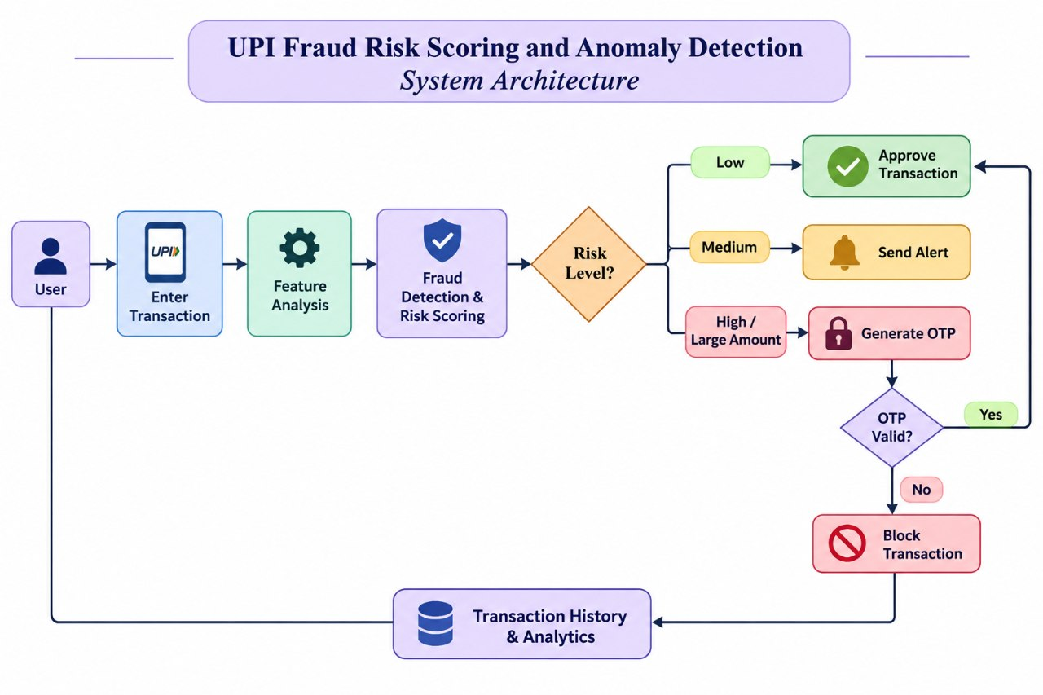
4.2 Description of System Modules
1. User Input Layer
Allows users to initiate UPI transactions by entering the transaction details. It acts as the starting point of the fraud detection system.
2. Enter Transaction Module: Collects transaction details such as amount, receiver information, and transaction time. These details are sent for further analysis.
3.Analysis Module: Extracts important features from transaction data, such as transaction amount, frequency, and user behavior. These features help identify unusual activities.
4. Fraud Detection and Risk Scoring Module: Analyzes transaction details using fraud detection techniques. It calculates a risk score to identify whether a transaction is safe or suspicious.
5. Risk Level Module: Classifies transactions into Low, Medium, and High risk levels based on the calculated risk score. It decides the next action for each transaction.
6. Approve Transaction Module: Automatically approves transactions with low fraud risk. The transaction is allowed to proceed safely.
7. Send Alert Module: Sends an alert when a medium-risk transaction is detected. It helps users become aware of suspicious activities.
8. Generate OTP Module: Generates an OTP for high-risk or large-amount transactions. The user must enter the correct OTP for verification.
9. OTP Validation Module: Checks whether the entered OTP is correct or not. If valid, the transaction is approved; otherwise, it is blocked.
10. Block Transaction Module: Blocks transactions when OTP verification fails. This prevents unauthorized or fraudulent transactions.
11. Transaction History and Analytics Module: Stores transaction details and maintains transaction history. It helps analyze past transactions and improve future fraud detection.

4.3 Application Execution Architecture
The UPI Fraud Risk Scoring and Anomaly Detection System is designed to run locally using Python and Streamlit.
The user starts the application from the project directory. Streamlit provides a web interface where users can enter UPI transaction details.
The application processes transaction data using feature analysis and a trained fraud detection model to calculate the risk score. Based on the risk level, the system approves the transaction, sends an alert, or generates an OTP for verification.
The application also stores transaction history and analytics to monitor activities and detect suspicious transactions.

CHAPTER 5
Design
5.1 User Interface Design and Screenshots
The UPI Fraud Risk Scoring and Anomaly Detection System is designed with a simple and interactive user interface using Python and Streamlit.
The main interface contains the following sections:
The main interface contains the following sections:
1. Main Application Screen
Displays the project title and interface with options to enter UPI transaction details.
2. Transaction Input Section
Allows users to enter transaction details such as transaction amount, receiver details, transaction time, and other required information.
3. Feature Analysis Section
Displays the important transaction features used for fraud detection, such as transaction amount, frequency, and user behavior.
4. Fraud Detection and Risk Scoring
Analyzes the entered transaction details and calculates a risk score using the fraud detection model.
5. Risk Level Display
Displays the transaction risk level as Low, Medium, or High based on the calculated risk score.

6. OTP Verification Section
Generates an OTP for high-risk or large-amount transactions and verifies the OTP entered by the user.
7. Transaction Results
Displays the final result, such as Approve Transaction, Send Alert, or Block Transaction.
8. Transaction History and Analytics
Displays previous transaction details and analytics to monitor transaction activities and identify suspicious patterns.

Insert the screenshots of the actual working application under this section.
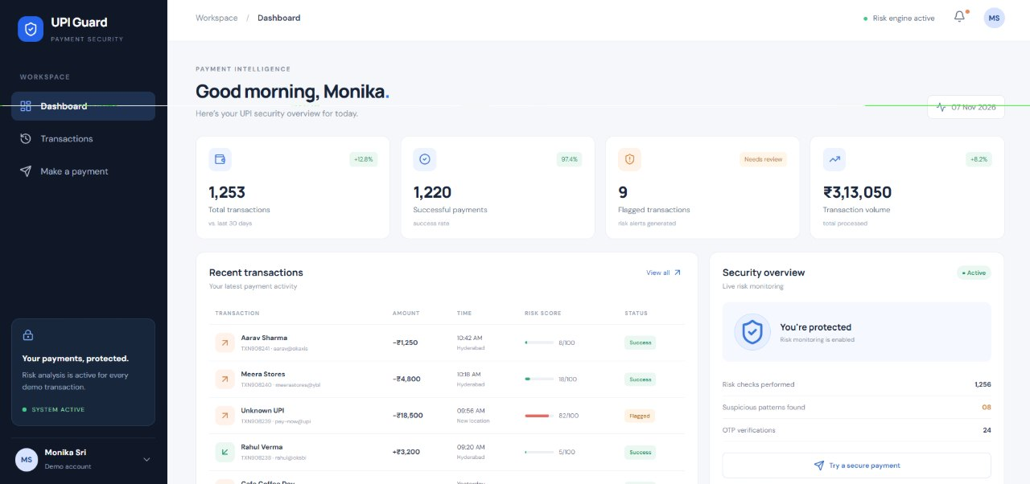

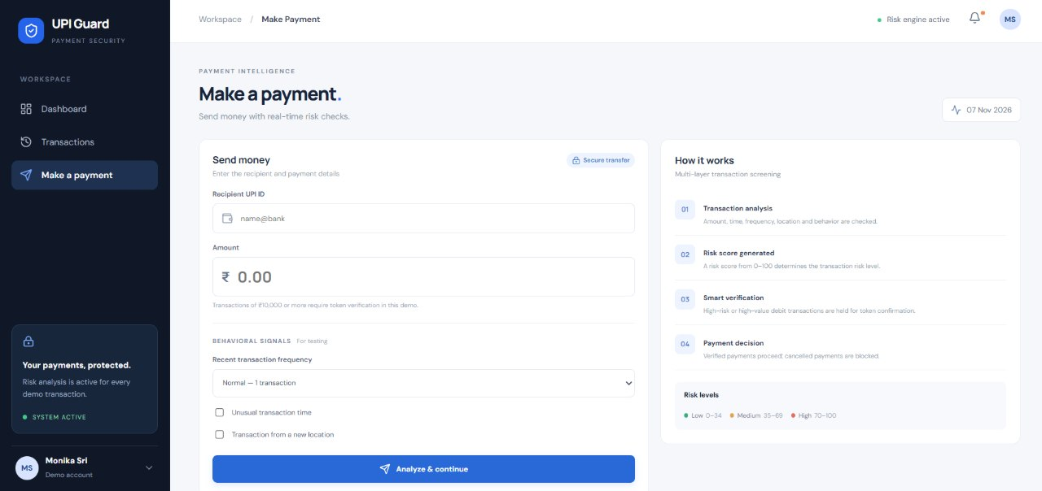
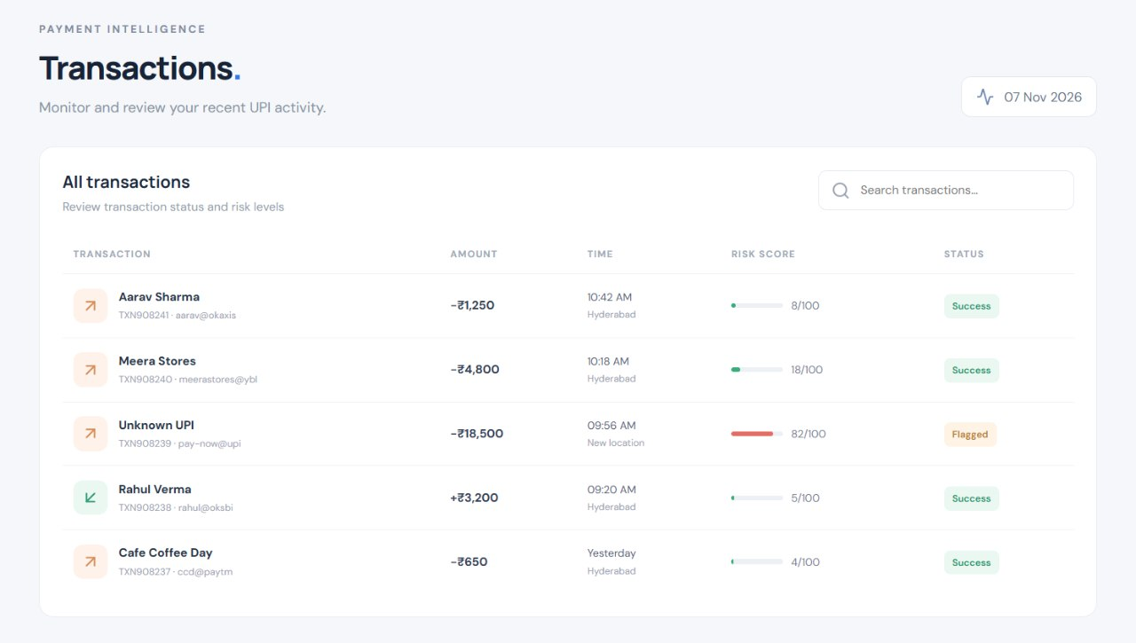
5.2 System Workflow / Data Flow Diagram
A Data Flow Diagram represents how data moves through the system.
In this project, the user enters UPI transaction details. The system analyzes the transaction using feature analysis and the fraud detection model.
Based on the risk score, the transaction is classified as Low, Medium, or High risk. Low-risk transactions are approved, medium-risk transactions generate alerts, and high-risk transactions require OTP verification.
Finally, the transaction details are stored in Transaction History and Analytics.
The overall data flow is:
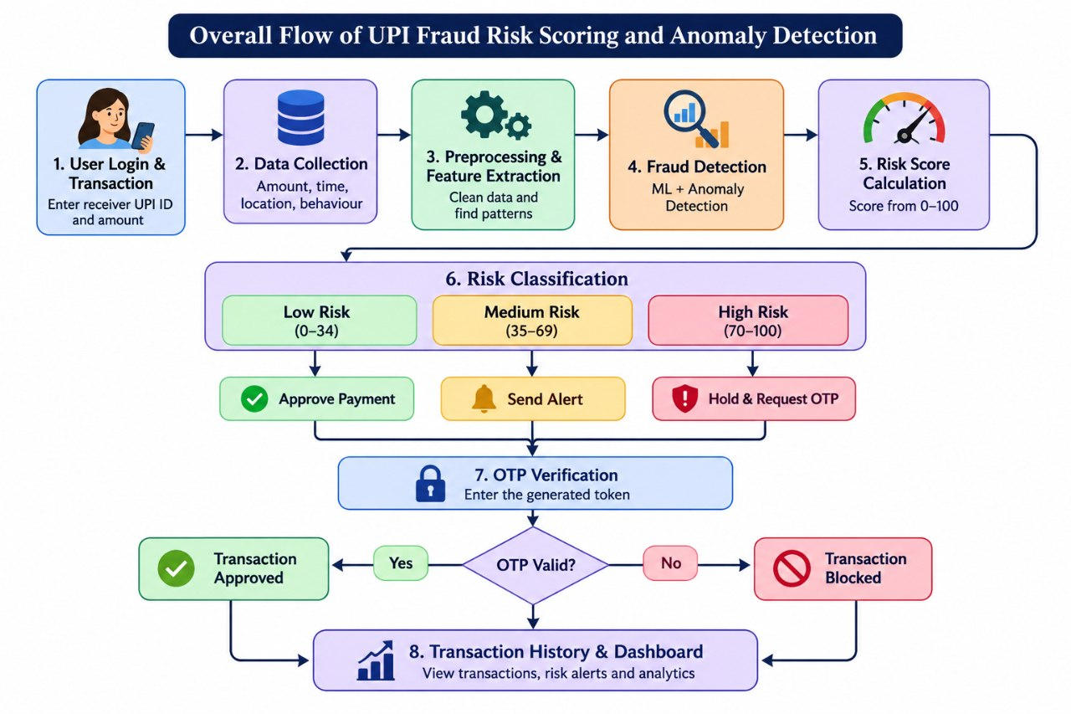

CHAPETER 6
IMPLEMENTATION
6.1 Module-wise Implementation
The project is implemented using Python and Streamlit. Each module performs a specific task in detecting fraudulent UPI transactions.
1. User Module: Allows users to access the application and enter transaction details.
2. Transaction Input Module: Collects transaction information such as amount, receiver details, and transaction time.
3. Feature Analysis Module: Extracts important features from transaction data for analysis.
4. Fraud Detection Module: Analyzes transaction details and calculates the fraud risk score.
5. Risk Level Module: Classifies transactions into Low, Medium, and High risk levels.
6. Approve Transaction Module: Approves transactions with low risk.
7. Send Alert Module: Sends alerts for medium-risk transactions.
8. OTP Verification Module: Generates and verifies OTP for high-risk transactions.
9. Block Transaction Module: Blocks transactions when OTP verification fails.
10. Transaction History Module: Stores transaction details and displays previous transaction records.
CHAPTER 7
Features
The UPI Fraud Risk Scoring and Anomaly Detection System provides several features to identify suspicious transactions and improve transaction security. The main features of the system are explained below.
1. User-Friendly Interface
The application provides a simple and interactive user interface using Python and Streamlit. Users can easily enter transaction details and view the results without technical knowledge.
2. Transaction Input
The system allows users to enter important UPI transaction details such as transaction amount, receiver information, transaction time, and other required details. These details are used for further fraud analysis.
3. Feature Analysis
The system analyzes important transaction features such as transaction amount, transaction frequency, and user behavior. These features help identify unusual transaction patterns.
4. Fraud Detection
The fraud detection module analyzes transaction details to identify suspicious activities. It helps detect unusual transactions and reduces the chances of financial fraud.
5. Risk Scoring
The system calculates a risk score for every transaction based on the analyzed features. This score helps determine whether a transaction is safe or potentially fraudulent.
6. Risk Classification
Based on the calculated risk score, transactions are classified into three levels:
- Low Risk: Transaction is considered safe and approved.
- Medium Risk: Transaction is suspicious and an alert is generated.
- High Risk: Additional OTP verification is required.
7. OTP Verification
For high-risk transactions, the system generates a One-Time Password (OTP). The user must enter the correct OTP to complete the transaction successfully.
8. Transaction Alerts
The system generates alerts whenever medium-risk or suspicious transactions are detected. These alerts help users become aware of possible fraudulent activities.
9. Transaction Blocking
If the OTP entered by the user is incorrect, the system blocks the transaction. This feature helps prevent unauthorized transactions.
10. Transaction History
The system maintains records of previous transactions, including transaction details, risk scores, and final transaction status. Users can refer to these records whenever required.
11. Analytics and Monitoring
The system provides transaction analytics to monitor transaction activities and identify suspicious patterns. It helps understand fraud trends and improves transaction monitoring.
12. Improved Security
The system combines fraud detection, risk scoring, alerts, and OTP verification to provide an additional layer of security for UPI transactions.

CHAPTER - 8
Testing
8.1 Functional Testing
Functional testing is performed to verify whether the main features of the UPI Fraud Risk Scoring and Anomaly Detection System work correctly.
The following operations are tested:
- Entering UPI transaction details.
- Processing transaction information.
- Performing feature analysis.
- Generating fraud risk scores.
- Classifying transactions into Low, Medium, and High risk levels.
- Approving low-risk transactions.
- Sending alerts for medium-risk transactions.
- Generating OTP for high-risk transactions.
- Validating OTP.
- Blocking transactions when OTP verification fails.
- Displaying transaction history and analytics.

8.2 Integration Testing
Integration testing checks whether all the different modules work together correctly.
The following sequence is verified:
- User enters UPI transaction details.
- The feature analysis module receives the transaction data.
- The fraud detection module calculates the risk score.
- The risk level module classifies the transaction.
- The system performs the required action based on the risk level.
- Transaction details are stored in the history module.
8.3 Tools Used for Testing
The following tools and libraries are used:
- Python: For executing the application.
- Streamlit: For testing the user interface.
- Scikit-learn: For fraud detection model evaluation.
- NumPy: For numerical operations.
- Pandas: For handling transaction datasets.
- Matplotlib: For visualizing results and graphs.
- VS Code and Jupyter Notebook: For development and testing.

8.4 Test Cases and Results
Test Case ID | Test Case | Expected Result | Status
TC-01 | Enter transaction details | Details should be accepted | Pass (if tested)
TC-02 | Analyze transaction | Features should be processed | Pass (if tested)
TC-03 | Detect low-risk transaction | Transaction should be approved | Pass (if tested)
TC-04 | Detect medium-risk transaction | Alert should be generated | Pass (if tested)
TC-05 | Detect high-risk transaction | OTP should be generated | Pass (if tested)
TC-06 | Enter valid OTP | Transaction should be approved | Pass (if tested)
TC-07 | Enter invalid OTP | Transaction should be blocked | Pass (if tested)
TC-08 | View transaction history | Previous records should be displayed | Pass (if tested)
CHAPTER 9
Deployment
9.1 Steps to Run the Application
The application can be executed locally using the following steps:
- Install Python on the computer.
- Open the project folder in Visual Studio Code.
- Create a Python virtual environment.
- Activate the virtual environment.
- Install the required Python libraries.
- Ensure that the trained KNN and SVM model files are available.
- Run the Streamlit application.
Command to execute the application:
python -m streamlit run app.py

After executing the command, Streamlit displays a local URL in the terminal.
Open that URL in a web browser to access the application.
9.2 Python Environment Configuration
The project uses a Python virtual environment to manage the required libraries.
The environment includes Python packages such as Streamlit, Pandas, NumPy, Scikit-learn, and Matplotlib for application development, data processing, and fraud detection.
The trained fraud detection model files and transaction dataset must be available in the correct project directory.
9.3 Local Application Execution
The application runs locally using Streamlit.
Users can enter UPI transaction details through the web interface. The application processes the data, calculates the fraud risk score, and displays the transaction result.
Separate front-end and back-end hosting are not required for the current implementation.

CHAPTER 10
Challenges and Limitations
10.1 Issues Faced During Development
During the development of the UPI Fraud Risk Scoring and Anomaly Detection System, some challenges were faced:
- Data Collection: Collecting suitable transaction data for fraud detection was challenging.
- Data Preprocessing: Cleaning and preparing transaction data required careful handling.
- Feature Selection: Selecting important features to identify fraudulent transactions was difficult.
- Model Accuracy: Improving the accuracy of fraud detection and reducing incorrect predictions was challenging.
- Risk Classification: Setting suitable risk levels for different transactions required proper analysis.
- OTP Verification: Implementing OTP generation and validation required additional logic.

10.2 Solutions Applied
The following solutions were applied to overcome these challenges:
- Used Python libraries such as Pandas and NumPy for data processing.
- Selected important transaction features for fraud detection.
- Used Machine Learning techniques to identify suspicious transactions.
- Applied risk scoring to classify transactions into Low, Medium, and High levels.
- Implemented OTP verification for high-risk transactions.
- Used Streamlit to develop a simple and interactive user interface.

10.3 Current Limitations
Although the system provides fraud detection features, it has some limitations:
- Dataset Dependency: The accuracy of the system depends on the quality and quantity of transaction data.
- False Predictions: Some genuine transactions may be identified as suspicious, and some fraudulent transactions may go undetected.
- Real-Time Integration: The current system may not be directly connected to actual UPI banking services.
- OTP Security: OTP verification depends on the implementation and may not include real SMS delivery.
- Limited Features: The system uses selected transaction features and may not detect every type of fraud.
- Scalability: The current local application may require further improvements to handle a large number of transactions.

CHAPTER 11
Future Enhancements
The UPI Fraud Risk Scoring and Anomaly Detection System can be improved in the future by adding more advanced features to make fraud detection more accurate and secure.
1. Real-Time Fraud Detection: The system can be connected to actual UPI transaction services to detect fraudulent activities in real time.
2. Advanced Machine Learning Models: Advanced algorithms such as Random Forest, XGBoost, and Deep Learning can be used to improve fraud detection accuracy.
3. Improved Risk Scoring: The risk scoring mechanism can be improved to provide more accurate risk levels based on transaction patterns.
4. SMS and Email Alerts: Notifications can be sent directly to users through SMS and email whenever suspicious transactions are detected.
5. Advanced OTP Security: Secure OTP verification can be implemented using real SMS or email services.
6. User Behavior Analysis: The system can analyze user spending habits, transaction locations, and transaction frequency to identify unusual activities.
7. Mobile Application Development: A mobile application can be developed to make the system easily accessible to users.
8. Cloud Deployment: The application can be deployed on cloud platforms to improve accessibility, scalability, and performance.
9. Improved Dashboard: More charts, graphs, and reports can be added to display fraud statistics and transaction history.
10. Continuous Model Training: The fraud detection model can be regularly updated using new transaction data to improve its performance.

CHAPTER 12
Conclusion
12.1 Summary of the Project
The UPI Fraud Risk Scoring and Anomaly Detection System is developed to identify suspicious and fraudulent UPI transactions using Machine Learning techniques. The system analyzes transaction details and calculates a risk score. Based on the risk level, transactions are classified as Low, Medium, or High. It provides transaction approval, alerts, and OTP verification to improve security. The application is developed using Python and Streamlit with a simple user interface.
12.2 What Was Achieved
- Developed a user-friendly application for UPI fraud detection.
- Implemented transaction feature analysis.
- Generated risk scores for transactions.
- Classified transactions into Low, Medium, and High risk levels.
- Implemented OTP verification for high-risk transactions.
- Added transaction alerts and blocking features.
- Maintained transaction history and analytics.
- Improved awareness of suspicious UPI transactions.
12.3 Skills Learned During Development
During the development of this project, we learned several technical skills:
- Python Programming: Learned to develop applications using Python.
- Machine Learning: Understood how Machine Learning helps detect fraudulent transactions.
- Data Processing: Learned to process and analyze transaction datasets.
- Streamlit: Learned to create interactive web applications.
- Feature Analysis: Understood how to select important transaction features.
- Risk Scoring: Learned to calculate and classify transaction risk levels.
- Testing and Debugging: Gained experience in testing the application and fixing errors.
- Project Development: Improved problem-solving, teamwork, and practical implementation skills

CHAPTER 13
References
- Python Software Foundation, Python Documentation. Available at: https://docs.python.org/3/
- Streamlit, Streamlit Documentation. Available at: https://docs.streamlit.io/
- Scikit-learn, Machine Learning in Python – Scikit-learn Documentation. Available at: https://scikit-learn.org/
- Pandas, Data Analysis and Manipulation Documentation. Available at: https://pandas.pydata.org/docs/
- NumPy, Numerical Computing Documentation. Available at: https://numpy.org/doc/
- Matplotlib, Data Visualization Documentation. Available at: https://matplotlib.org/stable/
- Reserve Bank of India (RBI), Digital Payment Security Guidelines. Available at: https://www.rbi.org.in/
- National Payments Corporation of India (NPCI), UPI – Unified Payments Interface. Available at: https://www.npci.org.in/
- Research papers and articles related to Machine Learning-Based Fraud Detection and Anomaly Detection in Digital Payments.
- GeeksforGeeks, Fraud Detection Using Machine Learning. Available at: https://www.geeksforgeeks.org/

CHAPTER 14
Appendices
14.1 Application Screenshots
14.2 Sample Code Snippets
import streamlit as st
import pandas as pd

st.title("UPI Fraud Risk Scoring and Anomaly Detection")
st.write("Enter UPI Transaction Details")

# Transaction Input
amount = st.number_input("Transaction Amount", min_value=0.0)
frequency = st.number_input("Transaction Frequency", min_value=0)

# Feature Analysis
st.subheader("Transaction Analysis")

risk_score = 0

if amount > 50000:
risk_score += 50

if frequency > 5:
risk_score += 30

# Risk Classification
st.subheader("Fraud Detection Result")
st.write("Risk Score:", risk_score)

if risk_score < 30:
st.success("Low Risk - Transaction Approved")

elif risk_score < 60:
st.warning("Medium Risk - Alert Generated")

else:
st.error("High Risk - OTP Verification Required")

otp = "1234"
entered_otp = st.text_input("Enter OTP")

if st.button("Verify OTP"):
if entered_otp == otp:
st.success("OTP Verified - Transaction Approved")
else:
st.error("Invalid OTP - Transaction Blocked")

# Transaction History
st.subheader("Transaction Details")

data = pd.DataFrame({
"Amount": [amount],
"Frequency": [frequency],
"Risk Score": [risk_score]
})

st.dataframe(data)

14.3 Installation and Setup Instructions

The UPI Fraud Risk Scoring and Anomaly Detection System is developed using Python and Streamlit. The following steps are used to install and run the application.
- Install Python on the computer.
- Install Visual Studio Code.
- Open the project folder in Visual Studio Code.
- Create and activate a Python virtual environment.
- Install the required libraries such as Streamlit, Pandas, NumPy, Scikit-learn, and Matplotlib.
- Ensure that the Python files, transaction dataset, and trained model files are available in the project folder.
- Open the terminal and execute the following command:
streamlit run app.py
- After execution, Streamlit displays a local URL in the terminal.
- Open the URL in a web browser to access the application.
- Enter UPI transaction details and view the fraud detection results.

14.4 User Manual
The application can be used through the following steps:
- Open the application using Streamlit.
- Enter the required UPI transaction details.
- Click the Analyze button to process the transaction.
- The system calculates the fraud risk score.
- View the risk level as Low, Medium, or High.
- Complete OTP verification if required.
- View the final transaction status.
- Check previous transactions in the history section.
14.5 Team Contributions
Monika Sri:
- Collected and prepared the UPI transaction dataset.
- Performed data cleaning and preprocessing.
- Selected important transaction features for fraud detection.
- Prepared data for Machine Learning.
Snigdha:
- Developed the fraud detection model.
- Implemented risk scoring and risk classification.
- Worked on Low, Medium, and High risk detection.
- Implemented OTP verification and transaction blocking logic.

B. Keerthi Reddy:
- Developed the user interface using Python and Streamlit.
- Integrated the fraud detection model with the application.
- Implemented transaction history and analytics.
- Performed application testing and documentation.

All three team members contributed to project integration, testing, debugging and documentation according to their actual work.

